When does a cultural movement become a renaissance?
C3 Framework Standard | D2.His.14.9-12. Analyze multiple and complex causes and effects of events in the past.
C3 Teachers Topic, Concept & Skill | ★ Era 6: Change ★ Identity ★ Interpretation

A renaissance brings to mind transition, change, invigoration, and widespread influence. Harlem in the 1920s and 1930s was a vibrant hub of literary, artistic, and musical expression. This inquiry asks students to consider the coexistence of social and political tension with a celebratory and hopeful future as they determine what elevated the African American experience in Harlem from a cultural movement to a renaissance.

Featured Sources
Source A: E. Simms Campbell, "Night-club Map of Harlem,” Library of Congress
Source B: Artists of the Harlem Renaissance Portraits, Library of Congress
Source C: Langston Hughes reading his poems with comment, Library of Congress
Source D: Lift Every Voice and Sing, Library of Congress

Formative Performance Tasks |  |  | Teacher Guidance
COLLABORATE | Complete a T-chart about the “Night-club Map of Harlem,” and artist portraits, noting observations/questions around cultural change. |  | Class begins with students looking at one of four quadrants of E Simm’s Campbell’s Night Club Map of Harlem. Each student completes a t-chart listing observations and questions about their quadrant, then collaborates with three other students to compile a cohesive list. Artist portraits may be used to enhance this exercise and provide more evidence for students’ observations.  Students then analyze the poetry and lyric Source Set to determine how the authors may answer the prompts of “Where we’ve been,” “Where we are,” and “Where we’re going.” Students collect their thoughts on a graphic organizer.  To conclude, students circle back to the idea of a map by creating an illustration or mind map that highlights examples of how Harlem’s artists brought forth a renaissance, captioning the work with a response to the compelling question that they select or develop independently.
DELIBERATE | Identify major themes found in Langston Hughes’ poetry and the lyrics of Lift Every Voice and Sing.
PRODUCE | Create a mind map that illustrates Harlem’s transformation from a cultural movement in the 1920s and 1930s to a powerful renaissance. Craft a claim or select one of the sample claims to serve as a caption.

When does a cultural movement become a renaissance?
Featured Source | Source A: E. Simms Campbell, "Night-club Map of Harlem,” Library of Congress

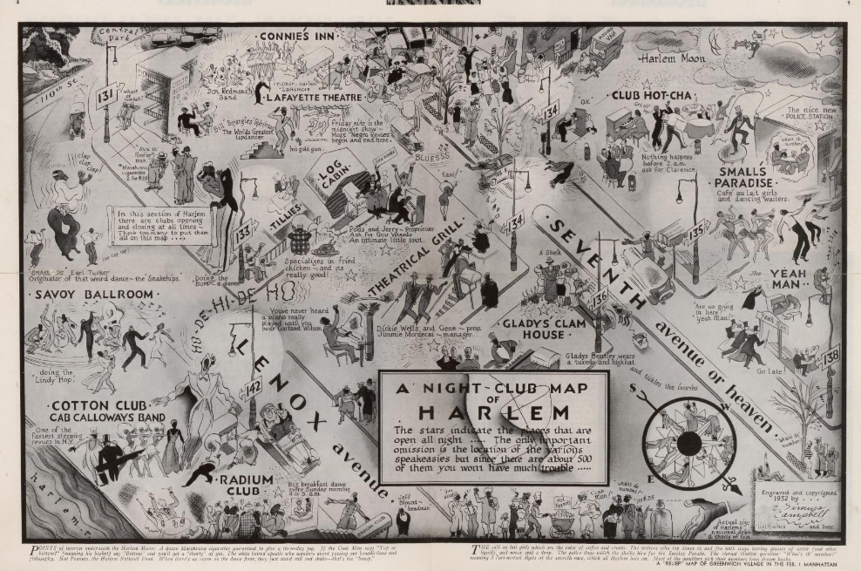
Public domain. Available at the Library of Congress: https://blogs.loc.gov/maps/2023/02/mapping-points-of-interest-underneath-the-harlem-moon/
When does a cultural movement become a renaissance?
Featured Source | Source A: Quadrant 1 of E. Simms Campbell, "Night-club Map of Harlem,” Library of Congress

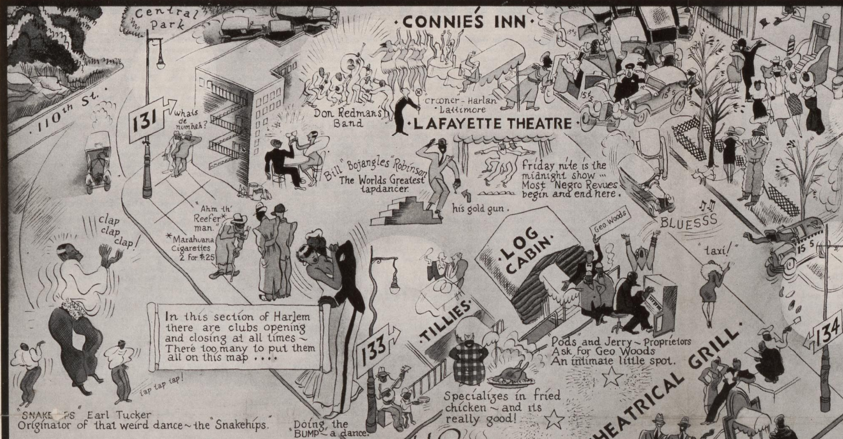
Public domain. Available at the Library of Congress: https://blogs.loc.gov/maps/2023/02/mapping-points-of-interest-underneath-the-harlem-moon/
When does a cultural movement become a renaissance?
Featured Source | Source A: Quadrant 2 of E. Simms Campbell, "Night-club Map of Harlem,” Library of Congress
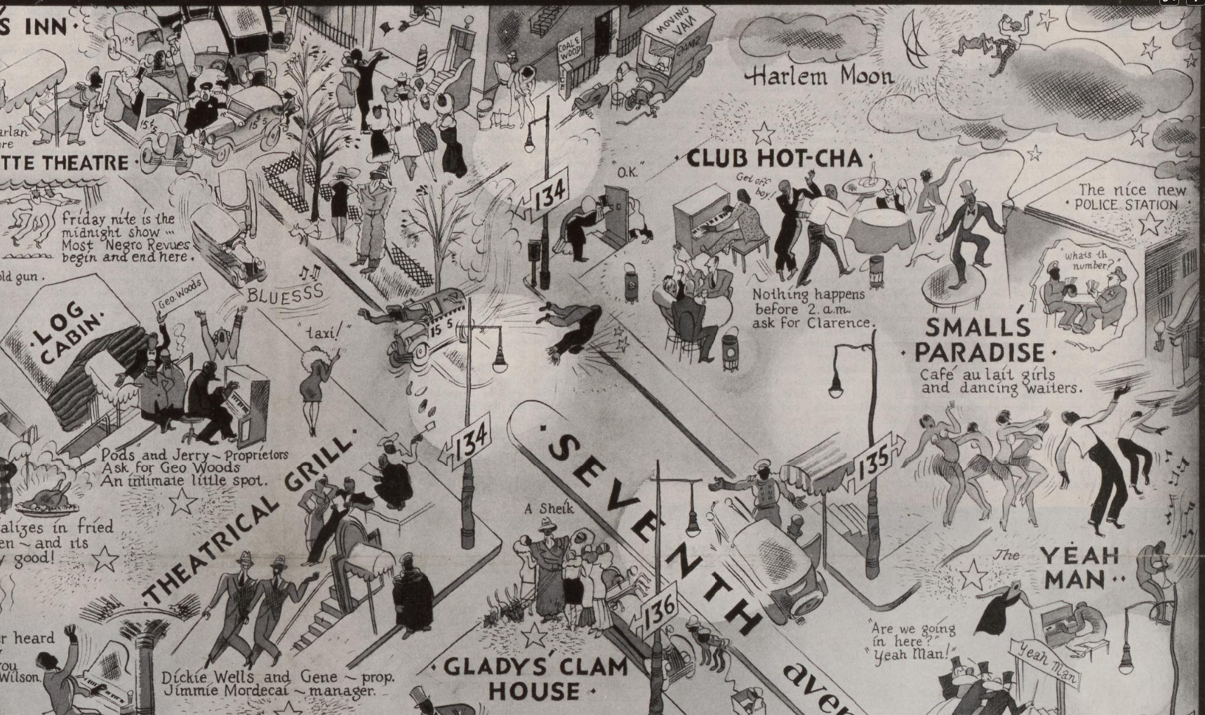
Public domain. Available at the Library of Congress: https://blogs.loc.gov/maps/2023/02/mapping-points-of-interest-underneath-the-harlem-moon/
When does a cultural movement become a renaissance?
Featured Source | Source A: Quadrant 3 of E. Simms Campbell, "Night-club Map of Harlem,” Library of Congress
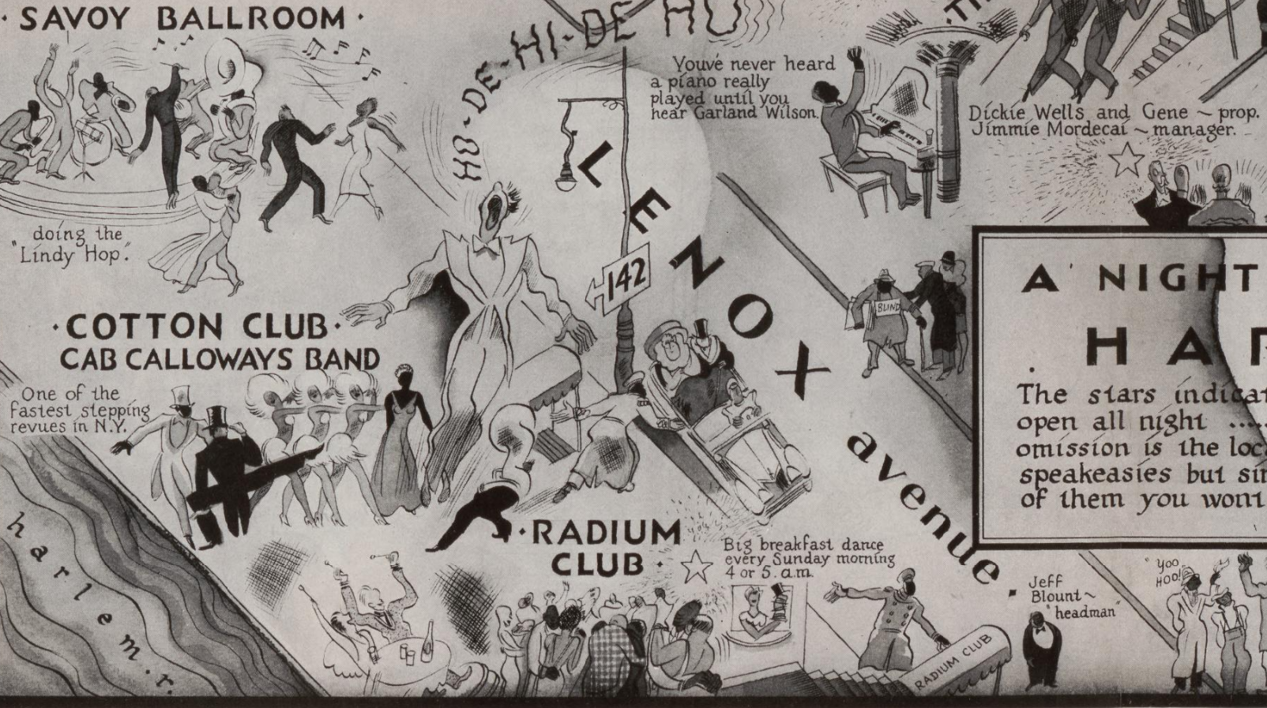
Public domain. Available at the Library of Congress: https://blogs.loc.gov/maps/2023/02/mapping-points-of-interest-underneath-the-harlem-moon/
When does a cultural movement become a renaissance?
Featured Source | Source A: Quadrant 4 of E. Simms Campbell, "Night-club Map of Harlem,” Library of Congress
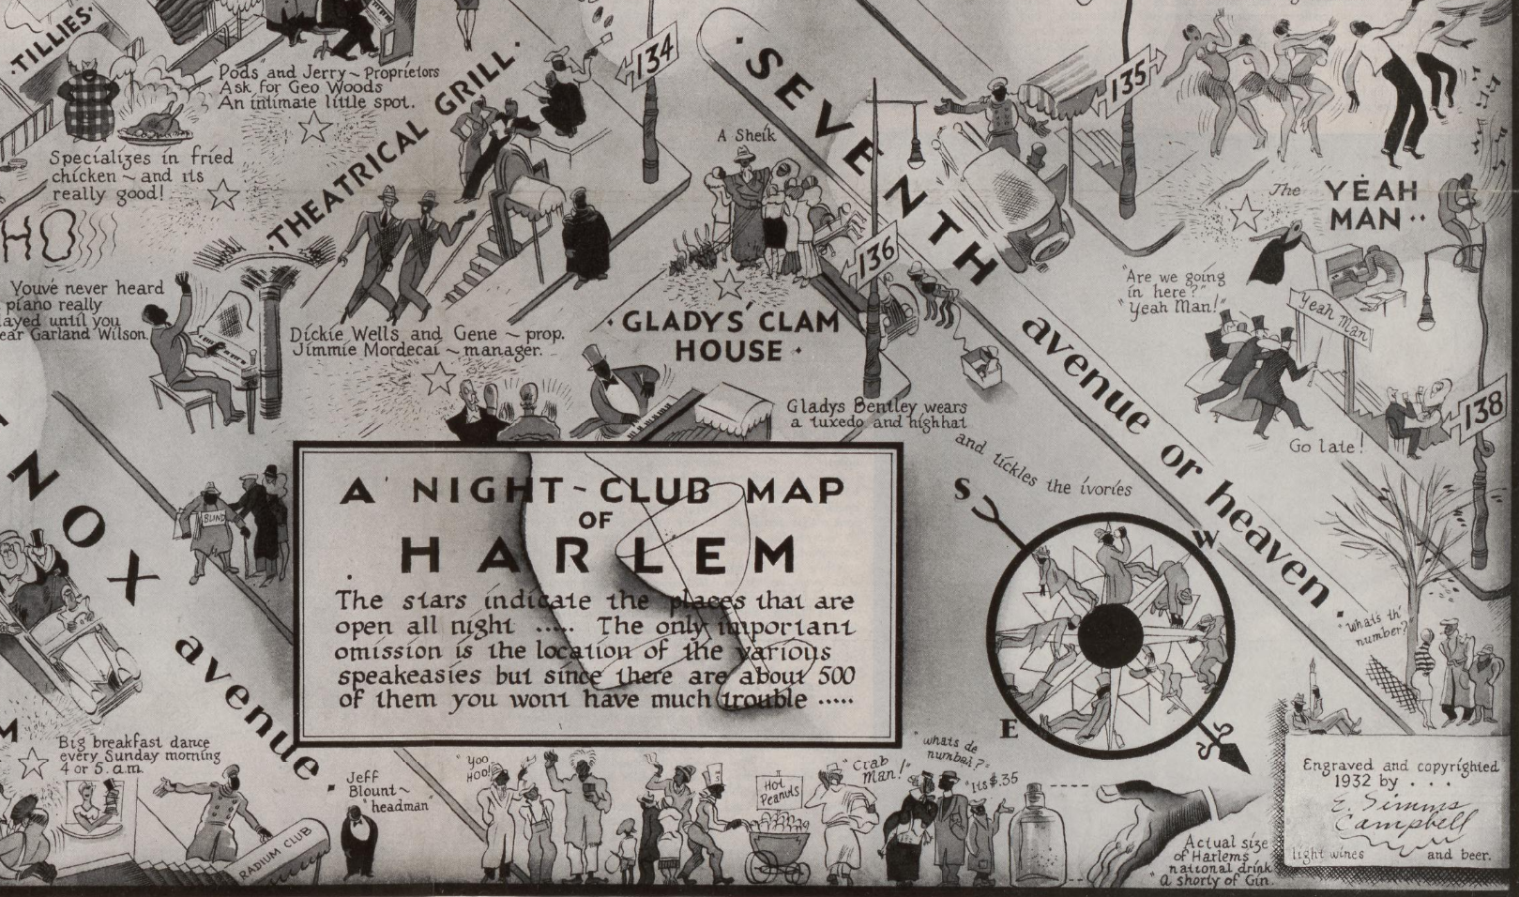
Public domain. Available at the Library of Congress: https://blogs.loc.gov/maps/2023/02/mapping-points-of-interest-underneath-the-harlem-moon

When does a cultural movement become a renaissance?
Featured Source | Source B: Portraits of Harlem Renaissance Artists, Library of Congress

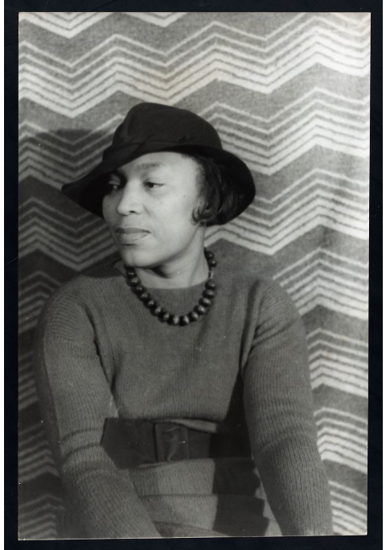

Photograph shows Zora Neale Hurston (1891-1960), an African American, female author, anthropologist, playwright, and filmmaker, who was active in the Harlem Renaissance, in front of a patterned backdrop.

Public domain. Available at the Library of Congress: https://www.loc.gov/classroom-materials/harlem-renaissance/

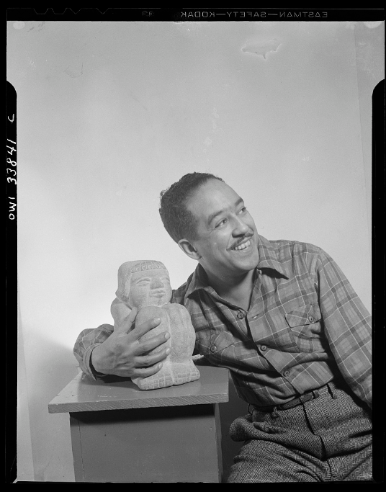
Portrait of Langston Hughes
Public domain. Available at the Library of Congress: https://www.loc.gov/classroom-materials/harlem-renaissance/

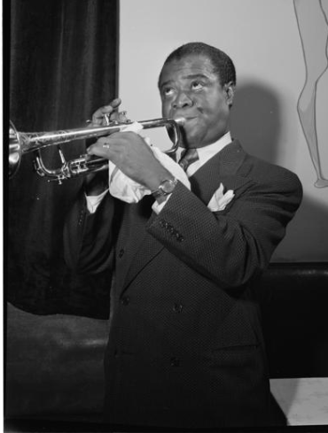
Portrait of Louis Armstrong, between 1938 and 1948

Public domain. Available at the Library of Congress: https://www.loc.gov/classroom-materials/harlem-renaissance/

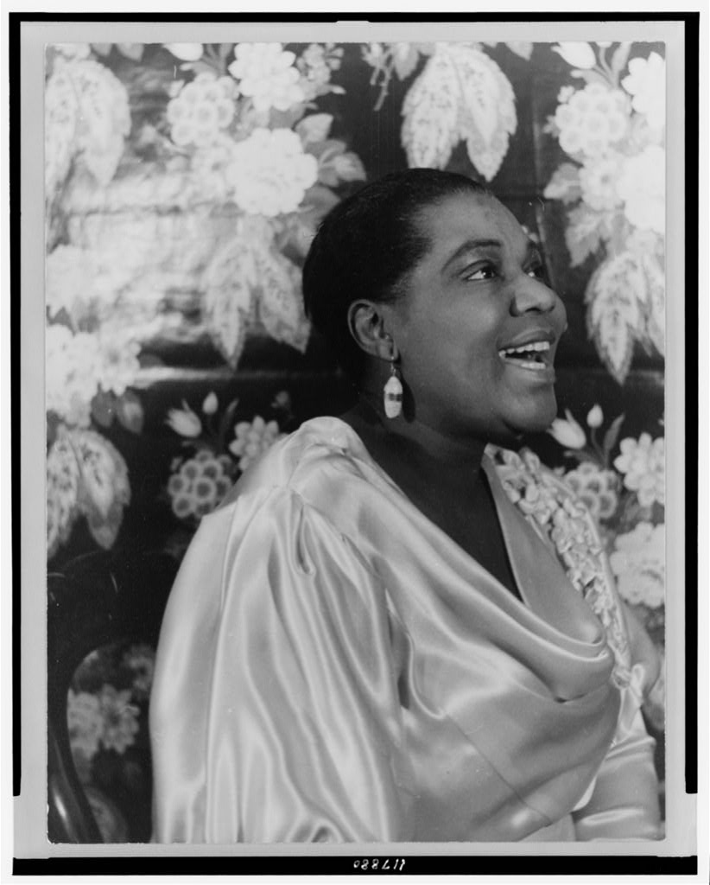Photograph shows Bessie Smith, a female, African American blues singer.
Public domain. Available at the Library of Congress: https://www.loc.gov/classroom-materials/harlem-renaissance/

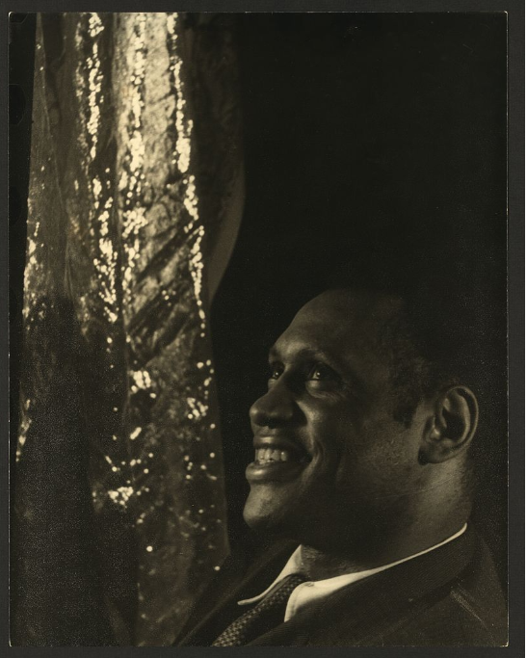
Photograph shows Paul Robeson, a male, African American concert artist, actor, football player, and activist.

Public domain. Available at the Library of Congress: https://www.loc.gov/classroom-materials/harlem-renaissance/
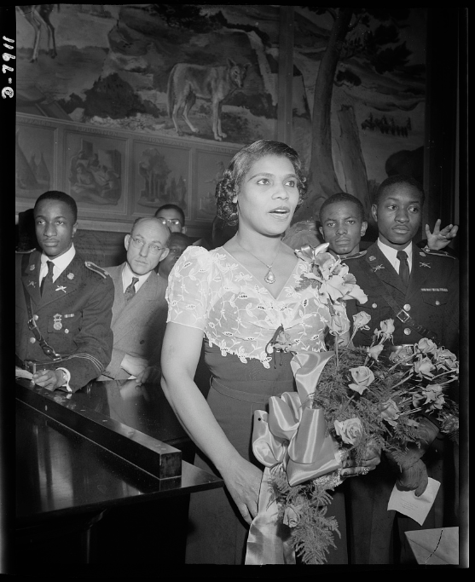
Marian Anderson mural dedicated. Marian Anderson, noted contralto, sings "The Star Spangled Banner" at the dedication of a mural commemorating her free public concert on the steps of the Lincoln Memorial on Easter Sunday, 1939.

Public domain. Available at the Library of Congress: https://www.loc.gov/classroom-materials/harlem-renaissance/
Compelling Question
Featured Source | Source C: Langston Hughes reading his poems with comment, Library of Congress  “The Negro Speaks of Rivers” (3:00 - 5:30)  “Democracy” (45:50 - 47:45)

The Negro Speaks of Rivers (Audio Recording - 3:00-5:30)

I’ve known rivers:
I’ve known rivers ancient as the world and older than the flow of human blood in human veins.

My soul has grown deep like the rivers.

I bathed in the Euphrates when dawns were young.
I built my hut near the Congo and it lulled me to sleep.
I looked upon the Nile and raised the pyramids above it.
I heard the singing of the Mississippi when Abe Lincoln went down to New Orleans, and I’ve seen its muddy bosom turn all golden in the sunset.

I’ve known rivers:
Ancient, dusky rivers.

My soul has grown deep like the rivers.

Democracy (Audio Recording - 45:50-47:45)

Democracy will not come
Today, this year
Nor ever
Through compromise and fear.

I have as much right
As the other fellow has
To stand
On my two feet
And own the land.

I tire so of hearing people say,
Let things take their course.
Tomorrow is another day.
I do not need my freedom when I'm dead.
I cannot live on tomorrow's bread.

Freedom
Is a strong seed
Planted
In a great need.

I live here, too.
I want freedom
Just as you.

Audio Recordings - Public domain. Available at the Library of Congress: https://www.loc.gov/item/93843023/
Compelling Question
Featured Source | Source D: Lift Every Voice and Sing (Lyrics and Sheet Music), Library of Congress
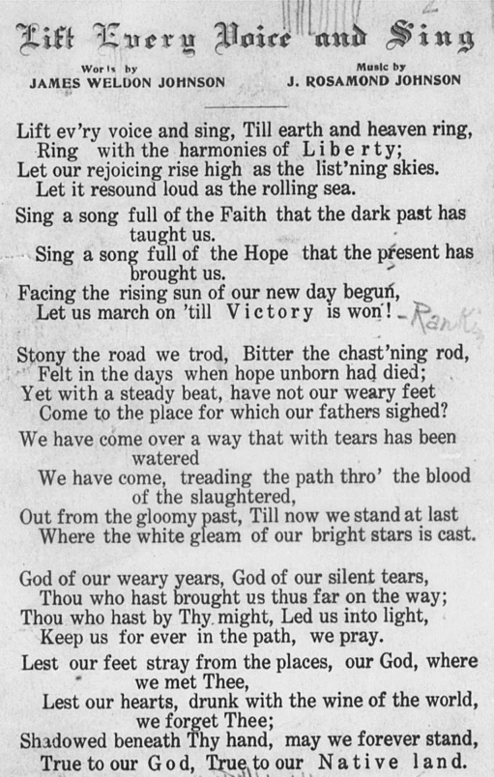
Early black migrants to Harlem, James and Rosamond Johnson, were respected leaders of the postwar renaissance. James served as general secretary of the New York NAACP and became an outspoken figure for civil rights and against lynching. In 1920, his colleagues honored him by proclaiming “Lift Ev’ry Voice and Sing” to be “the Negro national anthem.” This designation reflected the song’s popularity in African American schools, organizations, and churches and ensured that it would take on new meanings as black migrants spread across the nation and extended campaigns for equal rights. (Historical Essay, Library of Congress)

Public domain. Available at the Library of Congress: https://www.loc.gov/resource/music.muslcdb-2021561009/?st=gallery
Life in Harlem

Observations | Questions

What story do the songs and poetry of the Harlem Renaissance tell us?

Where We’ve Been
Where We Are
Where We’re Going

Mind Map: When does a cultural movement become a renaissance?

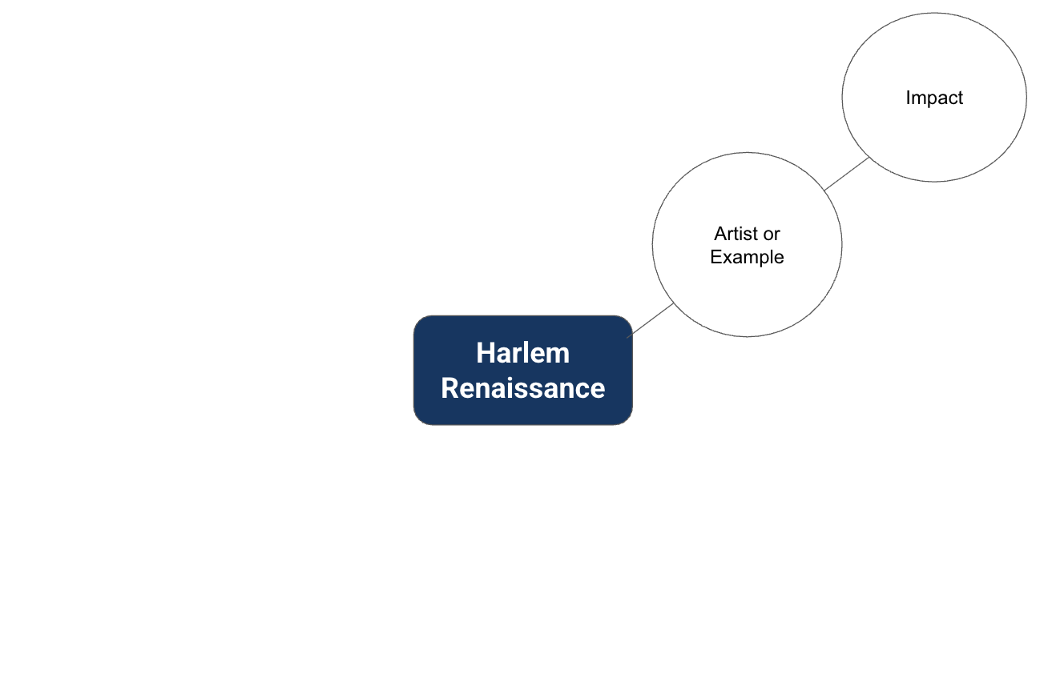

Claim:

