What story does the Great Migration tell us about change?
C3 Framework Standard | D2.His.6.9-12. Analyze the ways in which the perspectives of those writing history shaped the history that they produced.
C3 Teachers Topic, Concept & Skill | ★ Era 6: Change ★ Historical Memory ★ Argument

The Great Migration reshaped not only African American life but also the cultural fabric of the entire United States, laying the groundwork for greater visibility, recognition, and influence of Black culture. This inquiry will provide experiences for students to analyze the movement of African Americans from 1890 to 1960 to understand the scale and scope of change in the United States as African Americans left the South.

Featured Sources
Source Set A: Experiences of the Great Migration, 1890-1917
Source Set B: Experiences of the Great Migration, 1919-1941
Source Set C: Experiences of the Great Migration, 1942-1960

Formative Performance Tasks |  |  | Teacher Guidance
COLLABORATE | Create a list of the changes sought or experienced during the Great Migration. Organize the sources under a set of student-created themes. |  | Class begins with students working in pairs to examine one of three Source Sets as they list the changes sought or experienced by African Americans during the Great Migration. Then, students will merge into groups of 6 as they discuss and compare the changes between each set of sources, spanning decades.  Students then work in their groups to evaluate a set of pre-made claims. They will discuss which would serve as the best response to the compelling question, “What story does the Great Migration tell us about change?”  Next, students write in their selected claim or may choose to craft their own as a group. They will use the sources examined previously to complete a graphic organizer, supporting their claim with evidence and connecting their ideas with clear reasoning.
DELIBERATE | Evaluate a set of sample claims and determine which is the best response to the compelling question.
PRODUCE | Complete a response to the compelling question by supporting the selected claim with evidence and reasoning.

What story does the Great Migration tell us about change?
Featured Source | Source Set A: 1890-1917 - Colored population of the United States: 1890

Distribution of African American Population: 1890
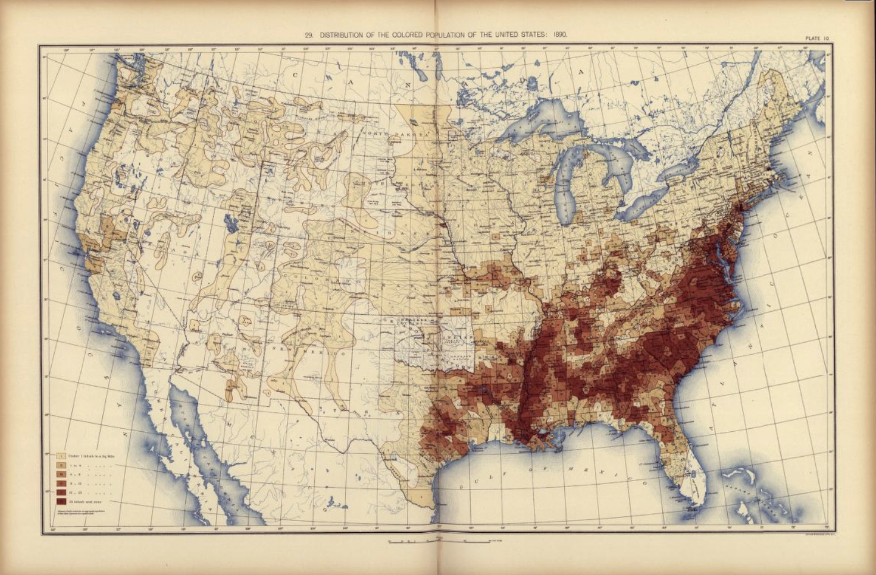

Public domain. Available at the Library of Congress: https://www.loc.gov/resource/g3701gm.gct00010/?sp=26&r=-0.272,-0.037,1.535,0.745,0
What story does the Great Migration tell us about change?
Featured Source | Source Set A: 1890-1917 - "Big Bill" Broonzy describes his move from Arkansas to Chicago

Bill Broonzy describes what motivated him before moving to Chicago around 1919.
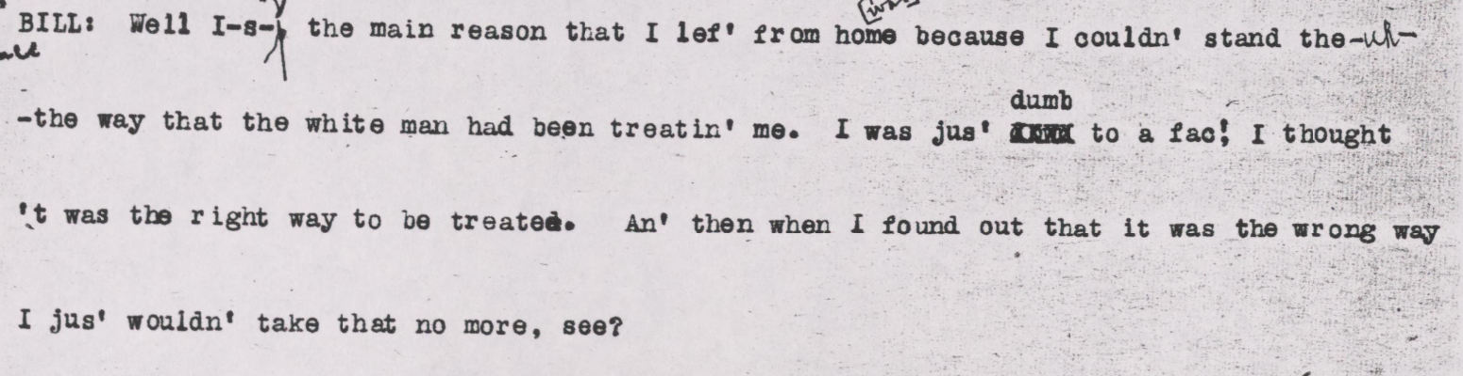

Public domain. Available at the Library of Congress:
https://www.loc.gov/resource/afc2004004.ms090459/?sp=14&__cf_chl_f_tk=EpSlCX6xfn8KorQ1U7lqF7yakoh7zpMPI9Fda86xm6U-1782998427-1.0.1.1-JfXhyFFUvvmrOfHGNdnkr9PbqBkbleE2.7gjX.qK638&r=-0.015,0.543,1.064,0.635,0

What story does the Great Migration tell us about change?
Featured Source | Source Set A: 1890-1917 - "South Unable to Put Stop to Negro Exodus," The Washington Times (1916), Library of Congress

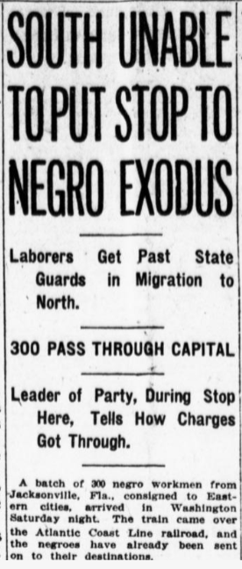

Public domain. Available at the Library of Congress: https://www.loc.gov/resource/sn84026749/1916-10-23/ed-1/?sp=1&r=-0.052,-0.176,1.002,0.598,0

What story does the Great Migration tell us about change?
Featured Source | Source Set A: 1890-1917 - Interview with Arthur Goodlett about his migration from Alabama to Omaha (1917), Library of Congress

Arthur Goodlet describes what motivated him and his wife to move from Century, Alabama to Omaha, Nebraska.
. . . .
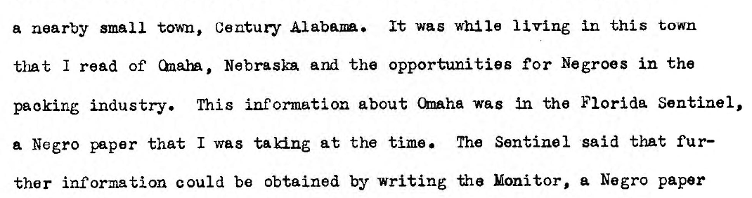
. . . .
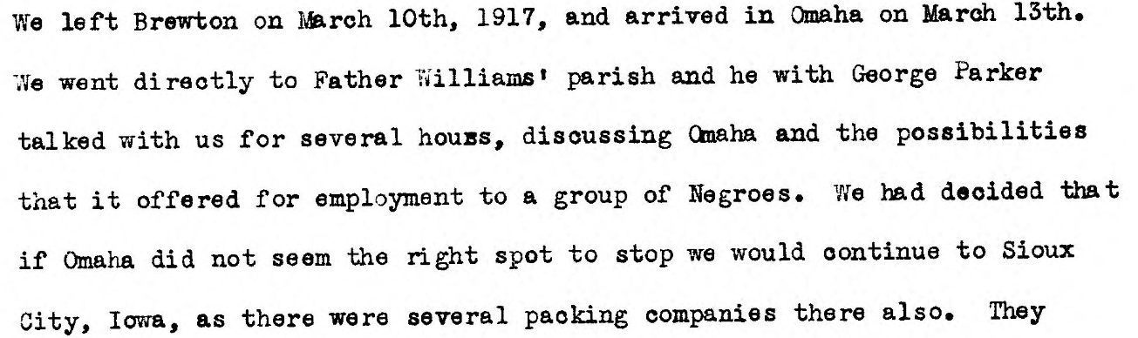
. . . .
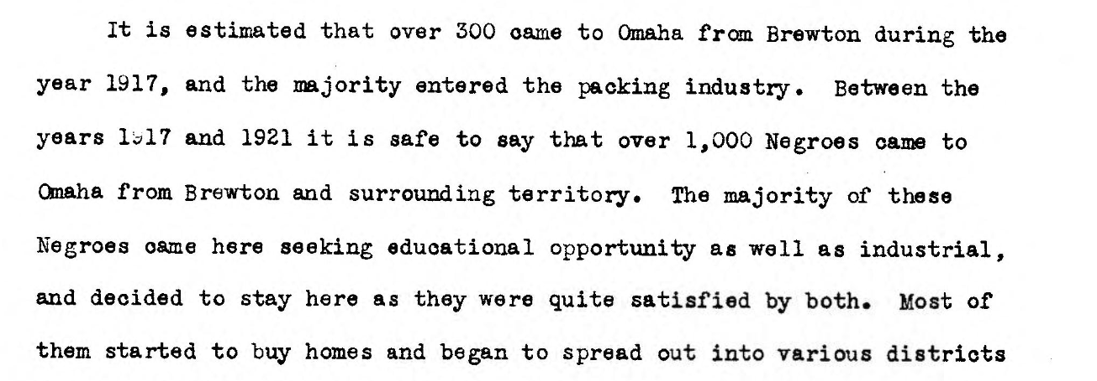

Public domain. Available at the Library of Congress: https://www.loc.gov/item/wpalh000831/

What story does the Great Migration tell us about change?
Featured Source | Source Set A: 1890-1917 - "The Charge," editorial in the Denver Star (1917), Library of Congress

Founded in 1888 and published in Denver, the Statesman was a weekly paper that served the African American community in Colorado, Wyoming, Montana, Utah, and New Mexico. The paper acted as a channel through which its readers could “voice their opinions, assert their rights, and demand their due recognition.” (Library of Congress, Chronicling America)

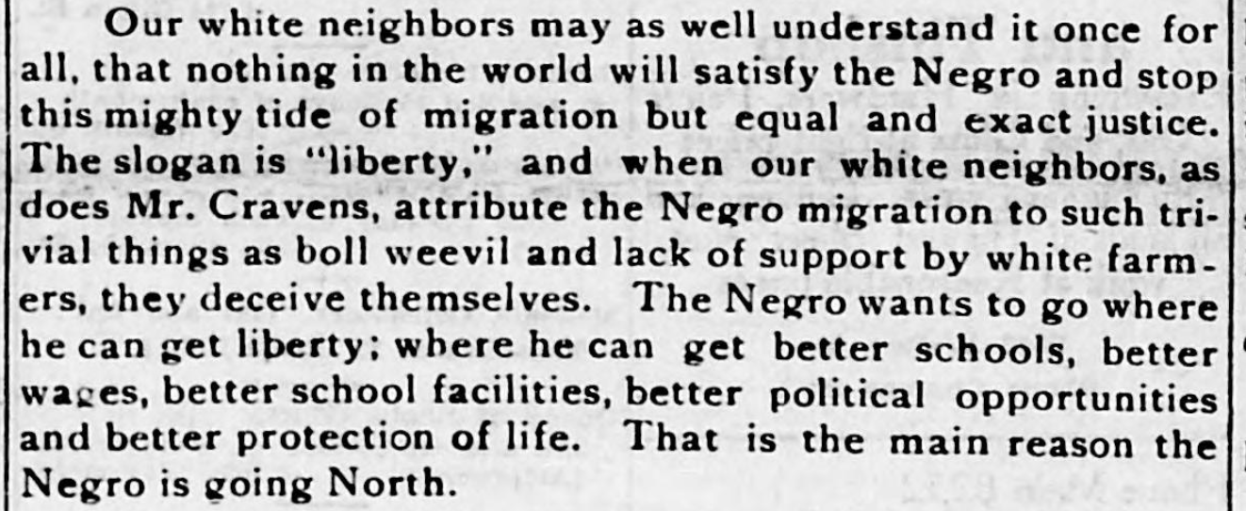

Public domain. Available at the Library of Congress: https://www.loc.gov/resource/sn84025887/1917-02-03/ed-1/?sp=1&r=0.132,0.558,0.432,0.243,0
What story does the Great Migration tell us about change?
Featured Source | Source Set B: 1919-1941 -"Extra Patrols, Closed Streets Are Ordered to Check Rioting,” The Washington Times (1919), Library of Congress

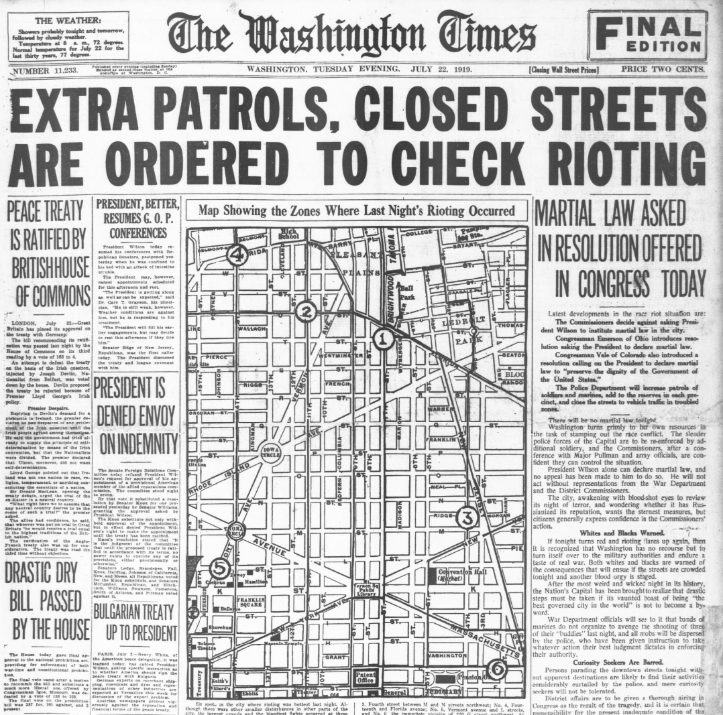

Public domain. Available at the Library of Congress: https://www.loc.gov/resource/sn84026749/1919-07-22/ed-1/?sp=1&r=-0.312,0.019,1.696,0.954,0
What story does the Great Migration tell us about change?
Featured Source | Source Set B: 1919-1941 - Newspaper coverage of the violence of Red Summer (1919), Library of Congress

The Chicago Whip was a weekly newspaper that ran from 1919 until around 1939. William C. Linton was its founding editor and publisher. He was born near Atlanta, Georgia and was the son of Reverend T. J. Linton, a minister with the African Methodist Episcopal Church. The Whip‘s focus on political and economic concerns is noted as reflecting shifts in African American urban life in the 1920s. (Library of Congress, Chronicling America)

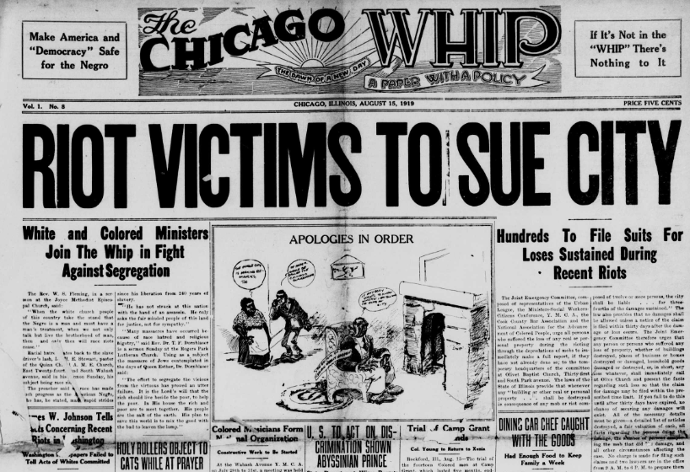

Public domain. Available at the Library of Congress:
https://www.loc.gov/resource/sn86056950/1919-08-15/ed-1/?sp=1&q=Race+Riots&st=pdf&r=-0.173,-0.067,1.346,1.346,0

What story does the Great Migration tell us about change?
Featured Source | Source Set B: 1919-1941 - Harlem Rent Parties (1938), Library of Congress

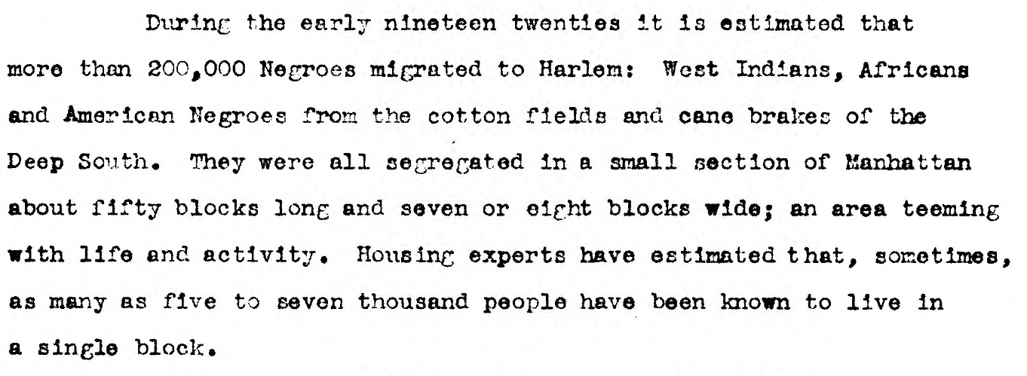
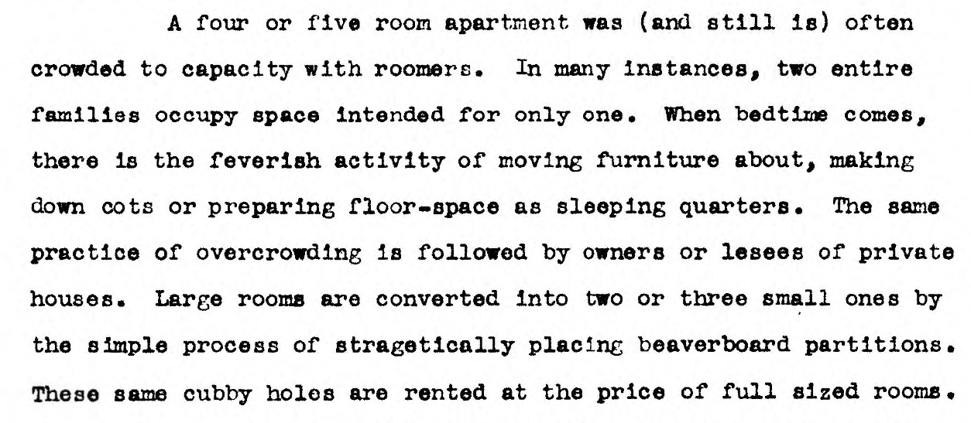

Public domain. Available at the Library of Congress: https://www.loc.gov/item/wpalh001365/
What story does the Great Migration tell us about change?
Featured Source | Source Set B: 1919-1941 - Trolley car conductors in Philadelphia (1940), Library of Congress

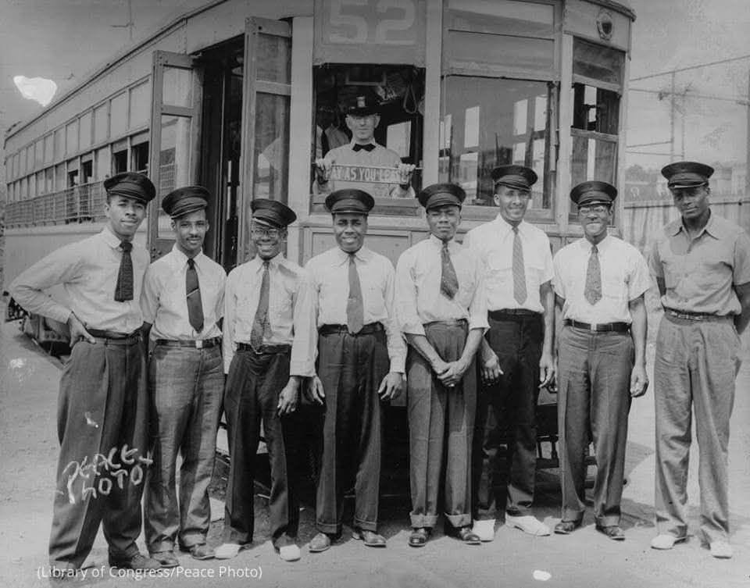

Public domain. Available at the Library of Congress: https://www.loc.gov/item/95518749/
What story does the Great Migration tell us about change?
Featured Source | Source Set C: 1942-1960 - Population Change, 1940-1960, Library of Congress

African American Population Change: 1940-1960
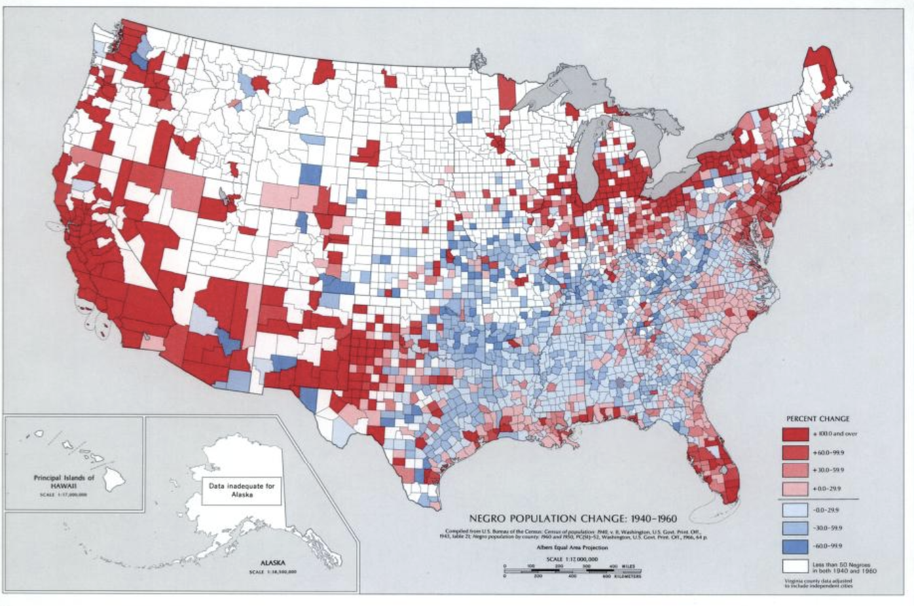
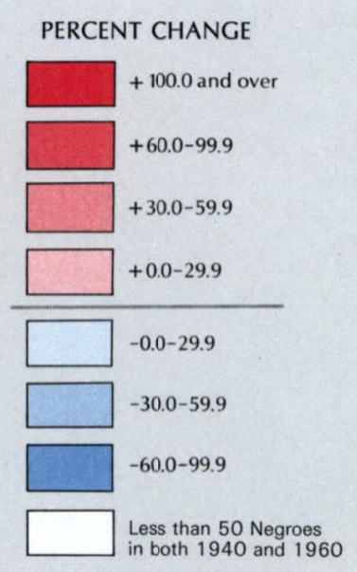
Public domain. Available at the Library of Congress: https://www.loc.gov/resource/g3701gm.gct00013/?sp=191&q=census&r=-0.129,-0.083,1.362,0.661,0
What story does the Great Migration tell us about change?
Featured Source | Source Set C: 1942-1960 - Man carrying sign in front of milk company, Chicago (1941), Library of Congress

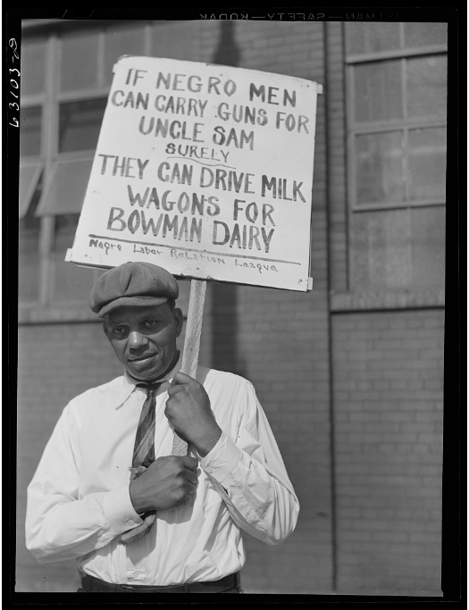

Public domain. Available at the Library of Congress: https://www.loc.gov/resource/fsa.8c19566/

What story does the Great Migration tell us about change?
Featured Source | Source Set C: 1942-1960 - Detroit, Michigan. Looking over slum houses. These are conditions under which families originally lived before moving to the Sojourner Truth housing project, 1942, Library of Congress

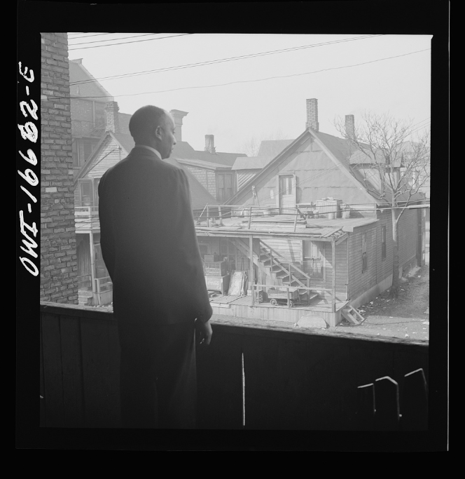

Public domain. Available at the Library of Congress: https://www.loc.gov/resource/fsa.8d25368/
What story does the Great Migration tell us about change?
Featured Source | Source Set C: 1942-1960 - Sign opposite the Sojourner Truth Homes housing project in Detroit (1942), Library of Congress

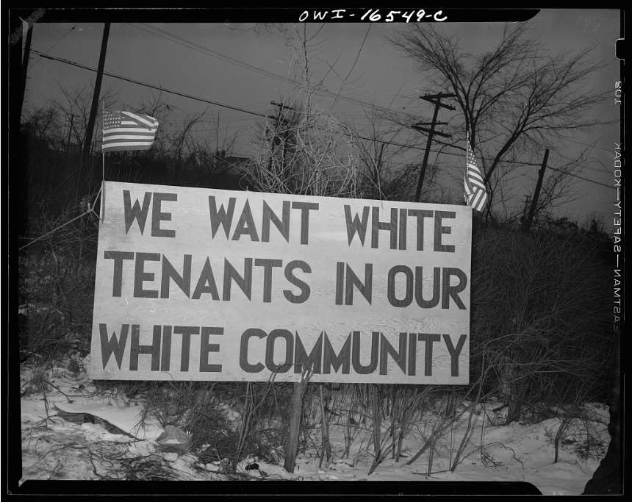

Public domain. Available at the Library of Congress: https://www.loc.gov/item/2017844754/
What story does the Great Migration tell us about change?
Featured Source | Source Set C: 1942-1960 - Some of the Boy Scouts who meet in the community center of the Ida B. Wells Housing Project. Chicago, Illinois (1942), Library of Congress

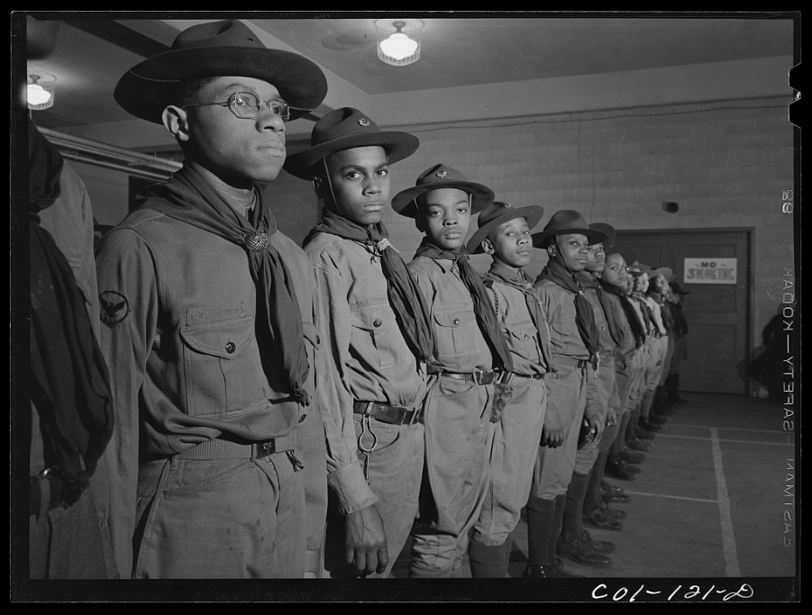

Public domain. Available at the Library of Congress: https://www.loc.gov/resource/fsa.8d02612/
What story does the Great Migration tell us about change?
Featured Source | Source Set C: 1942-1960 - Jewel Mazique working in the stacks of the Library of Congress (1942), Library of Congress

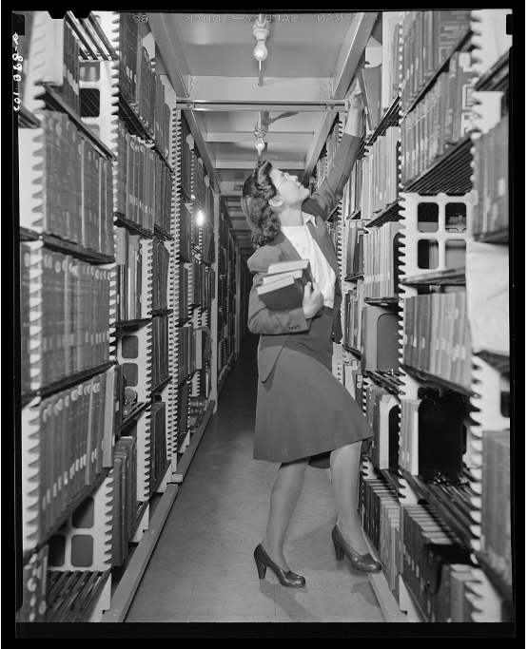

Public domain. Available at the Library of Congress: https://www.loc.gov/resource/fsa.8d02847/
What story does the Great Migration tell us about change?
Featured Source | Source Set C: 1942-1960 - Two women working in an aviation plant in Inglewood, California (1942), Library of Congress

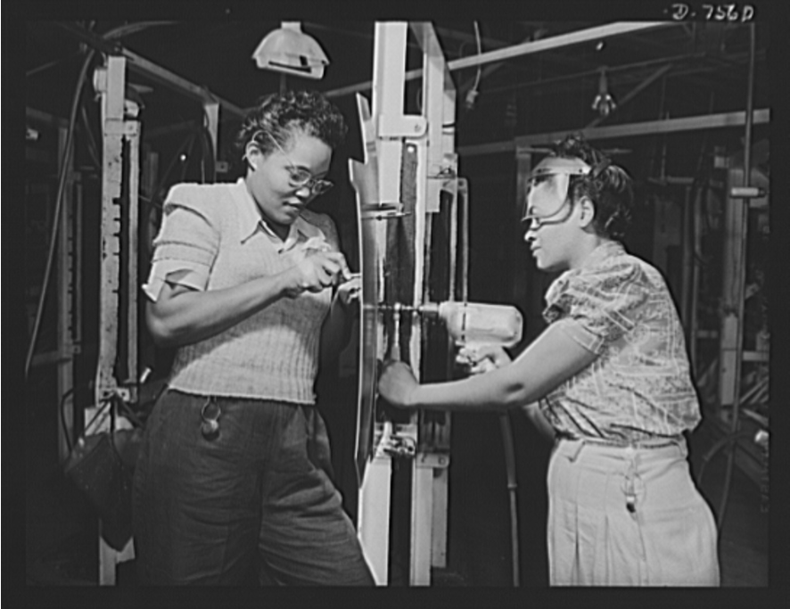

Public domain. Available at the Library of Congress: https://www.loc.gov/resource/fsa.8b05132/
What story does the Great Migration tell us about change?
Featured Source | Source Set C: 1942-1960 - Newsreel coverage of the Chicago Defender's Bud Billiken parade, 1945 (begins at 0:30), Library of Congress

“All-American News” were the first newsreels produced for a black audience. Made in the 1940s and 1950s, they were originally intended to encourage black Americans to participate in, and support the war effort, and to reflect an African-American perspective on world and national events. Highlights of this issue include segments about the 16th annual Bud Billiken Day celebration in Chicago, on August 11, 1945, and American troops landing in Manila, Philippines in August, 1945.
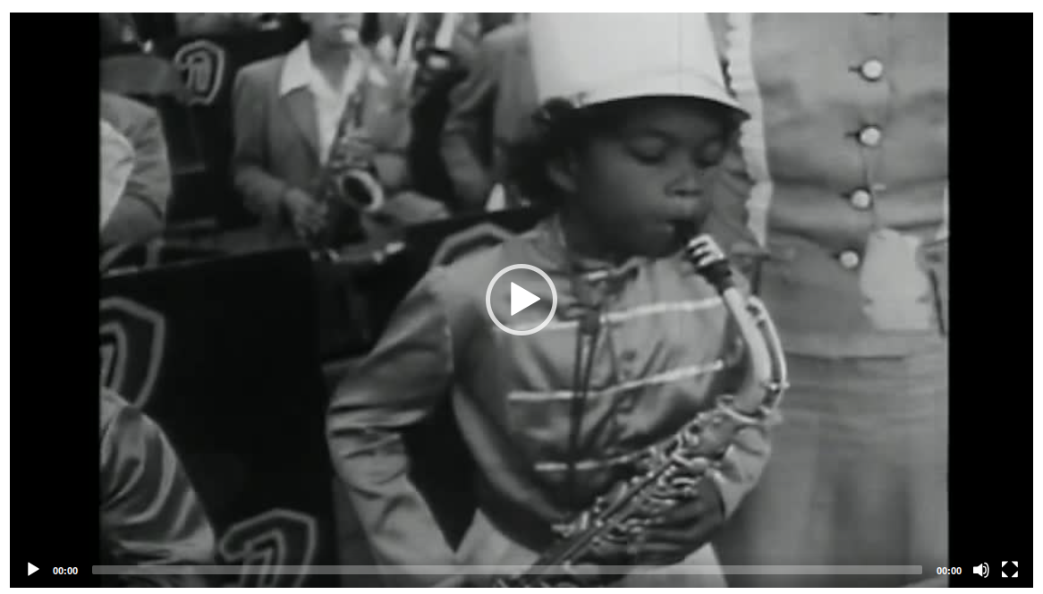

Public domain. Available at the Library of Congress: https://www.loc.gov/item/2018600165/
What story does the Great Migration tell us about change?
Featured Source | Source Set C: 1942-1960 - "A Time for Freedom": Newsreel coverage of the 1957 Prayer Pilgrimage for Freedom, Library of Congress

This documentary features footage from the "Prayer Pilgrimage for Freedom," a civil rights demonstration at the Lincoln Memorial on May 17, 1957. It also includes interviews with attendees, and scenes from the Montgomery bus boycott, Harlem, New York, and segregated areas in the South.
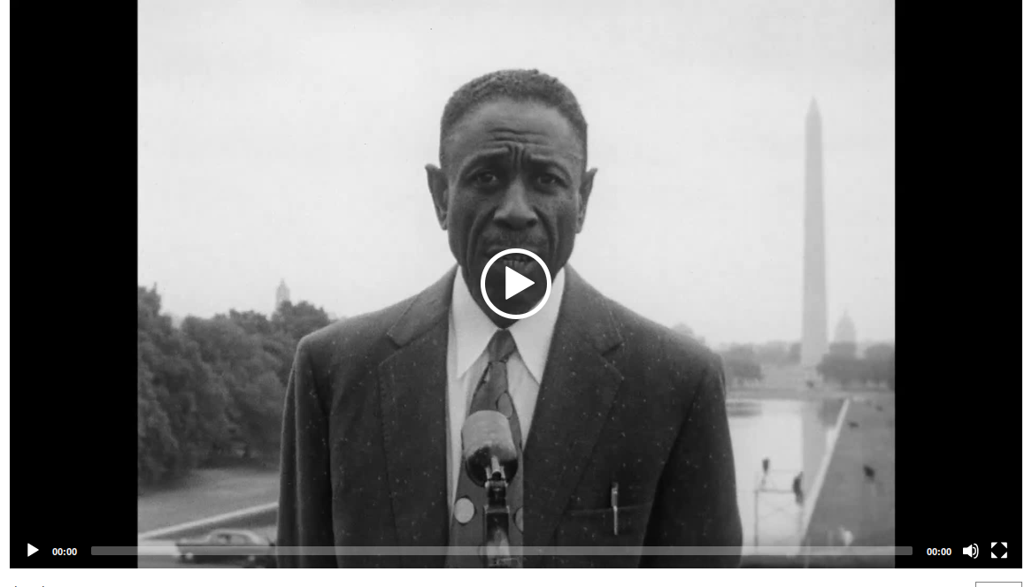

Public domain. Available at the Library of Congress: https://www.loc.gov/item/2024601014/

Claims: What story does the Great Migration tell us about change?

The Great Migration demonstrates that social progress is an incremental process rather than a sudden revolution.

Moving geographic locations does not automatically guarantee immediate change.

Progress and change are frequently met with friction, backlash, and conflict.

While institutional changes are often slow, resilient communities can create immediate safe spaces.

While the Great Migration offered economic opportunity, it also revealed that race-based violence and oppression were national continuities rather than isolated regional issues.

Over the course of the Great Migration, Black resistance changed from informal, everyday survival to highly visible political activism.

Different groups experience and drive change in distinct ways.

The Great Migration transformed African Americans from a primarily rural southern population into a dominant force in urban American culture.

Lasting change requires a shift from individual actions to organized, institutional power.

Economic opportunities for marginalized groups are often influenced by a constant desire for economic mobility alongside labor shortages caused by national and global crises.

Change occurs in compounding generational waves that alternate between advancements and resistance.

Graphic Organizer: What story does the Great Migration tell us about change?

