What made the 1920s roar?
C3 Framework Standard | D2.His.1.9-12. Evaluate how historical events and developments were shaped by unique circumstances of time and place as well as broader historical contexts.  D2.His.2.9-12. Analyze change and continuity in historical eras.
C3 Teachers Topic, Concept & Skill | ★ Era 6: Change ★ Historical Memory ★ Knowledge

Following the chaos of World War I and the Spanish Flu, the 1920s was a period dominated by social change. Nicknamed “The Roaring ‘20s”, the decade saw people redefining American culture in positive and negative ways. In this inquiry, students will examine cultural movements and events of the 1920s to determine what made them roar.

Featured Sources
Sources A-C: Flappers Source Set, Library of Congress
Sources D-F: Prohibition Source Set, Library of Congress
Sources G-I: Scopes Trial Source Set, Library of Congress, Historical Thinking Matters
Sources J-L: Rise of the Ku Klux Klan Source Set, Library of Congress

Formative Performance Tasks |  |  | Teacher Guidance
COLLABORATE | Make a list of changes during the 1920s. |  | Class begins by introducing students to a series of source sets on culture in the 1920s: Flappers, Prohibition, the Scopes Monkey Trial, and the Rise of the Ku Klux Klan (KKK). First, students work in pairs to analyze two of the source sets to create a list of changes during the 1920s using an organizer.  Students then join with another pair group who looked at the other two source sets, and sort the changes into positive and negative changes using a T-chart.  Finally, students will use their T-charts to create a newspaper headline and short column (similar to those in the source set) of their own that answers the compelling question. The columns should be 4-6 sentences in length, using evidence from the sources to support their arguments.
DELIBERATE | Sort changes into positive and negative changes.
PRODUCE | Create a newspaper headline and column that answers the compelling question, supported with examples from the sources.

What made the 1920s roar?
Featured Source | Source A: “Those Fluttering Flappers,” The Evening World (New York, NY), April 20, 1920.

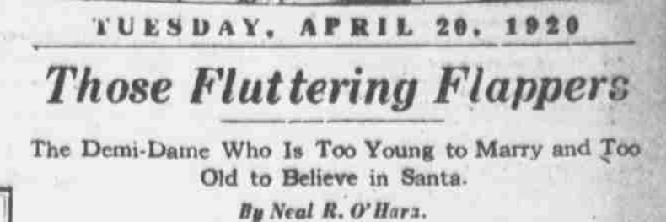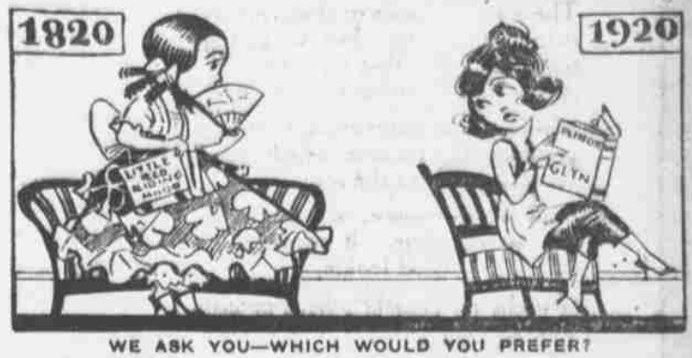

Public domain. Available at the Library of Congress:
https://www.loc.gov/resource/sn83030193/1920-04-20/ed-1/?sp=21&q=Flappers+Fluttering&r=0.103,0.454,0.48,0.249,0

What made the 1920s roar?
Featured Source | Source B: “Typical Flappers,” Weekly Journal-Miner (Prescott, AZ), August 2, 1922.
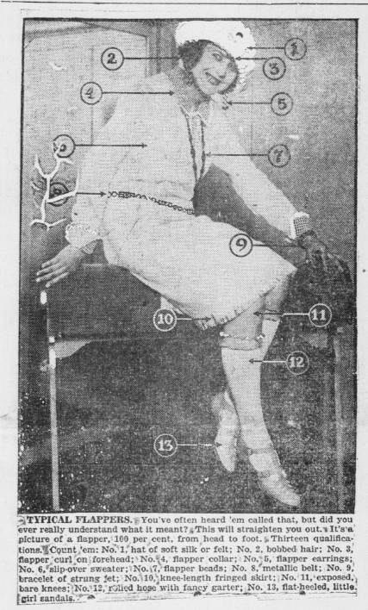

Public domain. Available at the Library of Congress:
https://www.loc.gov/resource/sn85032923/1922-08-02/ed-1/?sp=1&r=-0.42,0.041,1.73,0.897,0

What made the 1920s roar?
Featured Source | Source C: “Boise Doesn’t Give Its Girls a Chance to Flap,”Great Falls Tribune (Great Falls, Mont.), May 12, 1922.

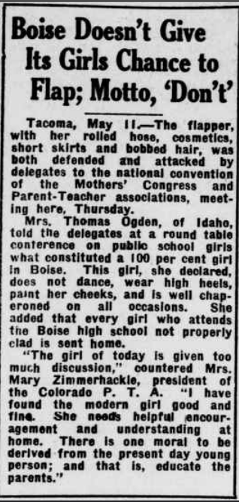

Public domain. Available at the Library of Congress:
https://www.loc.gov/resource/sn83045217/1922-05-12/ed-1/?sp=1&q=cosmetics+flapper&r=0.197%2C0.137%2C0.841%2C0.436%2C0&st=pdf&pdfPage=undefined

What made the 1920s roar?
Featured Source | Source D: Interview with Samuel D. Mobley (74) of Chester County, South Carolina, c. 1936.

“I have noticed that every attempt to legislate morals into the people has resulted in disaster. I will call your attention to the fact that you and I remember when we had the old barroom system, the State dispensary system, prohibition, and the present retail liquor shops. No system is perfect, but the worst of all was the prohibition law. Whiskey caused some trouble in Papa Noah’s family and resulted in some confusion in Uncle Lot’s household. But religion and morals should be taught and insulated in the church and home, and self-control and temperance should be read and studied from the Bible rather than the Statutory Code.”

Public domain. Available at the Library of Congress:
https://www.loc.gov/resource/wpalh3.30080206/?sp=3&st=pdf&r=-0.207%2C-0.103%2C1.415%2C1.415%2C0&pdfPage=5

What made the 1920s roar?
Featured Source | Source E: Interview with Roaldus Richmond, Vermont, c. 1936.

“Me work? Only suckers work. … That was during Prohibition and all the boys was running booze. My brothers, the older ones, had a gang bootlegging. I went in with ‘em and we made plenty dough. There was dough in that racket all right, and it was fun to bring it in. Times was good then, everybody had money, everybody was spending it. … A gang from Burlington tried to chisel in but they didn’t last long. We high-jacked three of their cars one night and they was loaded, what I mean loaded. We gave them a good beating, we put a couple of ‘em in the hospital. They kept away from Barre after that, they didn’t bother us no more. … We knew the officers and they knew us. You know, the same as you know football players on another team, something like that.”

Public domain. Available at the Library of Congress:
https://www.loc.gov/resource/wpalh3.38010606/?sp=1&st=pdf&r=-0.207%2C-0.14%2C1.415%2C1.415%2C0&pdfPage=undefined

What made the 1920s roar?
Featured Source | Source F: Mapping Gangland, Library of Congress, 1931

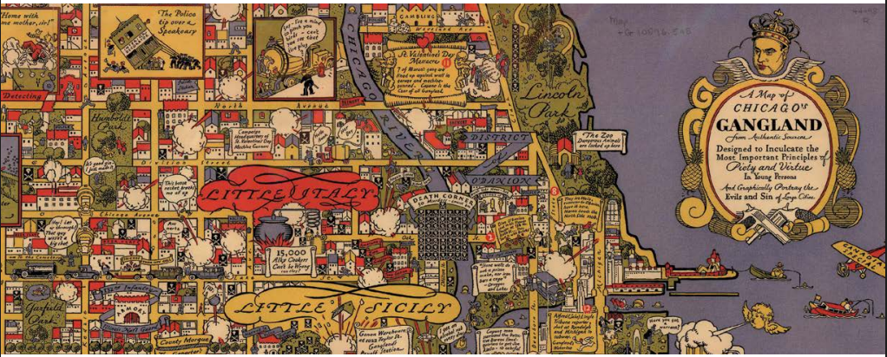

This pictorial work offers a satirical look at corruption and violence in Capone's Chicago. In his 1931 pictorial map of gangland Chicago, Bruce Roberts declares an intention to scare impressionable young viewers straight — to, as the title puts it, “graphically portray the evils and sin of large cities.” Any map that uses a smoking handgun in its compass rose to point north, however, might be better appreciated for its satire and social criticism. The dark humor is evident. The crowned head of mob boss Al Capone sits atop the cartouche, a reluctant nod to his kinglike power over the crime-ridden city. A dark parody of a nursery rhyme serves as the map’s border: “Sing a Song of Gangsters, Pockets Full of Dough, Four-and-Twenty Bottles, Make a Case You Know.” In the upper left, a “Gangland Dictionary” explains euphemisms such as “taken for a ride” — i.e., murdered. The humor reveals some truths: Prohibition was little respected in Chicago, with its numerous bootlegging operations and speakeasies to which police were accused of turning a blind eye. The map depicts a “shamus” — a derogatory term for a police officer — on North Avenue scolding bootleggers for parking in front of a fire hydrant while ignoring their truck-sized beer keg. Gang violence in the city reached national attention with the notorious St. Valentine’s Day massacre of 1929, illustrated on the map west of Lincoln Park. There, Capone’s men mow down a rival gang with tommy guns. Taxes, of all things, were Capone’s downfall: A federal jury convicted him of tax evasion in 1931. Of irony is the inset west of the stockyards where an officer, ignoring a gangster’s literal smoking gun and a nearby corpse, declares: “Say, Uncle Sam wants to see about your Income Tax.” Not everyone embraced the map’s sardonic image of Chicago. Sponsors of the 1933 World’s Fair purportedly destroyed copies to minimize the chance visitors would see it.

Public domain. Available at the Library of Congress:
https://www.loc.gov/lcm/pdf/LCM_2019_0910.pdf

What made the 1920s roar?
Featured Source | Source G: “Scopes is Indicted in Tennessee for Teaching Evolution,” New York Times, July 17, 1925.

Scopes Is Indicted in Tennessee for Teaching Evolution
Nashville, Tenn., May 25 -- John T. Scopes, young Dayton (Tenn.) high school teacher, tonight stands indicted for having taught the theory of evolution to students attending his science classes in violation of a law passed by the Tennessee Legislature and signed by the Governor on March 21, 1925. The date for this trial has been fixed for July 10 at Dayton. The hearing of the case will bring many notables to the little mountain town, including William Jennings Bryan for the prosecution and Clarence Darrow of Chicago and Dudley Field Malone of New York for the defense.
The indictment, returned by the Grand Jury convened in special session, was returned after evidence by Walter White, Superintendent of the Dayton public schools, and eight high school students had been heard by jurors. The session followed a charge by Judge John T. Raulston, who interpreted the law and included in his presentation for the reading of the first book of Genesis from the King James version of the Bible, in which the story creation is detailed.
The specific charge of the indictment is that on April 24, 1925, John T. Scopes, "did unlawfully and willfully teach in public schools of Rhea County, Tenn., which said schools are supported in part and in whole by the public school funds of the State, certain theory and theories that deny the story of Divine creation of man as taught in the Bible and did teach thereof that man descended from a lower order of animals." The penalty prescribed in the law for such violation is a fine from $100 to $500.

Public domain. Available at the Library of Congress:
https://www.loc.gov/item/2006683542/

What made the 1920s roar?
Featured Source | Source H: Excerpt from Dudley Field Malone’s speech on the fourth day of the Scopes trial, July 15, 1925. Dayton, Tennessee

Dudley Field Malone served as John Scope’s defense attorney during his trial.

“What I don't understand is this, your Honor, the prosecution inside and outside of the court has been ready to try the case and this is the case. What is the issue that has gained the attention, not only of the American people, but people everywhere? Is it a mere technical question as to whether the defendant Scopes taught the paragraph in the book of science? You think, your Honor, that the News Association in London, which sent you that very complimentary telegram you were good enough to me to show me in this case, because the issue is whether John Scopes taught a couple of paragraphs out of his book?

I believe and we believe that men who are God-fearing, who are giving their lives to study and observation, to the teaching of the young -- are the teachers and scientists of this country in a combination to destroy the morals of the children to whom they have dedicated their lives? Are preachers the only ones in America who care about our youth? Is the church the only source of morality in this country?

The least that this generation can do, your Honor, is to give the next generation all the facts, all the available data, all the theories, all the information that learning, that study, that observations has produced -- give it to the children in the hope of heaven that they will make a better world of this than we have been able to make it. We have just had a war with twenty million dead. Civilization is not so proud of the work of the adults. Civilization need not be so proud of what the grown-ups have done. For God's sake let the children have their minds kept open -- close no doors to their knowledge; shut no door from them. Make the distinction between theology and science. Let them have both. Let them both be taught. Let them both live....
We are ready to tell the truth as we understand it and we do not fear all the truth that they can present as fact. … We feel we stand with progress. We feel we stand with science. We feel we stand with intelligence. We feel we stand with fundamental freedom in America.”
(Profound and continued applause.)
(The bailiff raps for order.)
Public domain. Accessed at: https://historicalthinkingmatters.org/scopestrial/1/sources/44/fulltext/

What made the 1920s roar?
Featured Source | Source I: “Hey, Go Back!”, Library of Congress, 1925.

John Scopes is shown as the man with the globe as his head, climbing a steep mountain with no clear end in sight. Tennessee is warning him to turn around and go back.

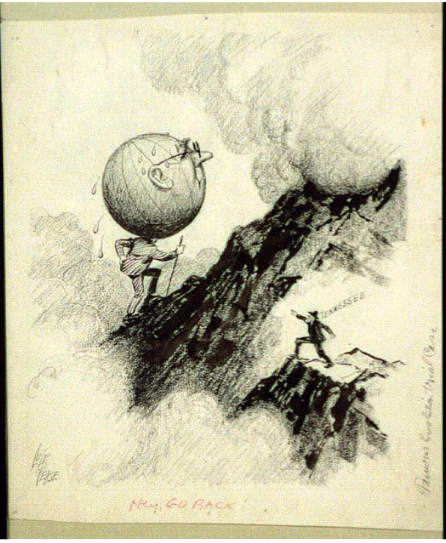

Public domain. Available at the Library of Congress:
https://www.loc.gov/resource/acd.2a10753/?__cf_chl_f_tk=6a9TWb8kR0kb0waa_UgWHK8iXfdPLfI5Ui0LnCvPoX4-1782951534-1.0.1.1-670R6Q5jSAvzDcAzxdvOfao0hRJgv3vrW8joR5lwnjo

What made the 1920s roar?
Featured Source | Source J: “Like the moth, it works in the dark”, Library of Congress, 1923.

The American flag is shown damaged to symbolize America post World War I.

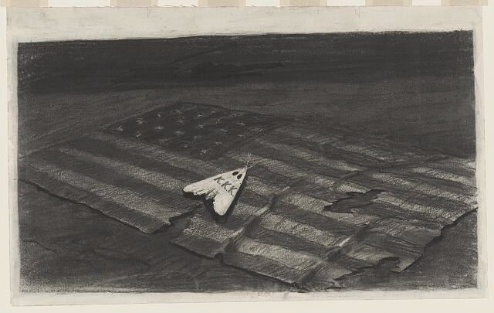

Public domain. Available at the Library of Congress:
https://www.loc.gov/pictures/item/2010716209/

What made the 1920s roar?
Featured Source | Source K: “Voice of the Knights of the Ku Klux Klan”, Minneapolis, Minnesota, 1923.

After World War I and the immigration surge of the early 1900s, the Ku Klux Klan made another rise in the United States. The Voice of the Knights of the Ku Klux Klan was a newspaper for the KKK in Minneapolis. They had their own newspaper because local papers would not publish any of their material even if paid.

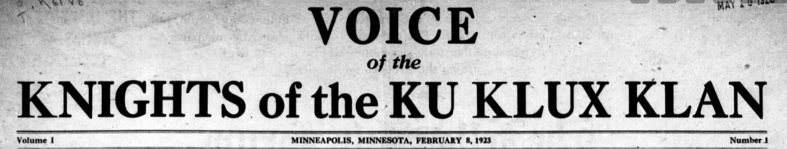
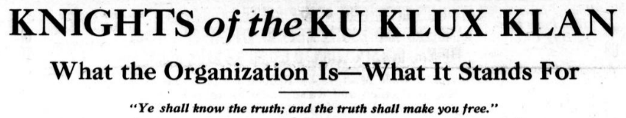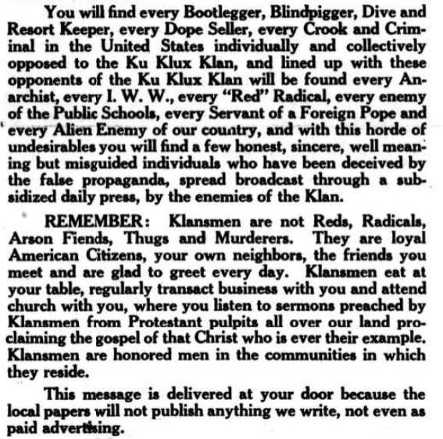
Public domain. Available at the Library of Congress:
https://www.loc.gov/resource/2019271211/1923-02-08/ed-1/?sp=1&st=image&r=-0.004,0.039,0.966,0.501,0

What made the 1920s roar?
Featured Source | Source L: Cross burning at a gathering of the Ku Klux Klan, Library of Congress, 1925.
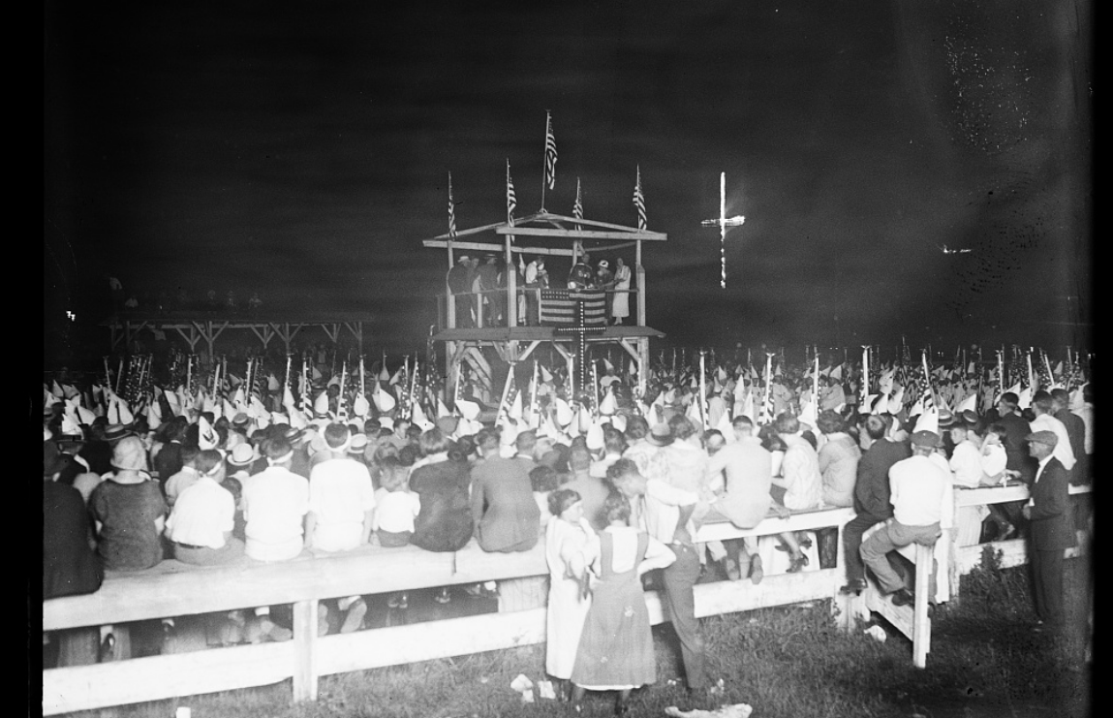

Public domain. Available at the Library of Congress:
https://www.loc.gov/resource/hec.45096/

