How did radio revolutionize American culture?
C3 Framework Standard | D2.His.1.9-12. Evaluate how historical events and developments were shaped by unique circumstances of time and place as well as broader historical contexts.
C3 Teachers Topic, Concept & Skill | ★ Era 6: Change ★ Progress ★ Questioning

Technology shapes society and identity, both in the past and present. By exploring the role of technology in history, we can better understand how it has shaped the country’s character.

Featured Sources
Source A: Consumer Advertising During the Great Depression: A Resource Guide, Library of Congress
Source B: Registry Titles with Descriptions and Expanded Essays, National Recording Preservation Board, Library of Congress

Formative Performance Tasks |  |  | Teacher Guidance
COLLABORATE | Listen to 1930s radio broadcasts and determine what made them so revolutionary. |  | Class begins by introducing students to the power of radio using Source A. Students then develop questions about “revolution” and the power of radio before browsing Source B, a collection of early radio broadcast samples. The variety of broadcast samples is assigned evenly across the class, or the class can focus on one sample, such as the full-day broadcast from WJSV, which includes news, music, shows, and advertisements. As students listen to the samples, they will use the organizer to deepen their discussion about what made radio so revolutionary.  Students then rank the topics of the broadcasts from most to least revolutionary by identifying the significance to American culture. Students will consider lingering questions or opportunities for further research.  Finally, students create a 30-second “broadcast” script that answers the compelling question. In their “broadcasts”, students should reference examples from the sources to support their argument. The questions students have generated throughout the inquiry will be embedded as teasers for a future hypothetical broadcast.
DELIBERATE | Rank the topics of the broadcasts from most to least revolutionary.
PRODUCE | Create a 30-second “broadcast” that answers the compelling question using evidence from the sources.

How did radio revolutionize American culture?
Featured Source | Source A: Consumer Advertising During the Great Depression: A Resource Guide, Library of Congress

Although in the 1920s people imagined a future in which the airwaves were dominated by educational programming,¹ radio broadcasting in America in the 1930s was largely dedicated to entertainment, advertising, and politics.² Despite the overall economic depression, the annual amount spent on radio advertising in 1933 was seven times higher than it had been in 1927, rising in relation to the 9 million more households that owned a radio set in 1933 as compared to 1929.³

Brands and advertising agencies were responsible for much of the radio programming throughout the "Golden Age of Radio."

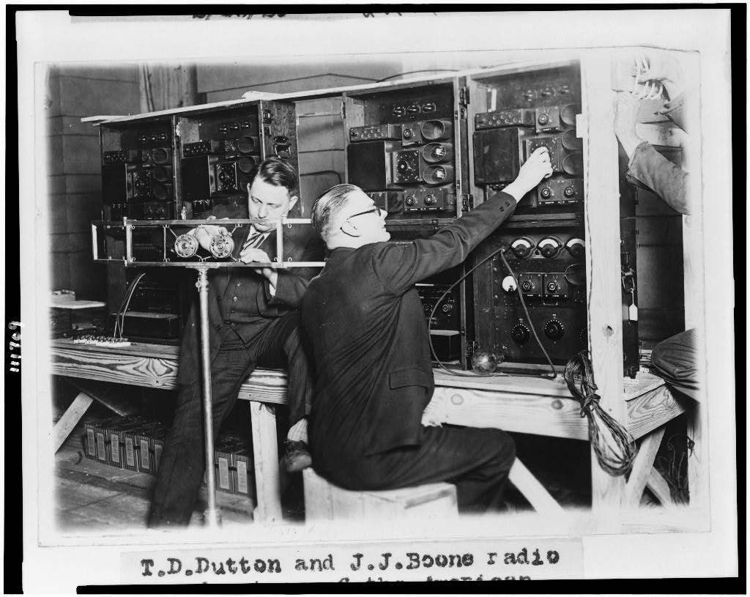
Advertising agencies would often create programs expressly to promote certain products, and agencies like Black-Sample-Hummert were dedicated to radio advertising.

Popular radio programs in the 1930s included short "humoristic" programs like Amos and Andy, which could be traced back to racist minstrelsy, children's programming, and soapy drama serials aimed at housewives that often included built-in product placement.⁴

Radio was also used for politics. Speeches and talks by politicians such as Huey Long and Franklin D. Roosevelt connected them with more people through the radio.⁵

[T.D. Dutton and J.J. Boone, radio broadcasters of the American Telephone and Telegraph Co]

Public domain. Available at the Library of Congress:
https://guides.loc.gov/consumer-advertising-great-depression/radio-and-broadcast-advertising

How did radio revolutionize American culture?
Featured Source | Source B: Registry Titles with Descriptions and Expanded Essays, National Recording Preservation Board, Library of Congress

"Crazy Blues." Mamie Smith. (1920)
With her recording of "Crazy Blues," Mamie Smith became the first black vocalist to make a commercial vaudeville blues record. The recording was a surprise hit, reputedly selling more than 250,000 copies. It revealed to record companies a previously neglected market for records--African-Americans. Subsequently, thousands of recordings were made of black jazz and blues artists, invigorating the record business and enabling the documentation and preservation of one of the richest eras of musical creativity in the United States. | Read & Listen:  Expanded essay by Ed Komara  Listen to 'Crazy Blues'  Radio Feature (MP3)

Armistice Day broadcast. Woodrow Wilson. (November 10, 1923)
This recording of former President Woodrow Wilson made by phonograph technician Frank L. Capps is the earliest surviving sound recording of a regular radio broadcast. It is also believed to be the earliest known example of a recording made by electrical, rather than acoustic, means. | Read & Listen:  Expanded essay by Richard Striner  Listen to Wilson's broadcast (MP3)

National Defense Test (USA). (September 12, 1924)
In the 1920s, before national radio networks existed, a group of radio stations from across the country cooperated in a test to determine how radio stations might respond in a national emergency. This is the recording of that experiment. It is notable as one of only a handful of extant recorded radio broadcasts from this era. Furthermore, it is technologically significant as an experiment of real-time switching between stations in 14 different cities. Featured on the recording are conversations between General John J. Pershing and other generals stationed throughout the country. | Read & Listen:  Expanded essay by Cary O'Dell  Listen to the National Defense Test (MP3)

Inauguration of Calvin Coolidge. (March 4, 1925)
Calvin Coolidge's inauguration in 1925 was the first presidential inauguration to be broadcast. Using the latest technology, RCA and Bell Telephone aired the ceremonies over a makeshift network of radio stations. "The New York Times" estimated that more than 25 million Americans would be able to hear the President's address, thus making it a national event in a manner not previously possible. Twenty-one radio stations, linked in a circuit throughout the country, broadcast the president's 47-minute inaugural address from the steps of the U.S. Capitol. | Read & Listen:  Expanded essay by Amity Shales and Rushad Thomas  Listen to Coolidge's inauguration (MP3)

"El Manisero" ("The Peanut Vendor") (Rita Montaner, vocal with orchestra); "El Manisero" (Don Azpiazu and His Havana Casino Orchestra). (1927; 1930)
Popular Cuban singer and radio artist Rita Montaner recorded the first version of the traditional song "El Manisero" in Havana in 1927. The Don Azpiazu and His Havana Casino Orchestra version of "El Manisero," adapted from Montaner's recording, was made in New York City three years later. It is the first American recording of an authentic Latin dance style composition. This later recording launched a decade of "rumbamania," introducing U.S. listeners to Cuban percussion instruments and Cuban rhythms. | Read & Listen:  Expanded essay by Carol Hess  Listen to the Rita Montaner version

"Bacon, Beans and Limousines." Will Rogers. (October 18, 1931)
At one of the lowest points of the Great Depression, Will Rogers took part in a national broadcast with President Herbert Hoover to kick off a nationwide unemployment relief campaign. Rogers praised Hoover's integrity and intentions, but also decried the tragedy of such hard times in a land of plenty: "We'll hold the distinction of being the only nation in the history of the world that ever went to the poor house in an automobile," he observed. The broadcast demonstrates the status Rogers had gained as a spokesperson for the "common man," who used popular culture to satirize financial and political corruption, especially as the country went from the extravagant twenties into economic depression. Although Rogers is sardonic, the talk also conveys his fundamental optimism and faith in the good-heartedness of the American people. | Read & Listen:  Expanded essay by Ben Yagoda (PDF, 102KB)  Listen to 'Bacon, Beans and Limousines'  Radio Feature (MP3)

"Fireside Chats." President Franklin D. Roosevelt's radio addresses. (1933-1944)
The Fireside Chats were an influential series of radio broadcasts in which Roosevelt utilized the media to present his programs and ideas directly to the public and thereby redefined the relationship between the President and the American people. | Read & Listen:  Expanded essay by Christopher H. Sterling  Listen to the recording (MP3)

"Tumbling Tumbleweeds." The Sons of the Pioneers. (1934)
The cowboy vocal group The Sons of the Pioneers was formed in 1933 by Roy Rogers, Tim Spencer and Bob Nolan. The group became America's premier western singing group and remained so for decades. They still perform today with different singers. The Sons of the Pioneers are widely admired for their smooth and adventurous harmonies. Their songs serve as the foundation of non-traditional, popular cowboy music. "Tumbling Tumbleweeds" was one of the songs cut at the Sons' first recording session, and it became the group's theme song, beautifully evoking the cowboy's love of the land. | Read & Listen:  Expanded essay by Nolen W. Berry  Listen to 'Tumbling Tumbleweeds'  Radio Feature (MP3)

"You're the Top." Cole Porter. (1934)
"You're the Top" is a work by composer/lyricist Cole Porter at the top of his form. Seamlessly, the words and music of this quintessential "list song" convey wit, exuberance, and charmingly high- and low-cultural references. This solo performance, by Porter, invites the listener to become part of Porter's universe and imagine the composer performing, much as he might have for friends on a luxury cruise or in his own Waldorf Astoria suite. | Read & Listen:  Expanded essay by Robert Kapilow  Listen to 'You're the Top'  Radio Feature (MP3)

"Every Man a King." Speech by Huey P. Long. (February 23, 1934)
Huey Long, governor of Louisiana from 1928 to 1932, was elected to the U.S. Senate in 1930 but did not take his Senate seat until 1932, after he had handpicked a successor for the governorship. A radical populist, he proposed a "Share the Wealth" plan with the motto "Every Man a King." The wealth was to be shared by increases in inheritance taxes which would "guarantee a family wealth of around $5,000; enough for a home and automobile, a radio, and the ordinary conveniences." In this 1934 radio speech, the Senator outlines his plan and explains why he no longer supports President Franklin D. Roosevelt. | Read & Listen:  Expanded essay by Christopher Sterling  Listen to the recording (MP3)

"Gang Busters." (July 20, 1935)
The radio crime drama series "Gang Busters" was the creation of Phillips H. Lord, producer of the successful "Seth Parker" radio series. Capitalizing on the public's fascination with gangsters, Lord based his new show on true crime stories, going so far as to obtain the cooperation of the FBI director J. Edgar Hoover. "G-Men," as the series was known initially, premiered on July 20, 1935, but the FBI's enthusiasm waned quickly and its cooperation diminished. Revised as "Gang Busters," the show remained on the air until the late 1950s. The program's spectacular opening, which included sirens, police whistles, gunshots and tires screeching, inspired the slang expression, "come on like gangbusters!" | Read & Listen:  Expanded essay by Cary O'Dell (PDF, 179KB)  Listen to 'Gang Busters' (MP3)

"War of the Worlds" ("The Mercury Theatre on the Air"). (October 30, 1938)
Orson Welles' Mercury Theatre's finely-crafted radio drama about Martian invaders is one of the best-written and produced works in its genre. Its realistic format caused considerable alarm to many listeners across the U.S. at the time of its original airing. | Read & Listen:  Expanded essay by Christopher Sterling  Listen to the recording

WJSV (Washington, D.C.). Complete day of radio broadcasting. (September 21, 1939)
This aural time capsule preserves a full day (6:00 AM to 1:00 AM) of broadcasting by a CBS network affiliate radio station. It is the first known recording of an American station. Highlights include Arthur Godfrey, soap operas, President Franklin Delano Roosevelt's address to Congress, coverage of the war in Europe, a baseball game, "Amos 'n' Andy," and "Major Bowes' Amateur Hour," as well as contemporary commercials. | Read & Listen:  Expanded essay by Cary O'Dell  Listen to the recording (MP3)  Full list of programs

"Grand Ole Opry." First network radio broadcast. (October 14, 1939)
Begun in Nashville over WSM on November 25, 1925, when it was originally known as the "WSM Barn Dance," the "Grand Ole Opry" is today the longest, continuously-running program in radio history. As it was then, the "Opry" broadcast (which has been broadcast from various locations over the years, including the legendary Ryman Auditorium in downtown Nashville), remains a showcase for top drawer country music talent. Regional for the first 14 years of its airing, the "Opry" went national over the NBC network in 1939. This inaugural broadcast featured the seminal talents of long-time "Opry" performer Uncle Dave Macon, as well as relative newcomer Roy Acuff, and the "Opry" announcers George D. Hay and David Stone. | Read & Listen:  Expanded essay by Paul Kingsbury  Listen to the recording (MP3)

Public domain. Available at the Library of Congress:
https://www.loc.gov/programs/national-recording-preservation-board/recording-registry/descriptions-and-essays/

How did radio revolutionize American culture?

Questions about revolution
What does it take for… | What happens when… | How much… | What kind of…

Questions about radio broadcasting and culture
Who… | What if… | Did everyone… | How did…

How did radio revolutionize American culture?

Identity 5 topics that were made culturally significant by radio broadcasts of the 1920s and 1930s.

How did radio revolutionize American culture?

 | Radio Topic | Significance to Culture
1
2
3
4
5
Unanswered Question(s):

How did radio revolutionize American culture?

30-Second Radio Script Template
Title: ___________________________

Opening Hook and Claim: How did radio revolutionize American culture?
(Sound effect: ___________________________)
Host:
Core Message: Reference Examples
Host: Take, for example …

This wasn’t just entertainment! it was ____________________________________________________________

Teaser for Next Episode - Spark curiosity with lingering questions or opportunities for further research:
Host:

Closing Tagline
Host:

(Sound effect: ___________________________)

