What did military industrialization cost the US?
C3 Framework Standard | D2.His.14.9-12. Analyze multiple and complex causes and effects of events in the past.
C3 Teachers Topic, Concept & Skill | ★ Era 5: Development ★Conflict & Change ★ Knowledge

Industrialization in the early 20th century changed warfare in fundamental ways. Technological innovations during World War I, made possible by industrialization, made war more destructive than ever before. At the same time, medical and scientific advancements helped save lives. In this building block inquiry, students explore both the destructive and constructive costs of industrialization on the military during World War I.

Featured Sources
Source Set: Technology during World War I

Formative Performance Tasks |  |  | Teacher Guidance
COLLABORATE | Brainstorm how mass production impacted warfare. |  | Class begins with the teacher displaying an image of a modern factory assembly line. As a class, students brainstorm ways mass production impacted warfare.  Next, the teacher divides students into small groups and distributes a copy of the Source Set to each group. Working together, students evaluate each image and determine whether the innovation shown represents a constructive cost (saves lives) or a destructive cost (causes damage). Then, students assign each innovation a numeric cost score on their graphic organizer.  After evaluating the sources, students calculate the final cost score by adding the scores they assigned to each innovation. (Note: the teacher may need to remind students to include the negative sign for each destructive cost when finding the sum of the values.) Based on their calculated final cost score, students summarize the cost of industrialization on the military.
DELIBERATE | Evaluate each innovation and assign it a numeric cost score. Add the individual cost scores to calculate your final cost score.
PRODUCE | Summarize the cost of industrialization on the military based on final cost scores.

What did military industrialization cost US?
Featured Source | Source A: Souilly (Meuse) France. “Miss Winifred Bryce, of 294 Henry Street, Brooklyn, N.Y. giving gum and cigarettes to wounded soldiers on a hospital train. Miss Bryce was connected with American Red Cross Evacuation Hospital #6-7, Souilly”, October 14, 1918, Library of Congress

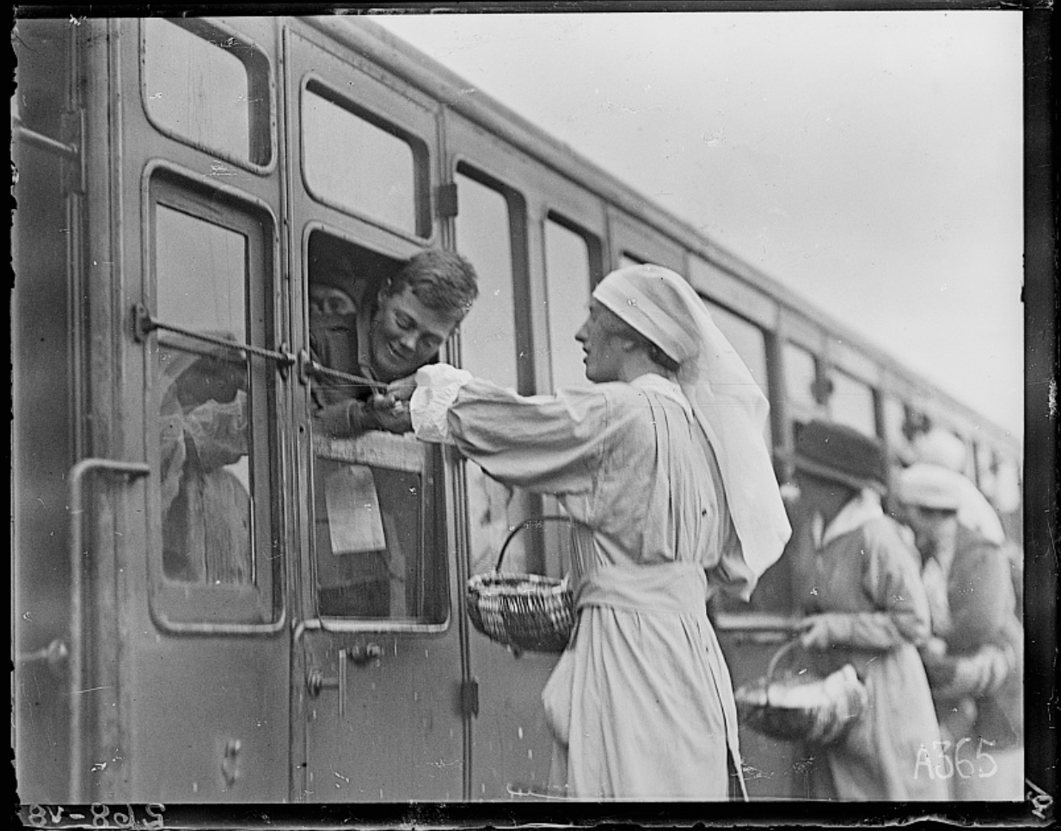

Public domain. Available at the Library of Congress: https://www.loc.gov/item/2017666367/

What did military industrialization cost US?
Featured Source | Source B: Detroit Publishing Co, “U.S.S. Free Lance, a Gatling gun and crew”, ca. 1898, Library of Congress

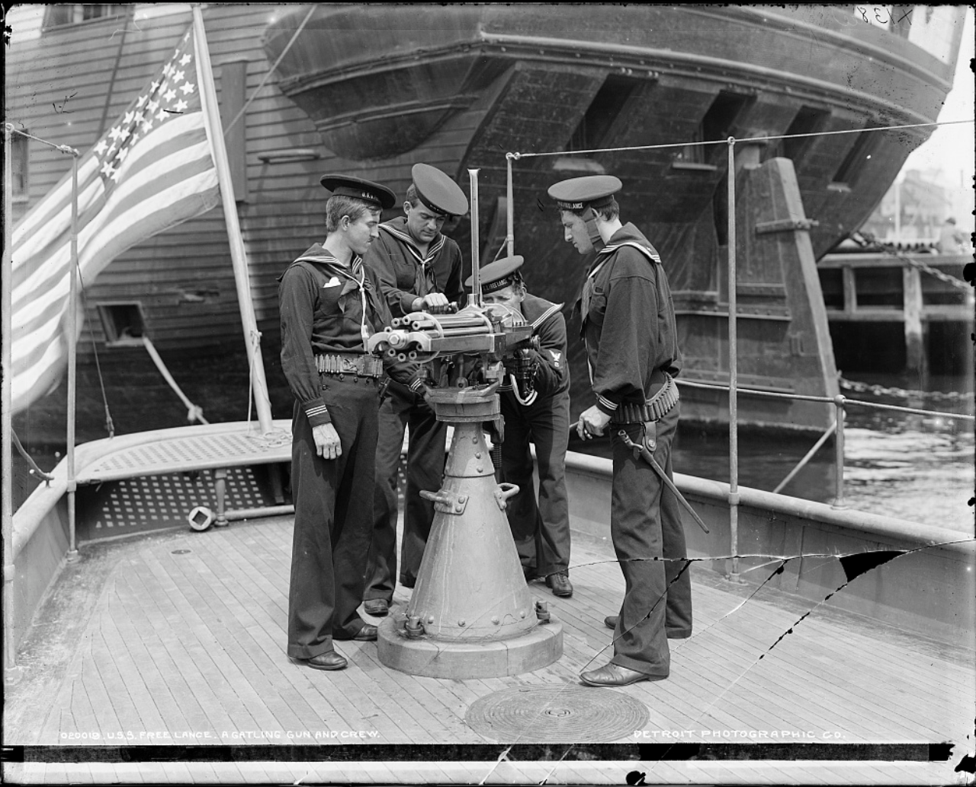

Public domain. Available at the Library of Congress: https://www.loc.gov/item/2025164794/

What did military industrialization cost US?
Featured Source | Source C: “Adjustable abduction arm splint made in ARC splint shops at Villa St Michel. This splint is articulated at the joints in order to bring arm to right angle with body or can be used at any height according to the treatment required for the fracture. Can also be used as Thomas arm splint. Adopted by army medical corps”, August 2, 1918, Library of Congress

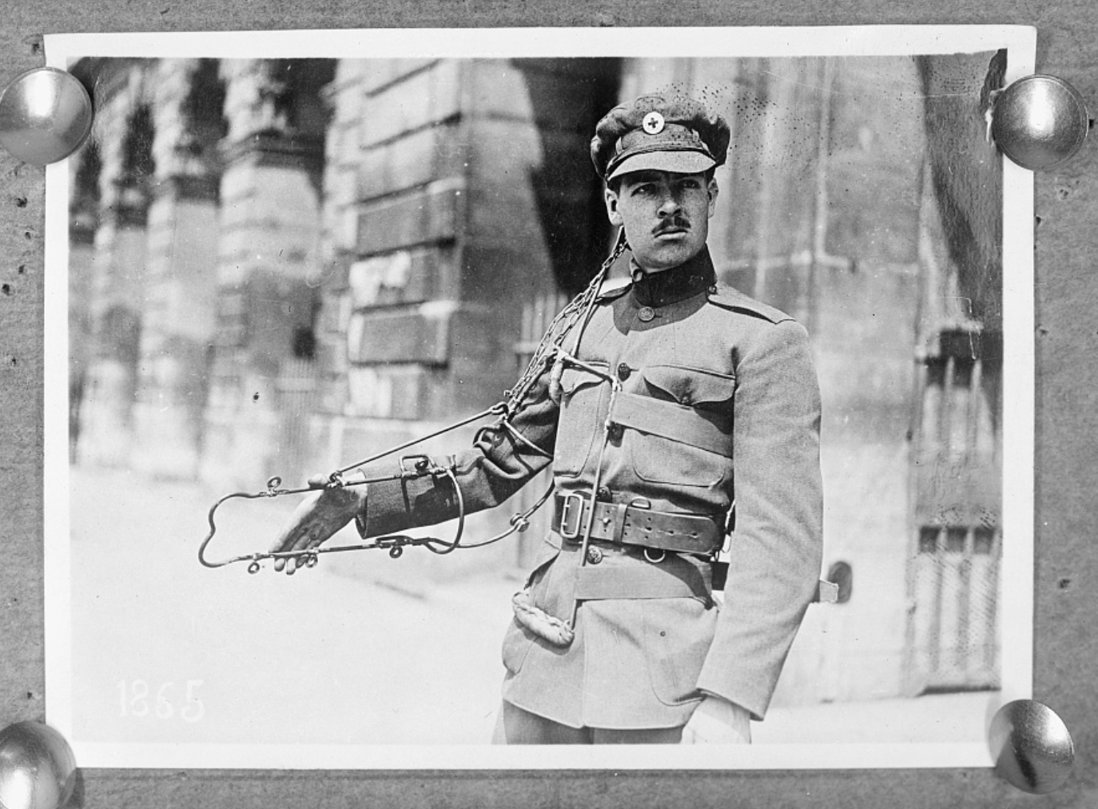

Public domain. Available at the Library of Congress: https://www.loc.gov/item/2017674538/

What did military industrialization cost US?
Featured Source | Source D: “Mobilized Strength and Casualties”, excerpted from The War of the Nations: Portfolio of Rotogravure Etchings, 528, Library of Congress

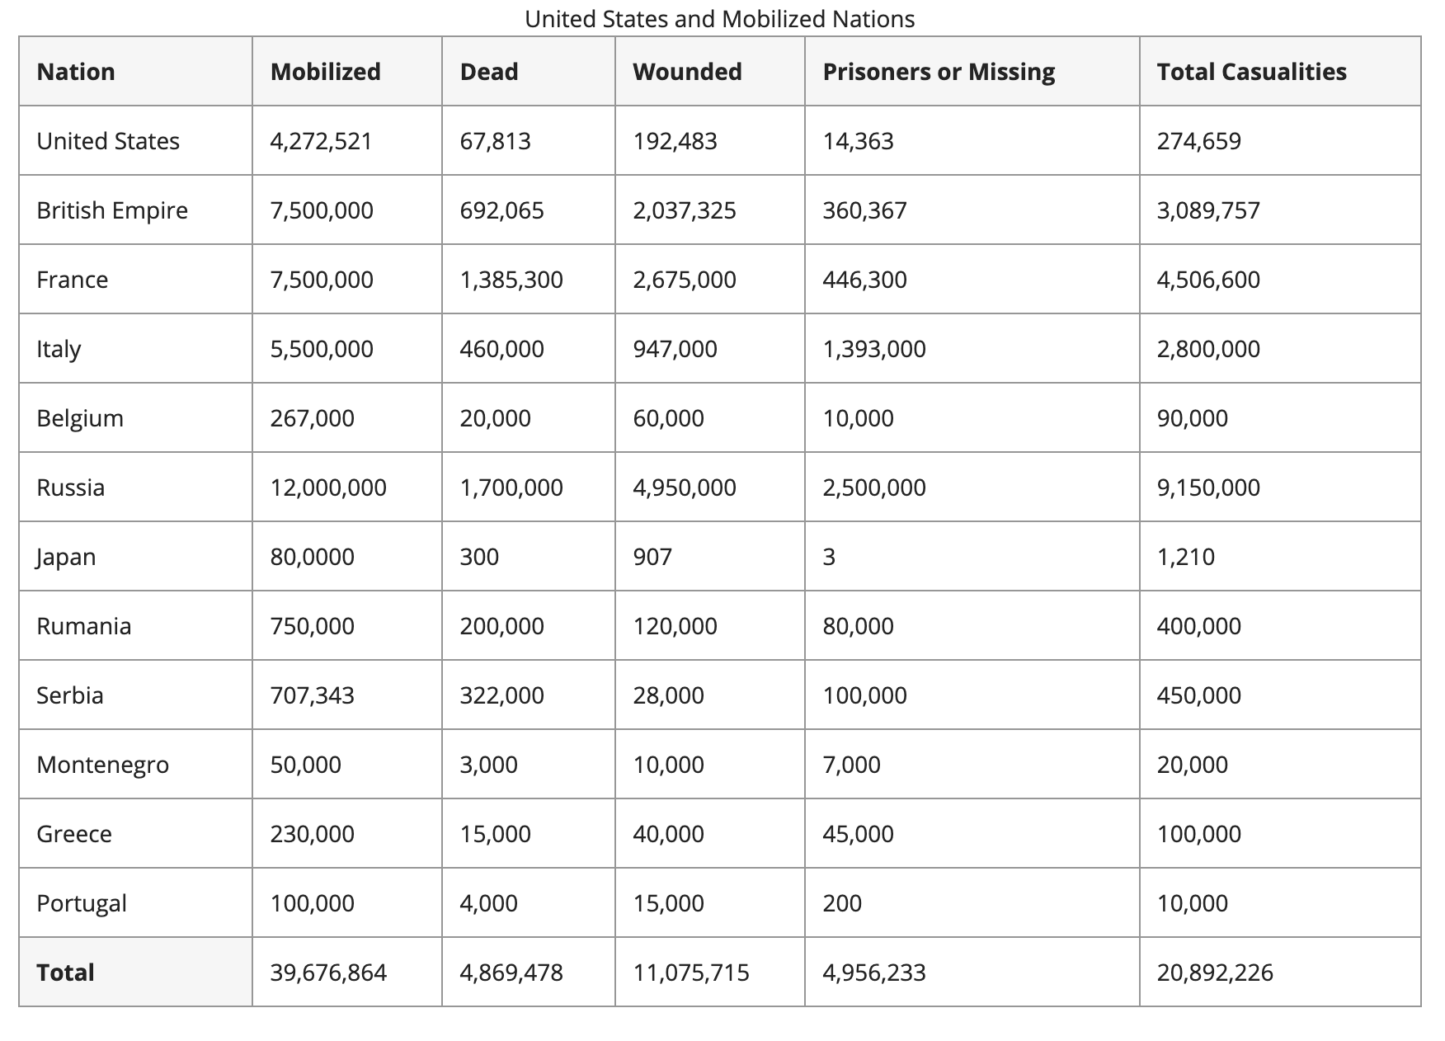
Public domain. Available at the Library of Congress: https://www.loc.gov/collections/world-war-i-rotogravures/articles-and-essays/events-and-statistics/mobilized-strength-and-casualty-losses/

What did military industrialization cost US?
Featured Source | Source E: Portable X-ray vehicle used by the French military and the Red Cross, “Voiture radiologique Massiot [voiture équipée pour pratiquer la radiologie, service de santé militaire de l'armée française et de la Croix-Rouge],” 1914, Bibliothèque nationale de France

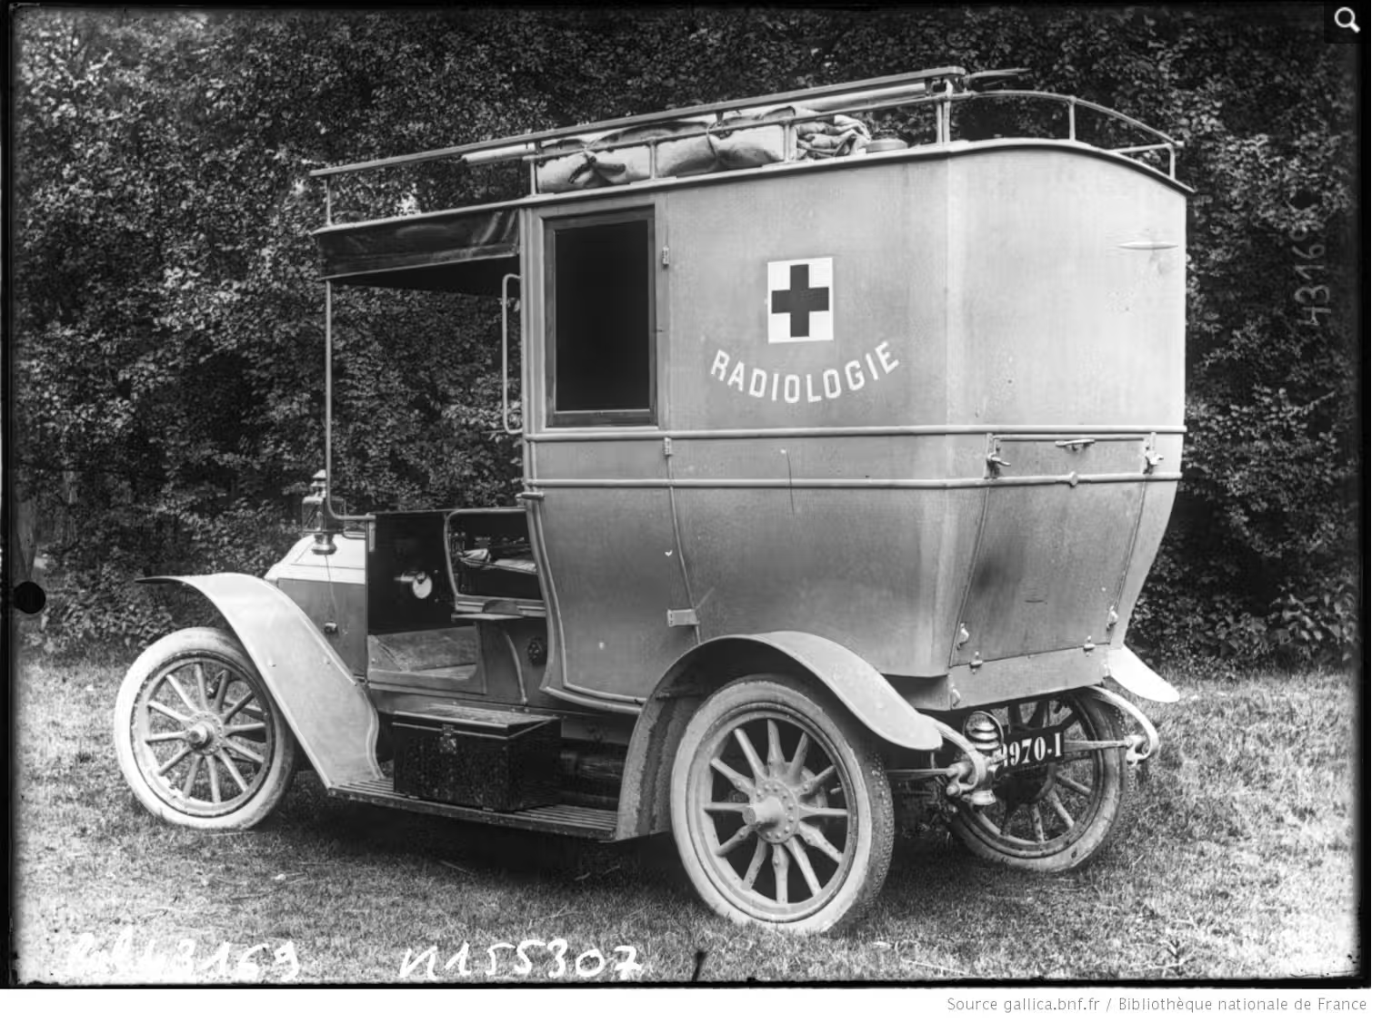
Public domain. Available at the Bibliothèque nationale de France: https://catalogue.bnf.fr/ark:/12148/cb40504352c

What did military industrialization cost US?
Featured Source | Source F: N.Y Central News Photo Service, “A formidable weapon in trench warfare”, ca. 1916-1918, Library of Congress

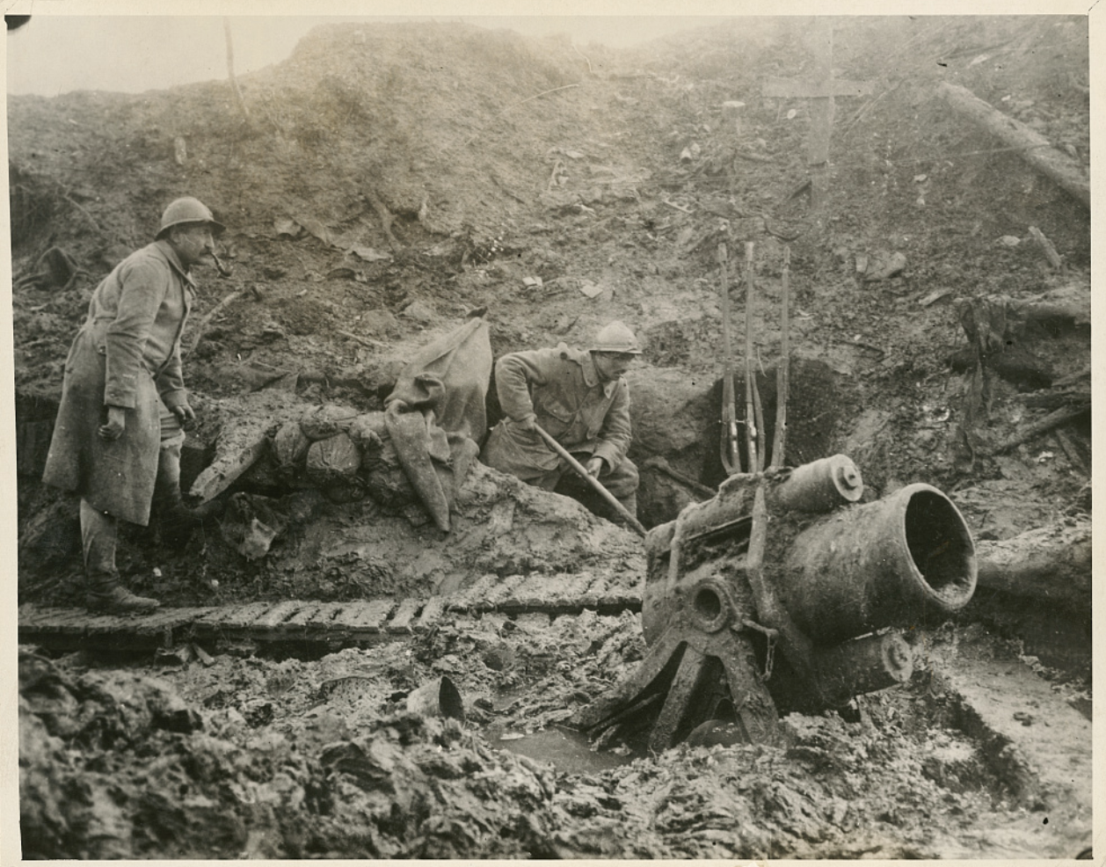

Public domain. Available at Library of Congress: https://www.loc.gov/resource/ppmsca.40788/?__cf_chl_f_tk=tMYqOYq5eVdrGo1s4OaAyfJlmrtWSEuDx6DAULc89eM-1783425325-1.0.1.1-WS3ZZeg419xPT.GNb0xaZivDHw.g7HfM_q7AbtUvmlQ

Graphic Organizer: What did military industrialization cost US?
Part 1: Analyze each image. Evaluate whether the innovation represents a Constructive Cost (saves lives) or a Destructive Cost (causes more damage). Give each cost a score by circling a number on the cost scale.

Destructive (-4 to -1): Weaponry designed for high-volume lethality, automated trenches, or heavy casualties.
Constructive (+1 to +4): Medical advancements, sanitation tools, or diagnostic technology designed to save lives.

Evidence from source:  -4 -3 -2 -1 0 1 2 3 4  Destructive Constructive  Evidence from source:  -4 -3 -2 -1 0 1 2 3 4  Destructive Constructive | Evidence from source:  -4 -3 -2 -1 0 1 2 3 4  Destructive Constructive  Evidence from source:  -4 -3 -2 -1 0 1 2 3 4  Destructive Constructive | Evidence from source:  -4 -3 -2 -1 0 1 2 3 4  Destructive Constructive  Evidence from source:  -4 -3 -2 -1 0 1 2 3 4  Destructive Constructive

Part 2: Add all the values you circled above to calculate your final cost score (don’t forget the negative sign if needed!). Based on your final cost score, summarize the cost of military industrialization.

Source A | Source B | Source C | Source D | Source E | Source F | Final Cost Score
_______ + | _______ + | _______ + | _______ + | _______ + | _______ = | _______

Overall, military industrialization cost…

