What did mass production cost the US?
C3 Framework Standard | D2.Civ.14.9-12. Analyze historical, contemporary, and emerging means of changing societies, promoting the common good, and protecting rights.
C3 Teachers Topic, Concept & Skill | ★ Era 5: Development ★ Civic Engagement ★ Taking Informed Action

Rapid industrialization in the early 20th century dramatically changed the nature of work in the United States. In 1911, the Triangle Shirtwaist Factory fire revealed just how unsafe working conditions were. 146 garment workers, most of whom were young immigrant women, died when a fire broke out in a factory with locked exit doors and inadequate fire safety measures. Public outrage over the disaster led to major workplace safety reforms and stronger labor laws in the United States.

Featured Sources
Source A: New-York Tribune, March 27, 1911, Library of Congress

Formative Performance Tasks |  |  | Teacher Guidance
COLLABORATE | Understand & Assess: Analyze newspaper headlines, identifying factors that contributed to the Triangle Shirtwaist Factory Fire. |  | Class begins with the teacher briefly explaining the context of the Triangle Shirtwaist Factory fire (mentioned in the section above), dividing students into small groups, and distributing a copy of Source A to each group. Students then carefully analyze each of the headlines written in response to the Triangle Shirtwaist Factory fire and identify what factors contributed to the tragedy, recording their responses on the graphic organizer. Next, students craft proposals that could prevent a future tragedy.  The teacher facilitates sharing the proposals with the class, perhaps by taping proposals up and conducting a gallery walk, trading proposals around the room in a circle, or guiding students to rotate between groups. After considering all of the proposals, students vote for the two they believe are the most effective by placing a sticky note (or marker) on their preferred proposals. Class concludes with a discussion of the decision-making process students used when voting.
PRODUCE | Act: Craft a proposal that could prevent a future tragedy.
DELIBERATE | Act: Vote for the proposals most effective to prevent a future tragedy.

What did mass production cost US?
Featured Source | Source A: New-York Tribune, March 27, 1911, Library of Congress

Headline 1 | Headline 2 | Headline 3
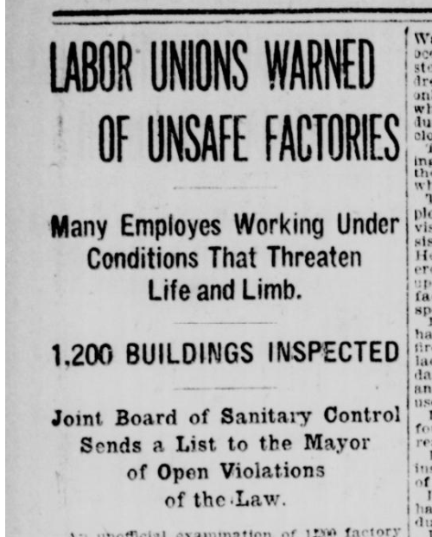 | 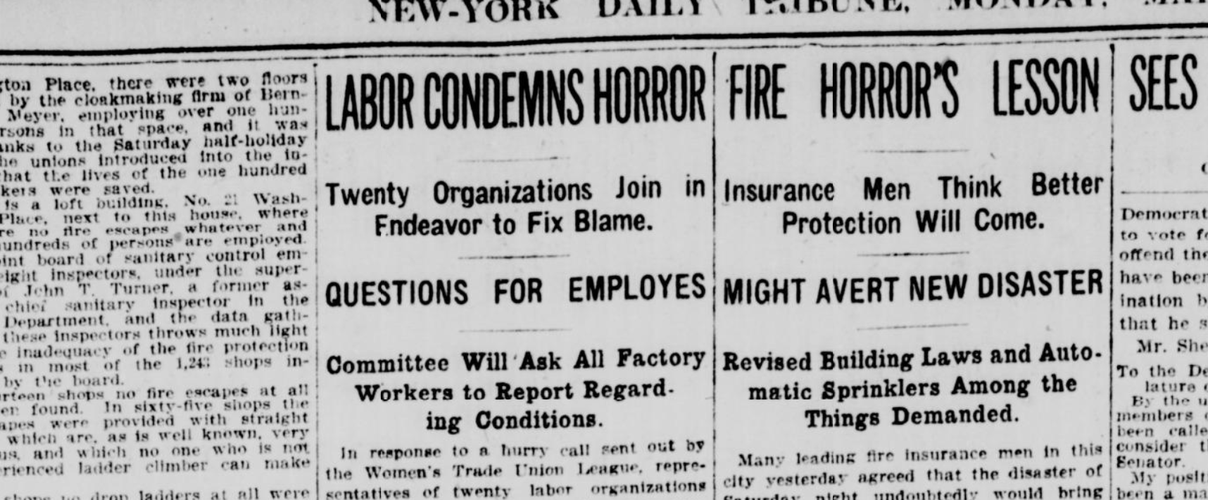

Public domain. Available at the Library of Congress: https://www.loc.gov/resource/sn83030214/1911-03-27/ed-1/?sp=4&q=Blame+Twenty+Organizations&r=0.011,-0.031,0.655,0.271,0

Graphic Organizer: What did mass production cost US?

Part 1: Analyze the headlines carefully. Record factors that may have contributed to the Triangle Shirtwaist Factory fire tragedy. |  | Part 2: Craft a proposal that could help prevent a future tragedy. Your proposal might start with In order to prevent a future tragedy [describe the change] ... because… [explain how it would help]
Why did the event become a tragedy? |  | Proposal


