What did big business cost the US?
C3 Framework Standard | D2.Eco.8.9-12. Describe the possible consequences, both intended and unintended, of government policies to improve market outcomes.
C3 Teachers Topic, Concept & Skill | ★ Era 5: Development ★ Historical Memory ★ Argument

Industrialization allowed factories to produce goods faster and more efficiently, helping some companies grow dramatically. Accompanying this growth were changes in the way businesses could be organized. Large companies called trusts came to define the economics of the Gilded Age. Trusts (or monopolies) controlled entire industries, reduced competition, and expanded their profits. While the owners of trusts benefited from this system, trusts had far-reaching negative consequences for others.

Featured Sources
Source Set: Gilded Age Political Cartoons

Formative Performance Tasks |  |  | Teacher Guidance
COLLABORATE | Identify and decode symbols that critique trusts in the political cartoons. |  | Class begins with the teacher defining the term trust or monopoly to the whole class. The teacher then divides students into pairs and distributes a copy of the Source Set to each team. Using the definition of trust as their background knowledge, students analyze each of the political cartoons that critique trusts during the Gilded Age. For example, students may note that the power of industrialization cost business competition, trust of public opinion, or trust in government. Students use the definition to identify two symbols used by each cartoonist and describe how the symbol is used to critique a trust, recording their observations on the graphic organizer.  Finally, students select the political cartoon that is the most effective critique of trusts to a modern viewer and justify their choice in a claim.
DELIBERATE | Determine which political cartoon presents the most effective critique of trusts to a modern viewer.
PRODUCE | Craft a claim that justifies the choice of the most effective political cartoon.

What did big business cost US?
Featured Source | Source A: Published by Keppler & Schwarzmann, “The tournament of today - a set-to between labor and monopoly / F. Graetz”, August 1, 1883, Library of Congress
Note: The jousting knight on the left wears armor labeled “Monopoly.” His plume (feather) is labeled “Arrogance,” the shield "Corruption of the Legislature," and the lance "Subsidized Press.” The figure on the right is labeled "Labor." The horse is labeled "Poverty” and his sledgehammer says "Strike." On the left is seating labeled "Reserved for Capitalists.”

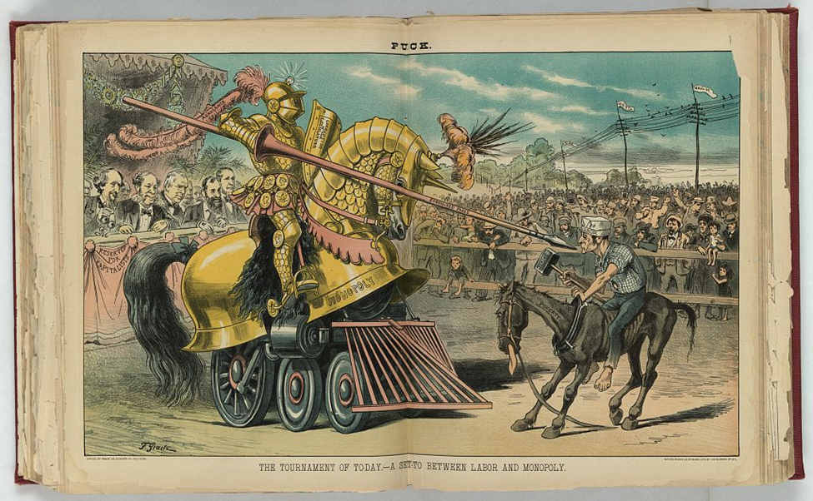

Public domain. Available at the Library of Congress: https://www.loc.gov/resource/ppmsca.28412/

What did big business cost US?
Featured Source | Source B: Frederick Opper, “Anti-trust cartoons: Nursery Rhymes for Infant Industries, No. 15: 'O' is the Oil Trust, a modern Bill Sikes; he defies the police, and does just as he likes”, ca 1901, Library of Congress
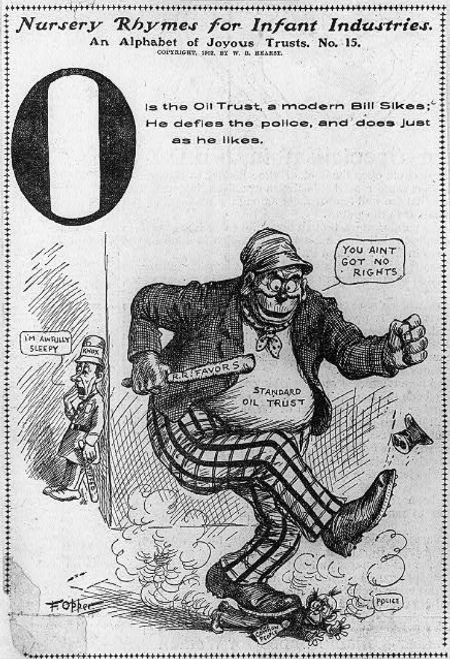

Public domain. Available at the Library of Congress: https://www.loc.gov/resource/cph.3b10757/

What did big business cost US?
Featured Source | Source C: J. Keppler, Published by Puck, “The Bosses of the Senate”, ca. 1889, Library of Congress

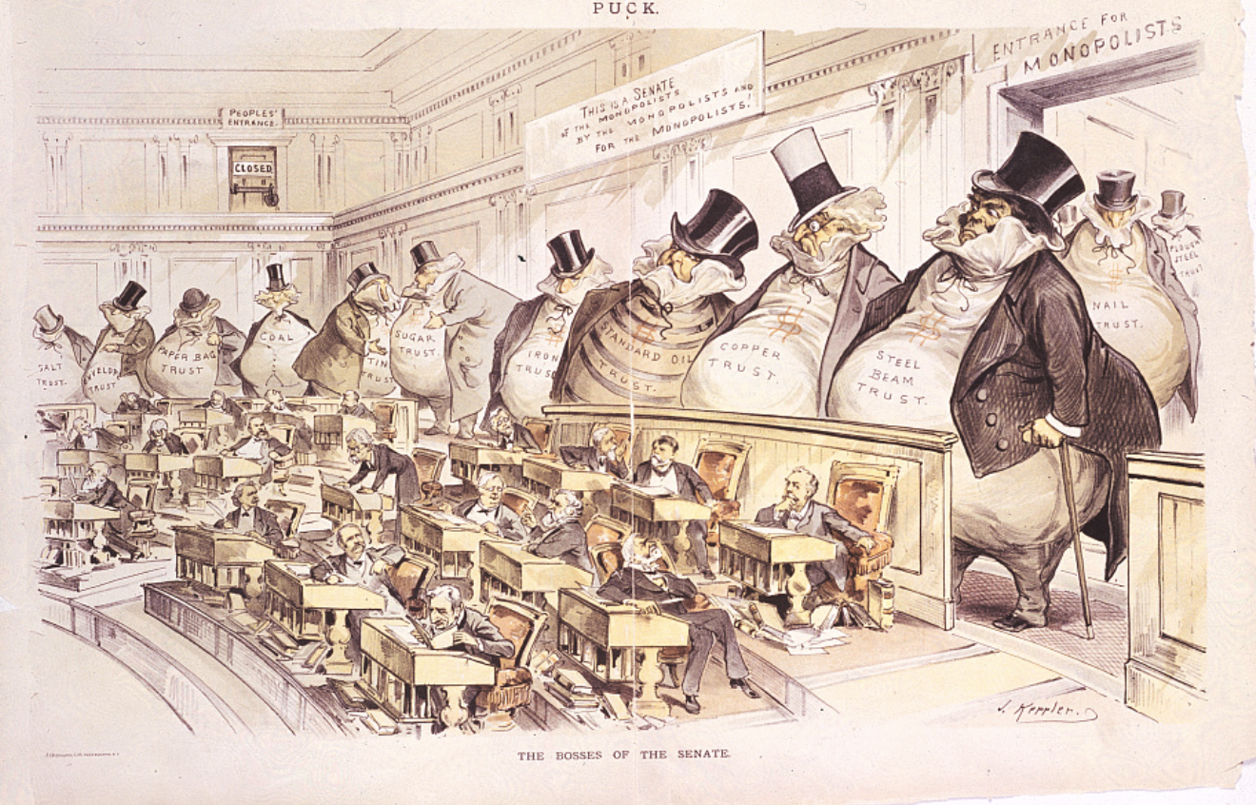

Public domain. Available at the Library of Congress: https://www.loc.gov/resource/cph.3b52004/

What did big business cost US?
Featured Source | Source D: Fairbank Beaumont, Published by Keppler & Schwarzmann, “The right of way / Fairbank”, 1910, Library of Congress
Note: The political cartoon shows a locomotive labeled "Private Monopoly Special" racing down tracks labeled "Opportunity" while two trains labeled "Plain People Local" and "Legitimate Business" have been side-tracked, giving the monopoly the "right of way".

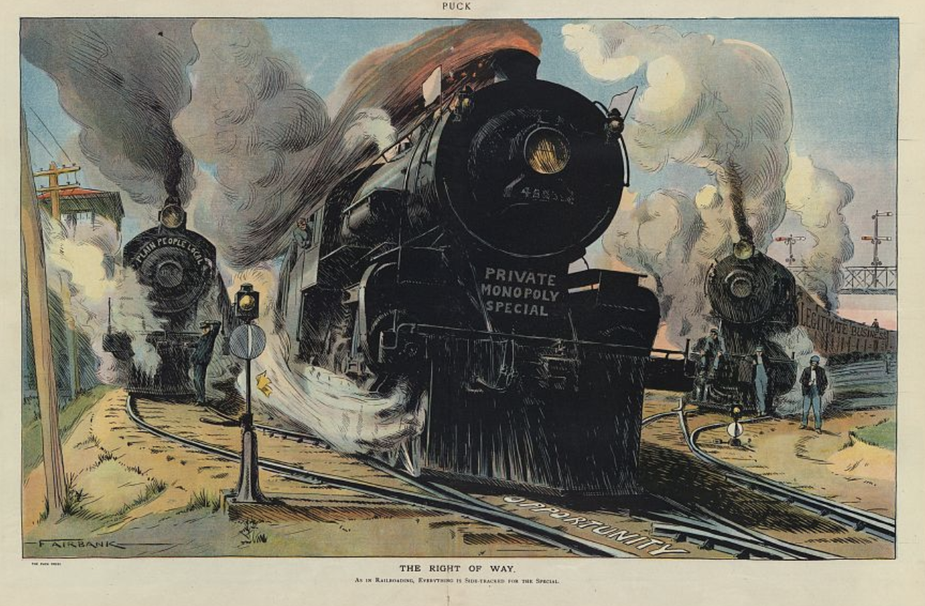

Public domain. Available at the Library of Congress: https://www.loc.gov/resource/ppmsca.27635/

Graphic Organizer: What did big businesses cost US?
Part 1: Carefully analyze each political cartoon. As you look at each image, identify two symbols/images that critique trusts/monopolies. Describe how each symbol is used as a critique.

Source A | Source B | Source C | Source D
Symbol #1 =  This is a critique of trusts because… | Symbol #1 =  This is a critique of trusts because… | Symbol #1 =  This is a critique of trusts because… | Symbol #1 =  This is a critique of trusts because…
Symbol #2 =  This is a critique of trusts because… | Symbol #2 =  This is a critique of trusts because… | Symbol #2 =  This is a critique of trusts because… | Symbol #2 =  This is a critique of trusts because…

Part 2: Select the political cartoon that is the most effective critique of trusts/monopolies to a modern viewer – someone like you! Justify your choice.
Source ______ is the most effective critique of trusts to a modern viewer because…

