How well do photographs reveal a community? (Immigration)
C3 Framework Standard | D2.His.8.9-12. Analyze how current interpretations of the past are limited by the extent to which available historical sources represent perspectives of people at the time.
C3 Teachers Topic, Concept & Skill | ★ Era 5: Immigration ★ Identity ★ Questioning

Photographs of immigrants from the early 1900s offer important insights into their communities. At the same time, photographs from the era required long exposure times, were taken in black and white, and did not always provide a complete or unbiased view of reality. In this inquiry, students will explore images of Chinese immigrant communities in the United States. The photographs in the source set were intentionally selected to highlight this duality - they capture key details but also prompt the viewer to ask questions.

Featured Sources
Source Set: Photographs of Immigrant Communities, Library of Congress

Formative Performance Tasks |  |  | Teacher Guidance
COLLABORATE | Participate in a whole-class brainstorm about what defines a community. |  | Class begins with a whole-class brainstorm around the question “What defines a community?” If needed, the teacher may encourage students to consider how they would define the communities they are a part of to help generate ideas. The teacher may emphasize that asking questions is central to the work of historians - even if not all questions can be answered. Next, the teacher distributes copies of immigrant community photographs in the featured source set to each small group. Working together, students carefully analyze the photographs, generating questions about each photograph. They may record their questions directly on the images, on sticky notes, or on the graphic organizer. The teacher then brings the class back together to introduce the compelling question – How well do photographs reveal a community? In their groups, students then select one photograph from the set and discuss what they would need to know to answer the compelling question. Again, students should record their questions on the image, on sticky notes, or on the graphic organizer. Students can share their questions with the class. As an extension, students could conduct research to answer the questions they generated.
PRODUCE | Craft questions about each of the photographs.
DELIBERATE | Pose questions that could help answer the compelling question for one of the photographs.

How well do photographs reveal a community?
Featured Source | Source A: Detroit Publishing Co., Byron, photographer, “In Chinatown, New York”, ca. 1900, Library of Congress
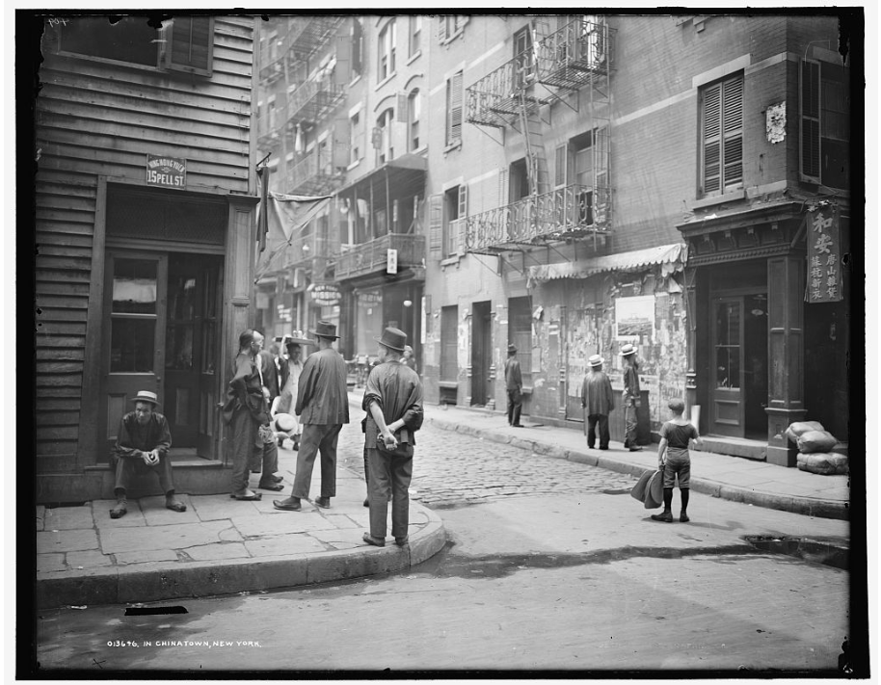

Public domain. Available at the Library of Congress: https://www.loc.gov/resource/det.4a09039/

How well do photographs reveal a community?
Featured Source | Source B: Alfred A. Hart, “Laborers and rocks, near opening of Summit Tunnel”, between 1865 and 1867, Library of Congress

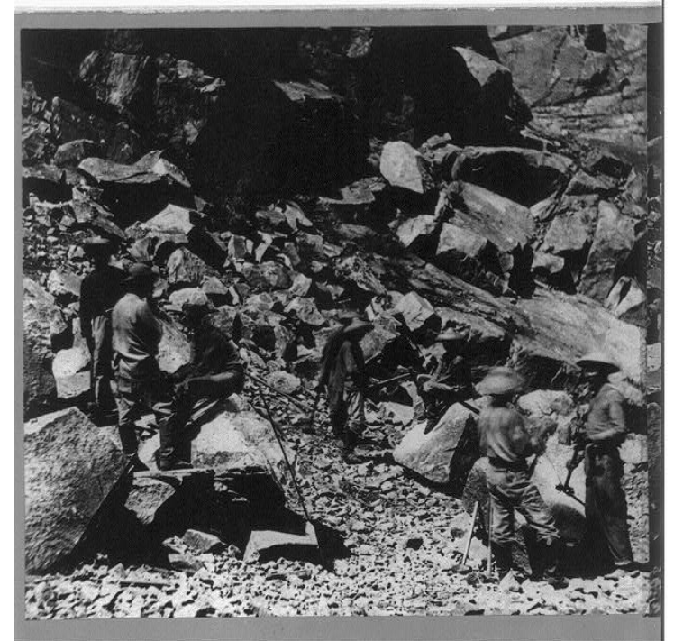
Public domain. Available at the Library of Congress: https://www.loc.gov/resource/cph.3a50798/

How well do photographs reveal a community?
Featured Source | Source C: Arnold Genthe, “The vegetable peddler, Chinatown, San Francisco”, created between 1896 and 1906, Library of Congress

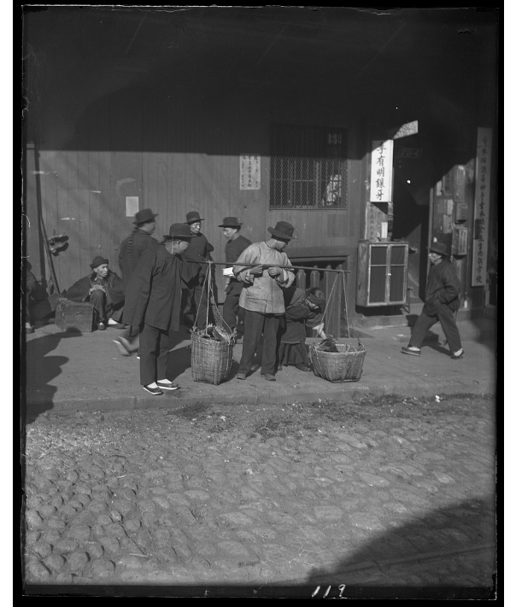
Public domain. Available at the Library of Congress: https://www.loc.gov/resource/agc.7a09129/

How well do photographs reveal a community?
Featured Source | Source D: Frances Benjamin Johnston, “Chinatown, San Francisco, Ca.l”, 1903, Library of Congress
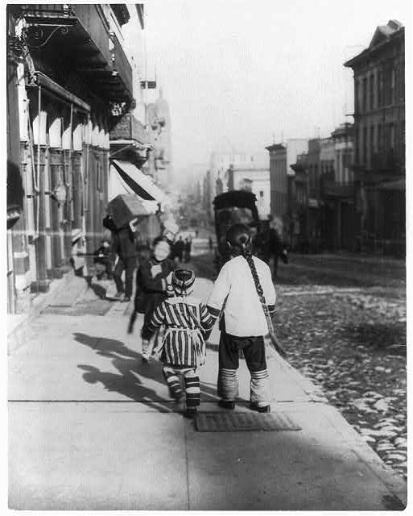
Public domain. Available at the Library of Congress: https://www.loc.gov/item/2003654728/

Graphic Organizer: How well do photographs reveal a community?
Part 1: Analyze each source. Then craft questions you have about each of the photographs.

Source A | Source B
Source C | Source D

Part 2: Select one of the photographs and explain what information you would need to know to answer the compelling question.

To answer the compelling question for photograph ________________, I would need to know…

