What stories do maps tell? (Immigration)
C3 Framework Standard | D2.Geo.2.9-12. Use maps, satellite images, photographs, and other representations to explain relationships between the locations of places and regions and their political, cultural, and economic dynamics.
C3 Teachers Topic, Concept & Skill | ★ Era 5: Immigration ★ Perspective ★ Knowledge

Choropleth population distribution maps use shading to show how population varies across different regions. By comparing the shades on the map, students can identify population patterns and see where people are, and are not, concentrated. These maps allow a unique opportunity for students to practice key geography skills like map reading and identifying patterns while also studying historic topics. In this building block inquiry, students analyze demographic data in the form of choropleth maps to explore where immigrants did and did not live in 1890.

Featured Sources
Source Set: Map Collection - The United States in 1890, Library of Congress

Formative Performance Tasks |  |  | Teacher Guidance
COLLABORATE | Brainstorm where people move and why they move there. |  | Class begins with small groups of students brainstorming where people move and why they move there to better understand the perspective of immigrants. The teacher might help prompt the discussion by encouraging students to consider what they know about historic immigration, immigrants today, or their own personal experiences moving.  After students have had time to brainstorm and record their ideas on the graphic organizer, the teacher facilitates a whole-group discussion that activates students’ prior knowledge and builds a foundation for the next steps of the inquiry. The teacher then distributes Source A to each group, and if necessary, explains how to read a choropleth map and points out the enlarged map key. Next, students analyze Source B, a population distribution map, and make three predictions on their graphic organizer about where immigrants lived in 1890. Source C, a political map of the U.S. in 1890, can serve as a student resource for place names. After students have made their predictions, the teacher distributes Source B to each group. Working together, students determine if the map corroborates, refutes, or does not address each of their predictions and explain their conclusions.
PRODUCE | Predict where immigrants lived in 1890 based on a population distribution map.
DELIBERATE | Compare the distribution of the foreign-born population map to determine if it corroborates students’ predictions.

What stories do maps tell?
Featured Source | Source A: Rand McNalley and Company, “Rand McNalley & Co.’s map of the United States showing, in six degrees the density of population, 1890”, 1892, Library of Congress
Note: Population density describes the number of people who live in an area. The higher the population density, the more people who live in the area. At the bottom right is a larger image of the map’s key.

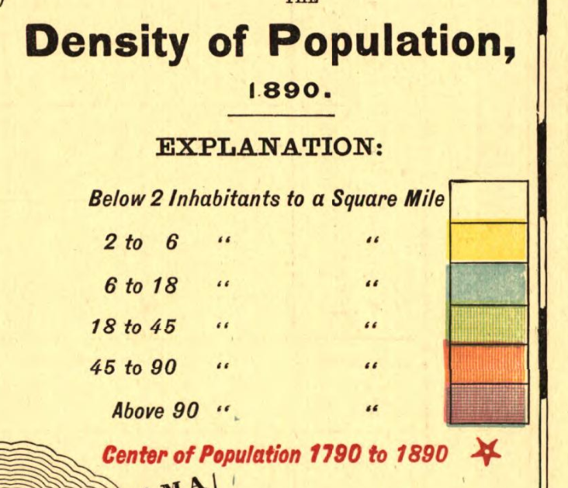
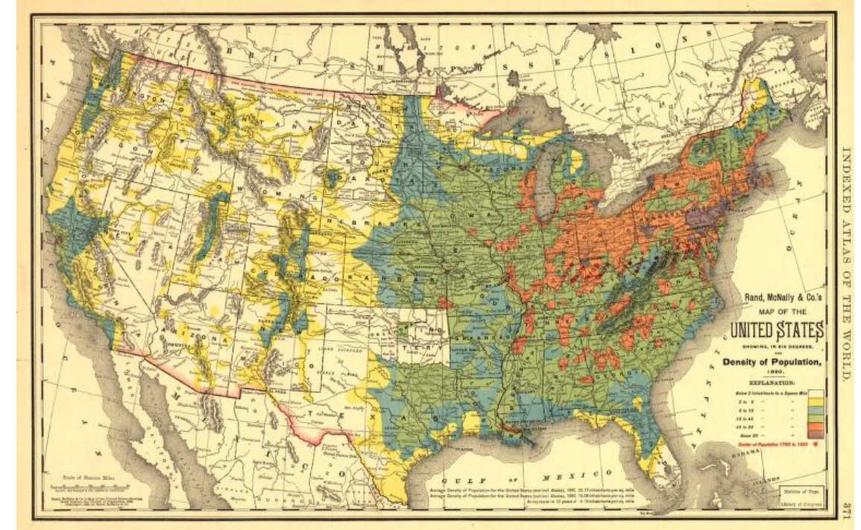

Public domain. Available at the Library of Congress: https://www.loc.gov/resource/g3701e.mf000043/

What stories do maps tell?
Featured Source | Source B: The United States Census Office and Henry Gannett, “Distribution of the foreign born population of the United States: 1890” from Statistical Atlas of the United States, Based Upon the Results of the Eleventh Census, 1889, Library of Congress
Note: At the bottom right is a larger image of the map’s key. The key shows the number of people who were born outside the U.S. who live in each square mile. The key refers to immigrants as inhabitants (inhab.).

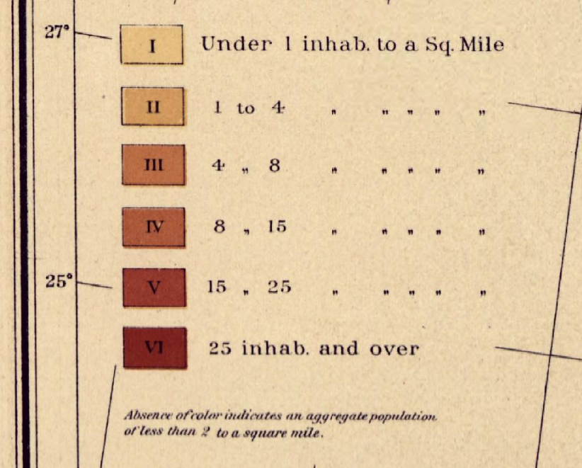
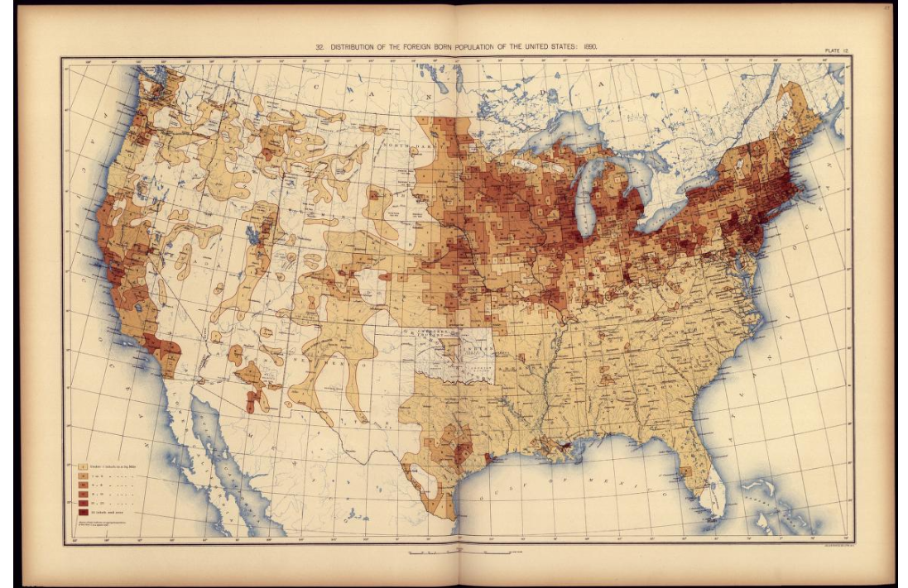

Public domain. Available at the Library of Congress: https://www.loc.gov/resource/g3701gm.gct00010/?sp=30

What stories do maps tell?
Featured Source | Source C: Globez, “Map of the United States in central North America from July 10, 1890, to September 16, 1893”, 2015, Wikimedia
Note: This is a political map of the United States in 1890.

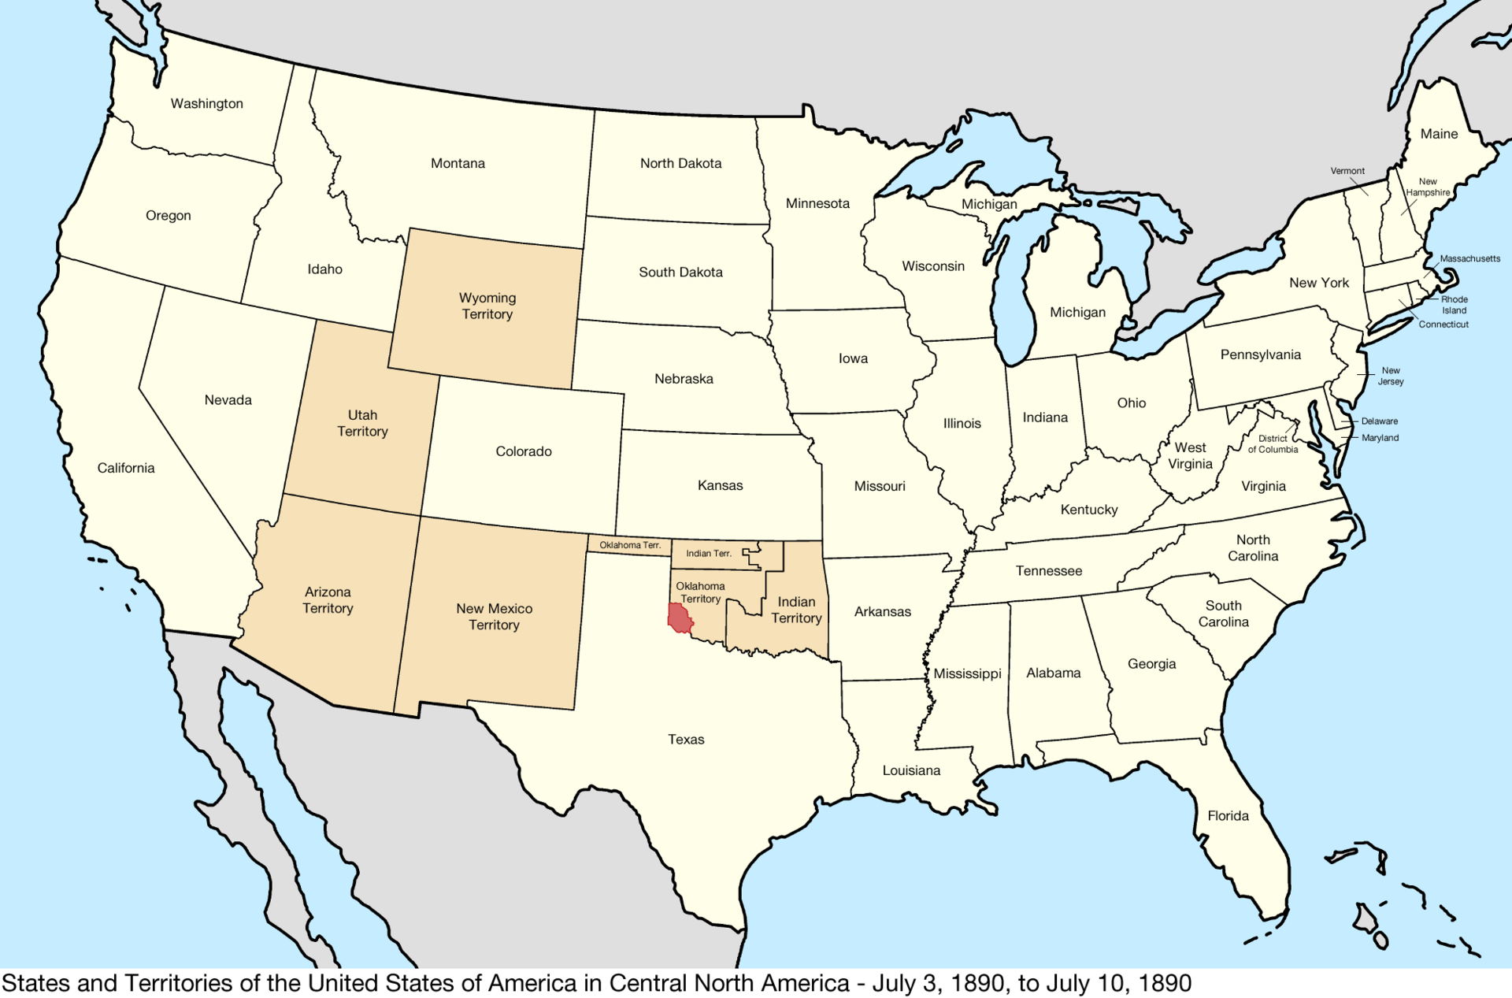

Creative Commons Attribution-Share Alike 4.0 International license. Available only at https://commons.wikimedia.org/wiki/File:United_States_Central_map_1890-07-10_to_1893-09-16.png

Graphic Organizer: What stories do maps tell?

Part 1:  Where do people move?  Why do they move there? | Brainstorm:

Part 2: Based on the patterns you see in Source A, make three distinct predictions about where immigrants lived in 1890. For each of your predictions, determine if Source B corroborates (supports), refutes (disproves), or does not address your initial prediction. Check the correct box and write a brief explanation defending your conclusion using evidence from the maps.

Source A | Source B | Source B
Prediction #1: | ______ corroborates my prediction  ______ refutes my prediction  ______ does not address my prediction | because…
Prediction #2: | ______ corroborates my prediction  ______ refutes my prediction  ______ does not address my prediction | because…
Prediction #3: | ______ corroborates my prediction  ______ refutes my prediction  ______ does not address my prediction | because…

