How does the media help define who we are?
C3 Framework Standard | D2.His.4.9-12. Analyze complex and interacting factors that influenced the perspectives of people during different historical eras.
C3 Teachers Topic, Concept & Skill | ★ Era 5: Immigration ★ Identity ★ Interpretation

The media influences our opinions about public policy by deciding which issues receive the most attention and how topics are covered. Political cartoons in the early 1900s helped shape public opinion about many topics, including immigration. The changing demographics of immigrants during the period were accompanied by a rise in nativism - or anti-immigration sentiment.

Featured Sources
Source A: Raymond Oscar Evans, “The American Wall - As Congressman Burnett Would Build It”, 1916, Library of Congress
Source B: Immigrant Perspective Cards

Formative Performance Tasks |  |  | Teacher Guidance
PRODUCE | Annotate the cartoon, identifying the meaning behind the symbolism used by the cartoonist. |  | Class begins with the teacher briefly providing any necessary context for the era in which the political cartoon was created. In small groups, students closely analyze the featured source, annotating the symbolism used by the cartoonist on the scaffolded graphic organizer (or use the version without scaffolding). If needed, review the meaning behind each symbol as a class.  Next, the teacher gives each group a stack of perspective cards. Students select one of the cards and collaborate to predict how that person might have responded to the political cartoon when it was published. Students then repeat this process for each perspective card. As they consider each point of view, students arrange the perspective cards to build a spectrum reflecting how the cartoon may have been received (a spectrum is provided at the bottom of the graphic organizer).  Note: The teacher may choose to adjust the perspectives on the cards to reflect previous themes of study.
COLLABORATE | Predict how different people would have responded to the political cartoon.
DELIBERATE | Use the perspective cards to create a spectrum that reflects how the political cartoon may have been received.

How does the media help define who we are?
Featured Source | Source A: Raymond Oscar Evans, “The American wall - as Congressman Burnett would build it”, 1916, Library of Congress

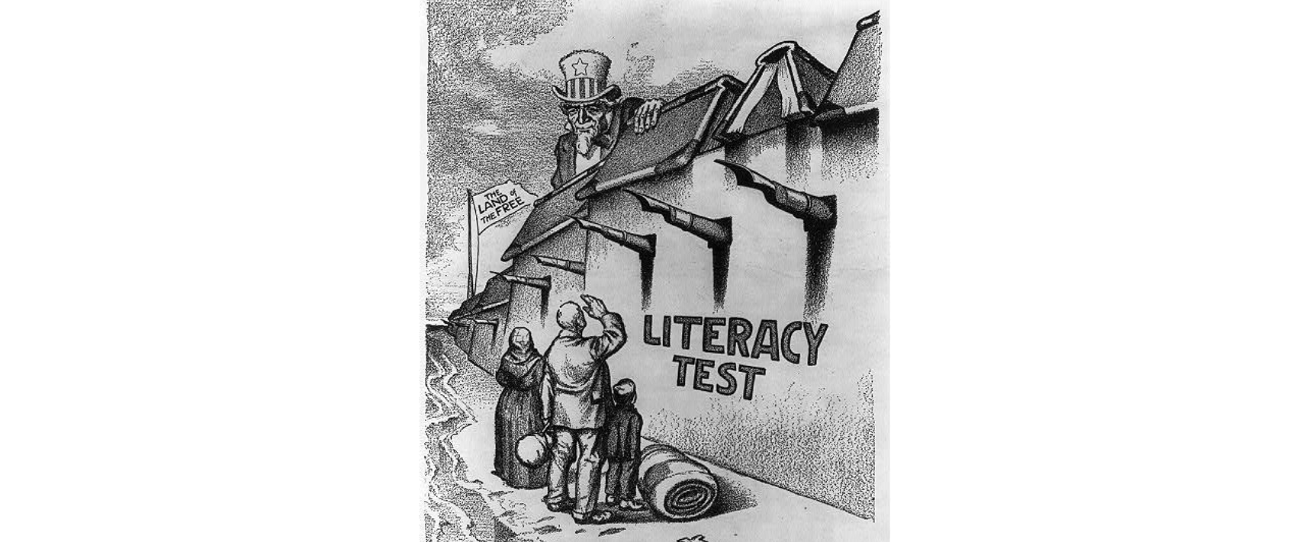

Public domain. Available at the Library of Congress: https://www.loc.gov/resource/cph.3b00563/

Graphic Organizer with Scaffolding: How does the media help define who we are?
Part 1: Annotate the political cartoon. Find examples of symbols the cartoonist uses. Identify what each symbol means.

Symbol #1:
Symbol #2:
Symbol #3:
Symbol #4:
Symbol #5:
Symbol #6:

Part 2: Arrange your perspective cards to build a spectrum showing how audiences may have interpreted the political cartoon. Label each end of your spectrum.

______________
______________

Graphic Organizer: How does the media help define who we are?
Part 1: Annotate the political cartoon. Find examples of symbols the cartoonist uses. Identify what each symbol means.

Part 2: Arrange your perspective cards to build a spectrum showing how audiences may have interpreted the political cartoon. Label each end of your spectrum.
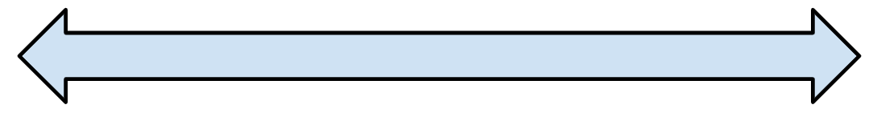

________________________ |  | ________________________

Perspective Cards: How does the media help define who we are?
Print and cut the cards below. Distribute one set to each group.

Adult immigrant from Ireland who cannot read or write | Immigrant from England who graduated from college
Russian-speaking immigrant child | Adult who immigrated to the US as a child from Italy
Adult from a small town in the US who does not know any immigrants | A politician trying to win the votes of American citizens who oppose immigration

