How do photographs shape a story? (Ellis Island)
C3 Framework Standard | D2.His.7.9-12. Explain how the perspectives of people in the present shape interpretations of the past.
C3 Teachers Topic, Concept & Skill | ★ Era 5: Immigration ★ Historical Memory ★ Argument

Ellis Island was the main entry point for millions of immigrants coming to the United States. The moment of arrival is part of many people’s understanding of American identity. This building block inquiry explores how photographs and visual representations help shape our understanding of key events and how we build memories of historic events.

Featured Sources
Source Set: Images of Immigrants Arriving in the United States, Library of Congress

Formative Performance Tasks |  |  | Teacher Guidance
COLLABORATE | Consider the emotions evoked by images of immigrants arriving in the United States. |  | Class begins with students working in pairs to closely analyze either Source A or Source B from the featured source set, recording the emotions the artist’s rendering evokes on the graphic organizer. The teacher then distributes one of the photographs from the source set to each pair of students. Students repeat the process, analyzing the photograph and recording the emotions it evokes. After looking at both a drawing and a photograph, students compare the two images and the feelings each evoked.  Next, the teacher prompts students to determine which image they would select to accompany a magazine article about immigrants arriving in the United States. Pairs then deliberate to select one image. To conclude the exploration of the sources, each pair then justifies their selection by crafting a claim that answers the compelling question: How do photographs shape a story?
DELIBERATE | Select an image to accompany an article about immigrants arriving in the United States.
PRODUCE | Justify student selections by crafting a claim that answers the compelling question: How do photographs shape a story?

How do photographs shape a story? (Ellis Island)
Featured Source | Source A: A.B. Shults, “Immigrants Landing at Castle Garden”, 1880, Library of Congress

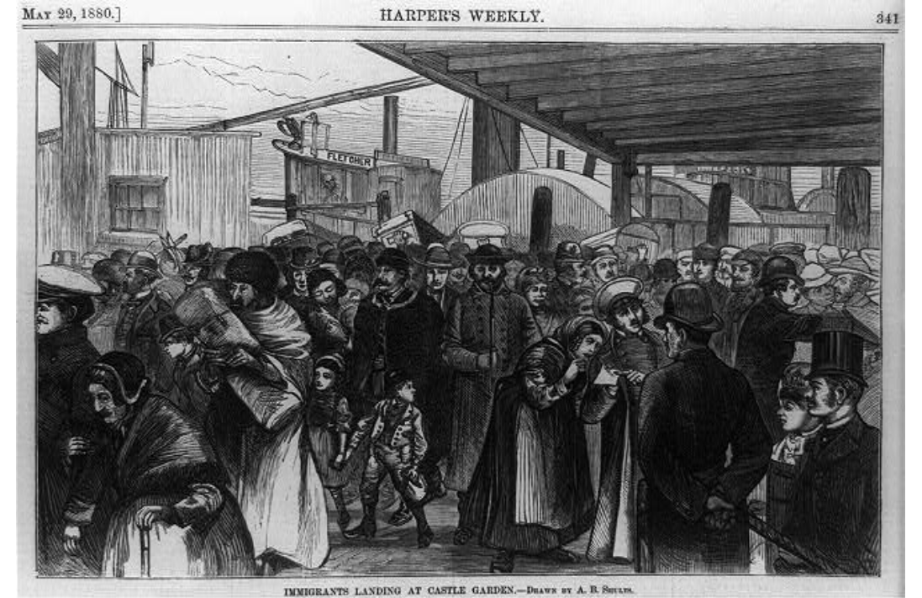

Public domain. Available at the Library of Congress: https://www.loc.gov/resource/cph.3b45445/

How do photographs shape a story? (Ellis Island)
Featured Source | Source B: “New York - Welcome to the land of freedom - An ocean steamer passing the Statue of Liberty: Scene on the Steerage deck / from a sketch by a staff artist”, 1887, Library of Congress

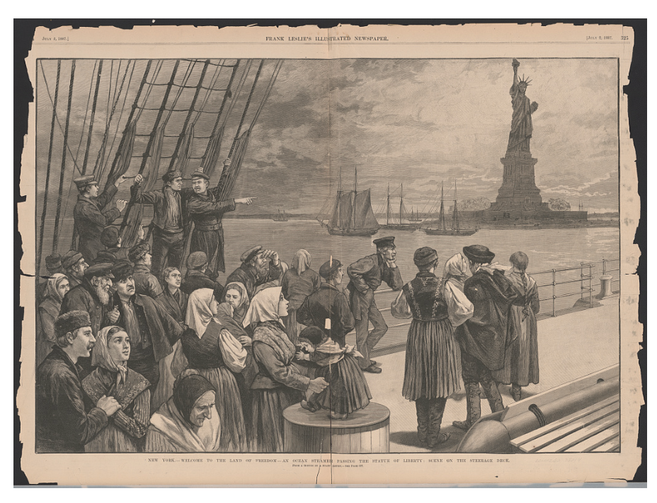
Public domain. Available at the Library of Congress: https://www.loc.gov/resource/ppmsca.51996/

How do photographs shape a story? (Ellis Island)
Featured Source | Source C: “Landing at Ellis Island”, 1902, Library of Congress

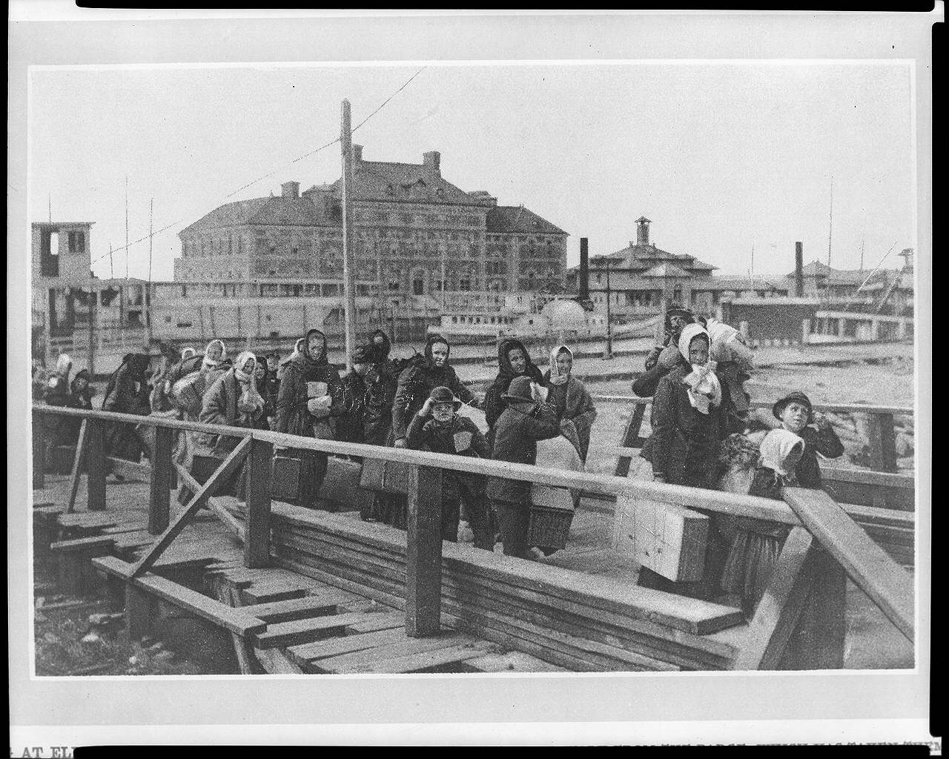

Public domain. Available at the Library of Congress: https://www.loc.gov/item/97501086/

How do photographs shape a story? (Ellis Island)
Featured Source | Source D: “Final discharge from Ellis Island –”, 1901, Library of Congress

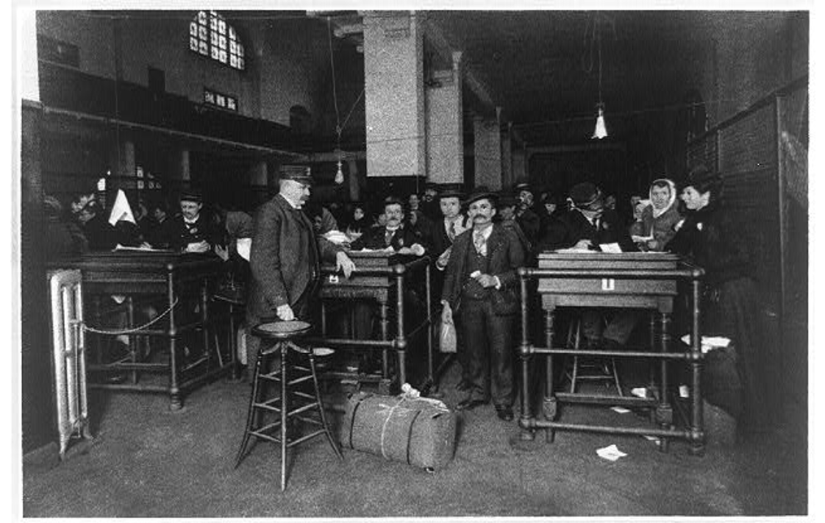

Public domain. Available at the Library of Congress: https://www.loc.gov/resource/cph.3b39451/

How do photographs shape a story? (Ellis Island)
Featured Source | Source E: Bain News Service, “Ellis Island”, no date, Library of Congress

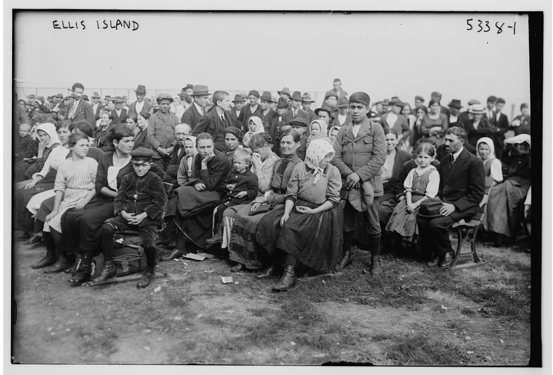

Public domain. Available at the Library of Congress: https://www.loc.gov/resource/ggbain.50437/

Graphic Organizer: How do photographs shape a story? (Ellis Island)
Part 1: Look carefully at the image. How does it make the viewer feel? Record your ideas below.

Artist Rendering | Photograph

Part 2: Which image would you select to accompany an article about immigrants arriving in the United States? (check one.)
______ Artist Rendering ______ Photograph

Part 3: How do photographs shape a story? Craft a claim that answers the compelling question and justifies the image you selected above.

Claim:

