How do we define patriotism during wartime?
C3 Framework Standard | D2.Civ.8.9-12. Evaluate social and political systems in different contexts, times, and places, that promote civic virtues and enact democratic principles.
C3 Teachers Topic, Concept & Skill | ★ Era 7: Conflict ★ Civic Engagement ★ Argument

World War II created a generation of heroes on the warfront as a generation of military families made countless sacrifices so the Allies could defeat the fascist Axis powers. Meanwhile, civilians on the home front also demonstrated what it meant to serve their country. This inquiry asks students to think about the concept of patriotism as they explore different ways Americans supported the war effort and the underlying values the United States was fighting for.

Featured Sources
Source Set: WWII on the Home Front

Formative Performance Tasks |  |  | Teacher Guidance
COLLABORATE | Write a caption that describes civic action taken by Americans in each source. |  | Class begins by examining a source set that includes a variety of wartime realities on the home front (production, employment, advertisements, war bonds, etc.). Students write a new caption for each source that describes the civic action taken and how it relates to the war or the American ideals being defended abroad.  Students then reach a preliminary consensus on the characteristics of “patriotism” during war and give each source a score on the provided organizer.  Next, students may revise their criteria as they create a dictionary entry that captures the complexities of wartime patriotism by including multiple definitions influenced by their sourcework. For example, they may describe patriotism via sacrifice, collaborative efforts, or even dissent in service of the ideals the nation claimed to be fighting for.
DELIBERATE | Score the civic actions taken based on group-created criteria for “patriotism.”
PRODUCE | Create a dictionary entry for “patriotism.”

How do we define patriotism during wartime?
Featured Source | Source A: War Production Posters, Office of Emergency Management
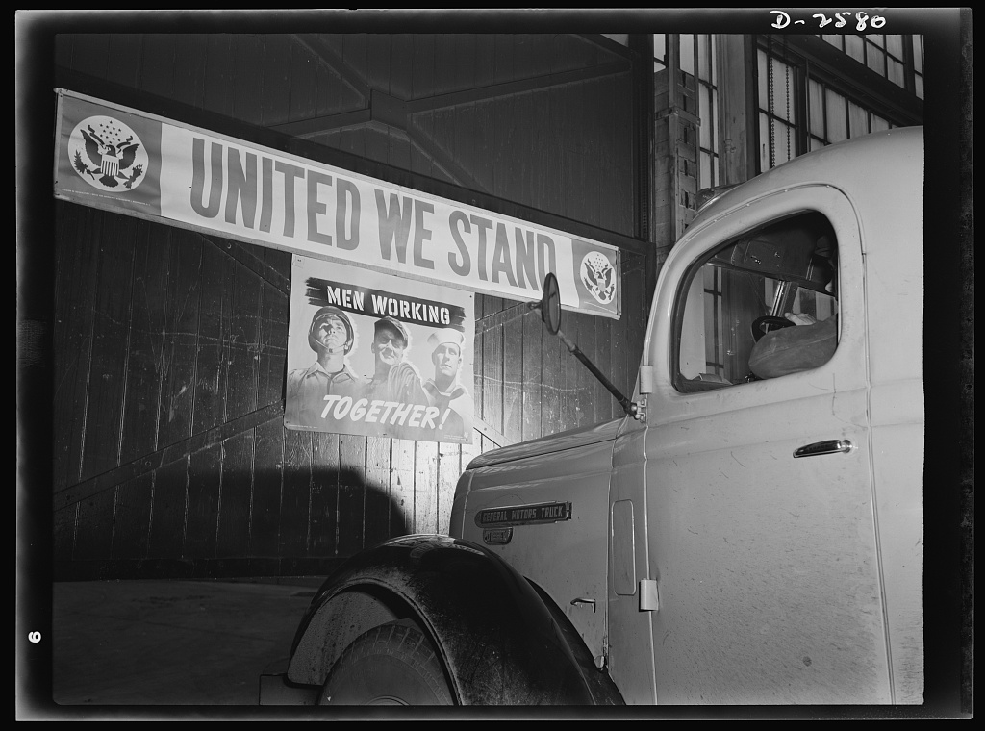
Signs posted throughout the mills of this Midwestern copper and brass plant, 1942.

Public domain. Available at the Library of Congress: http://hdl.loc.gov/loc.pnp/fsa.8e10913

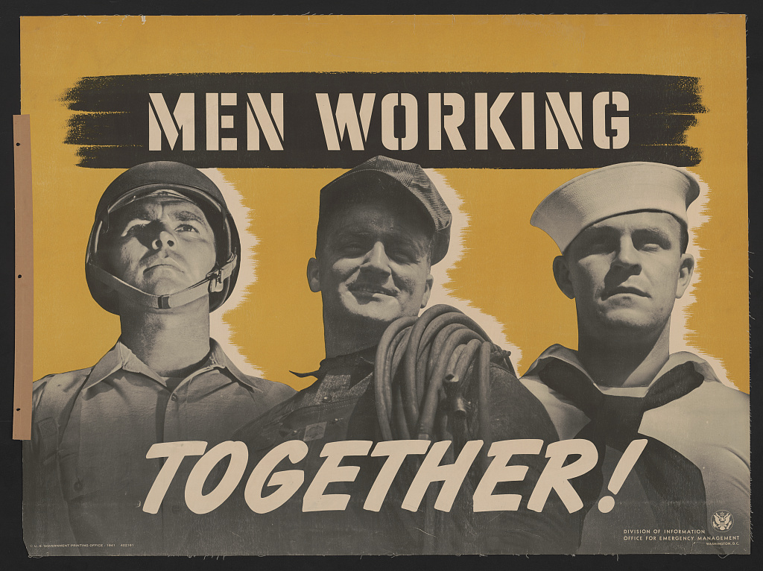

Men Working Together. Lithograph by the Office of Emergency Management, 1941

Public domain. Available at the Library of Congress: http://hdl.loc.gov/loc.pnp/ds.08153

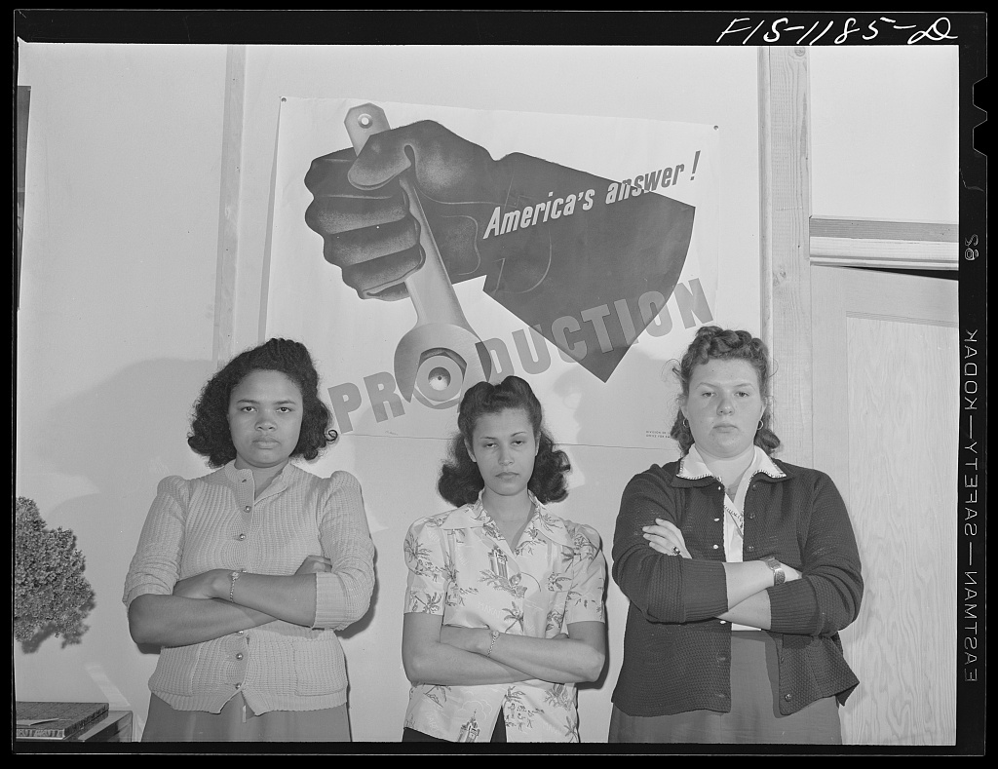
Women employed at Pacific Parachute Company, San Diego, California. 1942.

Public domain. Available at the Library of Congress:
http://hdl.loc.gov/loc.pnp/fsa.8d03450

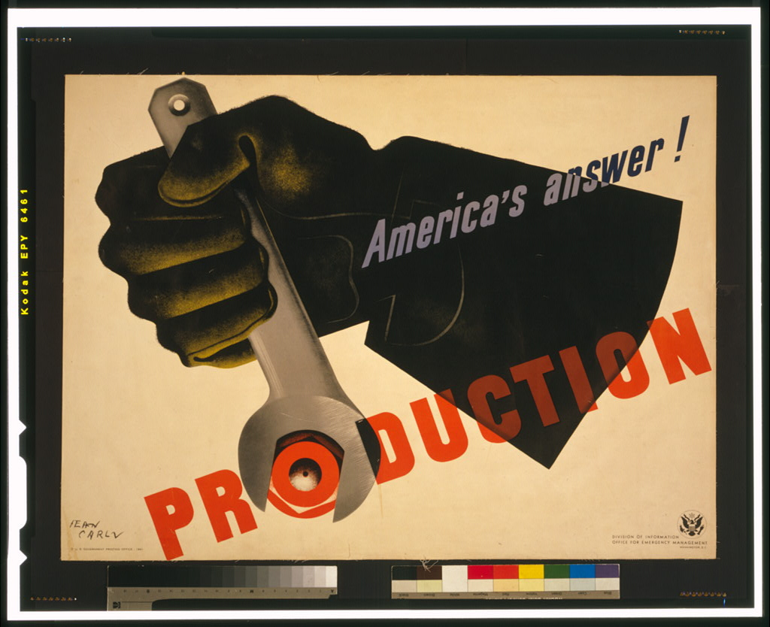

Production, America’s answer!
Lithograph by Jean Carlu, 1941.

Public domain. Available at the Library of Congress: http://hdl.loc.gov/loc.pnp/cph.3g07085

How do we define patriotism during wartime?
Featured Source | Source B: Libby Foods Advertisement and Rationing Guide, Evening Star (Washington, D.C.), 1943

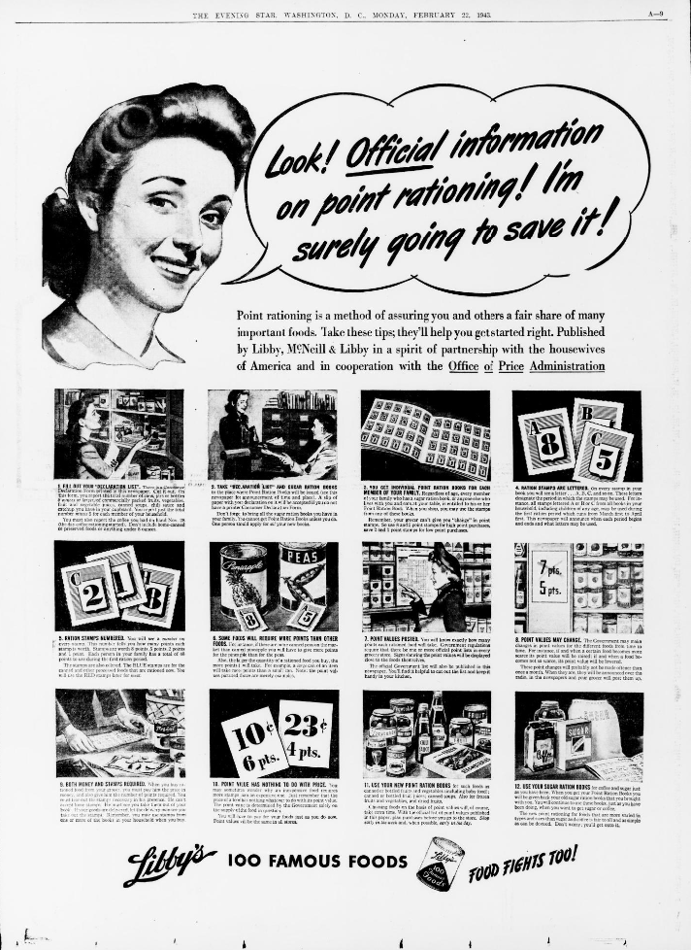

Public domain. Available at the Library of Congress:
https://www.loc.gov/resource/sn83045462/1943-02-22/ed-1/?sp=9&r=-0.784,-0.09,2.568,1.533,0

How do we define patriotism during wartime?
Featured Source | Source C: Posters for The New York City Department of Water Supply, Gas & Electricity

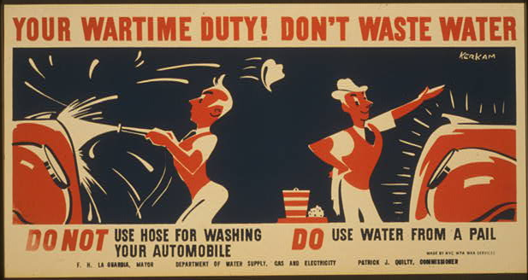
Public domain. Available at the Library of Congress: https://www.loc.gov/item/98516602/

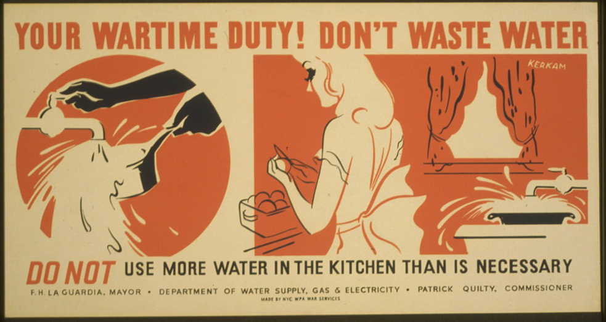
Public domain. Available at the Library of Congress: https://www.loc.gov/item/98516601/

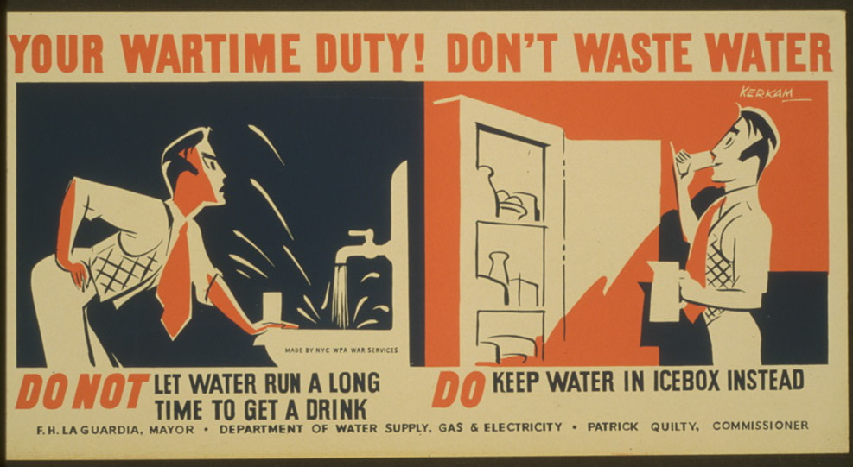
Public domain. Available at the Library of Congress: https://www.loc.gov/item/98516596/

How do we define patriotism during wartime?
Featured Source | Source D: NAACP Convention and March on Washington Plan, 1941
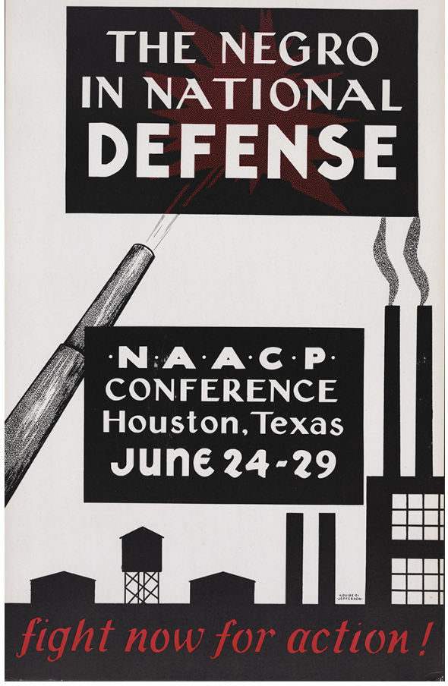
During World War II the NAACP renewed efforts to end discrimination in the military. At the war’s onset, only the Army accepted black draftees. Through NAACP intervention, President Roosevelt established black organizations in every major branch of the armed services.

A. Philip Randolph (1889–1979) and Walter White scheduled a March on Washington for July 1, to follow the NAACP’s Annual Convention in Houston, Texas, held from June 24 to June 29, 1941. The theme of the convention was “The Negro in National Defense.”

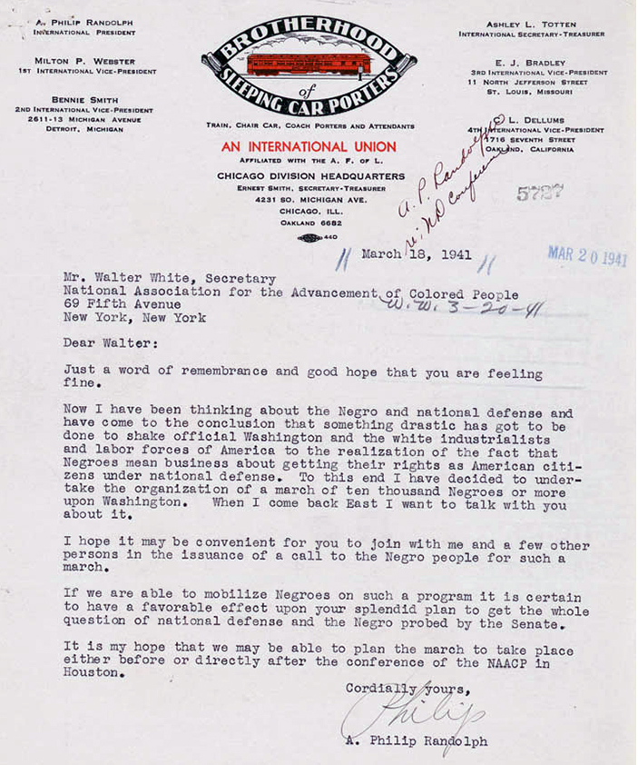

In this letter, labor leader A. Philip Randolph suggests to Walter White “a mass March on Washington” by thousands of African Americans to protest discrimination in defense industries and the armed forces. On June 18, A. Philip Randolph and Walter White met at the White House with President Franklin D. Roosevelt, Assistant Secretary of War Robert Paterson, and other officials. On June 25, the threat of the march prompted President Roosevelt to sign Executive Order 8802, which banned discrimination in defense industries receiving government contracts. The Fair Employment Practices Committee (FEPC) was established to investigate and monitor hiring practices.

Public domain. Available at the Library of Congress: https://www.loc.gov/exhibits/naacp/world-war-ii-and-the-post-war-years.html

How do we define patriotism during wartime?
Featured Source | Source E: War Bonds Posters

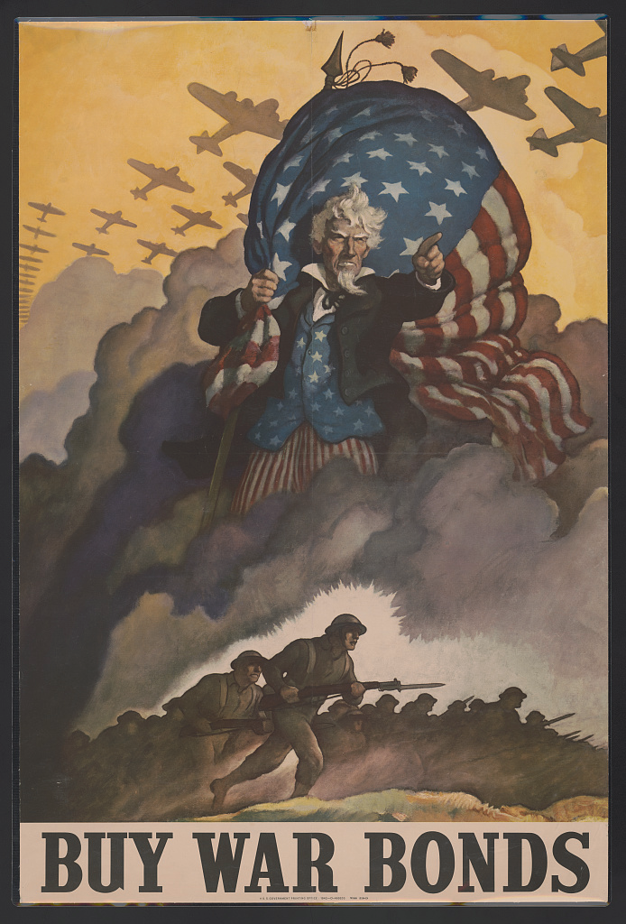
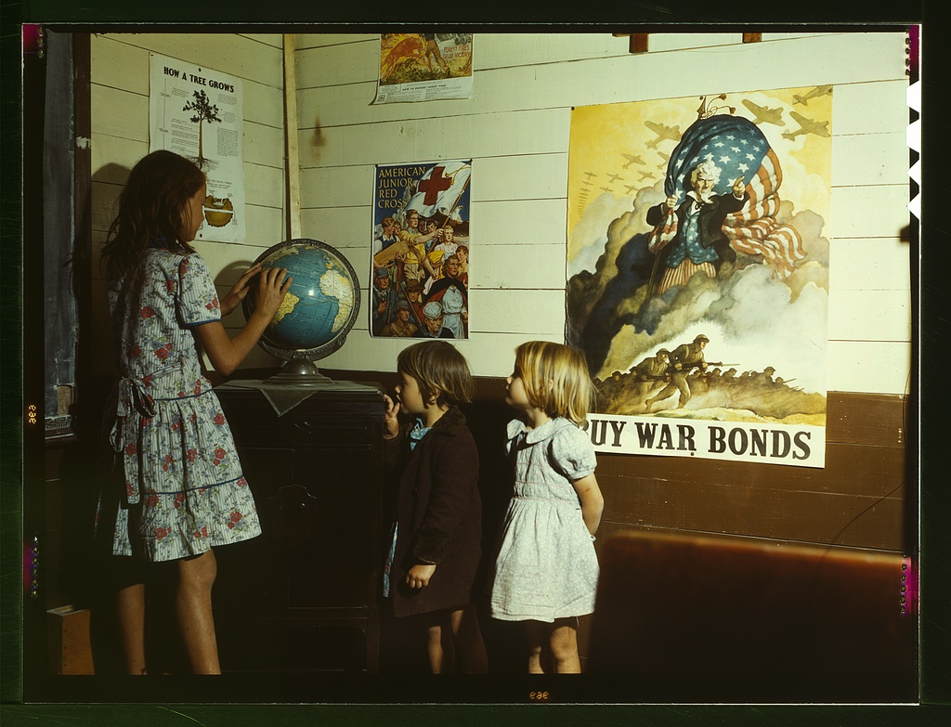
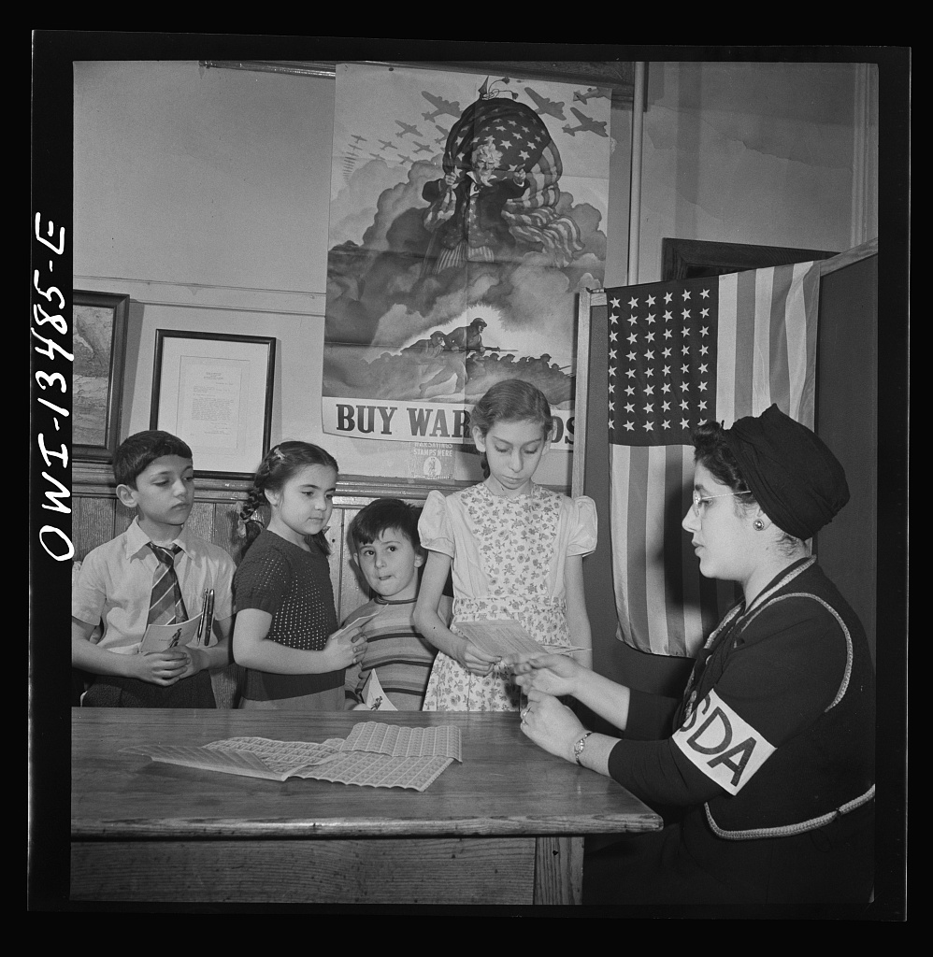

Top Left: Italian-American children buying stamps and bonds at Public School Eight, New York, New York. 1942.
Public domain. Available at the Library of Congress: http://hdl.loc.gov/loc.pnp/fsa.8d24226

Top Right: Rural school children, San Augustine County, Texas, 1943.
Public domain. Available at the Library of Congress: http://hdl.loc.gov/loc.pnp/fsac.1a35427

Right: Buy War Bonds. Lithograph by N.C. Wyeth, 1942.
Public domain. Available at the Library of Congress: http://hdl.loc.gov/loc.pnp/ds.12471

How do we define patriotism during wartime?
Featured Source | Source F: Double V Campaign
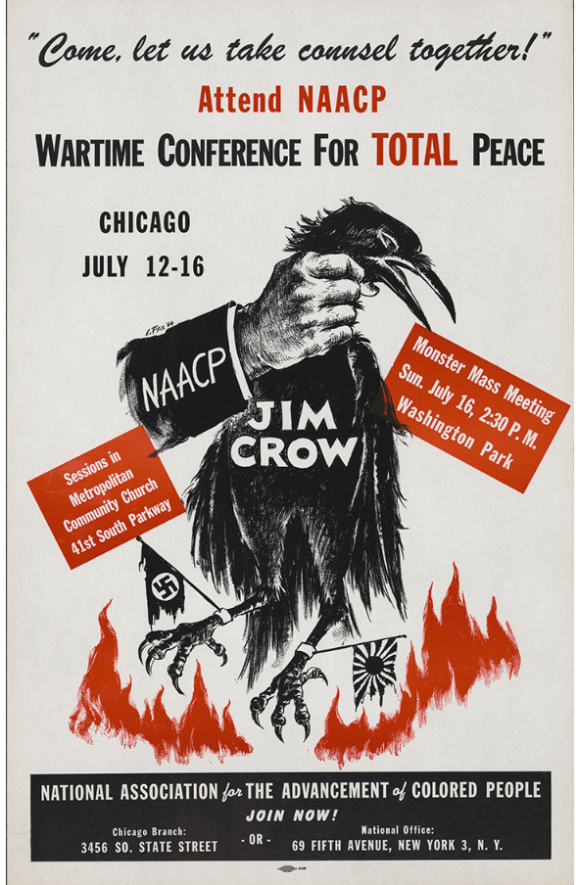
In 1942 the NAACP joined the “Double V” Campaign being conducted by the Pittsburgh Courier. The purpose was to mobilize black civilians to fight for “a double victory–full democracy abroad and at home.” They were encouraged to help defeat the Axis forces abroad by participating in Civilian Defense programs and Jim Crow at home by supporting the NAACP. The campaign’s hope is symbolically captured by this poster. It shows a hand labeled “NAACP” grasping a dead crow, “Jim Crow,” over a flaming battlefield. Jim Crow’s feet are shackled with the tattered flags of Nazi Germany and Japan.

Public domain. Available at the Library of Congress: https://www.loc.gov/exhibits/naacp/world-war-ii-and-the-post-war-years.html

The Double V Victory

During World War II, African Americans made tremendous sacrifices in an effort to trade military service and wartime support for measurable social, political, and economic gains. As never before, local black communities throughout the nation participated enthusiastically in wartime programs while intensifying their demands for social progress.

The federal government also vigorously solicited the support of HBCUs in numerous programs like the War Bond and Stamp Savings program and the Army Enlisted Reserve Corps, which was a precursor to the United States Army Reserve. In addition to thousands of Africans Americans, more than 50,000 non-African-American students throughout the South were registered in defense-related training programs.
Many black leaders and organizations such as the National Association for the Advancement of Colored People (NAACP) were acutely aware and concerned about African American disaffection for the war. Rightly so, black Americans had little to celebrate, considering that many of them were barred from civil defense training programs and jobs, as Jim Crow philosophy permeated the branch services of the Army, Navy, and Marines, and African Americans who suffered from maltreatment and assaults at the hands of whites had no recourse in the justice system.

At Howard University, many students linked wartime support to the civil rights movement and began to participate in sit-ins and demonstrations that protested segregationist policies of restaurants, department stores, and drugstores throughout the Washington, DC, area.

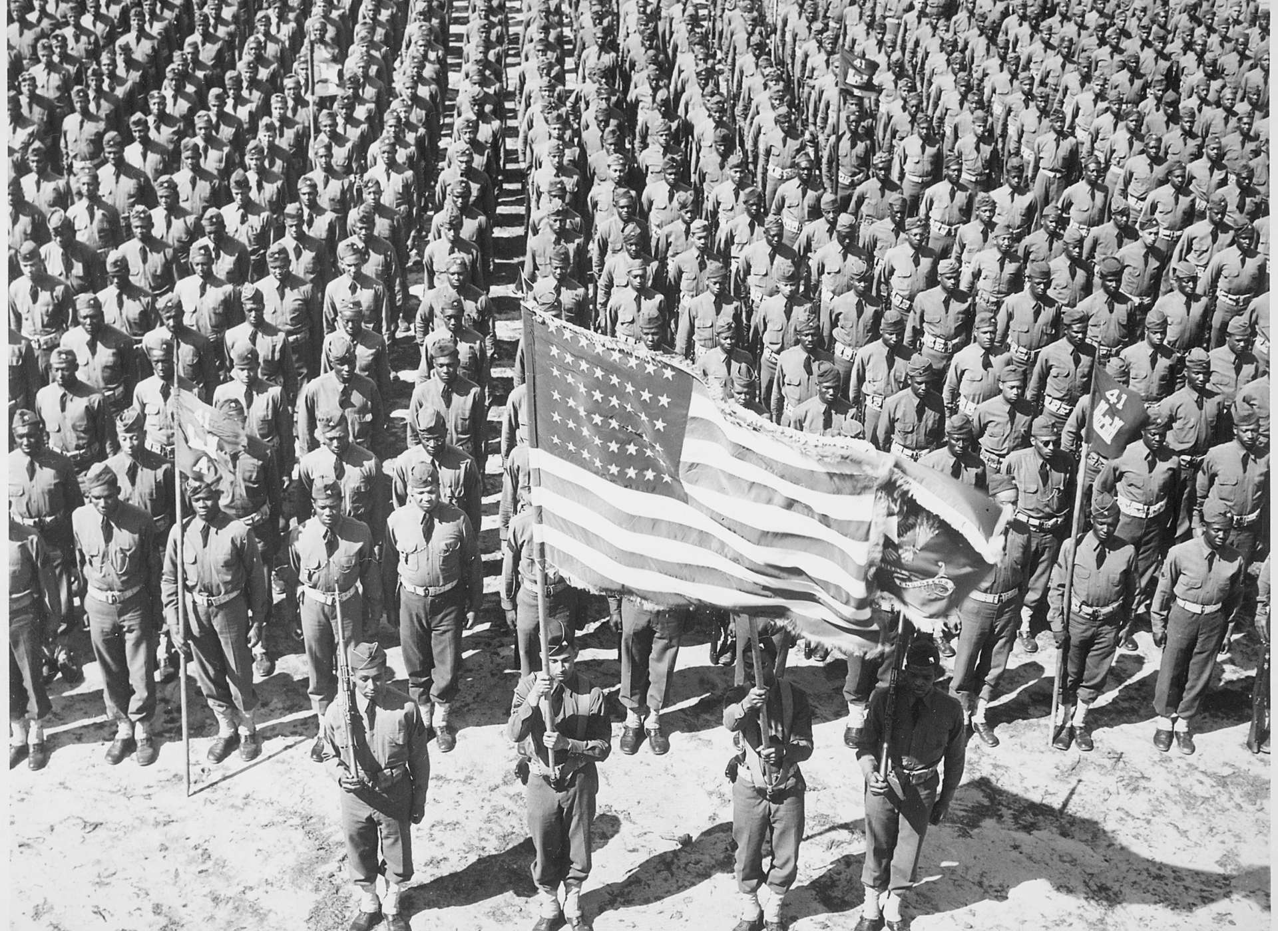
While World War II represents a benchmark in the modern civil rights movement, it also reflects a decisive moment in the personal and collective histories of millions of African Americans throughout the South as they sought to escape white supremacy and oppression in pursuit of employment and enfranchisement opportunities. Thus, the contributions of African Americans to the Home Front during the war became a key factor in America’s arsenal of democracy and its ability to defeat its enemies.

On parade, the 41st Engineers at Ft. Bragg, North Carolina,

Public domain. Available at the Library of Congress: https://www.nationalww2museum.org/war/articles/double-v-victory
How do we define patriotism during wartime?
Featured Source | Source G: Scrap Collections

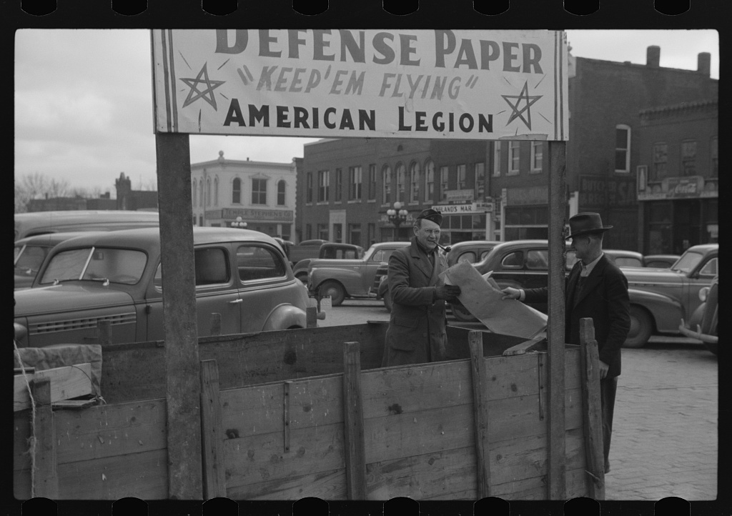
At the American Legion booth for collecting scrap paper. Chillicothe, Missouri

Public domain. Available at the Library of Congress: https://www.loc.gov/item/2017747026/

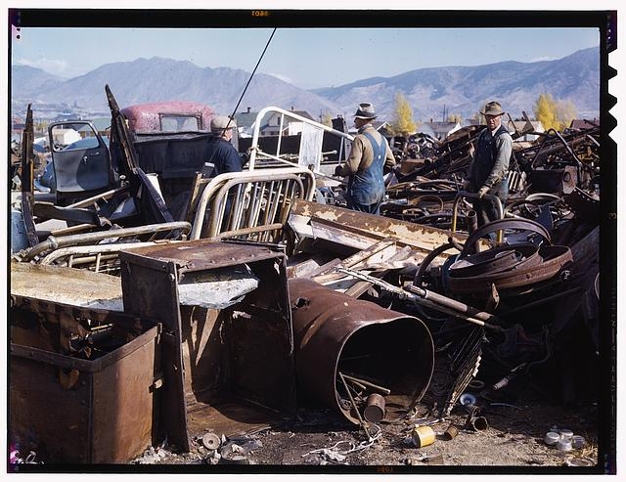

Scrap and salvage depot, Butte, Montana

Public domain. Available at the Library of Congress: https://www.loc.gov/pictures/resource/fsac.1a35026/?co=fsac

How do we define patriotism during wartime?
Featured Source | Source H: Women at Work
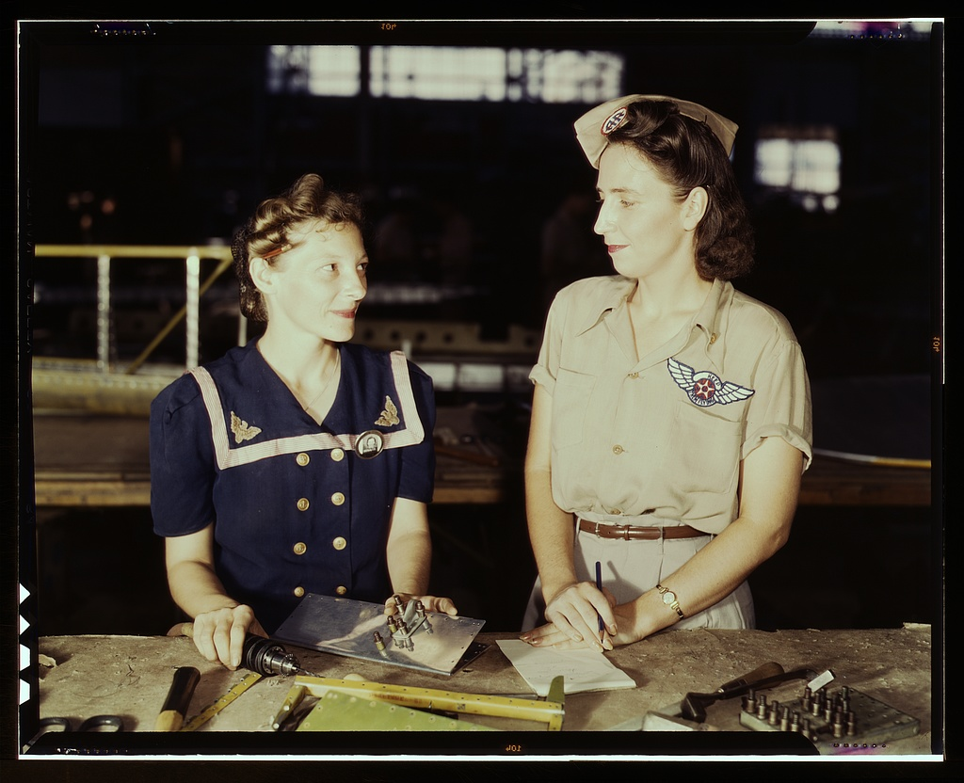
Pearl Harbor widows have gone into war work to carry on the fight with a personal vengeance, Corpus Christi, Texas. Mrs. Virginia Young (right) whose husband was one of the first casualties of World War II, is a supervisor in the Assembly and Repairs Department of the Naval Air Base. Her job is to find convenient and comfortable living quarters for women workers from out of the state, like Ethel Mann, who operates an electric drill.

Public domain. Available at the Library of Congress: https://www.loc.gov/item/2017878250/

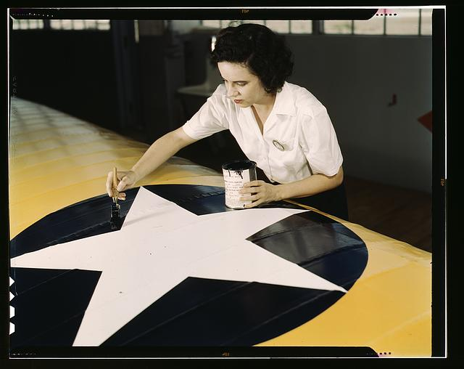

Women from all fields have joined the production army, Corpus Christi, Texas. Miss Grace Weaver, a civil service worker at the Naval Air Base, and a school teacher before the war, is doing her part for victory along with her brother who is a flying instructor in the Army. Miss Weaver paints the American insignia on repaired Navy plane wings

Public domain. Available at the Library of Congress: https://www.loc.gov/pictures/resource/fsac.1a34890/?co=fsac

How do we define patriotism during wartime?
Featured Source | Source I: Memorial Day Parade, Southington, Connecticut

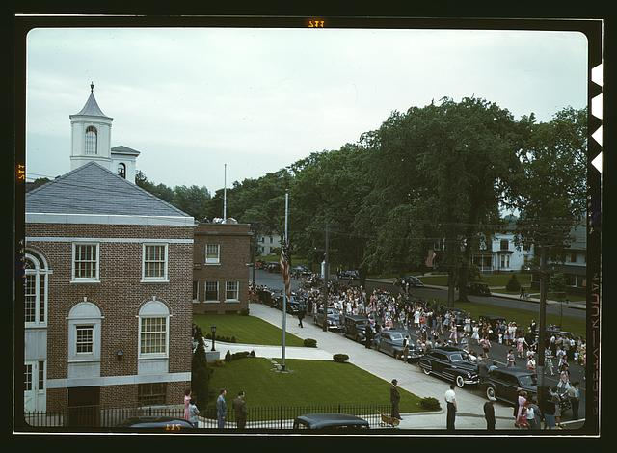

An American town and its way of life, Southington, Conn. The Memorial Day parade moving down the main street. The small number of spectators is accounted for by the fact that the town's war factories did not close.

Public domain. Available at the Library of Congress: https://www.loc.gov/pictures/resource/fsac.1a35002/?co=fsac

How do we define patriotism during wartime?
Featured Source | Source J: Students at Washington High School at class, training for specific contributions to the war effort, Los Angeles, Calif.
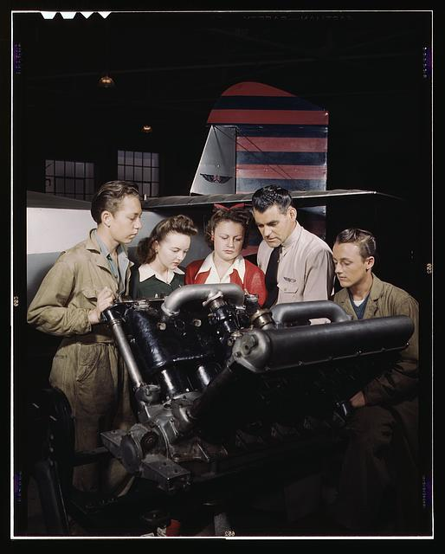

Public domain. Available at the Library of Congress: https://www.loc.gov/pictures/resource/fsac.1a35366/?co=fsac

How do we define patriotism during wartime?
Featured Source | Source K: Rumor Control Program, Office of War Information

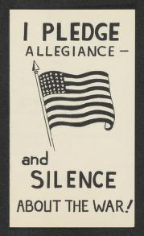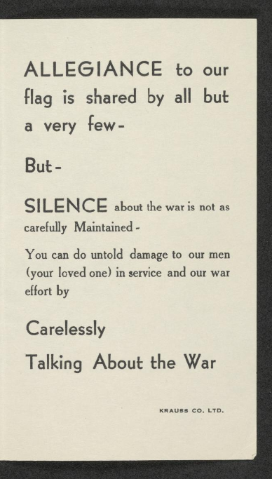

Public domain. Available at the Library of Congress: https://www.loc.gov/item/afc1945001_ms01007/

The Office of War Information wanted to understand more about the ways that misinformation spread through the media and how the same media could be used for public education about the war. Although the project was often described in its own documents as a “rumor control” effort, the researchers were well aware that control of rumors and misinformation in a free society with a free press is extraordinarily difficult.

The project was an opportunity to study the spread of rumors, to learn about rumors circulating that might have an impact on national security (such as speculation on military preparedness that might be used as propaganda by the enemy), and to create educational outreach in order to help head off rumors in the first place.

A different part of the project was an effort to survey high school and college students about rumors and opinions related to the war as well as jokes, sayings, and poetry. The answers given were wide-ranging, but often focused on the things most likely to capture the attention of young people, such as concerns about the draft and the impact of the war on social life.
“I have heard that Churchill is an old windbag and that he is practically an ally of the Axis. They say that he is only interested in the English aspect of the war.” (Dennison College, Granville, Ohio. White male college sophomore.)

The war stirred up issues of prejudice and social inequity. Many of the responding schools were African American. The reports of African American students about what they had heard are particularly interesting at this moment in American history when they were frustrated with the extremely slow progress towards the more equal society that they envisioned and now had to deal with the realities of the war.

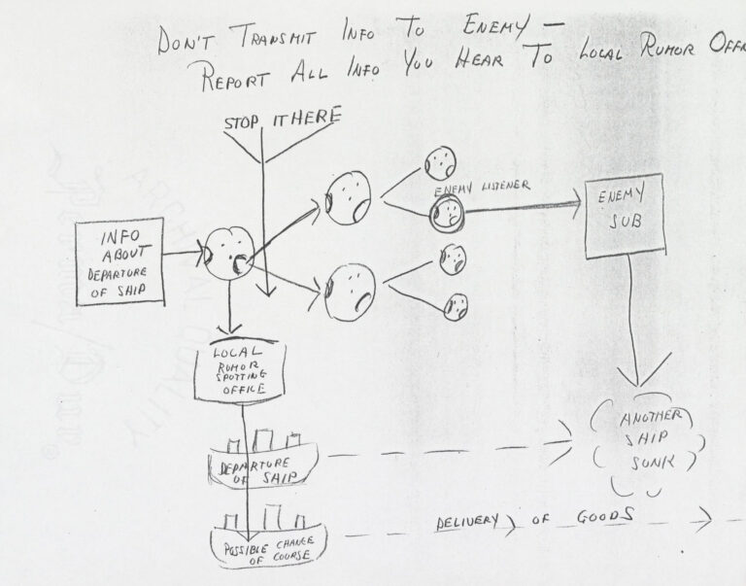
“Conditions won’t be better for the Negro after this war. Look at the many race problems he faced after the last war for Democracy.” (Wilberforce University, Wilberforce, Ohio. African American freshman male.)

“Don’t transmit info to the enemy”. This idea for a public education program shows how collecting rumors was hoped to prevent national security problems and direct information circulating among the public to useful channels.

Public domain. Available at the Library of Congress: https://blogs.loc.gov/folklife/2021/06/new-collection-online-world-war-ii-rumor-project/

How do we define patriotism during wartime?
Featured Source | Source L: “What Happened to the One We Used to Have?” Published in the Washington Post, October 9, 1946

Newspaper articles describing the plight of European war refugees, legal impediments to their admission to the U.S., and statements urging President Truman to liberalize immigration regulations preceded Herblock’s cartoon by days. In this cartoon, Herblock questions the reduction of immigration quotas during the Depression and World War II. He depicts Lady Liberty, representing U.S. immigration policy, as a figure halting immigrants, not as the traditional beacon of hope to new arrivals. Reduction of immigration quotas during the Depression and World War II highlight changes in policy that Herblock clearly questions.

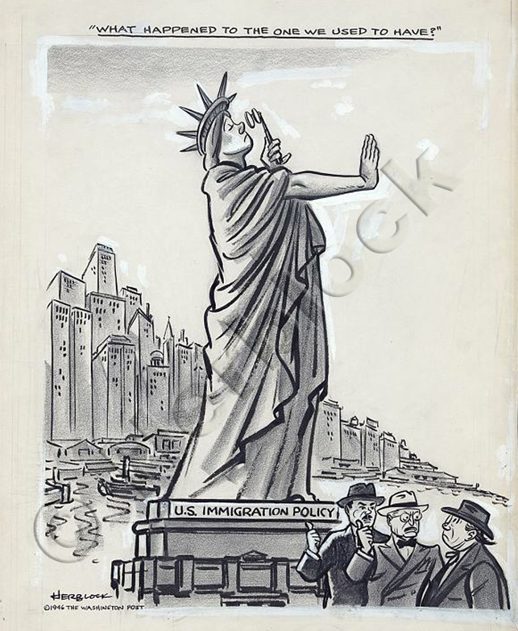

Public domain. Available at the Library of Congress: www.loc.gov/exhibits/herblock/classic-cartoons-by-a-master.html#obj0

