How did pioneers shape westward expansion?
C3 Framework Standard | D2.Geo.7.9-12. Analyze the reciprocal nature of how historical events and the spatial diffusion of ideas, technologies, and cultural practices have influenced migration patterns and the distribution of human population.
C3 Teachers Topic, Concept & Skill | ★ Era 5: Development ★ Progress ★ Interpretation

Manifest Destiny was the belief that the United States was meant to expand across the North American continent. The painting “American Progress” embodied these ideas and has come to symbolize westward migration. The imagery and symbolism within the painting provide students with an idealized visual representation of the many groups who moved west in search of land, resources, and opportunity.

Featured Sources
Source A: George A. Crofutt, “American progress”, ca. 1873, Library of Congress
Source B: Solomon D. Butcher, “Morrison residence on Victoria Creek near Merna, Custer County, Nebraska”, ca. 1886, Library of Congress
Source C: “Gold Miner, El Dorado, California”, ca. 1848-1853, Library of Congress
Source D: C.H. Grave, ”Salt Lake City showing Temple Square and the distant mountains, Utah”, ca. 1900, Library of Congress
Source E: R.K Fox, “Annie Oakley - famous rifle shot and holder of the Police Gazette championship medal”, ca. 1899, Library of Congress
Source F: Pile of buffalo skulls, originally taken in 1892, “Where the Buffalo No Longer Roamed”, 2012, Smithsonian Magazine

Formative Performance Tasks |  |  | Teacher Guidance
PRODUCE | Craft a definition of the term progress. |  | Class begins with a whole-class discussion that establishes a definition of the term progress. Next, students work in pairs to analyze Source A. Using the prompts on the graphic organizer, they compare and contrast the portrayal of East and West in the painting.  Next, the teacher combines pairs into small groups and distributes Sources B-F to each group. Working collaboratively, students analyze each image and identify ways pioneer groups shaped westward expansion. After groups share their ideas with the class, students individually synthesize the discussion and record their final reflections on their graphic organizer.
COLLABORATE | Compare and contrast the two sides of the image, American Progress.
DELIBERATE | Assess how pioneers shaped westward expansion.

How did pioneers shape westward expansion?
Featured Source | Source A: George A. Crofutt, “American progress”, ca. 1873, Library of Congress
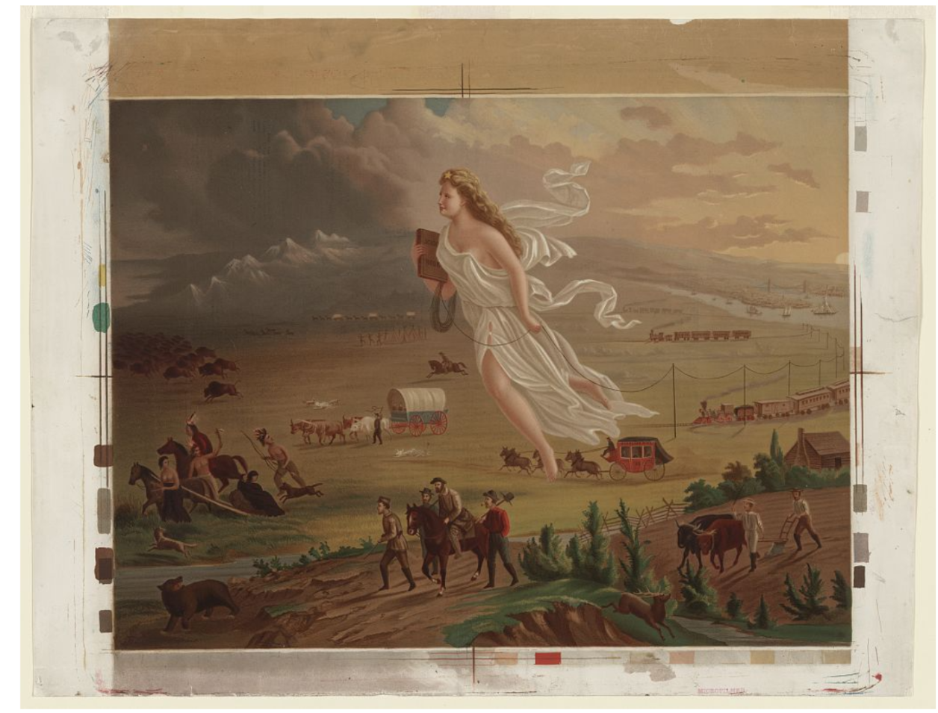
Public domain. Available at the Library of Congress: https://www.loc.gov/resource/ppmsca.09855/

How did pioneers shape westward expansion?
Featured Source | Source B: Solomon D. Butcher, “Morrison residence on Victoria Creek near Merna, Custer County, Nebraska”, ca. 1886, Library of Congress

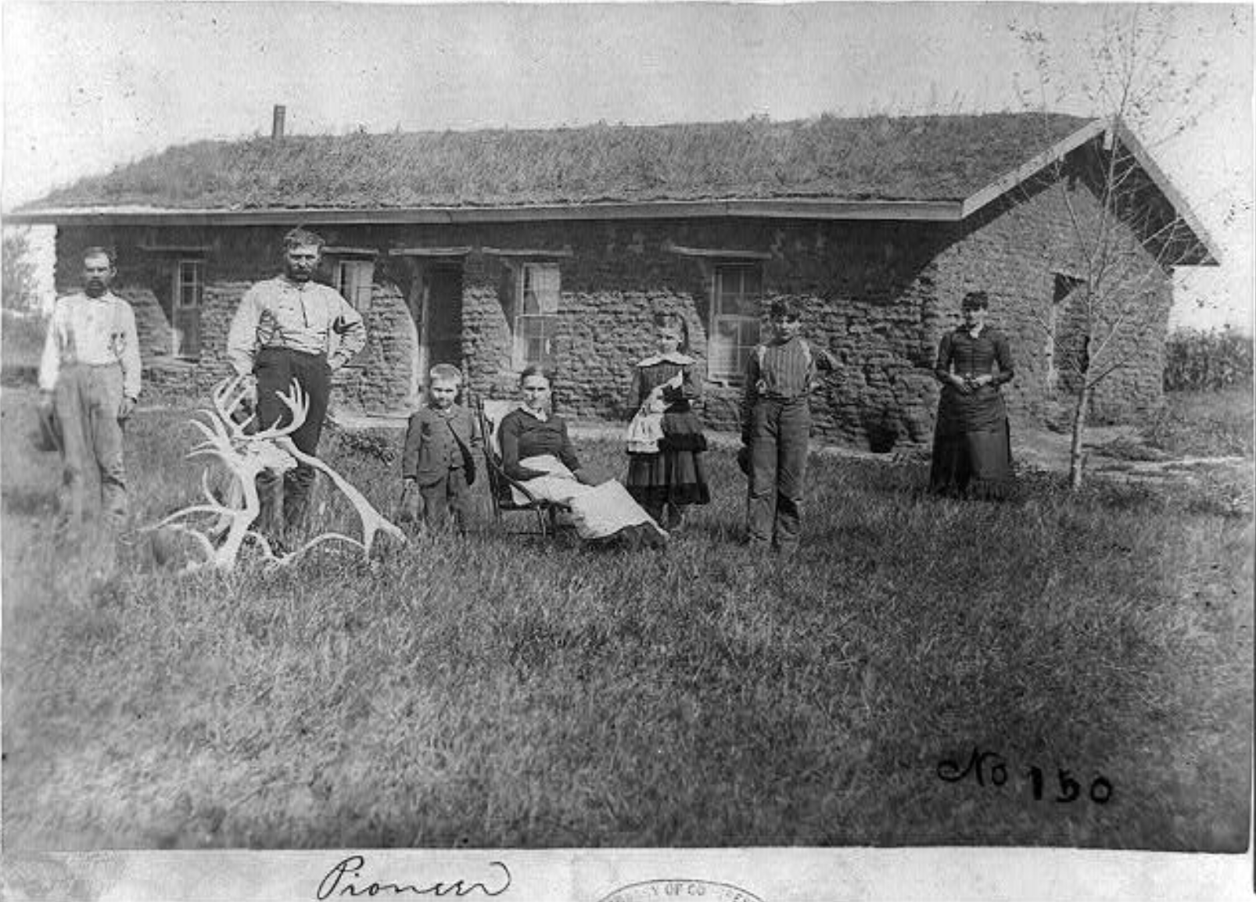

Public domain. Available at the Library of Congress: https://www.loc.gov/resource/cph.3a15689/

How did pioneers shape westward expansion?
Featured Source | Source C: “Gold Miner, El Dorado, California”, ca. 1848-1853, Library of Congress
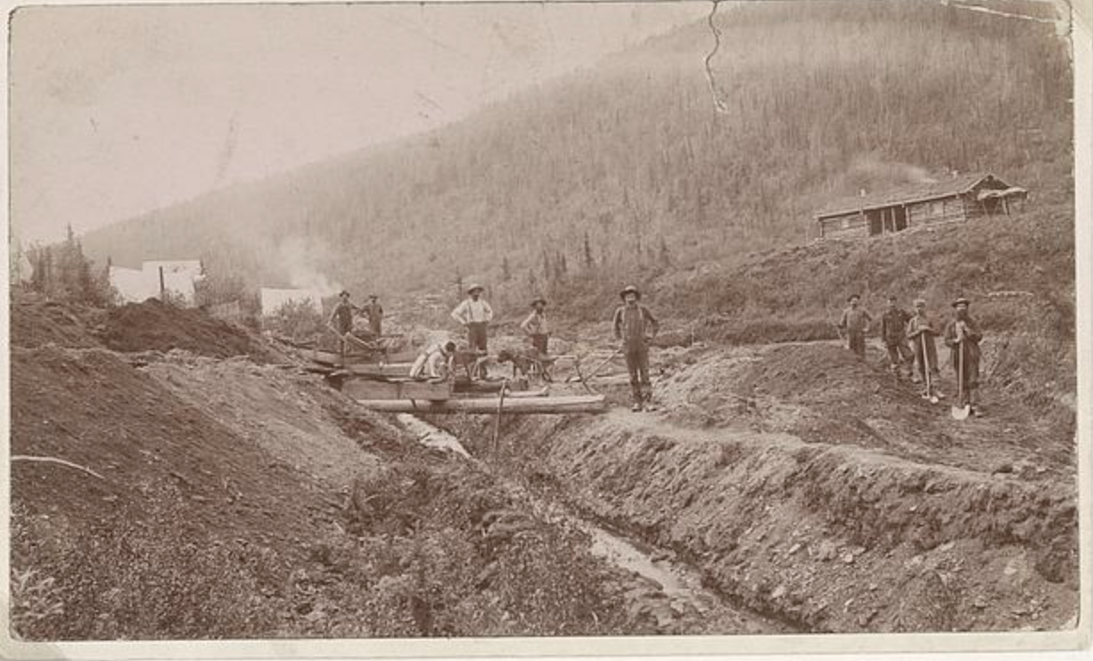

Public domain. Available at the Library of Congress: https://www.loc.gov/pictures/resource/ds.04487/?loclr=blogpic

How did pioneers shape westward expansion?
Featured Source | Source D: C.H. Grave, “Salt Lake City showing Temple Square and the distant mountains, Utah”, ca. 1900, Library of Congress

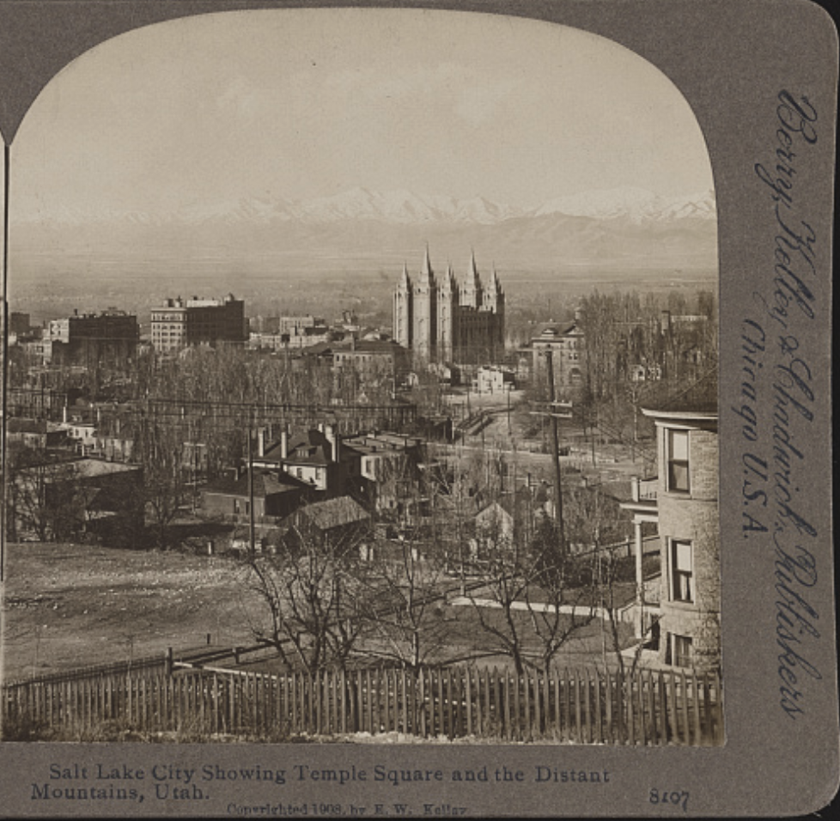

Public domain. Available at the Library of Congress: https://www.loc.gov/resource/stereo.1s15788/

How did pioneers shape westward expansion?
Featured Source | Source E: R.K Fox, “Annie Oakley - famous rifle shot and holder of the Police Gazette championship medal”, ca. 1899, Library of Congress

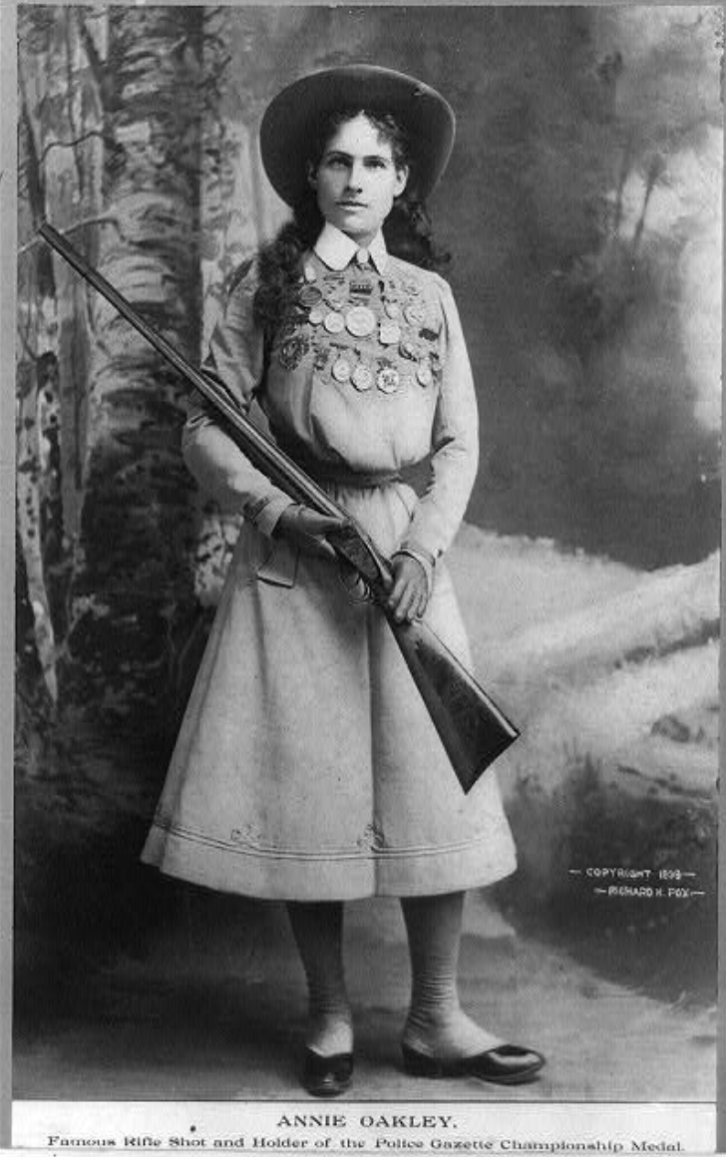

Public domain. Available at the Library of Congress: https://www.loc.gov/resource/cph.3a10507/

How did westward expansion impact the environment?
Featured Source | Source F: Pile of buffalo skulls, originally taken in 1892, “Where the Buffalo No Longer Roamed”, 2012, Smithsonian Magazine

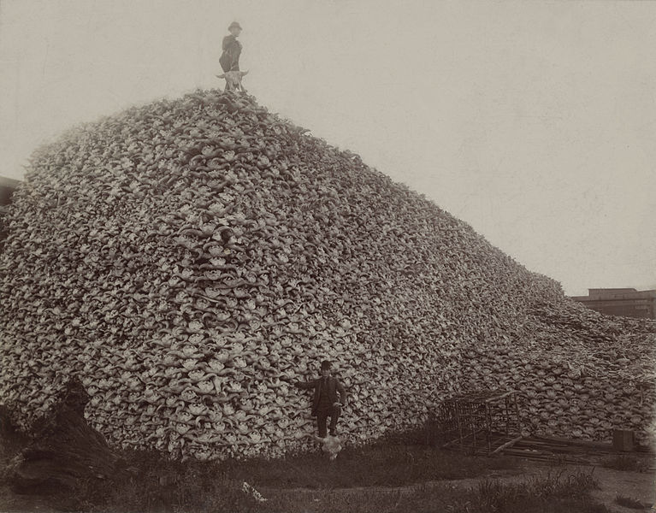

Public domain. Available online at the Smithsonian Magazine: https://www.smithsonianmag.com/history/where-the-buffalo-no-longer-roamed-3067904/

Graphic Organizer: How did pioneers shape westward expansion?
Part 1: Look carefully at the image given to you. Record your observations in the spaces provided.

The West (left side) | The Divine Figure in the Middle | The East (right side)
Describe what you see: | Describe what you see: | Describe what you see:
Who/what is retreating on this side of the image? | How does her presence define the idea of migration? | Who/what is benefiting on this side of the image?

Part 2: Look carefully at the images given to you. Based on your analysis of each image, record your answer to the question in the spaces provided.

Pioneer Group | How did this group shape or contribute to westward expansion?
Homesteaders and Farmers
Prospectors and Miners (Forty-Niners)
Religious Migrants (Mormons)
Women

