How do we conserve?
C3 Framework Standard | D2.Geo.6.9-12. Evaluate the impact of human settlement activities on the environmental and cultural characteristics of specific places and regions.
C3 Teachers Topic, Concept & Skill | ★ Era 10: The Earth ★ Perspective ★ Knowledge

Yellowstone became the first U.S. national park in 1872. As more Americans recognized the importance of protecting natural places from overuse and development, conservation became a national priority. With the creation of the U.S. National Park Service in 1916, the national park network grew through the 1900s, and today it maintains 63 parks around the United States. In this inquiry students will investigate the compelling question, “How do we conserve?”

Featured Sources
Source A: Xiaoyong Li, Hanqin Tian, Chaoqun Lu, and Shufen Pan, “Four-century history of land transformation by humans in the United States (1630–2020)”, 2025, Earth System Science Data
Source B: “Civilian Conservation Corps (CCC)”, Shenandoah, National Park Service
Source C: Summary: H.R.3710, “National Parks and Landmarks Conservation Act”, Library of Congress
Source D: “Know the rules”, Guadalupe Mountains National Park, National Park Service

Formative Performance Tasks |  |  | Teacher Guidance
DELIBERATE | Describe differences in land use over time. |  | Class begins with students working in small groups to compare maps depicting land use over time and discuss key differences they observe. Students record their observations and identify patterns of change on the graphic organizer.  Students then analyze a collection of sources and identify how each source contributes to national conservation efforts, recording their ideas on the graphic organizer. Teachers may help students by pointing to the intentionality required for conservation and to the combination of federal government efforts in creation and maintenance with individual efforts in land use. Finally, students write an evidentiary claim based on their ideas to answer the compelling question.
COLLABORATE | Identify what each source adds to national conservation (i.e., creation, maintenance, individual use).
PRODUCe | Write a claim that answers the compelling question with reference to each source.

How do we conserve?

Which maps are you comparing? |  | Observations/Comparisons
Map #1 Year | Map #2 Year | Observations/Comparisons

Source | What does this source add to national conservation?
B
C
D

Question →  How do we conserve? | Claim →

How do we conserve?
Featured Source | Source A: Xiaoyong Li, Hanqin Tian, Chaoqun Lu, and Shufen Pan, “Four-century history of land transformation by humans in the United States (1630–2020)”, 2025, Earth System Science Data

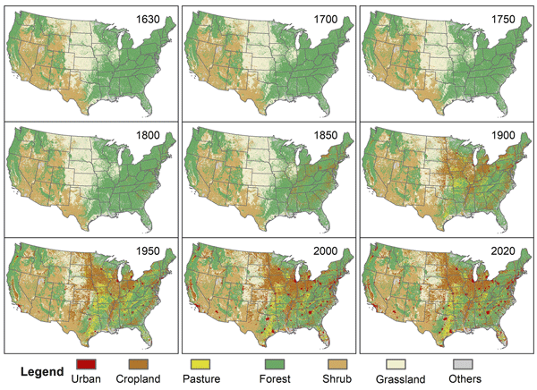

How do we conserve?
Featured Source | Source B: “Civilian Conservation Corps (CCC)”, Shenandoah, National Park Service

Civilian Conservation Corps (CCC)

The CCC, Civilian Conservation Corps, was a relief program funded from 1933-1942. FDR formed the CCC as a part of his First 100 Days legislation. The program was designed for the immediate relief of families with unemployed young men.
Much of the work that the Civilian Conservation Corps accomplished was located in national, state, and local parks. In 9 years the CCC planted nearly 3 billion trees and developed more than 800 parks across the United States. This work included building shelters, stocking rivers and lakes with nearly 1 billion fish, clearing beaches, digging canals and ditches, restoring historic battlefields, and countless other projects.
Between May of 1933 and March of 1942, 12 CCC camps in 9 different locations opened in and around what was to become Shenandoah National Park. Each camp was home to around 200 boys at any given time. The U.S. Army controlled the camps and regimented the lived of those who lived there. During the nine years the Civilian Conservation Corps existed in Shenandoah, they helped build the infrastructure for the future national park. Their achievements included the instillation, construction, and landscaping of areas all along Skyline Drive, overlooks, picnic grounds, and developed areas.In their cumulative accomplishments are some impressive statistics:
- 28 sewage systems
- 136 miles of phone lines
- 1,145 miles of fire trails
- 101 miles of trails
- 4001 signs and markers
- 147,595 trees and shrubs planted
- 361 acres of land seeded

How do we conserve?
Featured Source | Source C: Summary: H.R.3710, “National Parks and Landmarks Conservation Act”, Library of Congress

Summary: H.R.3710 — 103rd Congress (1993-1994)

Introduced in House (11/22/1993)
Title II: National Park Conservation - Requires the Director to prepare and transmit to specified congressional committees a "State of the National Parks" report to document the condition of the National Park units, including appropriate baseline information and documentation of problems related to their use and management and proposed solutions to such problems.
(Sec. 202) Requires the Director to establish a research program, within the National Park Service, to: (1) develop an appropriate knowledge base regarding the natural and cultural resources of the National Park System; (2) evaluate and protect such resources; and (3) understand and improve the effects of human interactions with them.
(Sec. 203) Requires the superintendent of each National Park System unit to maintain a current and comprehensive resource management plan to be reviewed and revised at least biennially to conform with this Act and to provide data for the report.
(Sec. 204) Sets forth procedures for the preparation of a conservation plan.
Authorizes the Director to make grants to State and local governments, Indian tribes, and private entities for assisting in the preparation of a conservation plan.
Allows the Director, under certain conditions, to provide grants to State and local governments and to Indian tribes to facilitate the implementation of the conservation plan.
Title III: National Landmark Conservation - Requires the Director to maintain a complete and current list of all National Landmarks which meet criteria promulgated by the Director for designating a National Landmark as endangered.
Title IV: Federal Program Consistency and Resource Protection - Prohibits a Federal agency from conducting or approving a Federal or federally assisted undertaking that will or is likely to adversely affect a National Heritage Resource (a unit of the NPS or a National Historic or Natural Landmark) with exceptions for national security and disasters. Prescribes procedures required of an agency before it may proceed with any undertaking that may adversely affect such a resource.

Public domain. Available at the Library of Congress: H.R.3710 - 103rd Congress (1993-1994): National Parks and Landmarks Conservation Act | Congress.gov | Library of Congress

How do we conserve?
Featured Source | Source D: “Know the rules”, Guadalupe Mountains National Park, National Park Service

Know the rules: Guadalupe Mountains National Park

There are a variety of rules and regulations that dictate how the parks must be managed. These laws and regulations help us protect park resources while also providing visitors with a safe and enjoyable experience.
- The Superintendent's Compendium contains important park specific rules and regulations. The Compendium is updated annually.
- No Drones in National Parks
- Pets disturb wildlife and are not allowed on trails. Your pets should remain at home as opportunities for pets are very limited in the park.
- Park entry fee required for all adult visitors.
- Overnight camping in the wilderness requires a permit
- Wood and charcoal fires are strictly prohibited due to generally dry weather conditions and intermittent high winds.
- Certain activities require a special use permit, including groups of over twenty persons hiking in the park.
- Practice Leave No Trace principles.
- If you come across a cairn while hiking, do not disturb it. Don’t knock it down or add to it.

