9-11 Inquiry Grades K-2
Do Community Helpers Ever Need Our Help?

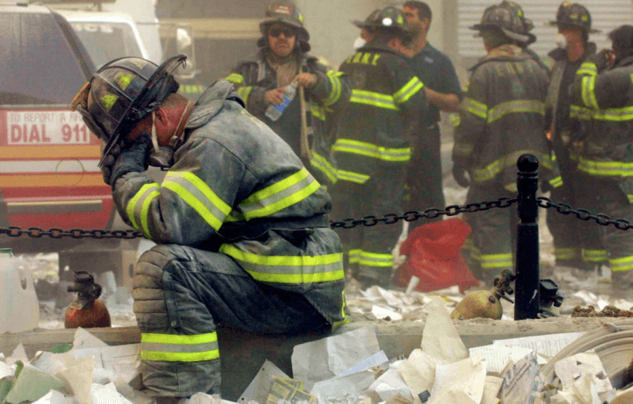
https://www.nextavenue.org/caring-other-911-victims/

Supporting Questions
- What makes a community helper’s job hard?
- What actions have people already taken to support community helpers?

9-12 Inquiry Grades K-2

Do Community Helpers Ever Need Our Help?
Standards and Content Angle | K.C.RR.1 Identify roles and responsibilities of self and others at home, in school and neighborhood settings.  K.I.UE.2 Construct responses to compelling questions about oneself and one’s community.
Staging the Compelling Question | Brainstorm a list of community helpers and their responsibilities.

Supporting Question 1 |  | Supporting Question 2
What makes a community helper’s job hard? |  | What actions have people already taken to support community helpers?
Formative Performance Task |  | Formative Performance Task
As a class, make a list of difficult jobs performed by community helpers. Discuss why these jobs are difficult.  For older students, the lists can be made independently following a whole-group discussion. |  | Students circle pictures of different service opportunities that they feel they would like to do to show support.
Featured Sources |  | Featured Sources
Source A: (Image) First responders at Ground Zero on Sept. 11, 2001  Source B: (Image) Firefighters battling a blaze in a burning building  Source C: (Image) Firefighter escorting flood victims to safety  Source D: (Image) Police officer helping a flood victim  Source E: (Image) Postal worker delivering mail in a snowstorm  Source F: (Image) Construction workers clearing debris after Puerto Rico earthquake  Source G: (Image) Doctor treating a patient in a tent after hospital is destroyed in Puerto Rico earthquake  Source H: (Image) Overcrowded Emergency Room – Mt. Sinai Hospital, New York City  Source I: (Image) Ambulance and Firetruck at the Pentagon on Sept. 11, 2001 |  | Source A: (Image) Volunteers serving food to first responders at Ground Zero.  Source B: (Image) Beds set up in St. Paul’s Chapel (NYC) for first responders who have traveled away from home to help at Ground Zero.  Source C: (Image) Volunteer offering emotional support to a construction worker at Ground Zero.  Source D: (Image) Thank-you cards written to community helpers in Florida.  Source E: (Image) A Kentucky student holding up a hand-made thank you card for paramedics.  Source F: (Image) Thank-you cards written to firefighters battling wildfires in California.  Source G: (Video clip) Volunteers serve Thanksgiving meal to first responders who will be on duty for the holiday (Greenville, S.C.)

Summative Performance Task | ARGUMENT: Do community helpers ever need our help? Construct an argument (e.g., a sentence with a picture, a poster) that evaluates the need to study, remember, and/or celebrate this expedition using specific claims and relevant evidence from sources while acknowledging competing views.
 | EXTENSION. As a class or individually, have students create thank-you cards for a community helper of their choice in their own city. Encourage them to complete one of the acts of service they circled on their formative assessment.

Overview

Inquiry Description
This inquiry leads students through an investigation of the various roles of professionals who work in the community. While the focus of this inquiry is limited primarily to first responders, teachers could expand the discussion to include other community helpers or “school helpers” such as the custodial staff, cafeteria staff, librarians, etc. By focusing on aspects of their jobs that are difficult and even dangerous, students have an opportunity to develop empathy and respect for individuals in their community by examining their roles in a new light.
Although this inquiry might be taught at any time during the school year, we recommend it as particularly useful on the first or second day. The focused nature of this inquiry offers an opportunity to introduce and establish a classroom environment that features investigation into genuine questions. Particularly for students in grades K-2, this may be their first experience with inquiry and the examination of sources. Introducing it early in the academic year sets the stage for further exposures to inquiry as the year progresses.
This this inquiry highlights the following additional standards:
- K.C.KGO.1 Identify leaders in the local community, and explain their roles and responsibilities.
It is important to note that this inquiry requires prerequisite knowledge of basic roles of firefighters, police officers, and other community helpers. While some of the images are from the attacks on September 11, 2001, it is not necessary to go into detail about his event if you feel that the students are too young for such a discussion.

Note: This inquiry is expected to take two 30 – 45 minute class periods. The inquiry time frame could expand if teachers think their students need additional instructional experiences (e.g., supporting questions, formative performance tasks, featured sources, writing). Teachers are encouraged to adapt the inquiry to meet the needs and interests of their students. This inquiry lends itself to differentiation and modeling of historical thinking skills while assisting students in reading the variety of sources.

Structure of the Inquiry
In addressing the compelling question through a focused inquiry, students have an occasion to participate in a genuine inquiry experience, but one in as little as two class periods. To do so, students work through a series of featured sources as they reflect on the compelling and supporting questions and address the formative and summative performance tasks.

Staging the Compelling Question
To stage the compelling question, teachers offer a brief overview of two elements of the inquiry. First, by having students brainstorm a list of community helpers, teachers call attention to the definition of a community helper. Then, by discussing and listing their various roles, teachers help students identify and understand the responsibilities of those individuals with regards to the wider community. Using the suggested flash cards and viewing the BrainPop Jr. video should enhance student understanding.
For free flashcards with pictures, visit https://prekinders-wpengine.netdna-ssl.com/wp-content/uploads/2013/02/community-helper-word-cards-1.pdf.
If you have a BrainPop, Jr. account, you may want to have students watch this short video about community helpers: https://jr.brainpop.com/socialstudies/communities/communityhelpers/

Supporting Question 1
The first supporting question for this focused inquiry is, “What makes a community helper’s job hard?” Cast in this fashion, the question points students directly toward aspects of these jobs which are difficult and which may necessitate support from the wider community.
The formative task is to make a list of difficult jobs performed by community helpers and briefly describe (orally or in writing) why these jobs are difficult (safety, weather, etc.). The featured sources (A-I) attempt to display various community helpers performing a variety of difficult tasks, during natural and man-made disasters.
Teachers may implement this task with the following procedures:
Start by displaying Source A to the entire class. As the teacher shows this image to the class, they should ask students the following questions –
- Who are the community helpers shown?
- What are they doing?
- What do you notice in the picture that might make this particular job dangerous?
  - Is there smoke/fire present?
  - What is the weather like?
  - Could something possibly fall on them or hurt them while they do their job?
  - How might they feel inside while performing this job? (scared, sad, nervous, etc.)
By asking these questions and discussing them as a group, the teacher lays a foundation for students to conduct their own analysis for the remaining sources. Sources B – I can be displayed hung on the walls around the classroom or laying out on desks/ tables as separate stations. Students can be grouped in pairs or small groups and given 1 minute to look at each source before rotating to the next one. Once the groups have been to every station, the teacher has the class reconvene and make a shared list of the different community helpers and difficult jobs they observed in the sources. As they are listed, the class can discuss why those jobs are difficult or dangerous.
The scaffolds and other materials may be used to support students as they work with sources are as follows:
- For younger students, it may be helpful to do several sources together as a whole group before separating the students into different stations. Teachers may even decide to show each source to the whole group instead of dividing the students into smaller groups. If choosing this option, the teacher may want to select a fewer number of sources to display for the sake of time / attention span.
- For older students, they may be given a sheet to record their answers to each of the questions listed above as they rotate between the sources. Or, the teacher may decide to have each small group analyze only one source and share their findings with the rest of the class. When it is time to compose a list, each group may want to make their own individual list based on what they heard other students share.
The following sources were selected to enhance student understanding of difficult jobs performed by community helpers.
- Featured Source A is an image of first responders at Ground Zero on September 11, 2001. (Again, it should be noted that students may analyze the source without discussing the attacks unless deemed developmentally appropriate). Featured Source B is an image of firefighters battling a blaze in a burning building. Featured Source C is an image of a firefighter rescuing flood victims in Louisiana. Featured Source D is an image of police officers helping stranded flood victims after Hurricane Harvey. Featured Source E is an image of a postal worker delivering mail in blizzard-like conditions. Featured Source F is an image of construction workers clearing debris after the Puerto Rico earthquake. Featured Source G is an image of a doctor and nurse in a makeshift tent hospital following the Puerto Rico earthquake. Featured Source H is an image of an overcrowded emergency room at a hospital in New York City. Featured Source I is an image of firefighters and ambulance workers on the scene at the Pentagon on Sept. 11, 2001.

Supporting Question 2
The second supporting question is, “What actions have people already taken to support community helpers?” By exposing students to existing examples of empathy and kindness, students are presented with realistic, achievable means of expressing thanks to community helpers.
The formative task is to circle pictures of various service opportunities that they feel like they would like to do themselves. The featured sources offer concrete means of showing support and may even inspire students to be creative and think of other alternatives.
Teachers may implement this task with the following procedures:
It may be helpful to make a class list on the board of the service opportunities after viewing each source. Then, teachers can present students with the Formative Assessment sheet displaying images of various service opportunities. The teacher can review with the class by briefly discussing each picture or simply allow students to begin circling which service opportunities they think they would like to try personally.
For older/more independent students, teachers could give them a blank piece of paper and ask students to draw or list actions people have taken to show support. They might then ask students to circle one or more actions that they would like to do themselves.
The following sources were selected to expose students to existing examples of gratitude for community helpers:
- Featured Source A is an image of volunteers from St. Paul’s chapel in New York City serving food to first responders at Ground Zero after the attacks on Sept. 11, 2001. Source B is an image of beds set up in St. Paul’s Chapel for first responders who have traveled far away from home to help at Ground Zero. Source C is an image of a volunteer offering emotional support to a construction worker at Ground Zero. Source D is an image of thank-you cards written to community helpers in Florida. Source E is an image of a Kentucky student hold a hand-made thank-you card for paramedics. Source F is an image of thank-you cards written to the firefighters battling the wildfires in California. Source G is a video clip of a news broadcast showing volunteers who serve Thanksgiving Dinner to first responders who will be on duty in Greenville, South Carolina.

Supporting Question 2: Formative Assessment

Name:______________________________________
Date: ______________________________________

Directions: Circle one or more pictures below showing how you could thank and support community helpers.
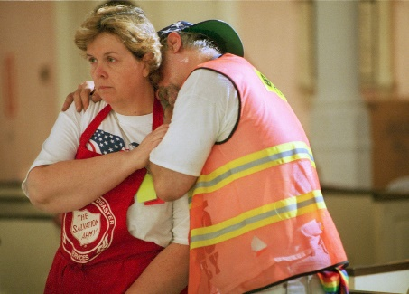
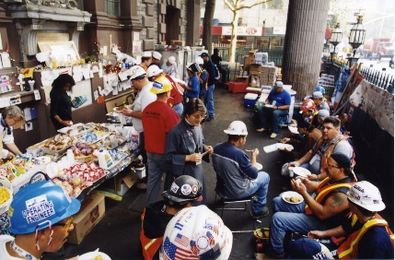

donate food give them a high-five or hug

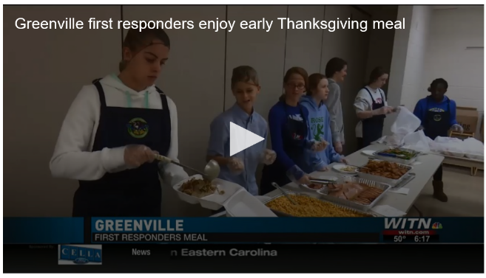
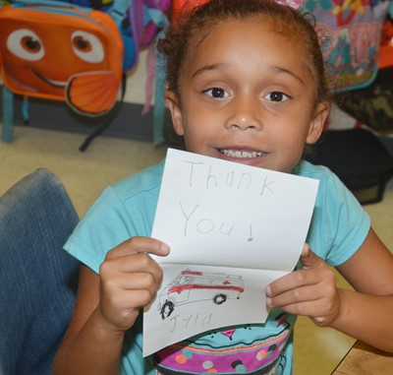

write thank-you cards serve a meal

I have my own idea! I will _____________________________________
(Draw your idea in the box above)

Summative Performance Task
At this point in the inquiry, students have examined the difficult aspects of various community helpers’ jobs, as well as different means they can choose to show their gratitude and support. In the summative performance task, students will construct an evidence-based argument that addresses the compelling question. It is important to note that students’ arguments could take a variety of forms. Given the focused inquiry setting and their age-appropriate developmental abilities, however, students may represent their argument in the form of an illustrated sentence or poster.
Students’ arguments will likely vary, but could include any of the following:

- Community helpers have difficult jobs and need our support and thanks.
- Community helpers have difficult jobs, but they are grown-ups and can handle it.
- Community helpers have difficult jobs, but a lot of other people help them, so I don’t really need to.
To support students in their writing, teachers may wish to offer sentence starters or prompts. Teachers may also want to listen to students make their arguments orally, and then model a written sentence for them to copy. Finally, teachers may wish to help students choose an image from the inquiry that they can use to support their arguments.
To extend their arguments, students can create their own thank-you cards or hand-written letters to a community helper of their choice.

Staging the Compelling Question
Featured Sources | Community Helper flashcards: https://prekinders-wpengine.netdna-ssl.com/wp-content/uploads/2013/02/community-helper-word-cards-1.pdf.  BrainPop, Jr. video lesson: https://jr.brainpop.com/socialstudies/communities/communityhelpers/
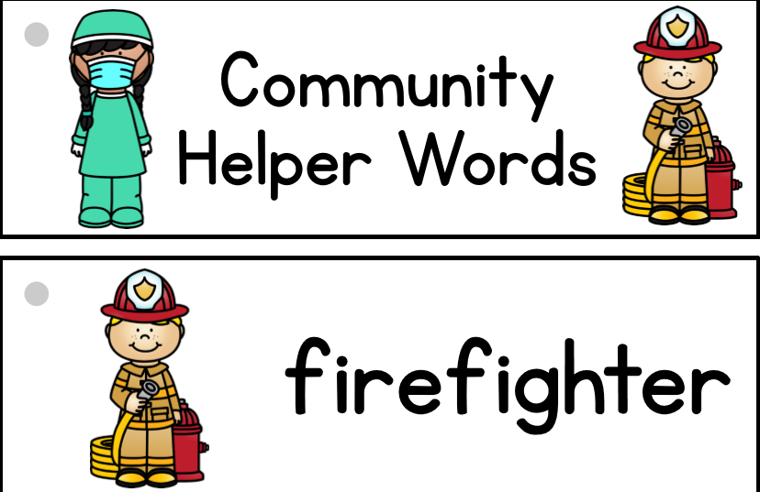

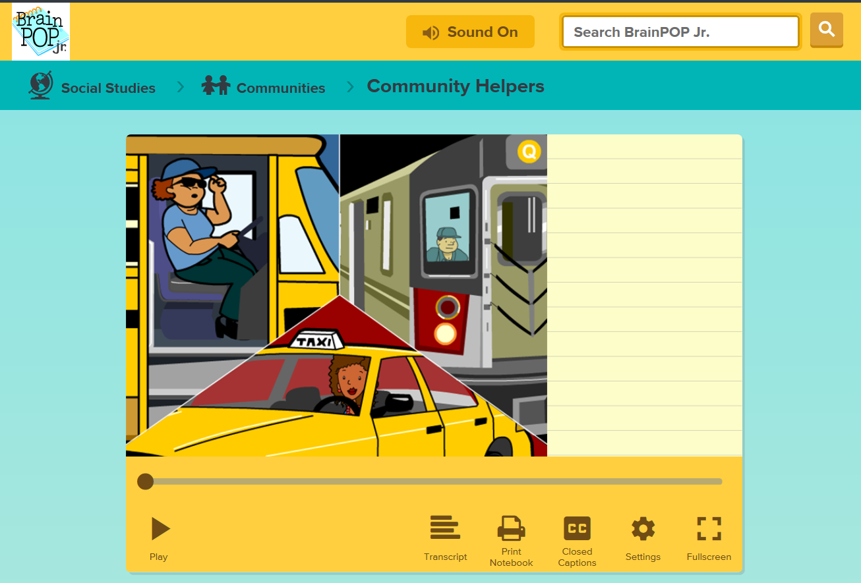

Supporting Question 1
Featured Source | Source A: (Image) First responders at Ground Zero on Sept. 11, 2001  https://americanprofile.com/articles/st-pauls-chapel-offers-hope-healing-at-ground-zero/

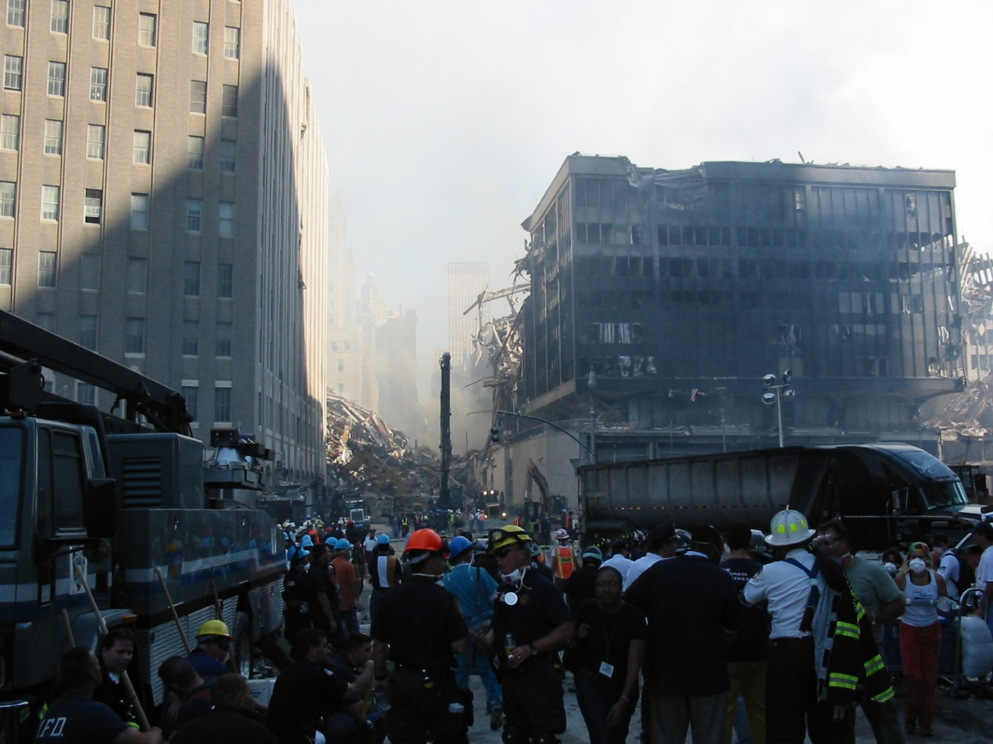

Supporting Question 1
Featured Source | Source B: (Image) Firefighters battling a blaze in a burning building  http://www.newslinq.com/firefighters/

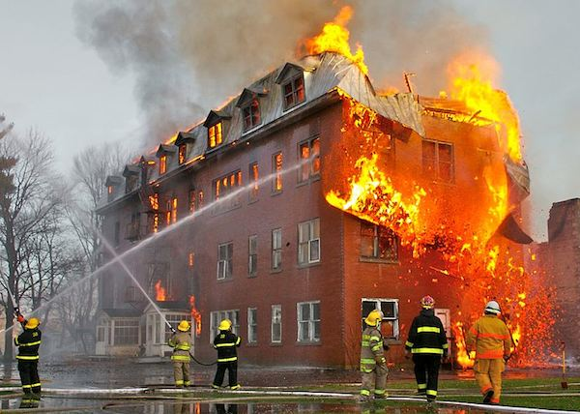

Supporting Question 1
Featured Source | Source C: (Image) Firefighter escorting flood victims to safety  https://www.washingtontimes.com/news/2016/aug/19/obama-offends-louisiana-flood-victims-me/

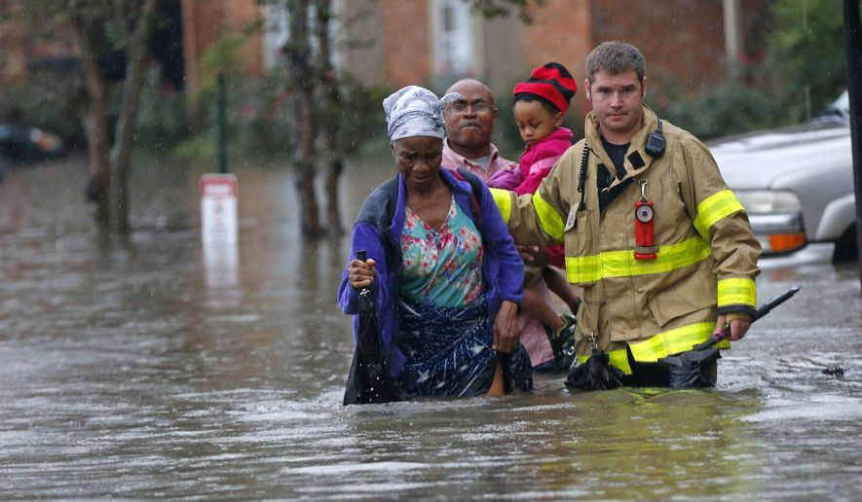

Supporting Question 1
Featured Source | Source D: (Image) Police officer helping a flood victim  https://www.cnn.com/2019/10/01/us/hurricane-harvey-houston-fbi-agents-btc/index.html
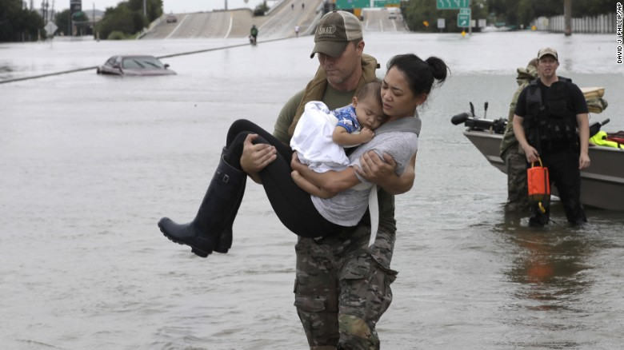

Supporting Question 1
Featured Source | Source E: (Image) Postal worker delivering mail in a snowstorm  https://minnesota.cbslocal.com/2014/02/26/good-question-what-are-the-weather-rules-when-it-comes-to-delivering-mail/
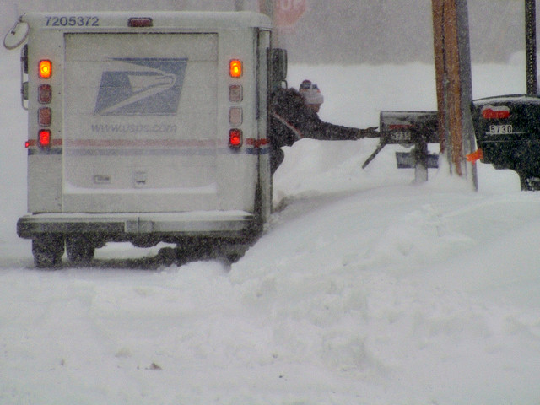

Supporting Question 1
Featured Source | Source F: (Image) Construction workers clearing debris after the Puerto Rico earthquake  https://www.travelandleisure.com/travel-news/puerto-rico-power-outage-following-earthquake
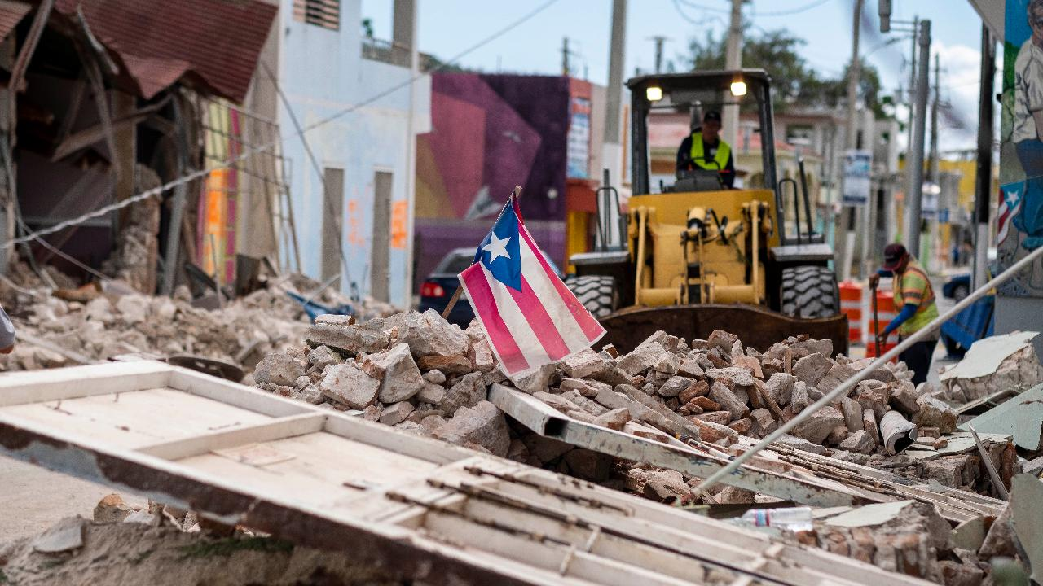

Supporting Question 1
Featured Source | Source G: (Image) Doctor treating a patient in a tent after hospital is destroyed in the Puerto Rico earthquake  https://www.npr.org/2017/10/05/555796327/following-disaster-teams-in-puerto-rico
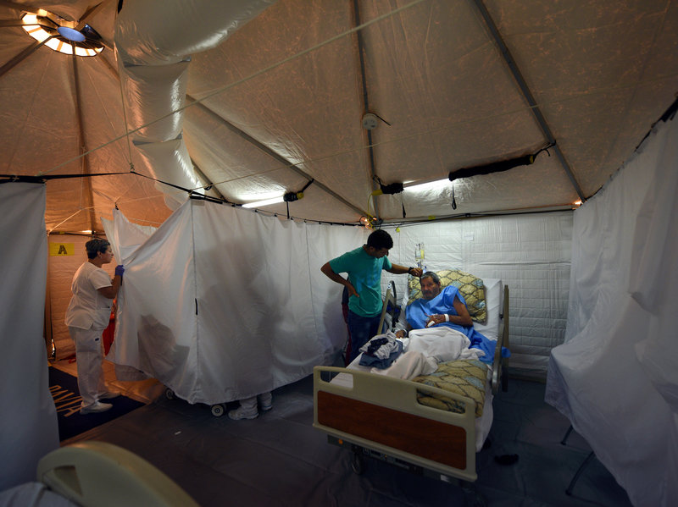

Supporting Question 1
Featured Source | Source H: (Image) Overcrowded emergency room – Mt. Sinai Hospital, New York City  https://nypost.com/2019/12/09/mount-sinai-hospitals-emergency-department-is-a-war-zone-workers-say/
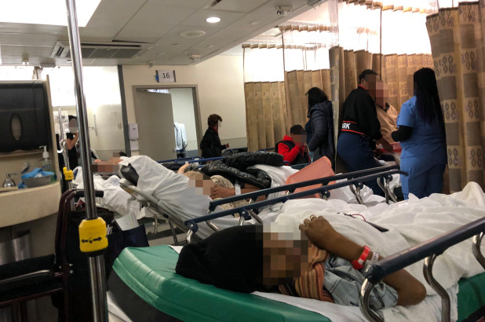

Supporting Question 1
Featured Source | Source I: (Image) Ambulance and firetruck at the Pentagon on Sept. 11, 2001  http://arlingtonfirejournal.blogspot.com/2005/03/attack-on-pentagon-sept-11-2001.html
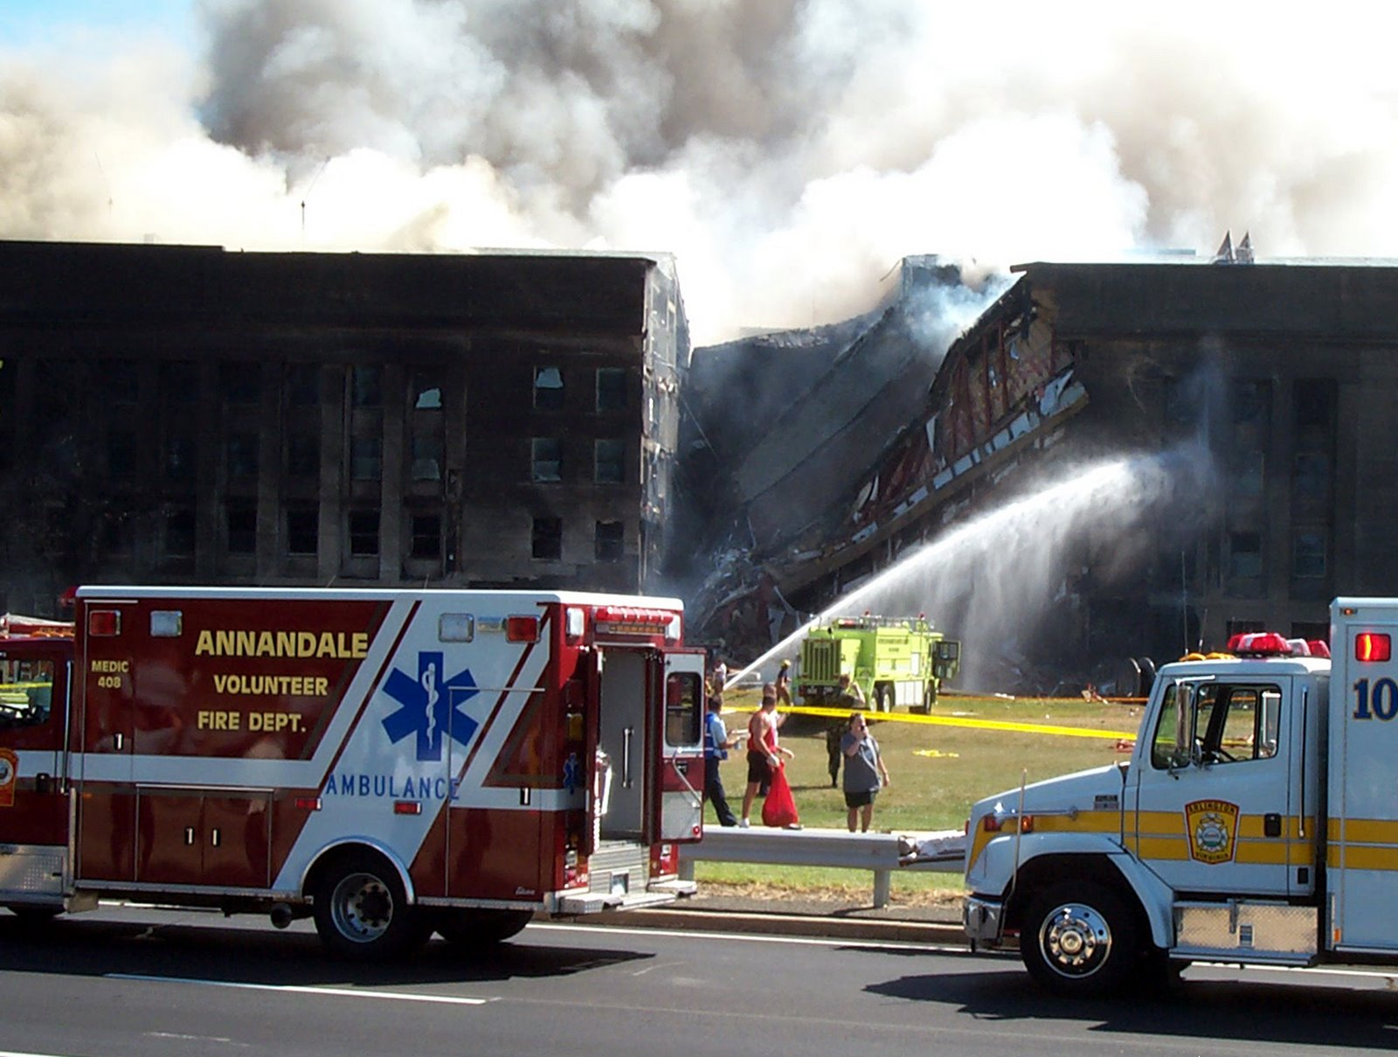

Supporting Question 2
Featured Source | Source A: (Image) Volunteers serving food to first responders at Ground Zero.  https://americanprofile.com/articles/st-pauls-chapel-offers-hope-healing-at-ground-zero/
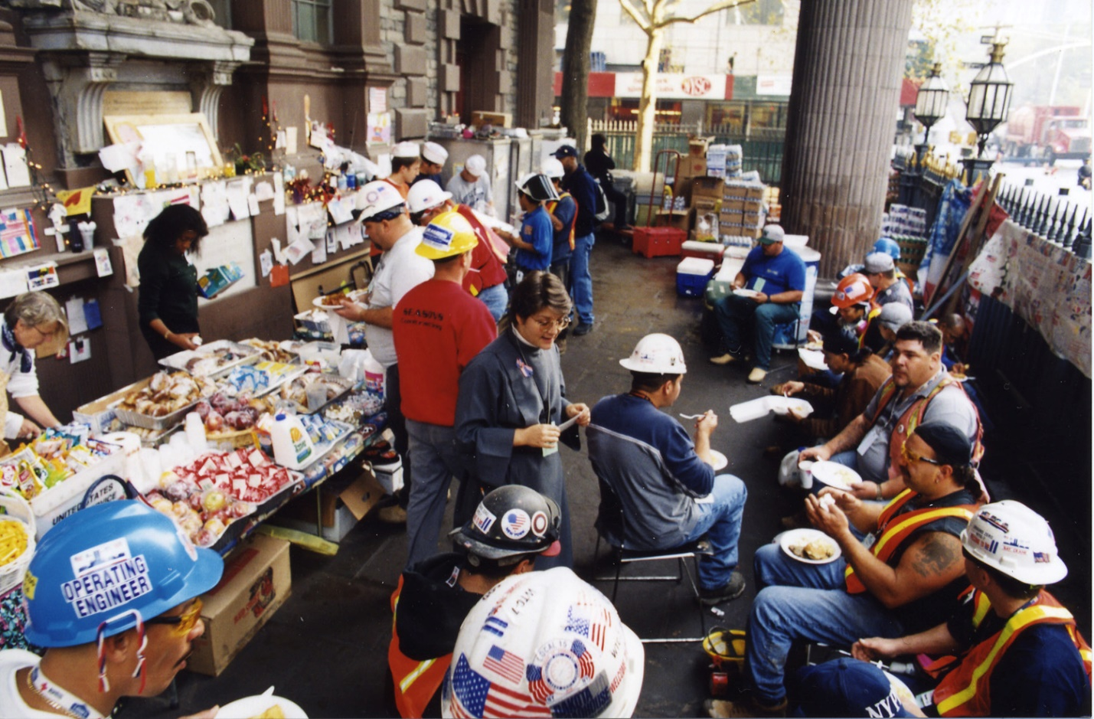

Supporting Question 2
Featured Source | Source B: (Image) Beds set up in St. Paul’s Chapel (NYC) for first responders who have traveled away from home to help at Ground Zero.  https://americanprofile.com/articles/st-pauls-chapel-offers-hope-healing-at-ground-zero/
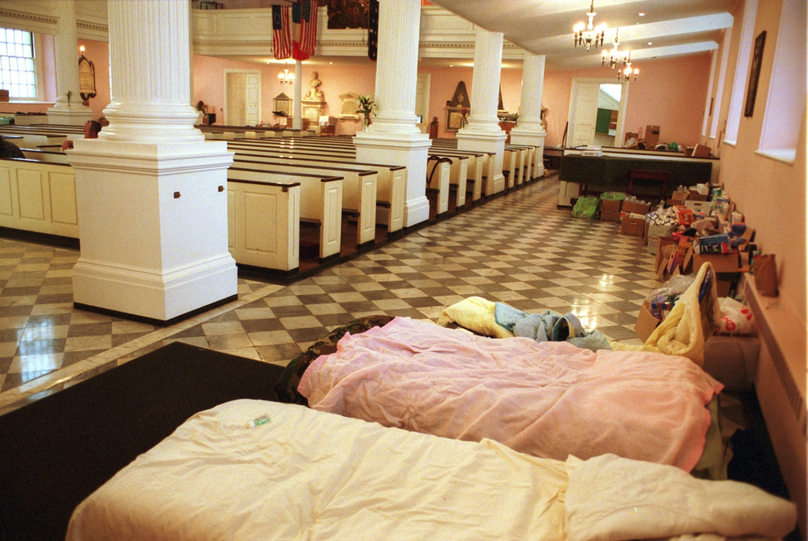

Supporting Question 2
Featured Source | Source C: (Image) Volunteer offering emotional support to a construction worker at Ground Zero.  https://americanprofile.com/articles/st-pauls-chapel-offers-hope-healing-at-ground-zero/
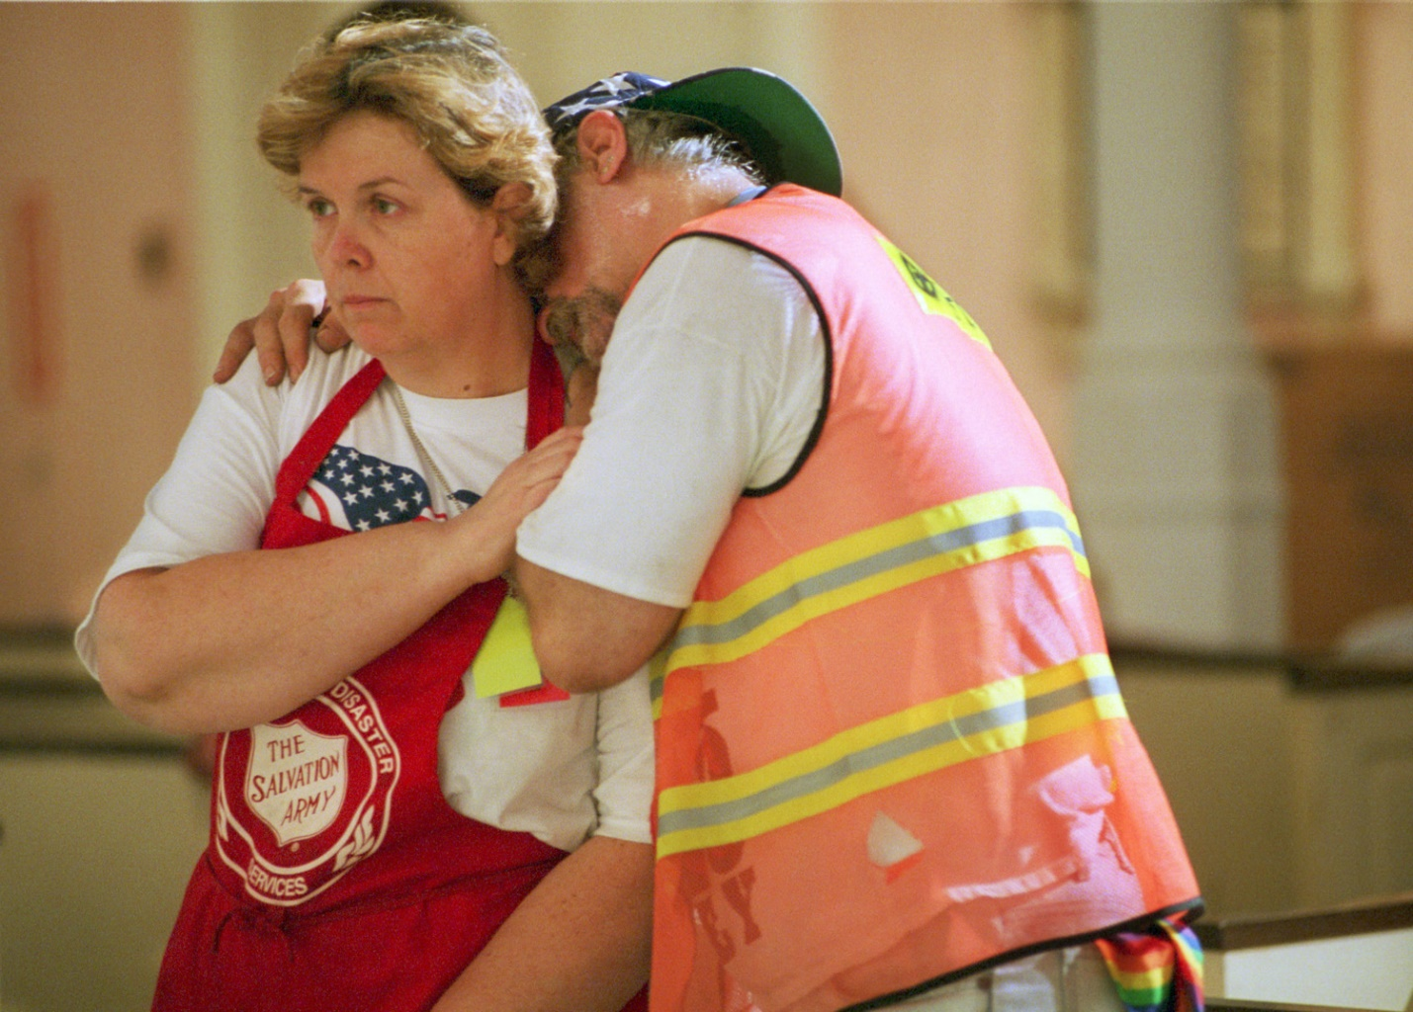

Supporting Question 2
Featured Source | Source D: (Image) Thank-you cards written to community helpers in Florida.  https://www.floridatoday.com/story/news/education/2014/09/15/students-write-dear-hero-thank/15658173/
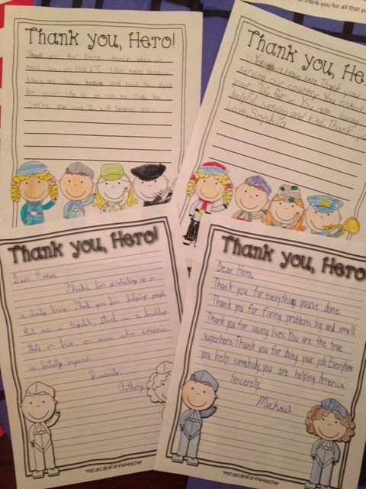

Supporting Question 2
Featured Source | Source E: (Image) A Kentucky student holding up a hand-made thank you card for paramedics.  https://www.cville.k12.ky.us/2/News/24717#sthash.LMEzOB5z.dpbs

Supporting Question 2
Featured Source | Source F: (Image) Thank-you cards written to firefighters battling wildfires in California.  https://www.sfgate.com/california-wildfires/article/carr-fire-firefighters-thank-you-sign-cards-13117702.php#photo-15941455
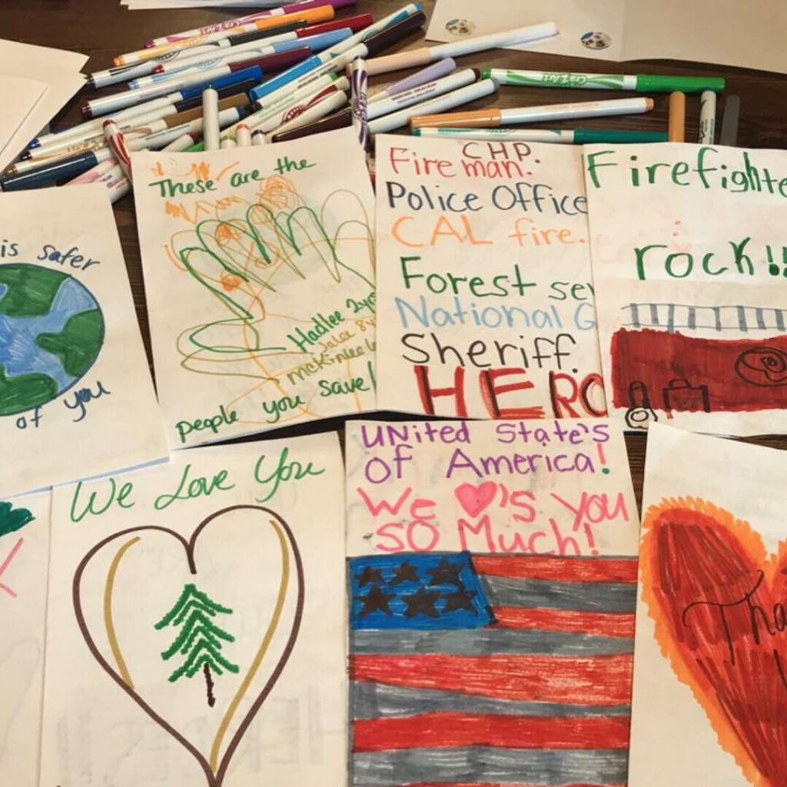

Supporting Question 2
Featured Source | Source G: (Video clip) Volunteers serve Thanksgiving meal to first responders who will be on duty for the holiday (Greenville, S.C.)  https://www.witn.com/content/news/Greenville-first-responders-enjoy-early-Thanksgiving-meal-501050731.html

