Secondary-Level Women’s Rights Inquiry
How can women achieve equality in a patriarchal society?

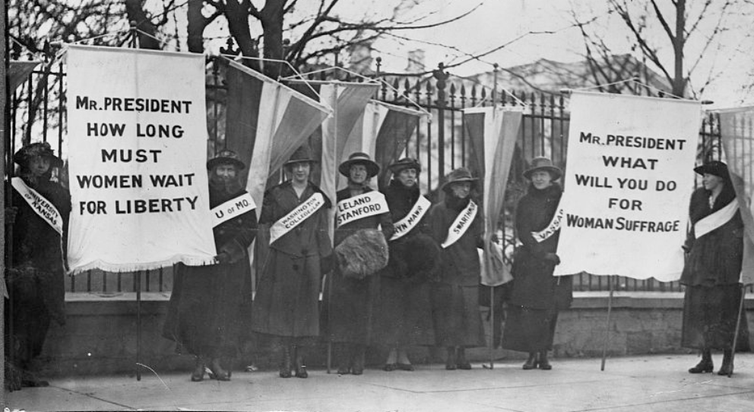
College women protesting in front of the White House, 1917. Library of Congress: https://www.loc.gov/resource/cph.3a32338/

Supporting Questions
- How did Madame C.J. Walker create her opportunity?
- How did Wilma Mankiller challenge injustice?
- How does Emma Watson work to empower women?

Secondary-Level Women’s Rights Inquiry

How can women achieve equality in a patriarchal society?
Standards and Content | D2.Civ.10.9-12. Analyze the impact and the appropriate roles of personal interests and perspectives on the application of civic virtues, democratic principles, constitutional rights, and human rights.
Staging the Compelling Question | Read and discuss the similarities and differences across three quotes related to women’s rights.

Supporting Question 1 |  | Supporting Question 2 |  | Supporting Question 3
How did Madame C.J. Walker create her own opportunity? |  | How did Wilma Mankiller challenge injustice? |  | How does Emma Watson work to empower women?
Formative Performance Task |  | Formative Performance Task |  | Formative Performance Task
Create an infographic that illustrates how Madame C.J. Walker created her own opportunity. |  | Write a paragraph that explains how Wilma Mankiller challenged injustice. |  | Write an evidenced-based claim that describes how Emma Watson works to empower women.
Featured Sources |  | Featured Sources |  | Featured Sources
Source A: The Incredible Rise of a Cosmetic Giant  Source B: Madam C. J. Walker: The Ultimate Self-Made Woman  Source C: Madam C.J. Walker: Her Crusade |  | Source A: Wilma Mankiller press conference at Ball State University, 1994-03-28  Source B: Mankiller: Wilma Mankiller: An American Hero  Source C: Wilma Mankiller Interview  Source D: Commencement Address at Northern Arizona University - Dec. 18, 1992 |  | Source A: Emma Watson Explains Why Some Men Have Trouble with Feminism  Source B: Emma Watson’s Speech for HeForShe IMPACT at World Economic Forum 2015  Source C: Emma Watson's Speech on Gender Equality at the UN

Summative Performance Task | ARGUMENT: How can women achieve equality in a patriarchal society? Construct an argument in the form of a poster that evaluates that addresses the compelling question using specific claims and relevant evidence and information from contemporary and historical sources.
 | EXTENSION: Develop an annotated bibliography that identifies sources on feminism and gender equality that would be appropriate to share with a younger group of students.
Taking Informed Action | UNDERSTAND: Research gender equity issues in your community.  ASSESS: Brainstorm interview questions around a selected issue.  ACT: Conduct interviews with members of the community and summarize the findings.
*Featured sources are suggested.

Overview

Inquiry Description
This inquiry leads students through an investigation of the three waves of feminism. The first wave (1848 to 1920) focused on inequalities like gaining women’s suffrage (the right to vote) and economic, civil, and political rights. In the second wave (1963 to the 1980s), women addressed a wide range of issues, including unofficial inequalities, official legal inequalities, sexuality, inequalities in the family and workplace, and reproductive rights. The third wave extended from the 1990s to the present. Third-wave feminists (1991-present) have changed the outlook with their increasing participation in a range of cultural, scientific, and arts-related activities which has led to their involvement in political organizations and issues.
This this inquiry highlights the following additional standards:

- D2.Civ.14.9-12. Analyze historical, contemporary, and emerging means of changing societies, promoting the common good, and protecting rights.
- D2.Civ.8.9-12. Evaluate social and political systems in different contexts, times, and places, that promote civic virtues and enact democratic principles.

Note: This inquiry is expected to take three or four 50-minute class periods. The inquiry time frame could expand if teachers think their students need additional instructional experiences (e.g., supporting questions, formative performance tasks, featured sources, writing). Teachers are encouraged to adapt the inquiry to meet the needs and interests of their students. This inquiry lends itself to differentiation and modeling of historical thinking skills while assisting students in reading the variety of sources.

Structure of the Inquiry
In addressing the compelling question, students and their teachers work through a series of supporting questions and the formative performance tasks and featured sources that are associated with those questions. As they do so, they build the requisite knowledge and skills necessary to successfully construct an evidence-based argument. The first formative task asks students to create an infographic that illustrates the approach that Madame C.J. Walker took in building her cosmetics empire in what is considered the first wave of feminism. The second wave of feminism is represented the second task featuring the political work on Wilma Mankiller. The task directs students to write a paragraph that explains how Mankiller work to oppose injustice. The third task, representing the third wave of feminism, focuses on the international work in which Emma Watson has engaged. Here, the task calls for students to write an evidence-based claim that addresses the supporting question.

Staging the Compelling Question
In staging the compelling question, students read quotes from the three women profiled in the inquiry—Madame C.J. Walker, Wilma Mankiller, and Emma Watson—and discuss the similarities and differences across them.

“I had to make my own living and my own opportunity. But I made it! Don’t sit down and wait for the opportunities to come. Get up and make them.” Madame C.J. Walker

“The most fulfilled people are the ones who get up every morning and stand for something larger than themselves. They are the people who care about others, who will extend a helping hand to someone in need or will speak up about an injustice when they see it.” Wilma Mankiller

“We want to empower women to do exactly what they want, to be true to themselves, to have the opportunities to develop. Women should feel free.” Emma Watson

Supporting Question 1
The first supporting question—“How did Madame C.J. Walker create her opportunity?—provides a deep look into a pioneer of first-wave feminism. Madame Walker stands out as an example of a woman who challenged the prevailing social norms about how business was conducted and by whom.
The formative task is to create an infographic that chronicles the approach Madame Walker took in building her cosmetic company. Teachers may structure students’ work on this task by showing the whole class the video in featured source A. They might then lead a discussion that focuses on the insights students gathered and questions that emerged. Then teachers might assign the two articles in sources B and C to small groups with the expectation that look for information that expands (perhaps both confirming and contradicting the video and their prior knowledge). Finally, ask each group of students to complete the formative task by creating an infographic. Teachers may use the following procedure to support students in developing their infographic.
Step 1: Decide what message(s) you would like to communicate with your information graphic.
Step 2: Gather information from the sources needed for the infographic.
Step 3: Choose a type of infographic. Infographic tools and templates are available online and in tools such as Microsoft PowerPoint. A sample infographic template is available in Appendix A
Step 4: Insert information gathered in step 2 into the infographic to accomplish you communication goal.
The following sources were selected to help students understand the first wave of feminism through the example of Madame C.J. Walker:
- Featured Source A is a secondary account covering the remarkable life that Madame Walker lived. The article highlights the range of obstacles Walker faced and the resilience she showed in facing down those obstacles.
- Featured Source B is another secondary account of Madame Walker’s life. In this article, the focus is largely on how she built her cosmetics empire.
- Featured Source C is a video that, like Source A, offers a thoughtful overview of Madame Walker’s life, struggles, and her successes.

Supporting Question 1
Featured Source | Source A: Madam C. J. Walker: The Ultimate Self-Made Woman  https://www.archbridgeinstitute.org/2017/10/31/madam-c-j-walker-the-ultimate-self-made-woman/

Madam C. J. Walker: The Ultimate Self-Made Woman
By Gary Hoover, published October 31, 2017 from Archbridge Institute
Below is an excerpt from this essay. Access the full essay at https://www.archbridgeinstitute.org/2017/10/31/madam-c-j-walker-the-ultimate-self-made-woman/
Her Westchester County neighborhood was the home of Vanderbilts, Morgans, and Astors. Jay Gould and John D. Rockefeller had assembled estates nearby. Sitting high above the Hudson River in Irvington-on-Hudson, New York, “Villa Lewaro” had views of the river and the Palisades on the opposite shore. Her mansion’s interiors were as sumptuous as the views — including ivory-enameled mahogany, hand-woven Aubusson carpets, a Cartier sculpture, and a large Estey player organ. Most elegant of all was Madam C. J. Walker herself, bedecked in diamonds from Tiffany’s, as she welcomed her guests in 1918.
Madam Walker’s accomplishments were staggering. She was almost 40 when she began to develop her business and only lived another 14 years. Yet in that period she trained over 40,000 agents, created great jobs for many more, helped millions with her hair care products and methods, visited every corner of America, donated to a multitude of causes, and played a strong leadership role in the African American community. The fact she was worth $600,000 when she died (almost $10 million in 2017 dollars), one of the wealthiest black women in the world — if not the wealthiest — was perhaps the least important of her achievements.
Madam Walker was not born to such status. She was born to slaves — her father valued at $700 and her mother at $600 on their owners’ books, alongside horses, corn, oxen, and farm implements. She, her parents, and five siblings shared a one-room sharecropper’s cabin. Soon she was an orphan and a single mother. But she did not let this humble beginning hold her back. Madam Walker was one of the most remarkable self-made women — or person of any gender — in American history. This is her story.

Supporting Question 1
Featured Source | Source B: Madam C.J. Walker: Her Crusade  http://content.time.com/time/subscriber/article/0,33009,989788-1,00.html

Madam C.J. Walker: Her Crusade
A black woman's hair-care empire set a style and smashed barriers
By Henry Louis Gates Jr. Monday, Dec. 07, 1998
Below is an excerpt from this essay. Access the full essay at http://content.time.com/time/subscriber/article/0,33009,989788-1,00.html

One could write a political history of African Americans based on changes in hairstyles, ranging from kinky and short to kinky and long, from greased and "pressed" (with a stocking cap) to straightened, waved or jerry-curled. But it was Madam C.J. Walker, as the historian Rayford W. Logan maintains, who "made straight hair 'good hair,'" and in doing so, made a fortune for herself and a decent standard of living for a work force of "agents" that numbered 20,000 in the U.S. and the Caribbean.
Sarah Breedlove was born on a cotton plantation near Delta, La., in 1867. Orphaned at age 7, married at 14, widowed at 20, Breedlove earned a subsistence living as a laundress in St. Louis, Mo. Seeking to supplement her income--and cure her case of alopecia, or baldness, commonly suffered by black women at the time because of scalp diseases, poor diet and stress--Breedlove became an agent for Annie Turnbo Pope Malone's Poro Co., selling its "Wonderful Hair Grower." Realizing the potential of these products, Breedlove took her daughter and $1.50 in savings to Denver, married her third husband, a newspaper sales agent named Charles Joseph Walker, and with him established a hair-care business that made brilliant use of advertising in the growing number of black newspapers.
Walker had invented her own "hair growing" product, she claimed, after "a big black man appeared to me [in a dream] and told me what to mix up for my hair." Some of the remedy was grown in Africa, she would recount, "but I sent for it, mixed it up, put it on my scalp, and in a few weeks my hair was coming in faster than it had even fallen out."

Supporting Question 1
Featured Source | Source C: The Incredible Rise of a Cosmetic Giant  https://www.youtube.com/watch?v=8wBh4enqj5g
The Incredible Rise of a Cosmetic Giant is a 14 minute video available on YouTube at https://www.youtube.com/watch?v=8wBh4enqj5g
The video was produced by Forgotten Lives, a podcast from Nic Waters.
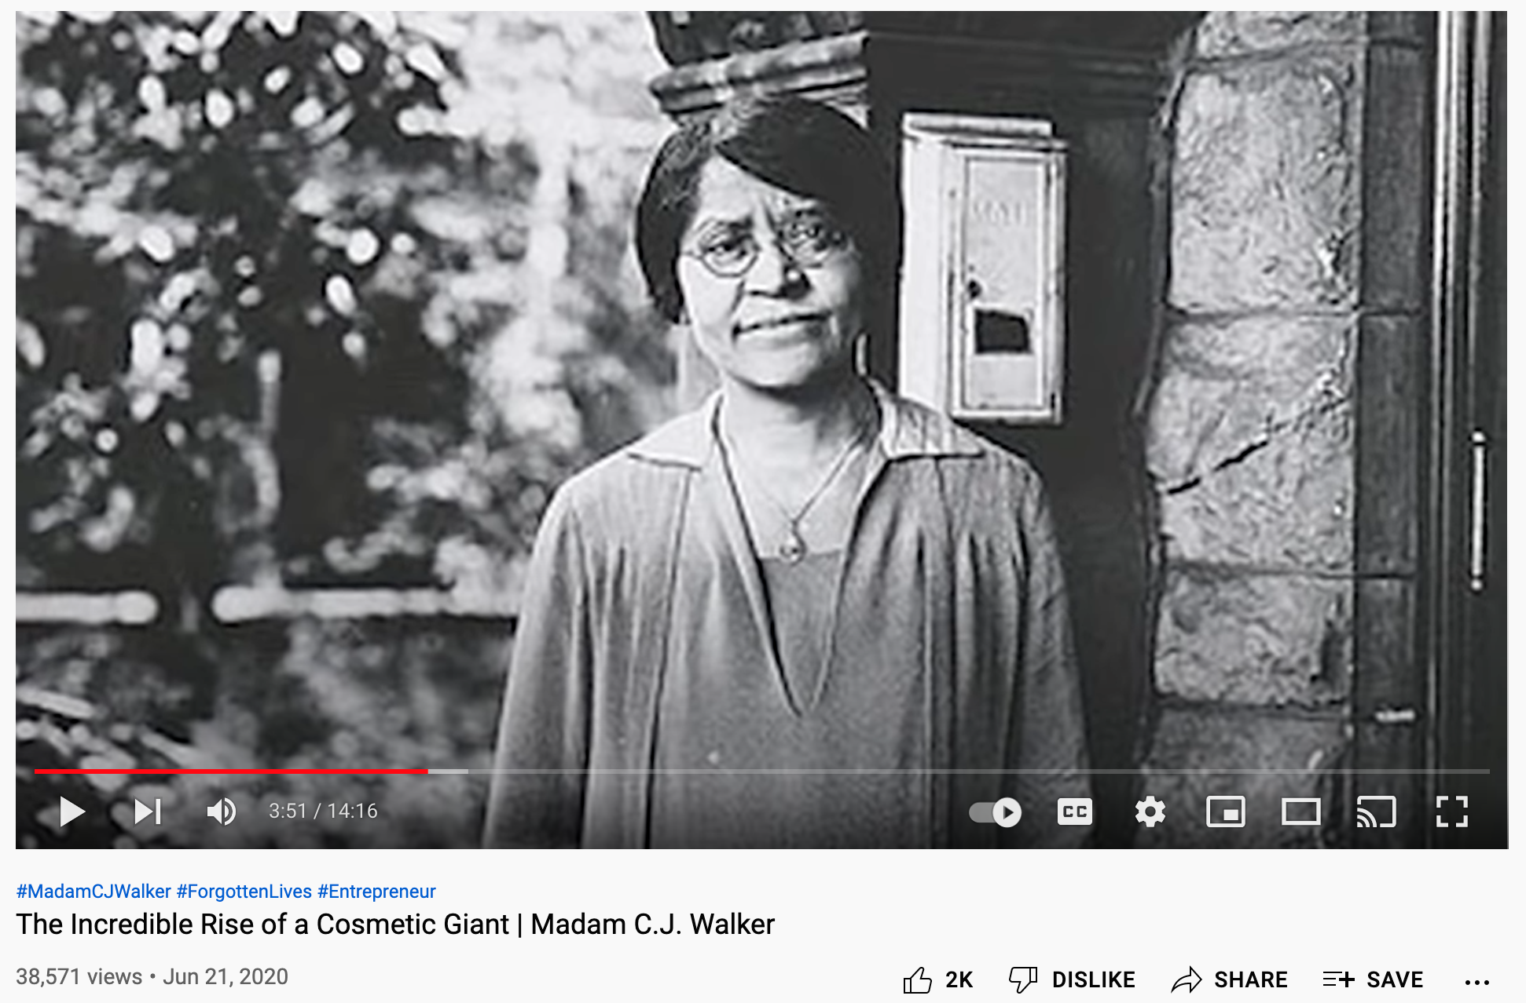

Supporting Question 2
The second supporting question—“How did Wilma Mankiller challenge injustice?”—offers students a second case of a woman working toward change. Mankiller, who was the first female chief of the Cherokee Nation, represents another wave of feminism through her work to challenge prevailing laws and norms.
The formative task asks students to write a paragraph that summarizes Mankiller’s work to fight against injustice. Teachers may implement this task with the following procedures.
- Provide students with a graphic organizer to pull information from the 3 sources.
- Structure the organizer to focus on the content of the supporting question, which asks about how Wilma Mankiller challenged injustice.
- Students might be expected to identify at least 5 examples of how Mankiller challenged injustice.
The following sources were selected to help students understand the second wave of feminism through the example of Wilma Mankiller:
- Featured Source A is the video of press conference with Wilma Mankiller prior to a lecture she gave at Ball State University. In this source, Mankiller talks about the history of feminism and her particular rise to a leadership position.
- Featured Source B is an interview with the director of the documentary film entitled Mankiller. The source describes Mankiller’s personal and professional lives and how they are intimately intersecting.
- Featured Source C is the commencement address Mankiller gave in 1992 at Northern Arizona University. In the speech, Mankiller offers her thoughts on the general state of the country and on how the students might live profitable and productive lives.

Supporting Question 2
Featured Source | Source A: Wilma Mankiller press conference at Ball State University, 1994-03-28 https://www.youtube.com/watch?v=Vdye1Qjd0Kc
The Wilma Mankiller press conference is a 19 ½ minute video available on YouTube at https://www.youtube.com/watch?v=Vdye1Qjd0Kc
The video is available from Ball State University Libraries on the occasion of a1994 lecture at Ball State University entitled "The Changing Roll of Cherokee Women." Topics discussed include issues related to women in leadership, her election as the first female chief of the Cherokee Nation, barriers for women seeking leadership roles in society, and Native American economic and social issues.

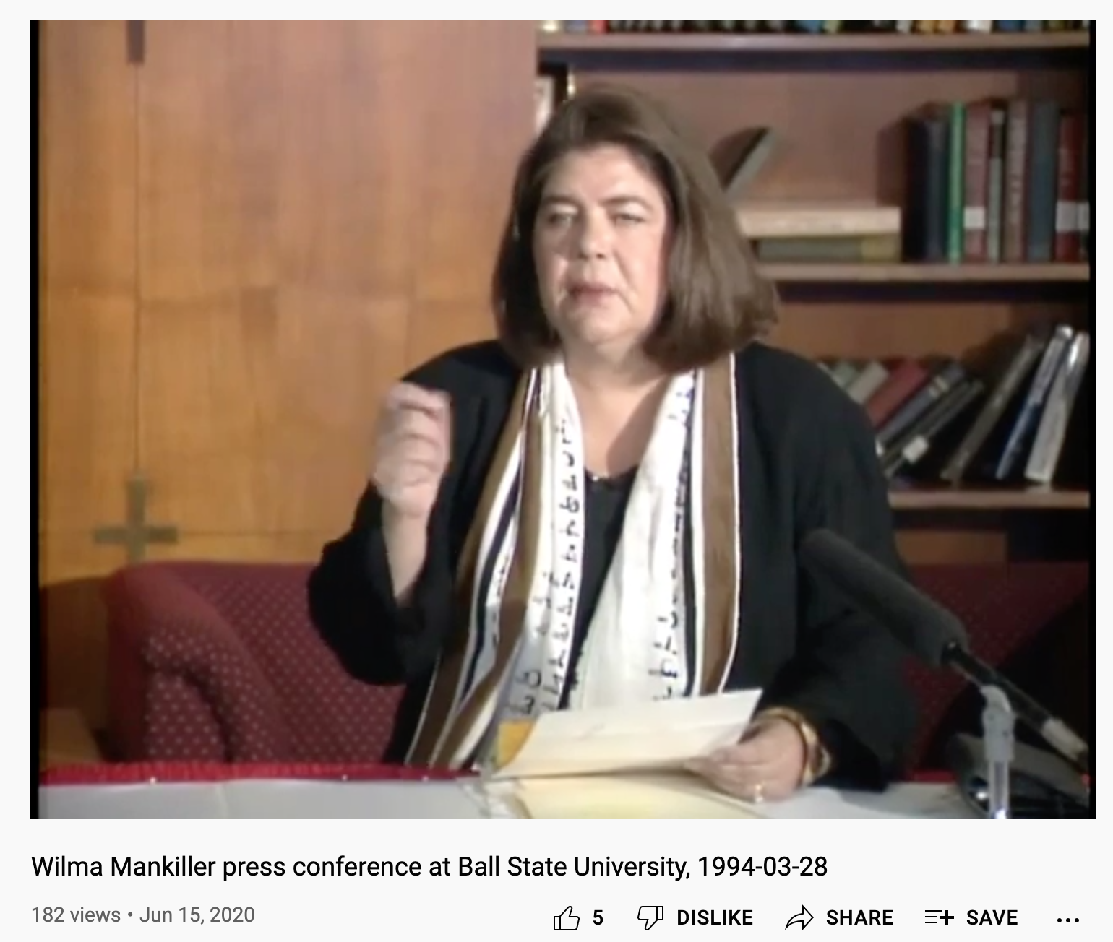

Supporting Question 2
Featured Source | Source B: Wilma Mankiller: An American Hero  https://www.womenshistory.org/articles/wilma-mankiller-american-hero
Wilma Mankiller: An American Hero
An Interview with film-maker Gale Anne Hurd, November 14, 2017
Mankiller is a video from Gale Anne Hurd, produced by Red Horse Native Productions and Valhalla Entertainment for a presentation of Vision Maker Media with major funding provided by the Corporation for Public Broadcasting.
Wilma Mankiller humbly defied the odds and overcame insurmountable obstacles to fight injustice and give voice to the voiceless. She overcame rampant sexism and personal challenges to emerge as the Cherokee Nation’s first woman Principal Chief in 1985. A new documentary, Mankiller, tells the story of this American hero. National Women’s History Museum Ambassador Gale Anne Hurd, the film’s executive producer, spoke with Shanna Duncan about this project.
What was it about Wilma Mankiller that drew you to this project?
Hurd: When Valerie Red-Horse Mohl first approached me about the documentary, I had to admit that I had never heard of Wilma! It was a travesty that a woman who had such a profound effect on her people and her nation was someone I had never heard of. I felt it was absolutely essential to tell Wilma’s remarkable story. She was the first woman elected Principal Chief of the Cherokee Nation. Wilma Mankiller was a uniter of people and worked in a bipartisan way, and now more than ever, people need to know more about her.
What was something you learned about her that surprised you?
Hurd: Wilma was very humble and did not like to talk about herself or her achievements. She illuminated that in the original Cherokee culture, women were revered and co-signed treaties along with the men. It was through interaction with the US, and previously with Britain, that their culture changed. In western European society, women were looked down upon. Their attitude was “who in their right mind would allow women to become such important leaders?” And it took hundreds of years until Wilma was elected for women to resume that level of leadership in what was traditionally a matriarchal culture.
It made me realize the effects of colonization, and the power that a dominant culture has over cultures that predate it.
Wilma considered herself a liberal Democrat, but was asked initially to run as Deputy Chief under Ross Swimmer, who was a conservative Republican. He told her, “You get things done and I can trust you with money. We don’t need to see eye to eye on everything.”
Wilma Mankiller’s family was part of an Indian relocation program to the [San Francisco] Bay Area, and that’s where she became an activist. At the time, the Black Panthers provided outreach to underserved communities, not just African Americans, but all disenfranchised communities. Wilma became an activist and participated in the occupation of Alcatraz. It was from a San Francisco American Indian community center that she learned about Native American activism. It wasn’t something that she initially thought was going to be her path. But our lives are impacted by who we encounter, who mentors us and our ability, when offered an opportunity, to have the confidence to say yes—even if we don’t know that we can be successful! We know from research that boys have that confidence and that society values it in men and inhibits it in women.
What do you think her legacy is?
Hurd: Wilma Mankiller said many times that during her time on earth she wanted to do what she could to make a difference for the Cherokee Nation. And she succeeded. She developed educational programs, increased access to health care, and she had to make incredibly difficult decisions along that path. Wilma overcame rampant sexism to be elected Deputy Chief on the ticket with Principal Chief Ross Swimmer. She and her running mate received threats, her tires were slashed, but he never told her to stand down. Swimmer stood up for her. Later, once she was Principal Chief herself, she made the difficult decision to allow gaming, realizing the difference it would make for her people. Through gaming, and the economic engine it has become for the Cherokee, they have the infrastructure for education and health care they needed to improve their community, and Wilma Mankiller was the prime mover behind all of that.
What should girls and young women who may not know anything about her walk away with?
Hurd: If you can dream it, you can be it. Wilma Mankiller was a woman who grew up in tremendous poverty. Her husband wanted her to be a stay-at-home wife and mother, but she had a dream to go back to the Cherokee Nation with her two daughters. She lived in her car when she returned to Oklahoma, and yet within a very few years, she became Principal Chief—all through hard work, drive, and the realization that she could make a difference for her people. If Wilma Mankiller could do it, you can do it.
As an Ambassador for the National Women’s History Museum, why do you think it’s important to tell the stories of women like Wilma Mankiller?
Hurd: I think that so often, we read on social media and in the mainstream media, that women aren’t equipped to do certain things. Yet without women like Ada Lovelace, we wouldn’t have computers! History is told through a male lens. It’s time to refocus that lens and realize that regardless of the odds stacked against them, women are equally responsible, not only for remarkable achievements, but also for leading humanitarian causes that make the world a better place.
I firmly believe that if our nation and the world were more aware of what women can achieve, and of their contributions to date, we would have had a woman president by now.
It is so important to have a place where not only girls and women, but boys and men can go to see, can have their eyes opened about what women have achieved.

Supporting Question 2
Featured Source | Source C: Wilma Mankiller Interview  https://www.voicesofoklahoma.com/interview/mankiller-wilma/
This interview with Wilma Mankiller was conducted by John Erling on August 13, 2009 as a part of the Voices of Oklahoma project (https://www.voicesofoklahoma.com/). The full interview is over 2 hours long and is organized in 16 chapters. Video and a written transcript of the interview is available at https://www.voicesofoklahoma.com/interview/mankiller-wilma
- Chapter 1 — Introduction
- Chapter 2 — Mankiller Flats
- Chapter 3 — Meaning of Mankiller/Wilma’s large family
- Chapter 4 — Trail of Tears
- Chapter 5 — Education system/Sequoya
- Chapter 6 — 1907- Broken Promises
- Chapter 7 — Fed. Government Relocation program
- Chapter 8 — California/education-activism/Alcatraz
- Chapter 9 — Return to Oklahoma-Gender an issue?
- Chapter 10 — Traffic accident/positive attitude
- Chapter 11 — Bell Community Project
- Chapter 12 — Project becomes model/Deputy Chief
- Chapter 13 — Opposition to Wilma as Principal Chief
- Chapter 14 — Advise to female leaders
- Chapter 15 — Gloria Steinham-Kidney transplant Future of Cherokee Nation
- Chapter 16 — Conclusion
Below is a brief biography of Wilma Mankiller
The first woman elected as Chief of the Cherokee Nation was Wilma Pearl Mankiller. She was born November 18, 1945 in Tahlequah, Oklahoma. Her father was a full-blood Cherokee and her mother was of Dutch and Irish ancestry. Wilma served as Principal Chief from December 1985 – 1995.
Wilma Mankiller was motivated to become active in Cherokee tribal affairs due to several life events that she discusses in detail in this interview recorded in 2009.
Wilma was inducted into the Oklahoma Women’s Hall of Fame in 1986, The Oklahoma Hall of Fame in 1994 and received the Presidential Medal of Honor in 1998.
Up until her diagnosis with pancreatic cancer in late winter/spring 2010, she continued to write, speak and teach American Indian Culture proudly living on Mankiller Flats, in rural Adair County, Oklahoma, on her grandfather’s land.

Supporting Question 2
Featured Source | Source D: Commencement Address at Northern Arizona University - Dec. 18, 1992  https://awpc.cattcenter.iastate.edu/2017/03/21/commencement-address-at-northern-arizona-university-dec-18-1992/
Commencement Address at Northern Arizona University - Dec. 18, 1992
Wilma Mankiller, December 18, 1992— Northern Arizona University, Flagstaff, Arizona
I ran into someone at the hotel this morning who asked me about how to address me since my credit card has "Wilma Mankiller, Principal Chief." I think some people still have a little trouble identifying with a female principal chief. It reminded me of the first time I had to address this issue. I went to a very prestigious eastern college to do a panel on Indian economic development, and this young man picked me up at the airport to take me to the university. He asked me, "Since principal chief is a male term, how should I address you?" I just ignored him and looked out the window of the car, and then he asked me if he should address me as "Chieftains." I continued to look out the window, and then he thought he would get silly and cute. He asked me if he should address me as "Chiefette."I finally told him to address me as Ms. Chief-mischief. So we went out to the university, and this young man was one of the people who got to ask the panel questions. His question to me was about my last name.
Mankiller is my maiden name, and way back in Cherokee history, Mankiller was like the ''keeper of the village" – like the equivalent of a general or someone who watched over a village – and this one fellow liked the title so much he kept it as his name; but that's not what I told this young man. I told him it was a nickname and I had earned it. So somewhere back East there is a young man who is wondering what I did to earn my last name.
I am not going to give the standard advice about going out into the world, because many of you have already been out in the world and worked and been very involved in your communities. What I would like to do is encourage you in whatever you pursue or wherever you go from here to get involved. What I have seen, I think, in the United States, not just in my community, tribal community, or rural community but in the United States in general, is a trend for all of us to think that somebody else is going to solve our problems for us.
It was interesting during this last year watching the presidential election and being aware of the daunting set of problems we face in this country – economy, education, health care, problems in the inner city; and everybody expecting somebody else to solve them. In the presidential election, no matter who was chosen for a candidate, people were counting on this one man to be able to articulate a clear vision for the future and then take care of all of the problems for the country. Do not think this is going to happen.
Even in my own community I have heard people talk about the environment, housing, homelessness, or any of the problems that we have: "Well, they're going to solve that problem." In American society it is always, "They're going to solve that problem." 1don't know who "they" are. I always tell our own people that I don't know who they are referring to. To me the only people who are going to solve our problems are ourselves – people like you and me. We have to personally take charge and solve our problems. I do not think that a great prophet is going to come along and save this country or save us and deal with all of these problems in a vacuum. We all have to take part. So I would encourage you to get involved; you will be immensely rewarded by getting into public service or by doing small things around your community and trying to help others.
The other advice I have to give you is, do not live your life safely. I would take risks and not do things just because everybody else does them. In my generation someone who had a big impact on me was Robert Kennedy, who in one speech said, "Some people see things the way they are and ask why, and others dream things that never were and ask why not?" I think that is where I hope many of you will be – people that question why things are and why we have to do them the way we have always done them. I hope you will take some risks, exert some real leadership on issues, and if you will, dance along the edge of the roof as you continue your life from here.
Finally, l just want to make a couple of comments about where I see our country going in general. I just came back from the Economic Summit in Little Rock, Arkansas, which was an intense two-day session focusing specifically on how to stimulate the economy, both short term and long term. I was encouraged by the number and diversity of people there – Republicans and Democrats. People from every sector of the business community and every sector of society talking collectively about how to gel the country moving again.
I think one of the things we have to do as a nation, besides addressing specific issues like the economy, health care, education, inner cities, and that sort of thing, is we have to examine the extent to which we continue to have stereotypes about one another. I think it is very difficult for us to collectively and symbolically join hands and begin to move forward in solving this country's problems if we continue to have these stereotypes about one another. There still exists in this country many negative stereotypes about black people, Latin people, and Asian people. God knows there are terrible stereotypes about Native Americans; these have to be overcome before we can move forward.
Sometimes I sit down with a diverse group of people in Oklahoma to work on some problem that we all have in common; it is almost like sitting down with people who have some kind of veil over their face or something. We all look at each other through this veil that causes us to see each other through these stereotypes. I think we need to lift back the veil and deal with each other on a more human level in order to continue to progress.
The minority population in this country is dramatically increasing, and that is a fact. If we continue to have this increase in minority population, we need to find ways of dealing with each other and working with each other in much better ways because it affects everybody. I do not think that we can say that what happens in Detroit does not somehow affect all America, because it does. I would urge all of you who are here today, both graduates and families, to examine the extent to which we hold those stereotypes about one another. And finally, I would hope my being here and spending just a couple of minutes with you today would help you lo eliminate any stereotypes you might have about what a chief looks like.

Supporting Question 3
The third supporting question—" How does Emma Watson work to empower women?”—brings students to the present in terms of the feminist movement. Watson, an English actress, has been active in giving her time and energy to speaking out to international audiences about women’s rights and the active role that men might consider playing in advancing feminist goals. Her efforts are representative of third-wave feminism, which has been defined as expanding the pursuit of women-oriented opportunities beyond the economic and legal arenas.
The formative task is for students to write an evidence-based claim that addresses the supporting question. Teachers may implement this task by showing the videos in Sources A and B to the whole class. The first video features Watson talking about the importance of men understanding the role that feminism has played in improving the lives of women and of society in general. The second video is a speech that Watson gave to the World Economic Forum in which she talks about the solidarity movement for gender equality.
After viewing the videos, teachers may ask their students to record salient ideas they picked up and any questions that they have. Teachers might then assign the Source C, the transcript of a speech that Watson gave to the United Nations. Students should read the text and record additional information that may be evidence about empowerment for women. With all their information available, students should then (individually or in small groups) construct claims and use the information they gathered as evidence to support their claims. Remind students that their claims are statements that they believe to be true, but because of their tentative nature must be supported by evidence. Claims should be factually correct, clearly stated, fully explained, and supported with evidence.
The following sources were selected to help students understand the third wave of feminism by focusing on the example of Emma Watson:
- Featured Source A is a video featuring Emma Watson talking about the importance of the feminist movement in general and what she argues is the key role that men can play in supporting and extending the movement for gender equality into the future.
- Featured Source B is a video in which Watson gives a speech to the World Economic Forum in 2015. The import of her talk is to highlight the successes of the HeForShe movement, which is intended to broaden the base of the feminist movement.
- Featured Source C is the transcript of Watson’s speech to the United Nations in which she briefly reviews her own journey to becoming a feminist and how important the future of the movement is for all women.

Supporting Question 3
Featured Source | Source A: Emma Watson Explains Why Some Men Have Trouble with Feminism  https://www.youtube.com/watch?v=4xWJf8cERoM

"Beauty and the Beast" actress and activist Emma Watson in a 2017 interview with Entertainment Weekly about her "HeForShe" campaign and feminism. Available from YouTube at https://www.youtube.com/watch?v=4xWJf8cERoM
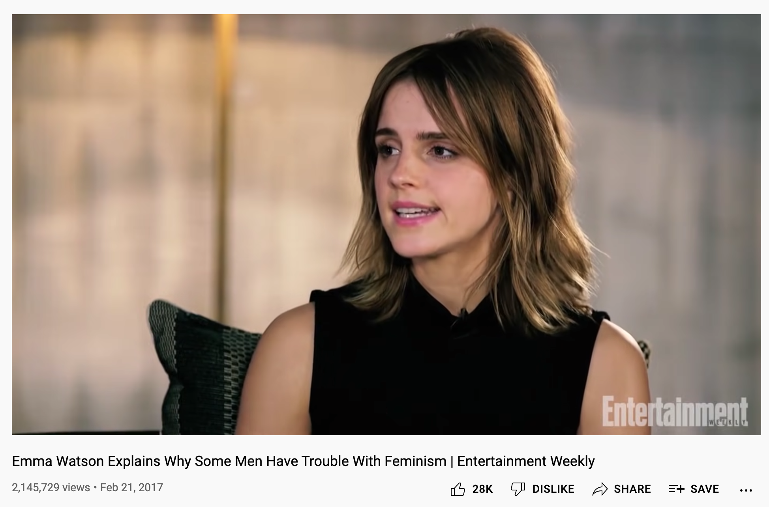

Supporting Question 3
Featured Source | Source B: Emma Watson’s Speech for HeForShe IMPACT at World Economic Forum 2015  https://www.youtube.com/watch?v=oE28bb11GQs
UN Women Goodwill Ambassador, Emma Watson, delivered this speech encouraging world and corporate leaders to take action for gender equality during the kickoff of a HeForShe program launch at the World Economic Forum at Davos on January 23rd, 2015.
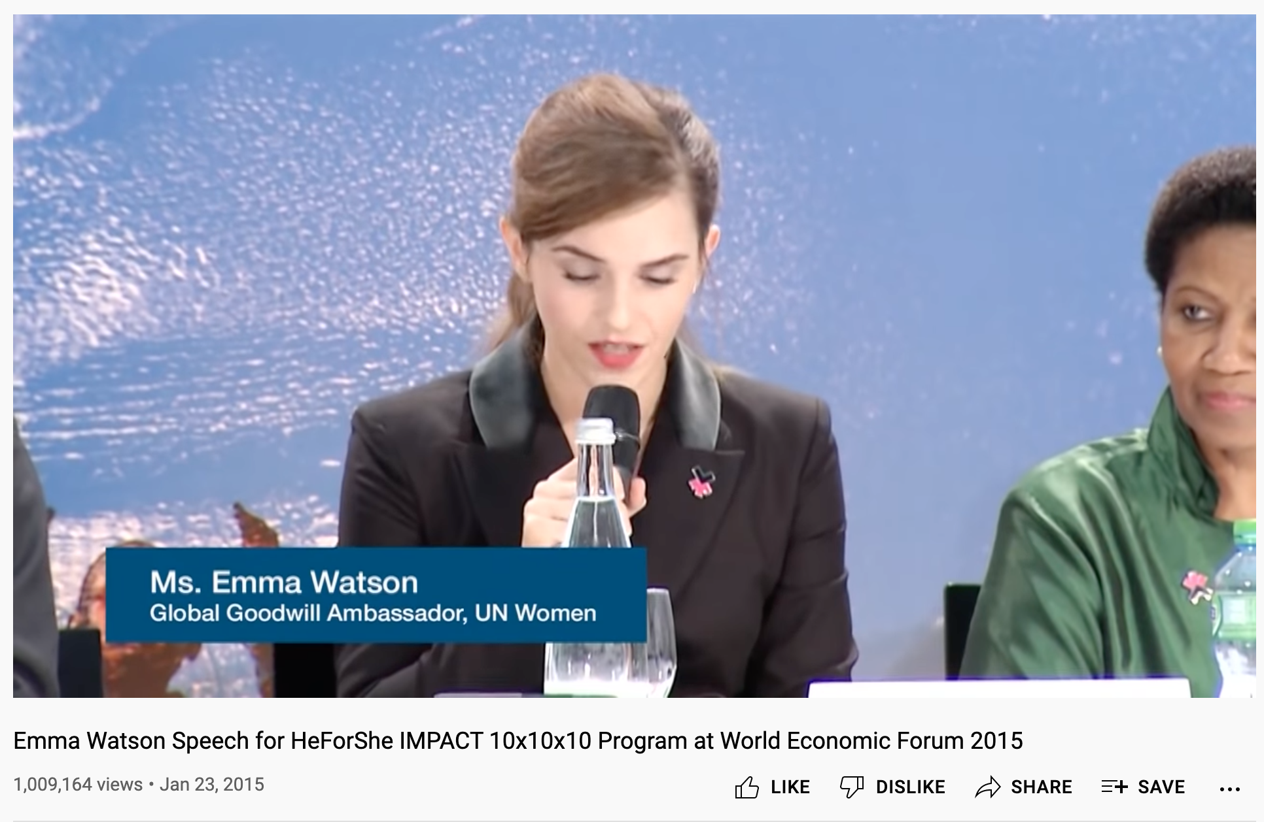

Supporting Question 3
Featured Source | Source C: Emma Watson's Speech on Gender Equality at the UN  http://ekladata.com/_oedgeUz1KhcmyRe5LgNBmlWwPU/Full-Transcript-of-Emma-Watson.pdf

Emma Watson's Speech on Gender Equality at the UN
On Saturday, September 20, 2014 British actor and Goodwill Ambassador for UN Women, Emma Watson, gave a smart, important, and moving speech about gender inequality and how to fight it. In doing so, she launched the HeForShe initiative, which aims to get men and boys to pledge to join the feminist fight for gender equality. In the speech Ms. Watson makes the very important point that in order for gender equality to be achieved, harmful and destructive stereotypes of and expectations for masculinity have got to change. Below is the full transcript of her thirteen-minute speech.
Today we are launching a campaign called for HeForShe. I am reaching out to you because we need your help. We want to end gender inequality, and to do this, we need everyone involved. This is the first campaign of its kind at the UN. We want to try to mobilize as many men and boys as possible to be advocates for change. And, we don’t just want to talk about it. We want to try and make sure that it’s tangible. I was appointed as Goodwill Ambassador for UN Women six months ago. And, the more I spoke about feminism, the more I realized that fighting for women’s rights has too often become synonymous with man-hating. If there is one thing I know for certain, it is that this has to stop.
For the record, feminism by definition is the belief that men and women should have equal rights and opportunities. It is the theory of political, economic and social equality of the sexes. I started questioning gender-based assumptions a long time ago. When I was 8, I was confused for being called bossy because I wanted to direct the plays that we would put on for our parents, but the boys were not. When at 14, I started to be sexualized by certain elements of the media. When at 15, my girlfriends started dropping out of sports teams because they didn’t want to appear muscly. When at 18, my male friends were unable to express their feelings.
I decided that I was a feminist, and this seemed uncomplicated to me. But my recent research has shown me that feminism has become an unpopular word. Women are choosing not to identify as feminists. Apparently, I’m among the ranks of women whose expressions are seen as too strong, too aggressive, isolating, and anti-men. Unattractive, even.
Why has the word become such an uncomfortable one? I am from Britain, and I think it is right I am paid the same as my male counterparts. I think it is right that I should be able to make decisions about my own body. I think it is right that women be involved on my behalf in the policies and decisions that will affect my life. I think it is right that socially, I am afforded the same respect as men.
But sadly, I can say that there is no one country in the world where all women can expect to see these rights. No country in the world can yet say that they achieved gender equality. These rights, I consider to be human rights, but I am one of the lucky ones.
My life is a sheer privilege because my parents didn’t love me less because I was born a daughter. My school did not limit me because I was a girl. My mentors didn't assume that I would go less far because I might give birth to a child one day. These influences were the gender equality ambassadors that made me who I am today. They may not know it, but they are the inadvertent feminists that are changing the world today. We need more of those.
And if you still hate the word, it is not the word that is important. It’s the idea and the ambition behind it, because not all women have received the same rights I have. In fact, statistically, very few have.
In 1997, Hillary Clinton made a famous speech in Beijing about women’s rights. Sadly, many of the things that she wanted to change are still true today. But what stood out for me the most was that less than thirty percent of the audience were male. How can we effect change in the world when only half of it is invited or feel welcome to participate in the conversation?
Men, I would like to take this opportunity to extend your formal invitation. Gender equality is your issue, too. Because to date, I’ve seen my father’s role as a parent being valued less by society, despite my need of his presence as a child, as much as my mother’s. I’ve seen young men suffering from mental illness, unable to ask for help for fear it would make them less of a man. In fact, in the UK, suicide is the biggest killer of men between 20 to 49, eclipsing road accidents, cancer and coronary heart disease. I’ve seen men made fragile and insecure by a distorted sense of what constitutes male success. Men don’t have the benefits of equality, either.
We don’t often talk about men being imprisoned by gender stereotypes, but I can see that they are, and that when they are free, things will change for women as a natural consequence. If men don’t have to be aggressive in order to be accepted, women won’t feel compelled to be submissive. If men don’t have to control, women won’t have to be controlled.
Both men and women should feel free to be sensitive. Both men and women should feel free to be strong. It is time that we all perceive gender on a spectrum, instead of two sets of opposing ideals. If we stop defining each other by what we are not, and start defining ourselves by who we are, we can all be freer, and this is what HeForShe is about. It’s about freedom.
I want men to take up this mantle so that their daughters, sisters, and mothers can be free from prejudice, but also so that their sons have permission to be vulnerable and human too, reclaim those parts of themselves they abandoned, and in doing so, be a more true and complete version of themselves.
You might be thinking, “Who is this Harry Potter girl, and what is she doing speaking at the UN?” And, it’s a really good question. I’ve been asking myself the same thing. All I know is that I care about this problem, and I want to make it better. And, having seen what I’ve seen, and given the chance, I feel it is my responsibility to say something. Statesman Edmund Burke said, “All that is needed for the forces of evil to triumph is for good men and women to do nothing.”
In my nervousness for this speech and in my moments of doubt, I told myself firmly, “If not me, who? If not now, when?” If you have similar doubts when opportunities are presented to you, I hope those words will be helpful. Because the reality is that if we do nothing, it will take seventy-five years, or for me to be nearly 100, before women can expect to be paid the same as men for the same work. 15.5 million girls will be married in the next 16 years as children. And at current rates, it won't be until 2086 before all rural African girls can have a secondary education.
If you believe in equality, you might be one of those inadvertent feminists that I spoke of earlier, and for this, I applaud you. We are struggling for a uniting word, but the good news is, we have a uniting movement. It is called HeForShe. I invite you to step forward, to be seen and to ask yourself, “If not me, who? If not now, when?”
Thank you very, very much

Summative Performance Task
At this point in the inquiry, students have examined the movement to increase gender equality through the individual and collective efforts that make up the feminist movement. Grounding the students’ study are three case studies of pioneering women: Madame C.J. Walker representing the first wave, Wilma Mankiller representing the second wave, and Emma Watson representing the current wave. By engaging with the featured sources through the formative performance tasks, students should have the requisite knowledge and skills to make evidence-based arguments in response to the compelling question.
Students should be expected to demonstrate the breadth of their understandings and their abilities to use evidence from multiple sources to support their claims. In this task, students represent their arguments by making posters that draw from the range of sources in general and the three cases of feminists in particular.
Students’ arguments will likely vary, but could include any of the following:

- Women can achieve equality through the enacting of individual agency.
- Women can achieve equality by challenging culturally embedded gender norms, beliefs, and expectation.
- Women can achieve equality by the emancipation of women from the patriarchal mindset and belief system.
- Women can achieve equality by working collectively with others to make an impact.
To extend their arguments, students can develop an annotated bibliography that identifies a range of sources on feminism and gender equality appropriate to a younger set of students.
Students have the opportunity to Take Informed Action by researching gender equity issues in their home communities (Understand). They might then develop a series of interview questions designed to explore a selected issue (Assess). Finally, students might use their questions as a means of conducting interviews with a range of community members and summarizing the results (Act).

Appendix A - Infographic

