2nd/3rd grade Tennessee Geography Inquiry
How did my state
get its shape?
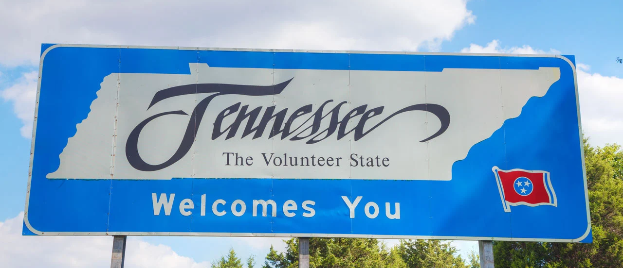

Supporting Questions
- How did Tennessee get its borders?
- How do people and places shape my state?

2nd/3rd grade Tennessee Geography Inquiry
How did my state get its shape?
Tennessee Social Studies Standards | Geo.2.18: Analyze how the location of regions affects the way people live, including their: food, clothing, shelter, transportation, and recreation.  3.04: Examine major political features on globes and maps, including: boundaries, cities, highways, railroads, and roads. Content Strand: G  3.12: Locate the following cities and physical features in Tennessee: Cities—Chattanooga, Knoxville, Memphis, Nashville; Rivers—Cumberland, Mississippi, Tennessee; Mountain Range—Great Smoky Mountains. Content Strand: G, T
Staging the Question | Generate a list of things that are special about Tennessee and discuss which three things are most important and why they are the most important.

Supporting Question 1 | Supporting Question 2
Whole Group | Small Group Work
How did Tennessee get its borders? | How do people and places shape my state?
Formative  Performance Task | Formative  Performance Task
Annotate a Tennessee map by highlighting the defining characteristics of Tennessee’s borders and regions. | Gather and annotate 10-15 sources that tell a story about people and/or places (e.g., musicians, cities, Smoky Mountains) in Tennessee. Then, make a list of how your assigned group’s people/places have shaped the state of Tennessee.
Featured Sources | Featured Sources
Source A: This is how each state got its shape, USA Today, 2021.  Source B: Tennessee: Get Facts and Photos about the 16th State, National Geographic Kids.  Source C: Google Earth | Source A: Resources for Jump Starting Student Research, various curated websites.  Source B: Student generated resources

Summative Performance Task | ARGUMENT How did my state get its shape? Construct an argument by making a poster that tells the story of how Tennessee got its shape using a variety of informational and geographic sources (e.g., images, maps).
Geo-Inquiry Process | Students will create an immersive “Tennessee Welcome Center” and guide community members through their exhibits.

Overview

Inquiry Description
This 2nd and 3rd grade inquiry expands student understandings of how a state is shaped by exploring the ways in which geographic and cultural forces work together to define a region. The compelling question—“How did my state get its shape?”—engages students in an examination of the defining characteristics of Tennessee by noting the history around the creation of Tennessee’s borders and regions in addition to an examination of Tennessee’s rich cultural heritage.
This inquiry utilizes whole group and small group instruction as the tasks and sources have students to move from more general to more specific information about the state of Tennessee. Students will begin the inquiry process by brainstorming what makes Tennessee special before moving into a whole group examination of how Tennessee got its borders. Students will annotate a blank Tennessee map using the sources. From there, students will be broken up into small groups and will examine different cultural dimensions of Tennessee. Groups will start their research with the curated websites before jumping into their own source collection. From their research, students will then use their sources to tell a story about how their topic shapes Tennessee. Finally, students will construct an argument in response to the compelling question by creating a poster which draws textual and visually displays their claims and evidence.
Ultimately, students will engage in the Geo-Inquiry process in which they create an immersive “Tennessee Welcome Center” that they will share with community members.
NOTE: This inquiry unit is anticipated to require three-to-five 45-minute class sessions. The time needed depends on what lesson elements teachers would like to focus on. Teachers are encouraged to add and subtract additional resources according to preference, instructional time, and student needs. Resources can also be modified as necessary to meet individualized education programs (IEPs) or Section 504 Plans for students with disabilities.

Structure of the Inquiry
In addressing the compelling question “How does my state get its shape?” students work through a series of supporting questions, formative performance tasks, and featured sources in order to construct an argument with evidence from a variety of sources.

Staging the Compelling Question
In staging the compelling question—“How did my state get its shape?”—students will brainstorm a list of things that are special about Tennessee. After students brainstorm on their own, they will assemble a class list of all the things that make Tennessee special. They will then discuss as a class which three things are most important about Tennessee and why. This task will encourage students to think about the ways Tennessee is unique in preparation for their exploration of Tennessee’s geographic and cultural defining characteristics.

Supporting Question 1
The first Supporting Question—“How did Tennessee get its borders?”—has students explore the geographic characteristics of Tennessee using information about the formation of Tennessee’s borders, the characteristics of Tennessee's different regions, and satellite images of Tennessee from Google Earth.Featured Source A is an excerpt from a USA Today article which describes how Tennessee’s borders were formed. Featured Source B is a National Geographic Kids article about Tennessee’s eight geographic regions. Featured Source C is a Google Earth map of Tennessee and can be used to supplement and aid Featured Sources A and B. The formative performance tasks will ask students to use information from the sources to annotate a blank Tennessee map (Appendix A) with information addressing the supporting question.

Supporting Question 2
The second Supporting Question—“How do people and places shape my state?”—has students break into small groups in which each group focuses on a different aspect of Tennessee’s unique cultural makeup (i.e. Artists, Musicians, Writers, the Great Outdoors, Wildlife, and Cities and Farmland). Source A is a curated list of websites around six themes to be used as a jumping off point for student led research. The remainder of the sources (10-15) for this supporting question will be student generated. The formative performance task asks students to use the sources they gathered to tell a story of how their assigned group’s people/places have shaped the state of Tennessee through a list of compelling facts.

Summative Performance Task
Students draw upon understanding developed through the formative performance tasks to craft evidence-based arguments responding to the compelling question—“How does my state get its shape?” The argument can be presented through a poster that tells a visual argument in response to the compelling question. To prepare for the crafting of an argument, students may gather their sources and notes, and discuss in small groups the relationship between the supporting questions/featured sources and the compelling question.
Student arguments will likely vary, but could include any of the following or a combination of the following:
- Tennessee gets its shape from its artists that show Tennessee’s creativity.
- Tennessee gets its shape from its musicians that show Tennessee’s talent.
- Tennessee gets its shape from its Smoky Mountains that show Tennessee’s natural beauty.
- Tennessee gets its shape from its cities that show Tennessee’s vibrancy.
- Tennessee gets its shape from its farmland that shows Tennessee’s traditions.
- Tennessee gets its shape from its politicians that show Tennessee’s leadership.

Geo-Inquiry Process
Students could engage in a Geo-Inquiry that focuses on a real world issue and take action on something that matters to them and connects with the ideas of the inquiry. This Geo-Inquiry process focuses on students sharing the defining characteristics of Tennessee with community members through a student designed “Tennessee Welcome Center.” Community members may include another class in the school, student guardians and/or parents, or even the general public. The inquiry asks students to collect resources around their state and expand their notion of how a state is shaped and the Geo-Inquiry process continues this by inviting students to creatively showcase how their state was shaped. Students will create an immersive experience using visuals, music, artifacts and/or demonstrations and then act as tour guides for community members as they explore the defining characteristics of Tennessee.
- Ask: Students will think about how they can engage their community in learning about how Tennessee is shaped.
- Collect: Students will collect multimodal sources (visual, audio, tangible) which go along with their summative task poster topics (i.e. Artists, Writers, Musicians, Great Outdoors, Wildlife, Cities and Farmland).
- Visualize: Students will visualize how they can communicate how the geographic and cultural forces work together to define their region in a “Tennessee Welcome Center.”
- Create: Students will create an immersive “Tennessee Welcome Center” showcasing the defining characteristics of Tennessee.
- Act: Students will act as tour guides and invite community members to walk through their “Welcome Center.”

Supporting Question 1
Featured Source | Source A: This is how each state got its shape, USA Today, 2021. Accessed  https://www.usatoday.com/story/money/2021/04/10/this-is-how-each-state-got-its-shape/43513185/.

Tennessee
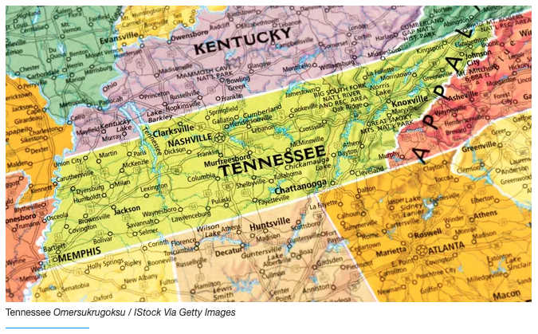

► Population: 6,770,010

► Size (square miles): 41,234

► Capital: Nashville

► Founded: June 1, 1796 (16th state to join)

► Famous landmarks: Graceland
Landlocked Tennessee borders eight states. At one time, the Mississippi River was its western border. But the river has meandered, causing confusion with neighboring states Missouri and Arkansas. The Supreme Court has ruled that the western border of Tennessee can't be shifted because of geographic changes caused by river movements.
As for the southern border, in 1818 Georgia and Tennessee appointed University of Georgia professor James Camak and Tennessee mathematician James Gaines to survey the border of their respective states. When Congress voted to make Tennessee a state in 1796, it set the boundary between Georgia and Tennessee at 35 degrees north latitude. Camak and Gaines put the border about a mile south of 35 degrees north. That border continues west to the Mississippi River.
To the east is North Carolina, from which northeast Tennessee separated in the 18th century. Its northern border was created during the colonial era when the British Crown declared that the border between North Carolina and Virginia would be 36 degrees, 30 minutes north latitude. That line continued west when Kentucky and Tennessee were established.

Supporting Question 1
Featured Source | Source B: Tennessee: Get Facts and Photos about the 16th State, National Geographic Kids. Accessed https://kids.nationalgeographic.com/geography/states/article/tennessee.

GEOGRAPHY AND LANDFORMS
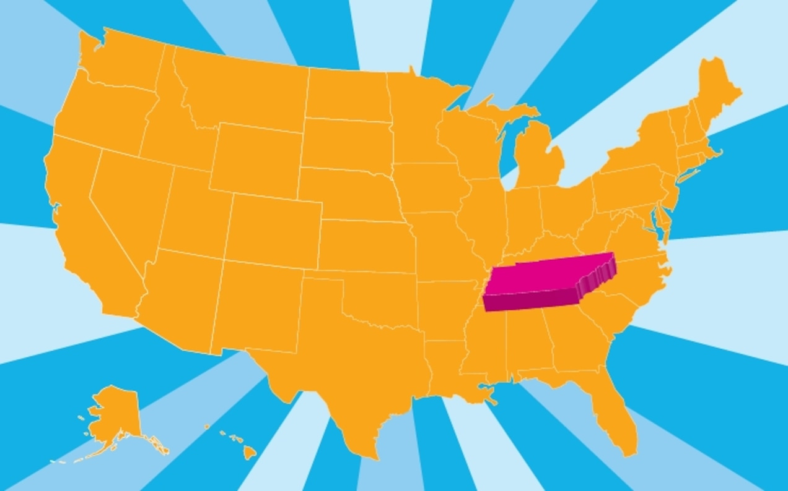
Tennessee is bordered by Kentucky and Virginia in the north, North Carolina in the east, Georgia, Alabama, and Mississippi in the south, and Arkansas and Missouri in the west. Its wiggly western border is formed by the Mississippi River. Geologists divide the land into six major regions.
The Unaka Mountains region is the most rugged in the state and rises along the eastern border. This area has forests and high peaks including Clingman’s Dome, Tennessee’s highest point. Great Smoky Mountains National Park is also here.
The Valley and Ridge region lies west of the mountains and is named for its low, fertile valleys and long tree-covered ridges. The ridges are sometimes called “folds.”
Stretching north to south farther west is the Cumberland Plateau. Created by streams, deep valleys and gorges lie below flat-topped mountains. Lookout Mountain has views of seven states!
The Central Basin is in the center of the state, surrounded by another region called the Highland Rim. (So the basin is sort of like a doughnut hole.) Erosion helped form the basin, which is mostly fertile farmland with some hills and ridges.
The Gulf Coastal Plain covers the westernmost part of the state. It lies on a fault line and in 1812 was the site of the worst earthquake in the continental United States. The temblor was so severe that land dropped several feet, the Mississippi River flowed backward, and a new lake called Reelfoot was created. The land closest to the Mississippi is fertile swampland and often called “the Delta.”

Supporting Question 1
Featured Source | Source C: Google Earth. Accessed https://earth.google.com/web/search/Tennessee.

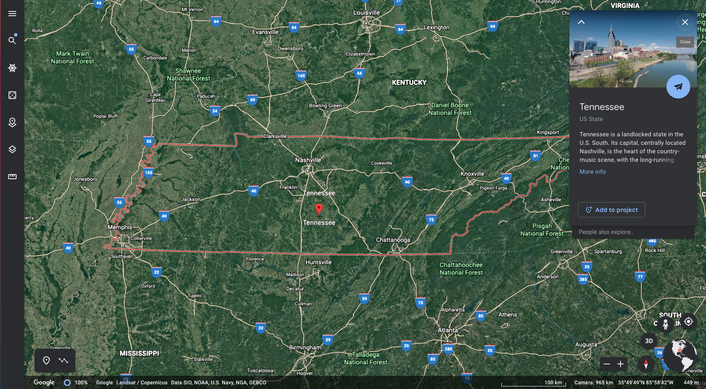

Supporting Question 2
Featured Source | Source A: Resources for Jump Starting Student Research, various curated websites.

Resources for Jump Starting Student Research
Artists  - Tennessee Craft  - Nashville Artists You Should Know  Musicians  - Musicians Hall of Fame  - Music - TN History  Writers  - Tennessee Authors | Great Outdoors  - Go Outdoors TN  - National Park Service - Smoky Mountains  Wildlife  - TN Wildlife Federation  - Youtube - Biodiversity in TN  Cities and Farmland  - Agriculture Land Value - GIS Map  - Biggest Cities in Tennessee

Appendix A
Featured Source | Source A: Blank Map of Tennessee

