4th Grade Geography Inquiry
Does Where You
Live Matter?
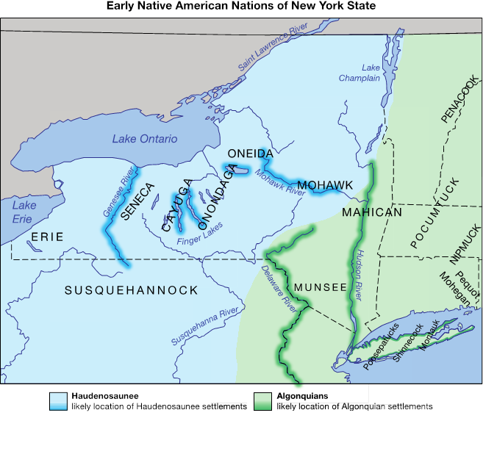
Created for the New York State K–12 Social Studies Toolkit by Binghamton University, 2015

Supporting Questions
- What physical features make New York State’s geography diverse?
- Where in New York State did early Native American groups settle and how did physical features affect their settlements?
- How did the early Native Americans in New York State interact with their physical environment to meet their needs?

4th Grade Geography Inquiry
How Does Where You Live Matter?
New York State Social Studies Framework Key Ideas & Practices | 4.1 GEOGRAPHY OF NEW YORK STATE: New York State has a diverse geography. Various maps can be used to represent and examine the geography of New York State.  4.2 NATIVE AMERICAN GROUPS AND THE ENVIRONMENT: Native American groups, chiefly the Iroquois (Haudenosaunee) and Algonquian-speaking groups, inhabited the region that became New York State. Native American Indians interacted with the environment and developed unique cultures.  Gathering, Using, and Interpreting Evidence Comparison and Contextualization  Economics and Economic Systems Geographic Reasoning
Staging the  Question | Brainstorm the relationship between humans and the physical environment through the concepts of opportunities and constraints.

Supporting Question 1 | Supporting Question 2 | Supporting Question 3
What physical features make New York State’s geography diverse? | Where in New York State did early Native Americans settle and how did physical features affect their settlements? | How did the early Native Americans in New York State interact with their physical environment to meet their needs?
Formative  Performance Task | Formative  Performance Task | Formative  Performance Task
Identify the physical features of New York State in a graphic organizer. | Using all available maps, complete a graphic organizer that categorizes the opportunities and constraints of the physical features that affected Native American settlements. | Develop and support a series of claims about how the Haudenosaunee and Algonquians modified and adapted to their physical environments.
Featured Sources | Featured Sources | Featured Sources
Source A: Image bank: Photographs of physical features  Source B: Image bank: Maps of New York State | Source A: Haudenosaunee and Algonquians settlement map  Source B: Topographic map of New York State | Source A: Excerpts from Haudenosaunee Guide for Educators  Source B: The People of the Shore: Shinnecocks of Long Island

Summative Performance Task | Argument How does where you live matter? Construct an argument supported with evidence that addresses the question of how physical features and available resources influenced the locations of early Native Americans settlements in New York State. Express this argument in the form of an essay.
 | Extension Express through Power Point presentations the ways in which the Haudenosaunee and Algonquian adapted to and modified their physical environments.
Taking Informed Action | Understand Brainstorm a list of the geographic opportunities and constraints in area neighborhoods and communities.  Assess Discuss how individuals and communities can turn constraints into opportunities.  Act Arrange for a local official to visit the class to review the class conclusions and discuss possible community actions.

Overview

Inquiry Description
This inquiry focuses on physical geography in general and on the relationship between early (pre-1700) Native American nations and their environments in particular through the compelling question “How does where you live matter?” The intellectual side of the compelling question highlights the idea that geography is not a neutral entity. Environments can exert an influence on human existence, but they are not immune from change—human activity can modify the physical landscape. The student engagement side of the compelling question is represented in the idea of agency—that humans can shape the environments around them. The reciprocal relationship between humans and their surroundings lies at the heart of this inquiry.
Three supporting questions guide students in their inquiry by exploring the diverse physical features of New York State, describing where two groups of Native American nations settled and the importance of the geography around them, and investigating how early Native Americans interacted with their physical environments in order to meet their needs and wants. Through an examination of the featured sources in this inquiry, students use early Native American settlements as a case study of the ways in which humans interact with the environment. The inquiry, then, is not intended to be the only one covering Key Idea 4.2 related to Native Americans in New York State. Other inquiries would be useful to explore Native American life through Conceptual Understandings 4.2b (Native American groups developed specific patterns of organization and governance to manage their societies) and 4.2c (Each Native American group developed a unique way of life with a shared set of customs, beliefs, and values).
NOTE: This inquiry is expected to take five to six 30-minute class periods. The inquiry time frame could expand if teachers think that their students need additional instructional experiences (i.e., supporting questions, formative performance tasks, and featured sources). Teachers are encouraged to adapt the inquiries​ to meet the needs and interests of their particular students. Resources can also be modified as necessary to meet individualized education programs (IEPs) or Section 504 Plans for students with disabilities.

Content Background
New York State is home to a variety of physical features, including lakes, oceans, rivers, waterfalls, marshes, coastlines, hills, forests, valleys, lowlands, plains, plateaus, and mountains. Across New York State, one can explore many different types of landforms—the Adirondack Mountains in the north, plains along the Great Lakes in the north and west, and the coastline along the Atlantic Ocean in the southeast.
With such geographic diversity, early Native Americans groups in New York State used the land and natural resources to support their settlements. From Lake Champlain to Long Island, Native peoples settled in areas near waterways. Water was the primary means for transportation, and trade; access to water and other natural resources supported Native Americans in meeting their basic needs. The Algonquians and Haudenosaunee people used different natural resources. Living nearer to the ocean and salt water, the Algonquians built large canoes to harvest clams, mussels, and saltwater fish. In contrast, the Haudenosaunee depended more on lakes and streams for food and transportation. The Haudenosaunee also relied more on farming, including the Three Sisters crops (corn, beans, and squash). Both groups interacted with their environments, albeit in different ways because of their perceptions of geographic factors.
Throughout this inquiry, students will explore how early Native Americans reacted to and modified their environments to meet their basic needs of food, clothing, and shelter. Because of the differences in physical environment and climate across New York State, early Native American groups took varied approaches toward meeting the needs of their people. Accordingly, there is evidence throughout New York State of various forms of shelter used by early Native Americans, including the Haudenosaunee longhouses and Algonquian wigwams.
NOTE: Haudenosaunee, the people of the longhouse, is the preferred term for the confederacy of five, and later six, nations the Europeans called the “Iroquois.” In this inquiry, the term “Haudenosaunee” will be used when referring to this group of otherwise independent nations. Algonquian refers to a language family rather than a political entity, so the phrase “Algonquian nations” will be used to signify that, although related by language, the groups are politically diverse.
It is also important to note that, although the terms “Native Americans” and “Native peoples” are used in this inquiry, the terms “American Indians” and “Indians” are used in much of the scholarly literature.

Content, Practices, and Literacies
A robust curriculum inquiry marries the key content students need to learn and the social studies practices they need to learn and master. The formative performance tasks in this inquiry build students’ content knowledge of New York State geography and support students as they apply social studies practices to learn how early Native American groups interacted with the land around them. The first formative performance task focuses students’ attention on identifying the range of physical features around the state through the practices of gathering evidence and applying their geographic reasoning. The second formative performance task introduces the case study of early Native groups. Continuing to employ the practices of Gathering, Using, and Interpreting Evidence and Geographic Reasoning, students layer on the social studies practice of Comparison and Contextualization as they examine the opportunities and constraints evident in physical surroundings. The third formative performance task highlights the ways humans interact with their geographic environments. In order to do so, students add the practice of Economics and Economic Systems to the accumulating practices of Gathering, Using, and Interpreting Evidence, Comparison and Contextualization, and Geographic Reasoning.
Evident across the three formative performance tasks is an increasing complexity of thinking. The first task works at the identification level in that students are identifying the various physical features of the New York State landscape. The second task also has an identification element in that students are asked to identify where early Native American groups settled. That task also asks students to identify and categorize the opportunities and constraints geographic features offered Native Americans. In the third task, students move to the interpretation of evidence by making and supporting claims about how Native groups modified and adapted to the areas in which they settled.
The New York State P–12 Common Core Learning Standards for English Language Arts & Literacy offer social studies teachers numerous opportunities to integrate literacy goals and skills into their social studies instruction. The Common Core supports the inquiry process through reading rich informational texts, writing evidence-based arguments, speaking and listening in public venues, and using academic vocabulary to complement the pedagogical directions advocated in the New York State K–12 Social Studies Framework. At the end of this inquiry is an explication of how teachers might integrate literacy skills throughout the content, instruction, and resource decisions they make.

Staging the Compelling Question
Compelling Question | How does where you live matter?
Featured Source | Source A: World topographic map
The inquiry opens with the compelling question “How does where you live matter?” Teachers might begin with a student-driven brainstorming session in which the class teases out several meanings of this compelling question. Ultimately, this inquiry relies on exploring the reciprocal relationship between humans and their physical environments.
To begin parsing the question, teachers may first ask students to wrestle with what it means for something to “matter” or “not matter.” Drawing on their real-world experiences and their background knowledge (including the third-grade curriculum that focuses on world cultures), students can describe examples in which places around their communities and around world matter (or do not matter) in people’s lives. Then teachers can draw students’ attention to the world topographic map asking them to think about what the map represents (i.e., geographic features) and what it supports and/or complicates about their initial ideas about which physical features matter. NOTE: Teachers will want to be sensitive to students’ prior knowledge and experience with maps; a preliminary discussion of the nature, value, and use of maps may be needed to refresh students’ understandings.
Teachers may wish to channel the discussion toward the identification of opportunities, or the advantages an environment can offer for human activities, and constraints, or the perceived limitations geography can present. If desired, a physical map of the world may be used as a visual aid to generate student observations and questions. Using a source like a map to spark students’ curiosity can help to illuminate any misconceptions they have. Those misconceptions may necessitate background lessons before the in-depth study evident in this inquiry.
Students may discuss their ideas as a whole class or in small groups, and then document their initial findings as teachers see fit. It might be helpful to plan time for this introductory discussion before beginning Formative Performance Task 1 in order to leave time to address any knowledge gaps or to share student work. Ideally, students can return to these ideas during and at the end of the inquiry. As the year progresses, students should be able to analyze and articulate how their ideas and perspectives may have changed or developed as a result of this inquiry. Concepts like opportunities and constraints could be useful in a number of inquiries throughout the grade four curriculum.

Staging the Compelling Question
Featured Source | Source A: World topographic map

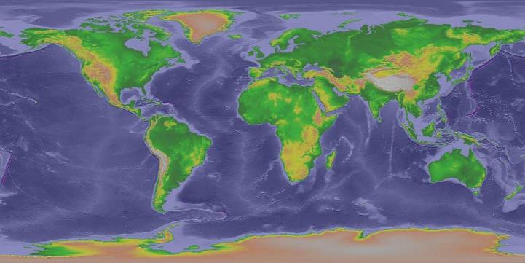
Public domain. National Geographic Data Center. http://www.ngdc.noaa.gov/mgg/topo/pictures/GLOBALeb10colshade.jpg.

Supporting Question 1
Supporting Question | What physical features make New York State’s geography diverse?
Formative Performance Task | Identify the physical features of New York State in a graphic organizer.
Featured Sources | Source A: Image bank: Photographs of physical features  Source B: Image bank: Maps of New York State
Conceptual Understanding | (4.1a) Physical and thematic maps can be used to explore New York State’s diverse geography.
Content Specifications | Students will be able to identify and map New York State’s major physical features, including mountains, plateaus, rivers, lakes, and large bodies of water, such as the Atlantic Ocean and the Long Island Sound.  Students will examine New York State climate and vegetation maps in relation to a New York State physical map, exploring the relationship between physical features and vegetation grown as well as between physical features and climate.
Social Studies Practices | Gathering, Using, and Interpreting Evidence  Geographic Reasoning

Supporting Question
As students begin to think about and investigate this supporting question and the featured sources, they will explore the diverse geography of New York State. The images and maps from all over New York State offer initial insights into the range of resources and physical features of the state.

Formative Performance Task
The formative performance task asks students to gather and identify geographic features of New York State from a variety of images and maps and to compile their findings on Part 1 of the Physical Features Task (Geographic Reasoning). The Gathering, Using, and Interpreting Evidence practice is evident when students (1) cite examples of landforms, bodies of water, and climate; (2) illustrate the chosen examples with drawings; (3) describe the chosen examples using text; and (4) choose one feature from each category to locate and correctly identify on a blank New York State map (Part 2 of the Physical Features Task).

Physical Features Task
Part 1 directions: Using your research into the diverse geography of New York State, complete this chart with specific information you have gathered.
Geographic Features | Name It | Illustrate It | Describe It
Landforms
Bodies of water
Natural resources

Part 2 directions: Choose at least one of the geographic features from each category on your chart to represent on this blank New York State map. Be sure to represent your chosen feature(s) in the correct locations. Remember, you may need to add mapping elements, such as a legend and compass rose, in order to accurately represent your thinking.
Created for the New York State K–12 Social Studies Toolkit by Agate Publishing, Inc., 2015.
Adapted from Map of United States of America with States - Single Color by FreeVectorMaps.com. https://www.freevectormaps.com/united-states/new-york/US-NY-EPS-01-0001.

Featured Sources
Featured Source A is an image bank of photographs representing a range of physical (as opposed to human-made) features—landforms, bodies of water, vegetation, and living things—as well as observable seasonal changes.
These images allow students to develop initial ideas about physical features and natural resources common to New York State, as well as other kinds of geography not found in New York State. Students might begin this task by answering the question “Is this (image) New York?” Students can think about and document what they observe, infer, and wonder about the photos using a graphic organizer.
Teachers might choose to use a few images and analyze them together as a class or give all the images to small groups of students to examine. Using the image numbers, teachers may choose to model this strategy orally with the whole class. In doing so, teachers can demonstrate and then encourage students to talk through the physical features they see in the images. Teachers may highlight a common landform (e.g., a lake) or a more unusual landform (e.g., a plateau) and ask students to offer hunches about whether the feature can be found in New York State. In doing so, students should be able to offer ideas about where this feature is likely to be located in New York State or elsewhere. Using real images allows students to make sense of this inquiry while developing a rich understanding of the diverse geography of New York State. (An answer key is provided with additional information about the images.)
Featured Source B is a collection of physical feature, climate, and natural resources maps that may be used to encourage students to use their geographic reasoning for an in-depth study of the diversity of New York State landscape. Teachers may supplement the featured maps by using existing classroom maps, maps from a classroom atlas, maps found through Internet searches, or maps provided by research groups (e.g., Cornell Cooperative Extension).
Using maps can be challenging for some students because of the vocabulary (e.g., elevation, precipitation) and because maps contain a lot of information that must be inferred. For example, the levels of elevation above 2,000 feet typically indicate mountainous areas. Students must then infer the opportunities and constraints such terrain may offer. Working through students’ initial hunches about what the various maps represent, then, will be helpful in later exercises where this kind of source is used.
The use of this array of maps, rather than political maps, combined with the earlier work using images of New York State’s diverse geography, allows students to make observations, develop questions, and make evidence-based claims, which will eventually lead them toward their arguments in response to the compelling question for this inquiry: How does where you live matter?
As students explore these resources, they should formulate general ideas about New York State’s geography and what makes it diverse. Teachers should encourage students to think about and discuss how the word “diverse” applies to geography in this inquiry of study. Students may also begin to make connections between the various sources of information. Doing so allows them to apply their knowledge as the work of this inquiry continues. Students will need to organize and maintain their graphic organizers, and any notes they have gathered, for use in the remaining formative and summative performance tasks.

Additional Resources
The sources described earlier are featured because they offer an opportunity to talk about the kinds of sources that teachers may use to teach the inquiry and how to use them. They are not meant to be a final or exhaustive list. Additional sources might include maps that show the following:
- Additional resources for wildlife density, fisheries (lake, river, and ocean), climate, and soil regions are available at the Harvest of History website: http://www.harvestofhistory.org/mod1_primary.html.
- Maps showing New York latitude and longitude are available at: http://www.mapsofworld.com/usa/states/new-york/new-york-maps/new-york-lat-long-map.jpg.
- A wealth of archival images, audio, and video of New York are available through the New York State Archives: http://www.archives.nysed.gov/a/digital/index.shtml.
Of course, there is often no substitute for physical sources, so something as simple as having boxes of soil and sand that students can feel may help them understand some of the differences between these physical features.

Supporting Question 1
Featured Source | Source A: Image bank: Photographs of physical features
Is This New York?

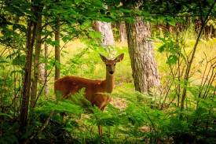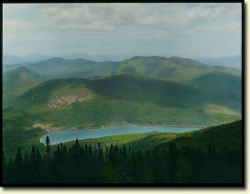
Image 1 Image 2

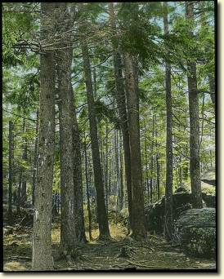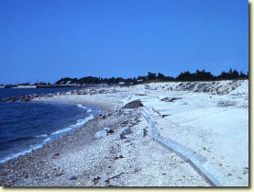
Image 3 Image 4

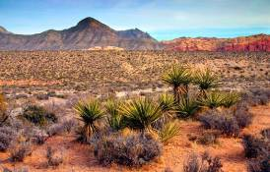
Image 5 Image 6

Teacher’s Key to Images
Image 1: Deer, lowlands, Bushnell’s Basin, New York; 43.04° N, 77.47° W.
© Hadimor.
Image 2: Adirondack Mountains, Tirrell Pond, New York; 43.85° N, 74.38 ° W.
Public domain. New York State Archives. http://iarchives.nysed.gov/PubImageWeb/viewImageData.jsp?id=80394.
Image 3: Kaaterskill Park, Greene County, New York; 42.10° N, 74.01° W.
Public domain. New York State Archives. http://iarchives.nysed.gov/dmsBlue/viewImageData.jsp?id=80821.
Image 4: Long Island Sound, Rocky Point, New York; 40.9536° N, 72.9272° W.
Public domain. New York State Archives. http://iarchives.nysed.gov/dmsBlue/viewImageData.jsp?id=185114.
Image 5: Sedona, Arizona; 34.86° N, 111.78° W.
© coleong.
Image 6: Christiansted, St. Croix, US Virgin Islands; 17.42° N, 64.46° W.
© IakovKalinin.

Supporting Question 1
Featured Source | Source B: Image bank: Elevation, climate, and natural resource maps of New York State

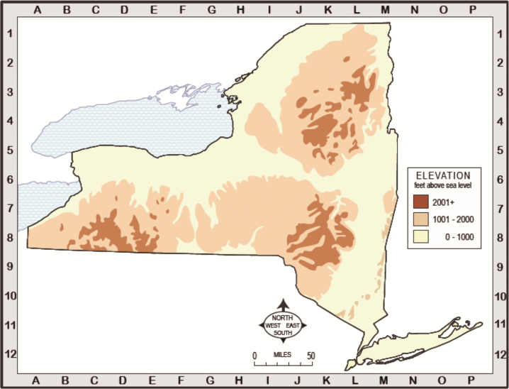
Map 1: Elevation map of New York.
© 2012 New York Geographic Alliance. Reprinted with permission.
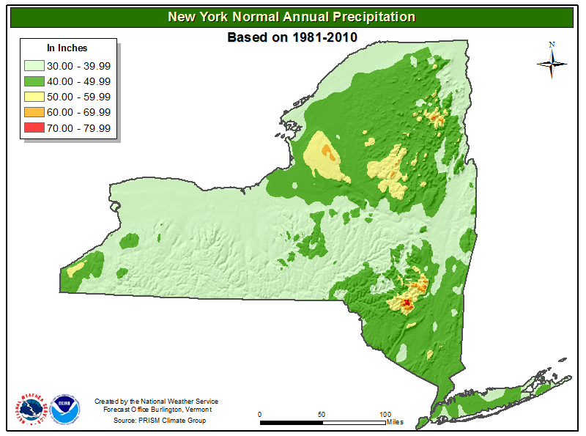
Map 2: New York normal annual precipitation.
Public domain. National Weather Service.
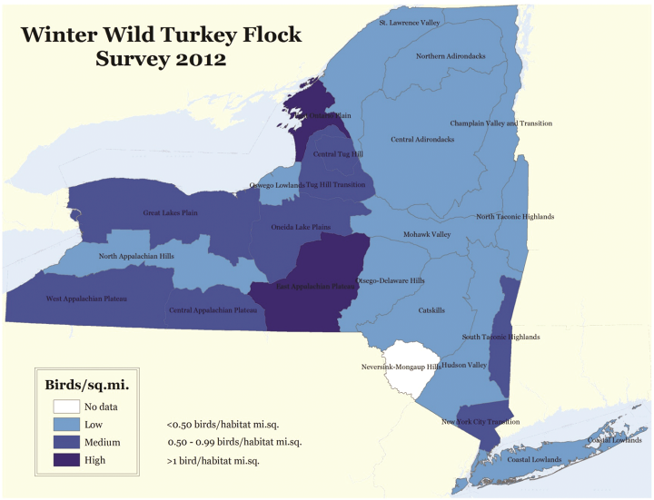
Map 3: Winter wild turkey flock survey, 2011.
Public domain. New York State Department of Environmental Conservation. http://www.dec.ny.gov/animals/82267.html.

Supporting Question 2
Supporting Question | Where in New York State did early Native Americans settle and how did physical features affect their settlements?
Formative Performance Task | Using all available maps, complete a graphic organizer that categorizes the opportunities and constraints of physical features that affected Native American settlement
Featured Sources | Source A: Haudenosaunee and Algonquian settlement map  Source B: Topographic map of New York State
Conceptual Understandings | (4.1a) Physical and thematic maps can be used to explore New York State’s diverse geography.  (4.2a) Geographic factors often influenced locations of early settlements. People made use of the resources and the lands around them to meet their basic needs of food, clothing, and shelter.
Content Specifications | Students will be able to identify and map New York State’s major physical features, including mountains, plateaus, rivers, lakes, and large bodies of water, such as the Atlantic Ocean and Long Island Sound.  Students will examine the locations of early Native American groups in relation to geographic features, noting how certain physical features are more likely to support settlement and larger populations.
Social Studies Practices | Gathering, Using, and Interpreting Evidence  Comparison and Contextualization  Geographic Reasoning

Supporting Question
For the second supporting question, students continue their investigations of New York State’s geography and their development of map-reading knowledge and skills by examining the settlement locations of two major groups of Native Americans, the Haudenosaunee and the Algonquian-speaking nations. Haudenosaunee and Algonquians are umbrella terms used to identify communities that spoke similar languages. Within the Haudenosaunee were several smaller, distinctly named groups, and the same was true for the Algonquians.
The focus of the supporting question is less on the cultural distinctions between the two groups of Native American nations and more on the relationship between the groups and their physical environments. Key to that relationship is understanding the perceptions of opportunities and constraints afforded by the local geographies. A physical environment may provide opportunities for human activities (e.g., characteristics that attract people to places, support economic needs, or provide recreation activities), but it can also impose constraints on human activities (i.e., landforms and climates that are not conducive to farming, trade, or transportation). It is important to note that physical features are not inherently opportunities or constraints—for the same feature could represent both. Instead, it is how humans perceive the possibilities and/or challenges of a physical feature that matters.
An example of the importance of geography can be seen in the names some Native groups gave to themselves. The Mohawks refer to themselves as the Keepers of the Eastern Door, which refers to their location at the eastern limit of early Haudenosaunee lands, and as People of the Flint, which refers to the plentiful supplies of chert, a form of mineral quartz that was useful in making arrowheads and other tools. Similarly, the Senecas refer to themselves as the Keepers of the Western Door and the Great Hill People, names that indicate both the geographic location and a characteristic of the local lands. (For additional examples of Native American names reflecting their physical environments, see Appendix A.)

Formative Performance Task
The formative performance task calls on students to (1) identify physical features from maps (Geographic Reasoning), (2) categorize the opportunities and constraints associated with them (Comparison and Contextualization), and (3) offer a rationale for their conclusions (Gathering, Using, and Interpreting Evidence). To support the students in this task, teachers might provide them with an analysis chart focusing on summarizing the visual evidence they see in the maps and making inferences about how certain physical features affected the survival of early Native American groups. Note that the Impact Chart provided here is only one possibility among many for approaching the task. The results of this task will contribute to Formative Performance Task 3 by providing students with examples of features that could be perceived of as opportunities and/or constraints. Students may then reference these examples as they make evidence-based claims about the interaction between Native American nations and their environments.
Opportunities and Constraints Chart
Physical features I learned about from the Haudenosaunee maps | Could this feature be an opportunity and/or a constraint? | Rationale for choice
Example: Rivers | Opportunity | Rivers can be used for transportation
Physical features I learned about from the Algonquian maps | Could this feature an opportunity  and/or a constraint? | Rationale for choice
Example: Mountains | Opportunity and constraint | Opportunity—wildlife for food; Constraint—difficult to grow crops

Featured Sources
Featured Source A presents basic information on the locations of early Native American settlements in New York State. The Haudenosaunee, who were called Iroquois by Europeans, lived in northern and central parts of New York State. The Haudenosaunee included the Mohawk, Oneida, Onondaga, Cayuga, and Seneca nations. The Algonquian peoples lived in southern and eastern New York State, in what are now called Long Island and the Hudson River Valley. The Algonquian groups included Mahicans, Munsees, Poosepatucks, Shinnecocks, and Montauks. Bodies of water were natural resources crucial to the successful settlement of Native American groups as they affected diets, shelters, trade, and mobility.
Students will note that more than the Five Nations of the Haudenosaunee are represented on the map. The Erie and Susquehannock groups were not part of what became known as the Iroquois Confederacy. They did, however, speak languages associated with the Iroquoian language family.
NOTE: Students should notice that Haudenosaunee and Algonquian lands extended beyond what is now New York State.
Featured Source B offers more specific topographic information about New York State, including elevation, lakes, and rivers. Although teachers may have students complete the formative performance task as individuals, there should be opportunities for students to work in pairs and small groups to analyze the complete set of maps, paying particular attention to the similarities and differences between the two Native groups. Students should also be able to make inferences as they look across the maps. For example, although the Mohawk nation occupied a large part of eastern New York State, much of that land was mountainous and offered potential challenges to the Mohawk people. Providing students with opportunities to verbalize their emerging understandings with a partner beforehand will help them think about and respond to the written task.

Additional Resources
The sources described earlier are featured because they offer an opportunity to talk about the kinds of sources that teachers may use to teach the inquiry and how to use them. They are not meant to be a final or exhaustive list. Additional/alternative sources include
- Eric W. Sanderson, Mannahatta: A Natural History of New York City. New York: Harry N. Abrams, 2009. (See pages 8, 18, 37–38).
- Bruce G. Trigger, ed., Handbook of North American Indians, vol. 15, Northeast. Washington, D.C.: The Smithsonian Institution Press, 1978.
Teachers and students are also likely to find engaging resources regarding Native life in their local libraries and museums.

Supporting Question 2
Featured Source | Source A: Haudenosaunee and Algonquian settlement map

Early Native American nations of New York State.
Created for the New York State K–12 Social Studies Toolkit by Binghamton University, 2015.

Supporting Question 2
Featured Source | Source B: Topographic map of New York State

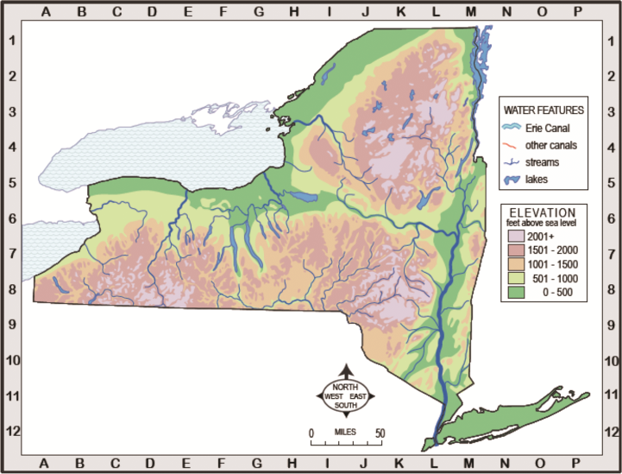
© 2012 New York Geographic Alliance. Reprinted with permission.

Supporting Question 3
Supporting Question | How did the early Native Americans in New York State interact with their physical environment to meet their needs?
Formative Performance Task | Develop and support a series of claims about how the Haudenosaunee and Algonquians modified and adapted to their physical environments
Featured Sources | Source A: Haudenosaunee Guide for Educators (excerpts)  Source B: The People of the Shore: Shinnecocks of Long Island
Conceptual Understanding | (4.2a) Geographic factors often influenced locations of early settlements. People made use of the resources and the lands around them to meet their basic needs of food, clothing, and shelter.
Content Specifications | Students will examine the locations of early Native American groups in relation to geographic features, noting how certain physical features are more likely to support settlement and larger populations.  Students will investigate how Native Americans, such as the Iroquois (Haudenosaunee) and the Algonquian-speaking peoples adapted to and modified their environment to meet their needs and wants.
Social Studies Practices | Gathering, Using, and Interpreting Evidence  Geographic Reasoning  Economics and Economic Systems

Supporting Question
The supporting question asks students to focus on how early Native Americans in New York State interacted with their physical environment to meet their needs. Features of one’s physical environment appear to offer opportunities and constraints. Those opportunities and constraints, however, are neither immutable nor one directional—humans have the capacity to adapt to a physical feature and/or modify it. A physical feature that might seem a constraint in one sense (i.e., mountains are challenging for growing crops) can be perceived as an opportunity in another (i.e., mountains can protect communities from unfriendly people).

Formative Performance Task
The formative performance task asks students to gather evidence from text and to make and support geographic and economic claims related to the supporting question on the Interaction Chart. As secondary accounts, the featured sources for this task are content rich, so students will need to read closely and carefully to pull information from them. In particular, students should be able to draw low-level inferences about how Native groups responded to their environments (Geographic Reasoning) and how they capitalized on nearby natural resources to meet their wants and needs (Economics and Economic Systems). The inferences students draw are considered low level in this case because the text is relatively explicit. For example, students will find the sentence, “The longhouse frame was made from cedar or hickory poles.” Assuming that students know that cedar and hickory are kinds of trees, they should be able to make a claim about trees being used to construct shelters.
After constructing a number of claims and citing the evidence for them, students are asked to identify what they think their arguments will be. Doing so at the end of this task, gives students a chance to rehearse their arguments before completing the Summative Performance Task. Teachers may have students share their charts with peers in order to check the relationships between their claims and evidence and whether their claims logically support their preliminary arguments. Students can then be encouraged to go back to their own charts and make revisions based on their peers’ feedback. Alternatively, teachers may create a jigsaw experience where each small group of students is responsible for creating one or two claims around portions of the text that they can then share with their peers to help them complete their charts.
In introducing the task and supporting question, teachers may want to emphasize the vocabulary term “interaction,” noting that students will encounter evidence of how the Native Americans both adapted to and modified the physical environment through their interactions. This reciprocal relationship defines the inquiry behind the compelling question.

Interaction Chart
How did the early Native Americans in New York State interact with (modify and adapt to) their physical environment to meet their needs?
Source A:  Excerpt 1: “Longhouses and Village Life” | Claim(s): Example: They used natural resources to build their housing
 | Evidence: The Haudenosaunee used cedar or hickory poles to frame their longhouses.
Excerpt 2: “Relationship to the Natural World” | Claim(s):
 | Evidence:
Excerpt 3: “The Importance of Deer” | Claim(s):
 | Evidence:
Source B:  The People of the Shore | Claim(s):
 | Evidence:
I think my argument will be:

Featured Sources
featured source A The National Museum of the American Indian’s Haudenosaunee Guide for Educators offers a range of ideas to explore. In the first excerpt (“Longhouses and Village Life,” p. 5), the following ideas surface: The Haudenosaunee used natural resources to meet their basic need for housing, villages were strategically built within clearings near forested areas and near sources of fresh water to meet food and shelter needs, and the scarcity of resources influenced patterns of relocation. In the second excerpt (“Relationship to the Natural World,” p. 10–11), the Haudenosaunee commitment to “maintain a reciprocal relationship with the land” is explained. This idea presents an opportunity to highlight and emphasize the vocabulary term “reciprocal” and to explore how the same physical feature may be both an opportunity and a constraint. Finally, the third excerpt (“The Importance of Deer,” p. 12) explains how the Haudenosaunee used all parts of the deer to meet their needs for food and clothing. Teachers may ask students to consider how other animal species were used to meet Native Americans’ wants and needs.
Featured Source B The People of the Shore: Shinnecocks of Long Island provides information about this Algonquian-speaking group who lived on Long Island. The images and text provide information about how food, clothing, and shelter needs were met through interaction with environment. This source provides insight into how archaeologists use artifacts to determine how early people lived, as well as information about the current members of the Shinnecock Indian Nation. For students who need assistance navigating the texts, teachers should consider having them partner-read with other students or do a whole-group reading of the texts before asking students to begin their analyses.

Additional Resources
The sources described earlier are featured because they offer an opportunity to talk about the kinds of sources teachers may use to teach the inquiry and how to use them. They are not meant to be a final or exhaustive list. Additional/alternative sources include:
- Information on Haudenosaunee clothing: http://www.tuscaroras.com/graydeer/pages/childrenspage.htm.
- Information about Haudenosaunee food and hunting: http://www.haudenosauneeconfederacy.com/foodandfarming.html.
- Charles T. Gehring and William A. Starna, trans. and eds., A Journey into Mohawk and Oneida Country, 1634-35: The Journal of Harmen Meyndertsz van den Bogaert, revised ed., Syracuse: Syracuse University Press, 2013.
- George O’Connor, Journey into Mohawk Country, New York: First Second, 2006.
- William A. Starna, From Homeland to New Land: A History of the Mahican Indians, 1600-1830, Lincoln, NE: University of Nebraska Press, 2013.

Supporting Question 3
Featured Source | Source A: National Museum of the American Indian Education Office, description of Haudenosaunee interaction with the physical environment, Haudenosaunee Guide for Educators, 2009
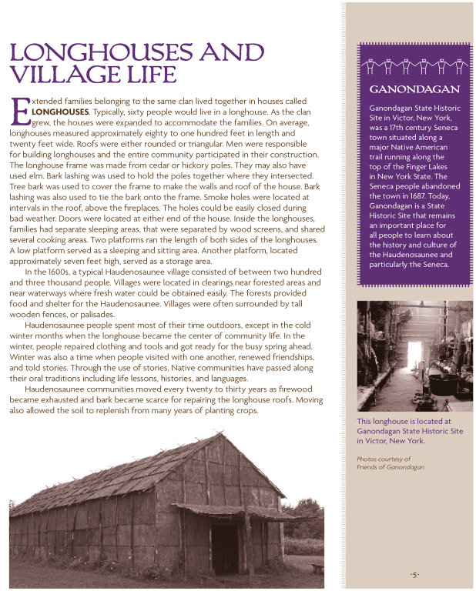
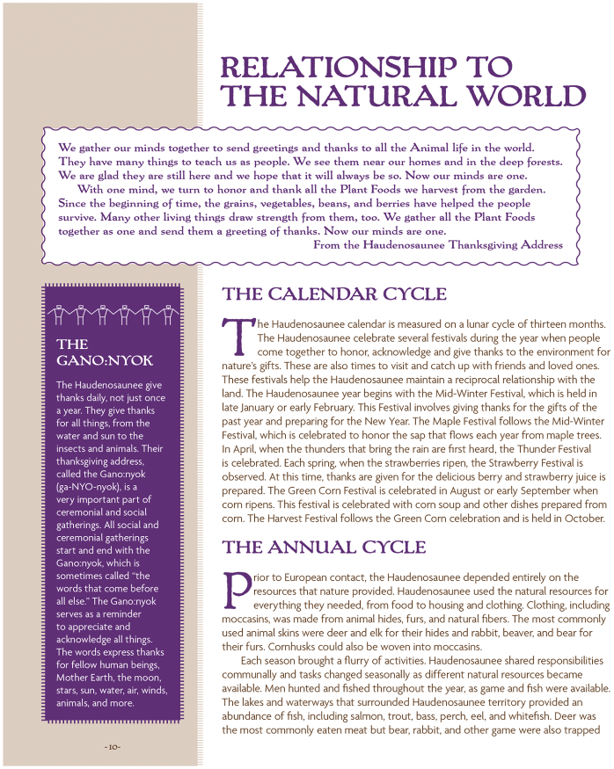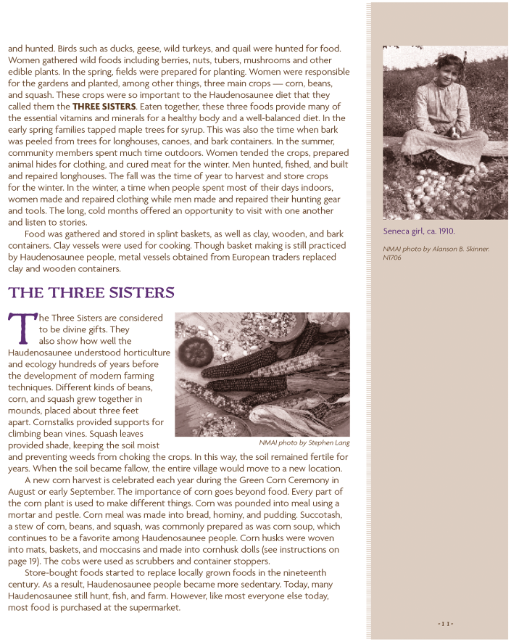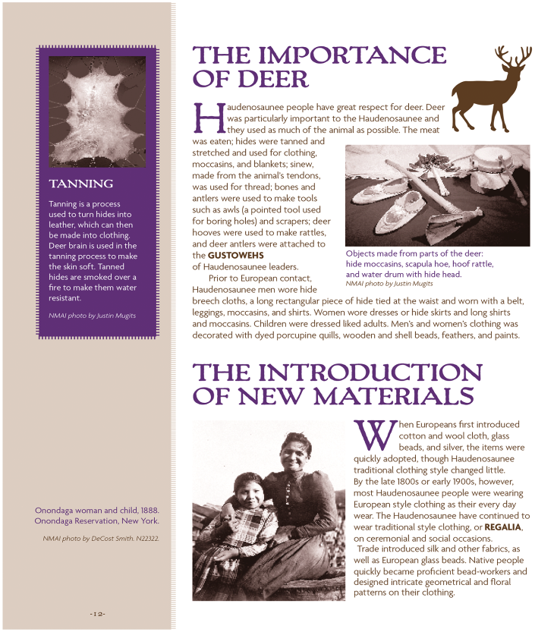
Reprinted from Haudenosaunee Guide for Educators. Copyright © 2009 NMAI, Smithsonian Institution. Used with permission. http://nmai.si.edu/sites/1/files/pdf/education/HaudenosauneeGuide.pdf.

Supporting Question 3
Featured Source | Source B: Patricia Polan, description of Shinnecock life, The People of the Shore: Shinnecocks of Long Island, 2016

The People of the Shore: Shinnecocks of Long Island
By Patricia Polan
INTRODUCTION
The Shinnecock Indian Nation is a tribe recognized by the federal government whose home community and reservation are a short distance west of Southampton, New York. (Refer back to Supporting Question 2 Source A to see where they had lived prior to English settlers arriving.) These native people, who spoke an Eastern Algonquian language, have lived on eastern Long Island since before the arrival of Europeans early in the seventeenth century. The Shinnecock Nation Culture Center and Museum is located on tribal land and is open to the public. This source explains the food, clothing, and dwellings of Shinnecocks along with wampum making and whaling.
ARCHAEOLOGICAL EVIDENCE
To learn something about people who had lived in the past, scientists called archaeologists carry out excavations--digs--where artifacts and other evidence of human activity are found. From these materials they draw conclusions about the daily lives of Native people. The Sebonac site discovered near today's Shinnecock reservation has provided archaeologists with information about the lives of these Native people from centuries ago.
At this site, there were mounds that prompted archaeologists to investigate the area. They found shells from oysters, hard and soft clams, scallops, mussel, whelk and crab in the mounds. In the vicinity, they also found evidence of bones from deer, raccoon, muskrat, and wild fowl, as well as shells from land snails and turtles. They found the charred remains of corn cobs and hickory nuts, tools made from bones and antlers and fragments of pottery.
The archaeologists located pits that were broad and basin-shaped, about six feet across and two to three feet deep. Shinnecocks used pits to cook food by lining them with stones, building a fire on top of the stones, and keeping it burning until the stones were hot. The food to be cooked was placed on top of the hot stones. To prepare other foods from corn or nuts, the people used stone pestles to grind in wooden mortars. Pottery made from clay was used for cooking. Utensils for eating included cups, bowls and spoons made of turtle shell and wood.
At the site, the archaeologists also found evidence of circular dwellings that were about twenty feet in diameter. There was evidence of arrow heads, fish hooks, harpoons, and sinkers which led researchers to conclude that hunting with bow and arrow and fishing were important to the people who used to live here.
TOOLS
The remains that archaeologists recover from sites are usually items that do not decay over time. Even so, food remains along with wooden and bone tools and sometimes woven nets and basket fragments are often found, providing more information about native culture. The descendants of indigenous people created tools as their ancestors had. The Shinnecocks used wood to make objects like these—one is a pot scrubber and the other is a broom.
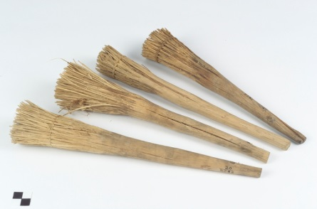
Scrub brush, pot scrubber
National Museum of the American Indian
Smithsonian Institution
(Catalog Number 20/5282)

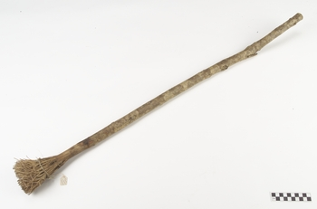
Broom
National Museum of the American Indian
Smithsonian Institution
(Catalog Number 20/5283)

HOUSES
The houses of the Shinnecock are called wigwams. These houses were constructed using small trees, or saplings, or poles which were driven into the ground, then bent and tied together to form a dome-shaped frame or framework. Other poles were lashed horizontally to the frame. The frame was covered with woven mats or bark sheets. The woven mats were made of leaves, rushes, or cattails. A hole was left open at the top for smoke from the fire to escape. Inside, there was a fire pit in the center. A bench would serve as a bed, table or seat. Items could be stored under the bench. There was an opening to serve as a door, which could be covered with a curtain of animal skin.
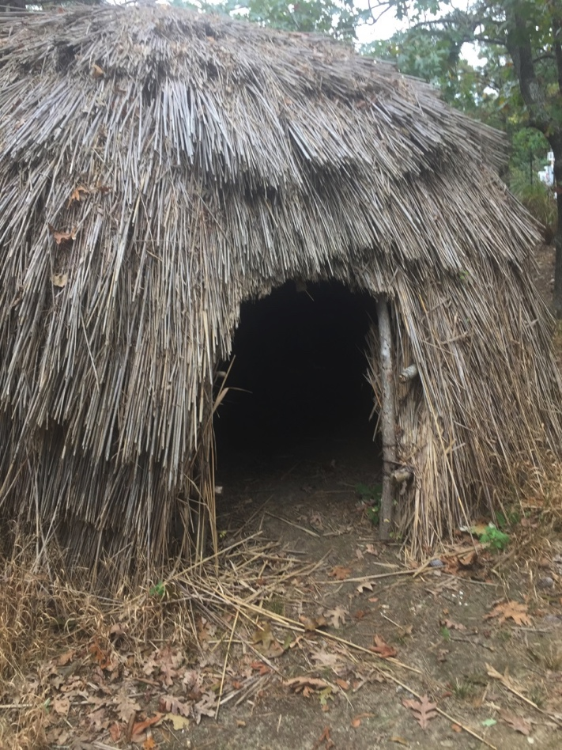
Wigwam located in Wikun Village
Shinnecock Nation Cultural Center and Museum
Photo by Patricia Polan

The Shinnecocks would move with the seasons and to be closer to resources. Some wigwams would be found near the fields where Shinnecocks grew corn, beans and squash. Others would be located near streams where fish could be caught. Still others would be near the shore in late summer and fall. In the winter, Shinnecocks would move inland. Other wigwams would be erected closer to hunting grounds.
FOOD
The Shinnecocks lived in a rich environment that provided them with a variety of foods. The fruits native to Long Island include mulberries, grapes, huckleberries, raspberries and strawberries. Butternuts, walnuts, acorns, hickory nuts and chestnuts were gathered in the fall. These nuts were husked and dried for later use. Then these were ground into coarse flour using a mortar and pestle and used in soups and stews.
Deer, bear, wolves, foxes, raccoons, opossum, rabbit, squirrel, weasel/mink, muskrat and beaver were hunted, along with turkey, duck, quail, partridges, pigeons, and geese. Seafood that was available included oysters, clams, scallops, lobsters, and crabs. Fish included bluefish, flounders, herring, bass, perch, trout and eels. Turtles and frogs were also part of their diet.
Shinnecocks also were farmers. They grew corn, beans, squash, and tubers, specifically, the Jerusalem artichoke which is in the sunflower family. Tubers are plants with thick, edible roots. Tobacco was also grown.
WAMPUM
The Shinnecocks and other Native people in the region made use of shells found in the waters of Long Island Sound, including whelk and the hard shell clam or quahog. The central column of the whelk was used to make white beads of various sizes and shapes to be worn as pendants and necklaces or attached to clothing. Later on, small, barrel-shaped, white beads were made from the whelk along with identically-shaped purple beads from quahog shells. Strung into strings or woven into belts, wampum was and in some cases is still used for a variety of purposes: as ornamentation, in trade, in ceremonies, in gift exchange, in treaty agreements, and as a currency.
Broom
National Museum of the American Indian
Smithsonian Institution
(Catalog Number 20/5283)
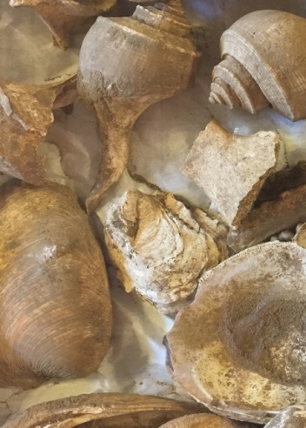
The spiral shell is a whelk and the larger shell is a quahog. These shells were found at an archaeological site.
On display at Shinnecock Nation Cultural Center and Museum.
Photo by Patricia Polan

IMAGES FROM LONG ISLAND
Beverly Jensen and David Martine are members of the Shinnecock Nation. Jensen’s book, Images of America: Shinnecock Indian Nation, provides the following photographs and explanations about Shinnecocks and their environment. Martine’s images provide an artist’s impression of Shinnecock life.
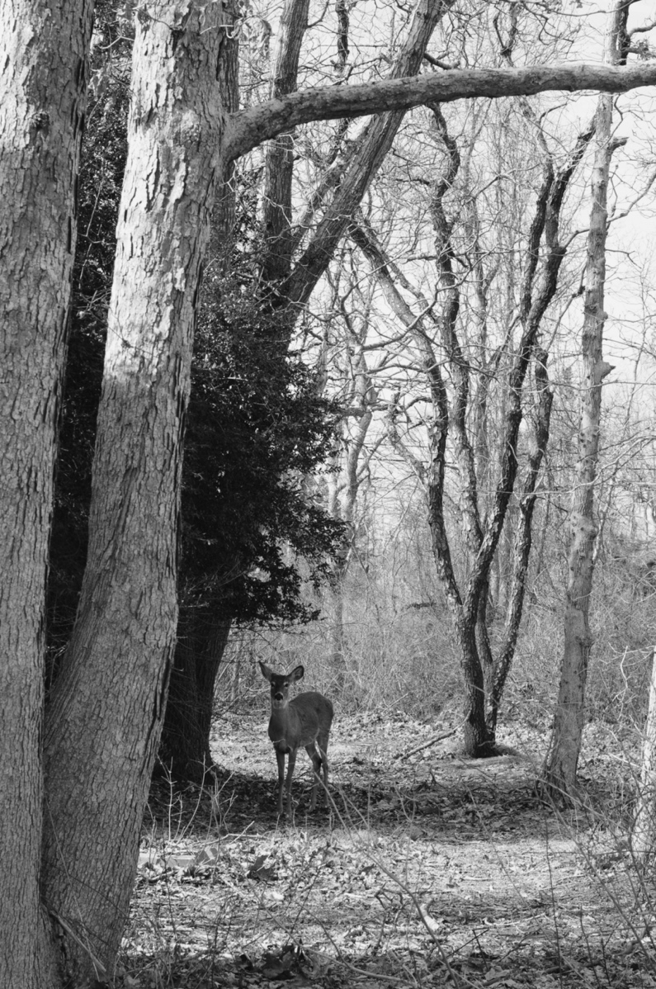
Deer was important to people of tradition. In addition to being a mythical symbol in some creation stories, deer has and continues to be a source of food. The meat can be cooked in a variety of ways, and deer dishes often show up on dining tables during winter months. One Shinnecock recently perfected a recipe for deer chili. Deer hide is used for male and female articles of clothing as well as moccasins and boots. In fact, every part of the deer is useful.
Caption and photograph by Beverly Jensen. Reprinted from Images of America: Shinnecock Indian Nation by Beverly Jensen. Arcadia Publishing, 2015, p. 10.
The Shinnecocks made use of edible plants, herbs, and berries. There were wild strawberries that grew in such abundance that, when in bloom, it looked as though snow covered the ground. Wild grapes also grew in this area. The forest provided a variety of nuts from trees including black walnuts, hickory nuts, butternuts, and chestnuts. Today, the Shinnecock Nation Cultural Center and Museum celebrate the importance of strawberries with an annual strawberry festival.
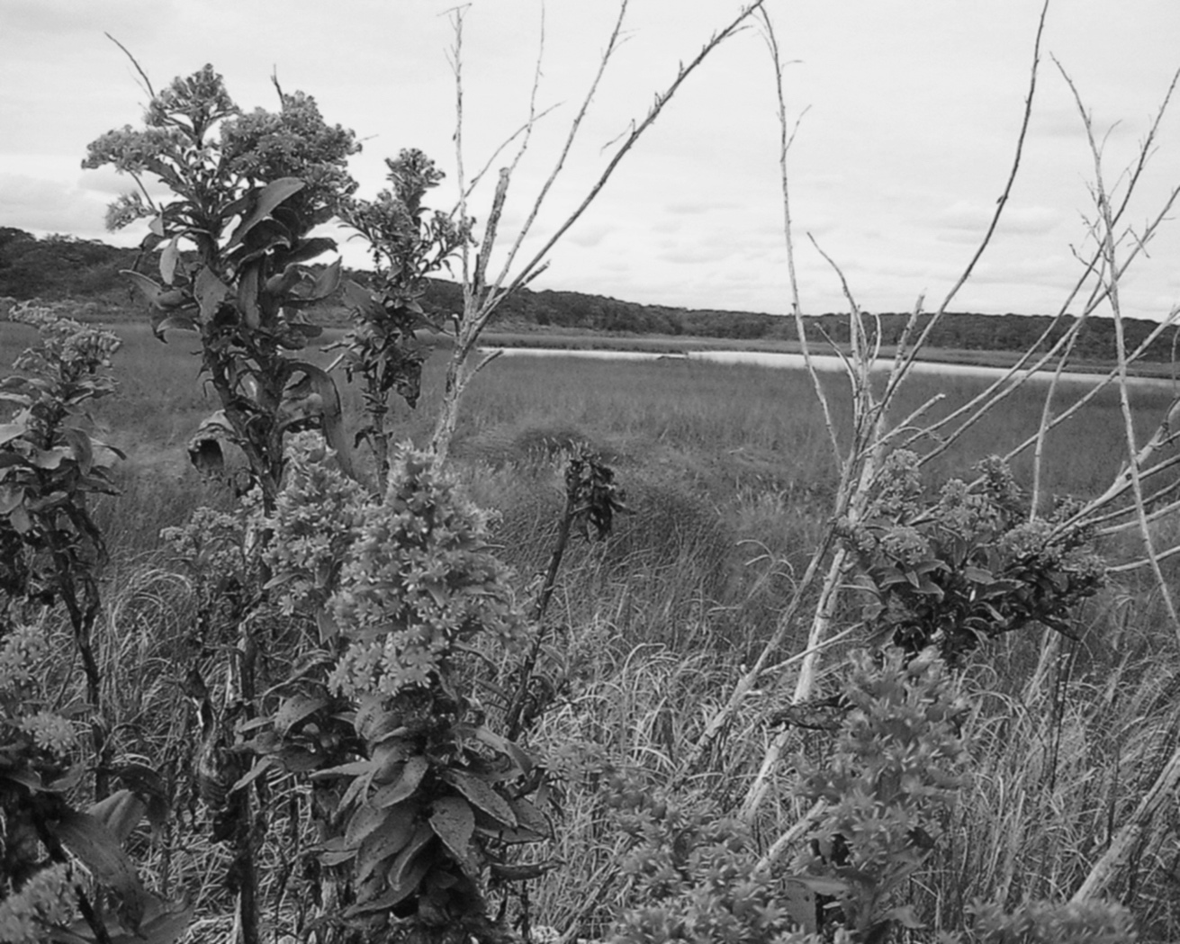
Ryer’s Creek at the southern end of the reservation is a quiet spot accessible by foot after a trek through woods or by boat from Shinnecock Bay or Heady Creek. The marshes around the creek are natural nesting places for shorebirds, and the woods just off the creek are favored camping sites of tribal members.
Caption and photograph by Beverly Jensen. Reprinted from Images of America: Shinnecock Indian Nation by Beverly Jensen. Arcadia Publishing, 2015, p. 20.
Some Shinnecocks were noted carvers of duck decoys, modeling their work on the fowl found in marshes on the reservation. They also served as guides for hunting shorebirds. Today, Shinnecock culture is shared at the Powwow held annually in September on the reservation.
Not to be forgotten is the seafaring heritage of the Shinnecock. From their dugout canoes, they tackled the mighty Atlantic Ocean hunting and harvesting right whales and successfully towing them back to land. Because of their expertise, Shinnecock whalers of the 18th and 19th centuries were often sought out as crew on whaling vessels out of eastern Long Island seaports, such as Sag Harbor. The whale pictured here was spotted from a vessel out of Montauk in June 2014.
Caption and photograph by Beverly Jensen. Reprinted from Images of America: Shinnecock Indian Nation by Beverly Jensen. Arcadia Publishing, 2015, p. 21.

WHALING
Whales could be found in the waters off the coast of Long Island usually in the late fall and into the spring. When whales beached on the shores of Long Island, people considered them community property and all would share in the work of cutting the whale for its meat. After colonists arrived, it was understood that a whale was to be shared and some deeds to land spelled out the rights of natives to the whale tail bone and fins when whales were found on shore.
The colonists recognized that Shinnecocks were skilled whale hunters and hired them to work on ships. These ships would sail far from Long Island in search of whales, even around South America to the Arctic Ocean.

David Bunn Martine is an artist who was born in Southampton, New York in 1960. He has lived on the Shinnecock Indian Reservation and has served as the director of the Shinnecock Nation Cultural Center and Museum. He has given permission for use of these images. For more information about David Martine, please see http://david martine.com.
Powdawe
Shinnecock Whale Hunt—17th Century

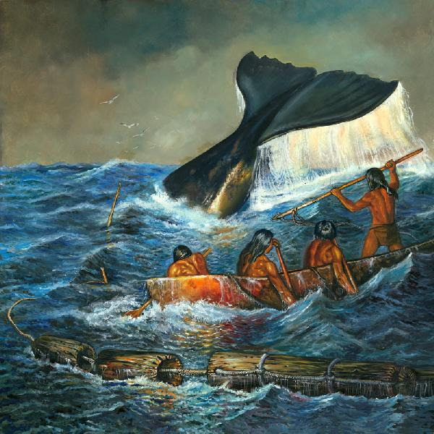

Powdawe, or whale hunt, was a challenge for the Shinnecocks. The strategy used was to wound the whale using a harpoon so that it could then be brought to shore.

Shinnecock Potedaup (Whale) Ceremony—17th Century

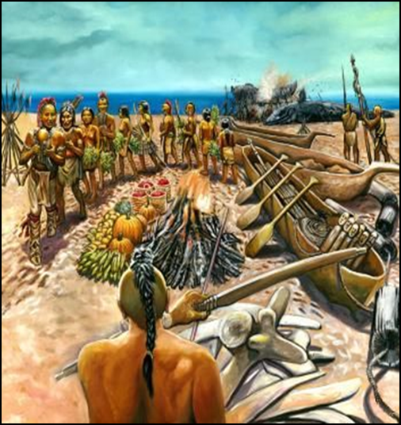

The Shinnecocks acknowledged the gift of the whale (potedaup) with a special ceremony. This ceremony involved a special dance around the sacred fire.

CONCLUSION
The Shinnecocks made use of resources they found in their environment. They were able to initially survive with whatever food from the sea, marshes or woods they could find. Later, they became involved in farming. Over time, as more and more people moved to Long Island, the Shinnecock were forced to sell or surrender their lands. Today, the Shinnecock reservation which is slightly larger than one square mile serves as home for over 600 people.

Sources
Bradley, James W. (2011) “Re-Visiting Wampum and other Seventeenth-Century Shell Games.” Archaeology of Eastern North America, Vol. 39 (pp.25-51). Accessed electronically 2/1/17 http://www.jstor.org/stable/23265113
Denton, Daniel. (1670). A Brief Description of New-York: Formerly Called New-Netherlands. London. (Paul Royster, editor & depositor, University of Nebraska-Lincoln) accessed electronically 1/24/2017 at http://digitalcommons.unl.edu/cgi/viewcontent.cgi?article=1025&context=libraryscience)
Jensen, Beverly. (2015). Shinnecock Indian Nation. Charleston, South Carolina: Arcadia Publishing.
Ritchie, William A. (1980). The Archaeology of New York State (Revised Edition). Fleischmanns, New York: Purple Mountain Press.
Salwen, Bert. (1978). “Indians of Southern New England and Long Island: Early Period.” In Trigger, Bruce G., ed. Handbook of North American Indians: Northeast (Volume 15). Washington: Smithsonian Institution.
Starna, William. (1990). “The Pequots in the Early Seventeenth Century.” In Hauptman, Laurence M. and Wherry, James D., eds. The Pequots in Southern New England: The Fall and Rise of an American Indian Nation. Norman: University of Oklahoma Press.
Stone, G. (Ed.). (1983). The Shinnecock Indians: A culture history. Stony Brook, NY: Suffolk County Archaeological Association.
Strong, J. (1983). “The Evolution of Shinnecock Culture.” In G. Stone (Ed.), The Shinnecock Indians: A culture history (pp. 7-51). Stony Brook, NY: Suffolk County Archaeological Association.

Summative Performance Task
Summative Performance Task | Argument How does where you live matter? Construct an argument supported with evidence that addresses the question of how physical features and available resources influenced the locations of early Native American settlements in New York State. Express this argument in the form of an essay.
 | Extension Express these arguments through PowerPoint presentations that highlight the ways in which the Haudenosaunee and Algonquians adapted to and modified their physical environments.
In this task, students write an extended, evidence-based argument responding to the compelling question. Although they may not be expected include counterclaims and evidence for them in this response, students should be able to demonstrate the ability to state their arguments coherently and to identify relevant pieces of evidence that support those arguments.
At this point in the students’ inquiry, they have identified examples of the diverse geography and natural resources of New York State, located physical features on various maps of New York State, described where early Native Americans lived, categorized the impact of their immediate physical surroundings, and identified text-based evidence to support their claims about how the early Native Americans in New York State interacted with their physical environments.
Before the Summative Performance Task, it may be helpful for students to review the sources provided and the graphic organizers created during the formative performance tasks. Doing so should help them develop their claims and highlight the appropriate evidence to support their arguments. Rehearsing their arguments, claims, and evidence orally may help students succeed on the task.
Students’ arguments will likely vary, but could include any of the following:
- Early Native Americans had to use the land and resources around them in different ways to meet their needs and wants.
- The physical features and natural resources of New York are different throughout the state, and so Native American groups developed different ways to live in their environments.
- The environment of a location offers opportunities and constraints for humans, and so the early Native Americans settled in places that best fit their lives.
- Early Native Americans proved that where people live is not as important as they ways in which they adapt to and change their environments.
It is possible for students to find support for any of these arguments in the sources provided and through their analysis of the sources.

Extension
Having students construct their evidence-based arguments in written form is one way of representing their new knowledge and understandings, but there is any number of alternatives. One way to have students express their arguments and evidence is through the creation of Power Point presentations. Working in small, mixed-ability groups, students might (1) work with the same prompt (i.e., using the case studies of how the Haudenosaunee and Algonquians adapted to and modified their physical environments to make an argument about whether where one lives matters) or (2) be split up such that half of the class responds to the prompt by focusing on the Haudenosaunee and the other half on the Algonquians.

Taking Informed Action
Compelling Question | Does where you live matter?
Taking Informed Action | Understand Brainstorm a list of the geographic opportunities and constraints in area neighborhoods and communities.  Assess Discuss how individuals and communities can turn constraints into opportunities.  Act Arrange for a local official to visit the class to review the class conclusions and discuss possible community actions.
Taking informed action can manifest in a variety of forms and in a range of venues. Students may express action through discussions, debates, surveys, video productions, and the like; these actions may take place in the classroom, in the school, in the local community, across the state, and around the world. The three activities described in this inquiry represent a logic that asks students to (1) understand the issues evident from the inquiry in a larger and/or current context, (2) assess the relevance and impact of the issues, and (3) act in ways that allow students to demonstrate agency in a real-world context.
For this inquiry, students draw on their overall understandings of the reciprocal relationships between humans and their environments through the case study of early Haudenosaunee and Algonquian settlements to explore the opportunities and constraints that they and their communities experience today.
To understand the situation, students may go through an oral and/or written brainstorming activity in which they list the opportunities and constraints afforded in their neighborhoods and community. To follow up from this exercise, students might ask family members to brainstorm similar lists and then compare and contrast those lists with the list developed by the class. To assess their understandings of the local environment, students may discuss in small-group or whole-group settings how constraints might be transformed into opportunities. For example, an undeveloped hilly area might be reimagined as a winter sledding park. And to act on the emerging class understandings, students might send their ideas for transforming one or more local areas to a community official and then invite the official to class to discuss the possibilities for and the process by which the students’ ideas could come to fruition. As teachers and students bring their taking informed action activities to a close, they might consider the idea of how their ideas might be sustainable and lead to the protection of the environment for the community’s benefit.

Common Core Connections
Social studies teachers play a key role in enabling students to develop the relevant literacy skills found in the New York State P–12 Common Core Learning Standards for English Language Arts and Literacy. The Common Core emphasis on more robust reading, writing, speaking and listening, and language skills in general and the attention to more sophisticated source analysis, argumentation, and the use of evidence in particular are evident across the Toolkit inquiries.
Identifying the connections with the Common Core Anchor Standards will help teachers consciously build opportunities to advance their students’ literacy knowledge and expertise through the specific social studies content and practices described in the annotation. The following table outlines the opportunities represented in the Grade 4 Inquiry through illustrative examples of each of the standards represented.
Compelling Question | Does Where You Live Matter?

Common Core Anchor Standard Connections
Reading | CCSS.ELA-LITERACY.CCRA.R.1 Read closely to determine what the text says explicitly and to make logical inferences from it; cite specific textual evidence when writing or speaking to support conclusions drawn from the text.  See Formative Performance Task 1: Students view a series of images and maps in order to describe, illustrate, and name key geographic features in New York State.  CCSS.ELA-LITERACY.CCRA.R.4 Interpret words and phrases as they are used in a text, including determining technical, connotative, and figurative meanings, and analyze how specific word choices shape meaning or tone.  See Formative Performance Task 3: The secondary texts on Native life provide a range of occasions through which students can build their denotative and connotative word skills.
Writing | CCSS.ELA-LITERACY.CCRA.W.1 Write arguments to support claims in an analysis of substantive topics or texts using valid reasoning and relevant and sufficient evidence.  See Summative Performance Task: Students write an extended, evidence-based argument responding to the compelling question  CCSS.ELA-LITERACY.CCRA.W.5 Develop and strengthen writing as needed by planning, revising, editing, rewriting, or trying a new approach.  See Formative Performance Task 3: Students share the results of their Interaction Charts with peers and then rework them based on feedback.
Speaking and Listening | CCSS.ELA-LITERACY.CCRA.SL.1 Prepare for and participate effectively in a range of conversations and collaborations with diverse partners, building on others’ ideas and expressing their own clearly and persuasively.  See the featured sources for Formative Performance Task 2: Students work in pairs and small groups to analyze the complete set of maps with particular attention given to the similarities and differences between the two Native groups.  CCSS.ELA-LITERACY.CCRA.SL.6 Adapt speech to a variety of contexts and communicative tasks, demonstrating command of formal English when indicated or appropriate.  See Taking Informed Action: Students send their ideas for transforming one or more local areas to a community official and invite the official to class to discuss the possibilities for and the process by which the students’ ideas could come to fruition.
Language | CCSS.ELA-LITERACY.CCRA.L.3 Apply knowledge of language to understand how language functions in different contexts, to make effective choices for meaning or style, and to comprehend more fully when reading or listening.  See Formative Performance Task 2: Students identify examples of features that could be perceived of as opportunities and/or constraints.

Appendix A: Geography Inquiry Vocabulary
Term | Definition
adaptation | Changes that humans make to their behaviors based on their perceptions of the physical environment.
Algonquians | The term for a group of politically independent, but language similar, Native American nations whose lands included the eastern part of New York State. Today the only land holdings that remain in Native American hands are the Shinnecock Reservation and Poospatuck Reservation.
Cayugas | People of the Great Swamp; Haudenosaunee nation whose lands were located in Central New York State.
climate | Patterns of weather in a region.
compass rose | A diagram of directions represented on a map.
confederacy | A generally loosely formed political group of otherwise independent entities.
constraint | Perceived disadvantages of a physical environment.
diversity (geographic) | Differences in the kinds of physical features in an area.
elevation | A measurement of the height of a physical feature.
Erie | Nation of Iroquoian-language speakers whose lands were located in Southwestern New York.
geography | The study of the earth’s physical features.
Haudenosaunee | The term for a group of independent, but politically and culturally similar, Native American nations whose lands include large parts of New York State.
interaction | The ways in which humans modify and adapt to their physical environment.
Iroquois Confederacy | A name given to the Five Nations of Haudenosaunee (Mohawk, Oneida, Onondaga, Cayuga, and Seneca nations) to which the Tuscaroras later joined.
legend | A key to the features represented on a map.
longhouse | A large, rectangular house constructed with wooden poles and sheets of tree bark.
Mahicans | People of the Waters that Flow Both Ways; Algonquian nation whose lands were located in Eastern New York State. Their descendants today are the Stockbridge-Munsees of Wisconsin.
Mohawks | People of the Flint; Keepers of the Eastern Door; Haudenosaunee nation whose lands were located in Eastern New York State
Montauks | Algonquian nation whose lands were located on the eastern end of Long Island, New York.
modification | Changes that humans make to the physical environment.
Munsees | The group of natives who resided in the Hudson Valley, Manhattan, eastern New Jersey, and western Long Island.
Native Americans | The original peoples of the Americas.
natural resources | Elements of the physical environment for which humans find uses.
Oneidas | People of the Standing Stone; Haudenosaunee nation whose lands were located in Central New York State. Today there are three Oneida communities, the Oneida Indian Nation (New York), the Oneida Nation of Wisconsin and the Oneida Indian Nation of the Thames (Ontario).
Onondagas | People of the Hills; Haudenosaunee nation whose lands are located in Central New York State
opportunity | Perceived advantages of a physical environment.
Poosepatucks | Algonquian nation whose lands are located on Long Island, New York
physical feature | Identifiable element of a physical environment (e.g., lakes, mountains, and forests).
precipitation | Any form of water in the atmosphere that falls to the earth (e.g., snow, rain, and sleet).
scarcity | The state of insufficient resources to satisfy all wants and needs.
Senecas | Great Hill People; Keepers of the Western Door; Haudenosaunee nation whose lands are located in Western New York State.
Shinnecocks | Algonquian nation whose lands are located on Long Island, New York
Susquehannocks | Nation of Iroquoian-language speakers whose lands were located in Southeastern Pennsylvania.
Three Sisters | The name given to crops central to Native American diets (corn, beans, and squash).
topographical map | A representation of the earth’s surface that highlights physical features.
transportation | The ability to move around a physical environment.
village | A place where a group of people settles and builds their homes.
wampum | Beads made from various shells that were and are still used by various Native nations throughout northeastern North America for ornamental or ceremonial use.
weather | The day-to-day state of the earth’s atmosphere.
wigwam | A domed dwelling with a round or oval floor plan constructed with wooden poles, tree bark, and mats woven from reeds or rushes.

