8th Grade Suburbs Inquiry
Were Suburbs Good
for America?
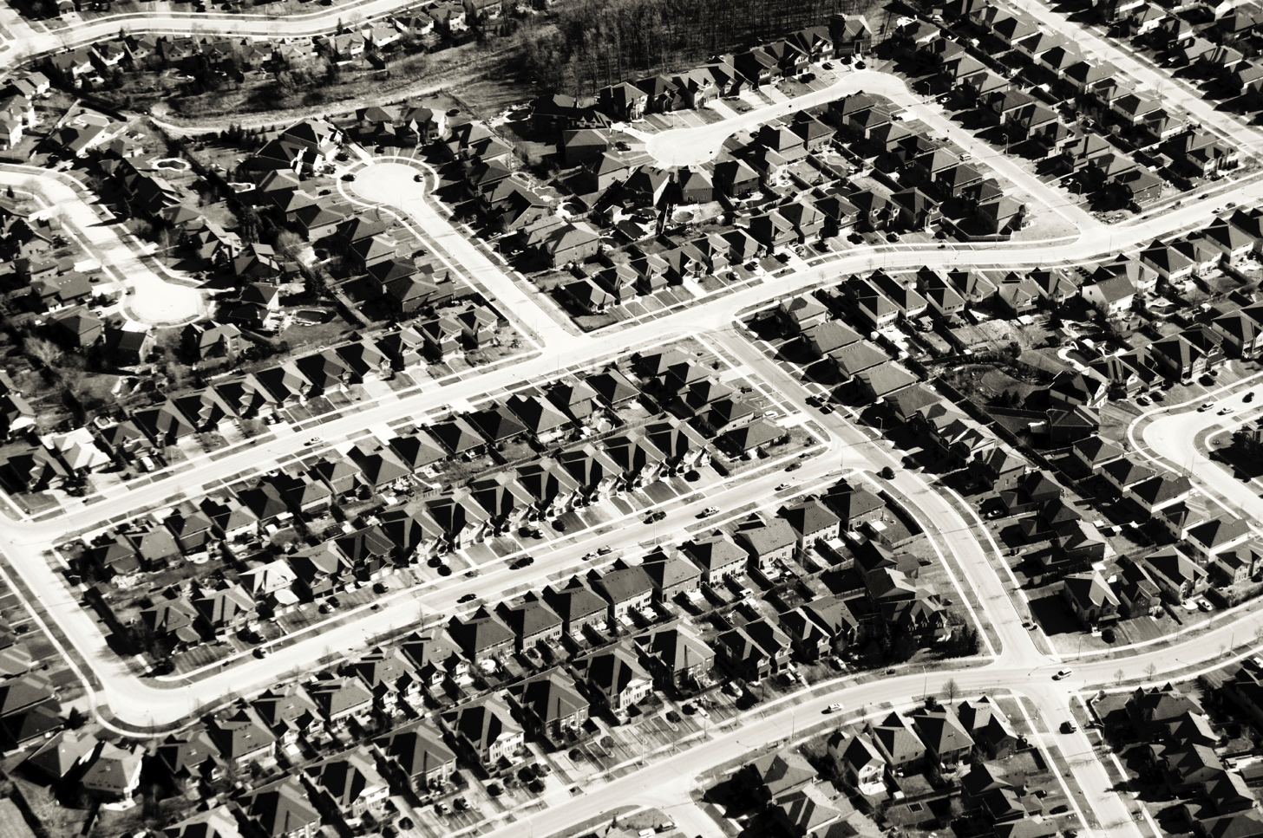
© iStock/© Stacey Newman.

Supporting Questions
- What were the economic and social conditions in the United States after World War II?
- How and why did suburbs grow in the 1950s?
- What were the potential benefits of suburbanization?
- What were some of the problems that suburbanization created?

8th Grade Suburbs Inquiry
Were Suburbs Good for America?
New York State Social Studies Framework Key Idea & Practices | 8.8 DEMOGRAPHIC CHANGE: After World War II the population of the United States rose sharply as a result of both natural growth and immigration. Population movements have resulted in changes to the American landscape and shifts in political power. An aging population is affecting the economy and straining public resources.  Gathering, Using, and Interpreting Evidence Comparison and Contextualization  Geographic Reasoning Economics and Economic Systems
Staging the Compelling Question | Brainstorm characteristics of the local community that are both positive and negative.

Supporting Question 1 |  | Supporting Question 2 |  | Supporting Question 3 |  | Supporting Question 4
 |  |  |  | Research
What were the economic and social conditions in the United States after World War II? |  | How and why did suburbs grow in the 1950s? |  | What were the potential benefits of suburbanization? |  | What were some of the problems that suburbanization created?
Formative  Performance Task |  | Formative  Performance Task |  | Formative  Performance Task |  | Formative  Performance Task
List the economic and social conditions in the United States after World War II. |  | Create a T-chart comparing public and private activities that encouraged suburban growth in the 1950s. |  | Make a claim supported by evidence about the positive effects of suburbanization. |  | Make a claim supported by evidence about the negative effects of suburbanization.
Featured Sources |  | Featured Sources |  | Featured Sources |  | Featured Sources
Source A: “Live Births in the United States, 1930–2007”  Source B: “Gross Domestic Product and Unemployment, 1933–1960”  Source C: “30-Year Mortgage Rates” |  | Source A: The GI Bill of Rights and How It Works  Source B: Excerpt from “Special Message to the Congress Regarding a National Highway Program”  Source C: Excerpt from “Levittown: The Imperfect Rise of American Suburbs”  Source D: Home Ownership Rates Over Time |  | Source A: Photographs from the Long Island Memories collection  Source B: Photographs from the Building the Suburban Dream collection |  | Source A: Lyrics of “Little Boxes”  Source B: Excerpt from The Affluent Society  Source C: Excerpt from The Other America

Summative Performance Task | ARGUMENT Were suburbs good for America? Construct an argument (e.g., detailed outline, poster, essay) that evaluates whether the growth of suburbs had a more positive or negative impact on America.
 | EXTENSION Write a magazine editorial presenting the argument.
Taking Informed Action | UNDERSTAND Research census data from a local or regional community (urban, suburb, or rural).  ASSESS Determine services people living in this area would need based on census information.  ACT Present ideas to the local council or board for how local officials can meet the needs of the people who live there.

Overview

Inquiry Description
This inquiry is focused on the compelling question “Were the suburbs good for America?” and deals with the period of rapid suburbanization immediately following World War II, from 1945 through the 1950s. The question challenges the notion that all economic development is beneficial and considers both the positive and negative outcomes of American suburban growth. Students have an opportunity to learn about economic and social conditions in the United States following World War II, the roles of the federal government and private industry in supporting suburban growth, and the economic and social impact of suburbanization on Americans in the 1950s.
In addition to the Key Idea listed previously, this inquiry highlights the following Conceptual Understanding:
- (8.8a) After World War II, the United States experienced various shifts in population and demographics that resulted in social, political, and economic consequences.
NOTE: This inquiry is expected to take four to six 40-minute class periods. The inquiry time frame could expand if teachers think their students need additional instructional experiences (i.e., supporting questions, formative performance tasks, and featured sources). Teachers are encouraged to adapt the inquiries​ in order to meet the needs and interests of their particular students. Resources can also be modified as necessary to meet individualized education programs (IEPs) or Section 504 Plans for students with disabilities.

Structure of the Inquiry
In addressing the compelling question “Were the suburbs good for America?” students work through a series of supporting questions, formative performance tasks, and featured sources in order to construct an argument supported by evidence while acknowledging competing perspectives.

Staging the Compelling Question

In staging the compelling question, “Were the suburbs good for America?” teachers may ask students to identify characteristics of their home communities that are both positive and negative. For example, students might mention positive things (e.g., parks, mass transit, good schools) and negative things (e.g., snarled traffic, limited shopping).

Supporting Question 1
The first supporting question—“What were the economic and social conditions in the United States after WWII?”—lays a foundation for the inquiry by focusing students on the years following World War II when the United States entered a period of unbridled optimism and self-confidence. The formative performance task asks students to list the economic and social conditions in the United States after World War II. The featured sources provide students with information about the postwar baby boom: Featured Source A depicts changes in birth rates, while Featured Source B illustrates the changes in gross domestic product (GDP is the value of all goods and services produced within a country over a one-year period) and unemployment. Featured Source C presents information on typical 30-year housing mortgage rates (i.e., the interest rate charged to home buyers).

Supporting Question 2
The second supporting question—“How and why did suburbs grow in the 1950s?”—builds upon the first by focusing on the forces that attracted many Americans to the suburbs in the decades after World War II. The formative performance task asks students to create a T-chart comparing public and private activities that encouraged suburban growth in the 1950s. The featured sources allow students to examine the role of the federal government and capitalists (private citizens) in expanding the nation’s infrastructure and responding to demographic trends following World War II. Featured Source A is an excerpt from the GI Bill of Rights, which provided servicemen with loan guarantees that many used to secure their first houses. Featured Source B demonstrates how the Interstate Highway Act affected the nation’s expansion toward the suburbs. Featured Source C, an excerpt from an article about America’s first planned suburbs, encourages students to examine the role of the private sector in the growth of the suburbs. Featured Source D is a chart that depicts changes in home ownership rates.

Supporting Question 3
The third supporting question—“What were the potential benefits of suburbanization?”—suggests that the move to the suburbs had a positive impact on the lives of millions of Americans. This question exposes students to the concept of home ownership as a positive economic indicator. The formative performance task asks students to make a claim supported by evidence about the positive effects of suburbanization while incorporating evidence from the featured sources. The featured sources enable students to engage in a larger research effort whereby they gather additional information on the benefits of living in the suburbs. These sources include images from two online collections of photographs that students can explore to understand the positive effects of suburbanization.

Supporting Question 4
The last supporting question—“What were some of the problems that suburbanization created?”—counters the position that suburbanization had a universally positive impact on America. With rapid suburbanization in many parts of the country, the social and economic implications were vast. Suburbs, some argue, may have democratized home ownership, but they do little to promote racial or socioeconomic integration within communities. The formative performance task asks students to make a claim supported by evidence about the negative effects of suburbanization while incorporating evidence from the sources provided. Featured Source A is the lyrics from a song critical of suburban life. Featured Sources B and C are excerpts from three books that explore the physical and social ramifications of suburbanization as a homogenizing experience.

Summative Performance Task
At this point in the inquiry, students have examined postwar economic conditions, the forces that promoted suburban growth, and the positive and negative impact of suburbanization. Students should be expected to demonstrate the breadth of their understandings and their abilities to use evidence from multiple sources to support their distinct claims. In this task, students construct an evidence-based argument using multiple sources to answer the compelling question “Were suburbs good for America?” It is important to note that students’ arguments could take a variety of forms, including a detailed outline, poster, or essay.
Students’ arguments will likely vary, but could include any of the following:
- Suburbs helped to promote a resurgent economy and a new era of American optimism.
- Home ownership and the move to the suburbs exemplified the achievement of the American Dream.
- America’s greatness in the 20th century was achieved through productivity that was stimulated by highway construction, the rise of the automobile, commercial home building, and related businesses.
- Suburbs supported a monolithic culture that in some ways limited creativity and individual expression.
- Suburbs furthered America’s racial and economic divides.
- Along with the mass media narrowing its expectations of women, the growth of suburbs isolated and marginalized women.
To extend the argument, teachers may have students write a magazine article presenting the claims and evidence they developed in the inquiry. The article could include images and should be written in the style of traditional print magazines such as Time or Life or newer online publications.
Students have the opportunity to Take Informed Action by examining the needs of people living in a local or regional community (urban, suburb or rural). Demographic shifts have resulted in the need for a wide range of new services. For example, some suburbs now have fewer children and more retired people and thus require services that are different from those of the classic suburbs of the 1950s. Some urban and rural areas may see demographic shifts that require different services. Students can understand the needs of a local or regional community by examining census data. With an understanding in place, students can assess the services people living in this community would need with the aid of information from the Census Bureau. Finally, students may act by presenting ideas to the local council or board for how local officials can meet the needs of the people who live there.

Supporting Question 1
Featured Source | Source A: Chart showing United States birth numbers, “Live Births in the United States, 1930–2008,” 2015

Live Births in the United States, 1930–2008

Created for New York State K–12 Social Studies Toolkit by Agate Publishing, Inc., 2015. Adapted from “Live Births and Fertility Rates: United States: 1930–2008, CDC/NCHS, National Vital Statistics System, December 8, 2010.

Supporting Question 1
Featured Source | Source B: Chart showing GDP and unemployment for the 30-year period spanning the Great Depression, World War II, and the postwar period, “Gross Domestic Product and Unemployment, 1933–1960,” 2015
NOTE: GDP stands for gross domestic product, which is defined as the value of all goods and services produced within a country within a specific time period.

Created for the New York State K–12 Social Studies Toolkit by Agate Publishing, Inc., 2015. Data from the Bureau of Economic Analysis (http://bea.gov/scb/pdf/2012/08%20August/0812%20gdp-other%20nipa_series.pdf) and the US Census Bureau (https://www.census.gov/statab/hist/HS-29.pdf).

Supporting Question 1
Featured Source | Source C: Chart showing the change in rates for 30-year mortgages in the 20th century, “30-Year Mortgage Rates,” 1961
NOTE: Mortgages rates are annual fees that lenders charge on the repayment of a loan. The concepts of compound interest and amortization affect how mortgage rates work. For example, if a lender charges 10 percent interest on a 10 year loan of $100,000, then the person who borrowed the money would need to pay compounded interest in addition to the $100,000 they borrowed. On a traditional amortized mortgage loan, over the 10 year life of the loan, the borrower would end up paying $58,580.88 in interest in addition to the principal of $100,000. The Federal Housing Administration (FHA), which sets standards for housing construction and insures housing loans, was created in 1934. The Federal National Mortgage Association, or Fannie Mae, which helps expand home ownership by providing local banks with money to finance home mortgages, was created in 1938.

30-Year Mortgage Rates

Klaman, Saul B. 1961. “Chart 9: Conventional Mortgage Interest Rates on Home and Income Property Loans, 1920–1956.” In The Postwar Residential Mortgage Market, Saul B. Klaman, p. 83. Princeton, NJ: Princeton University Press. Copyright ©1961, by National Bureau of Economic Research, Inc. All Rights Reserved. Used with permission.

Supporting Question 2
Featured Sources | Source A: Army Times, information provided to soldiers returning from World War II about benefits available to them, The GI Bill of Rights and How it Works (excerpt), no date

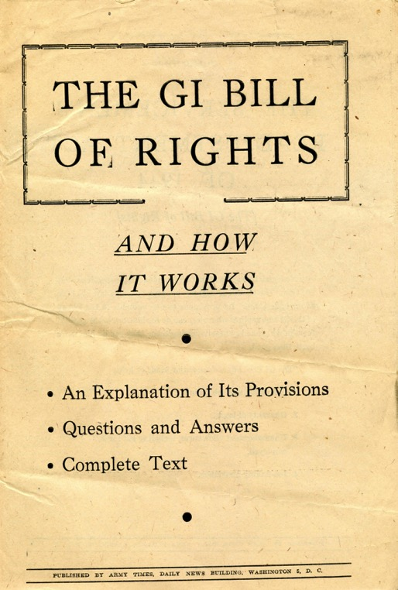 | 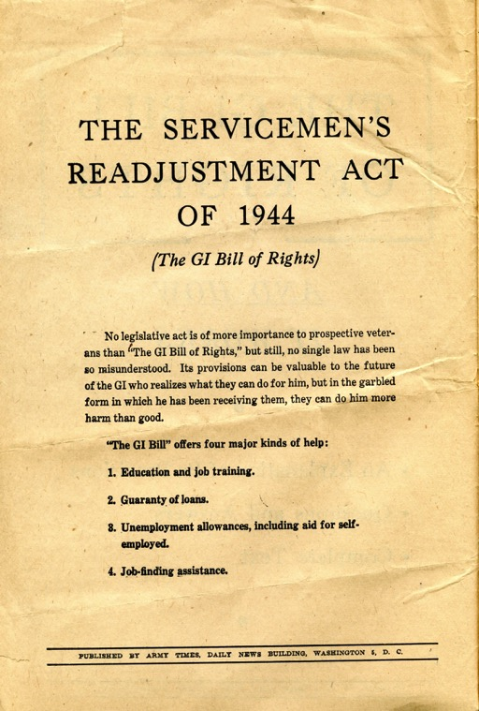

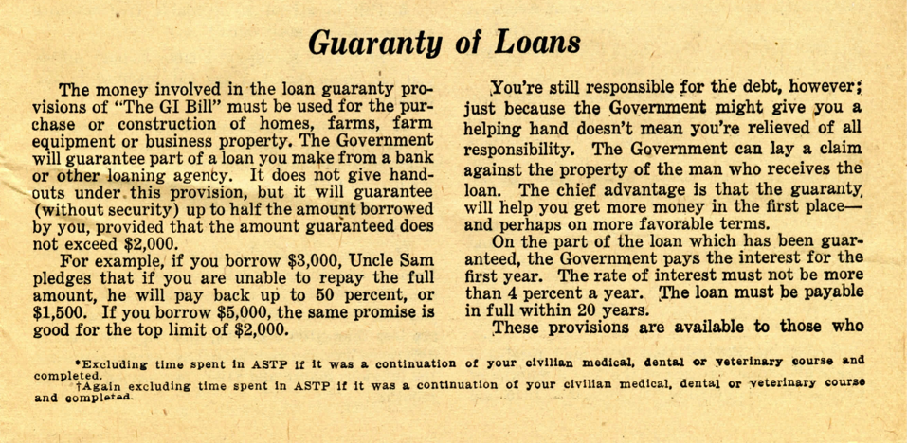

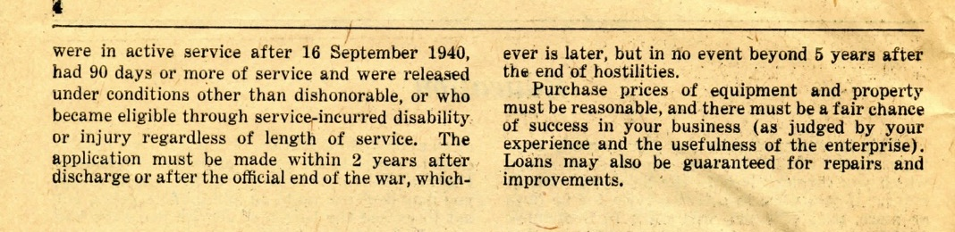

Used by permission of the National WWII Museum. http://www.nationalww2museum.org/learn/education/for-teachers/primary-sources/gi-bill.html.

Supporting Question 2
Featured Source | Source B: Dwight D. Eisenhower, message to Congress, “Special Message to the Congress Regarding a National Highway Program” (excerpt), February 22, 1955; Secretary of Commerce, map of United States interstate road system showing the estimated need for roadways by 1965, from Needs of the Highway Systems 1955–84, March 28, 1955
Special Message to Congress
To the Congress of the United States:
…The Nation’s highway system is a gigantic enterprise, one of our largest items of capital investment. Generations have gone into its building. Three million, three hundred and sixty-six thousand miles of road, travelled by 58 million motor vehicles, comprise it. The replacement cost of its drainage and bridge and tunnel works is incalculable. One in every seven Americans gains his livelihood and supports his family out of it. But, in large part, the network is inadequate for the nation’s growing needs.
In recognition of this, the Governors in July of last year at my request began a study of both the problem and methods by which the Federal Government might assist the States in its solution. I appointed in September the President’s Advisory Committee on a National Highway Program, headed by Lucius D. Clay, to work with the Governors and to propose a plan of action for submission to the Congress. At the same time, a committee representing departments and agencies of the national Government was organized to conduct studies coordinated with the other two groups. All three were confronted with inescapable evidence that action, comprehensive and quick and forward-looking, is needed.
First: Each year, more than 36 thousand people are killed and more than a million injured on the highways. To the home where the tragic aftermath of an accident on an unsafe road is a gap in the family circle, the monetary worth of preventing that death cannot be reckoned. But reliable estimates place the measurable economic cost of the highway accident toll to the Nation at more than $4.3 billion a year.
Second: The physical condition of the present road net increases the cost of vehicle operation, according to many estimates, by as much as one cent per mile of vehicle travel. At the present rate of travel, this totals more than $5 billion a year. The cost is not borne by the individual vehicle operator alone. It pyramids into higher expense of doing the nation's business. Increased highway transportation costs, passed on through each step in the distribution of goods, are paid ultimately by the individual consumer.
Third: In case of an atomic attack on our key cities, the road net must permit quick evacuation of target areas, mobilization of defense forces and maintenance of every essential economic function. But the present system in critical areas would be the breeder of a deadly congestion within hours of an attack.
Fourth: Our Gross National Product, about $357 billion in 1954, is estimated to reach over $500 billion in 1965 when our population will exceed 180 million and, according to other estimates, will travel in 81 million vehicles 814 billion vehicle miles that year. Unless the present rate of highway improvement and development is increased, existing traffic jams only faintly foreshadow those of ten years hence.
To correct these deficiencies is an obligation of Government at every level. The highway system is a public enterprise. As the owner and operator, the various levels of Government have a responsibility for management that promotes the economy of the nation and properly serves the individual user. In the case of the Federal Government, moreover, expenditures on a highway program are a return to the highway user of the taxes, which he pays in connection with his use of the highways.
Public domain. Available at the US Presidency Project website: http://www.presidency.ucsb.edu/ws/?pid=10415.

Map of United States Interstate Road System Showing the Estimated Need for Roadways by 1965

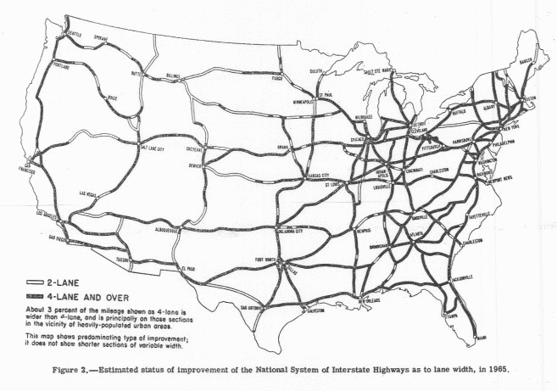

Public domain. From Needs of the Highway Systems 1955–84, Figure 2, p. 10. Available at the National Surface Transportation Policy and Revenue Study Commission website. http://transportationfortomorrow.com/final_report/pdf/volume_3/historical_documents/03_needs_of_the_highway_system_1955_1984.pdf.

Supporting Question 2
Featured Source | Source C: Crystal Galyean, article about the development of one of the first suburban communities, “Levittown: The Imperfect Rise of American Suburbs” (excerpts), April 10, 2015.
The Imperfect Rise of the American Suburbs
In 1947, entrepreneur Abraham Levitt and his two sons, William and Alfred, broke ground on a planned community located in Nassau County, Long Island. Within a few years, the Levitts had transformed the former farmland into a suburban community housing thousands of men—many of whom were veterans returned from World War II—and their families. The Levitts would go on to create two other communities in New Jersey and Pennsylvania, and the legacy of the first Levittown has become a legend in the history of the American suburbs. Even at the time, the iconic community represented for many all that was hopeful and wholesome for the estimated twenty million Americans who followed Levittown’s lead and made the trek to suburbia in the 1950s.
But underneath the uniform houses lining the curved, meticulously gardened roads of Levittown lies a much more turbulent story. Although 1950s suburbia conjures visions of traditional family life, idyllic domesticity and stability, the story of the suburbization of America is also one of exclusion, segregation and persecution. Levittown itself arguably embodied the best and worst of the postwar American story; it was a result of the entrepreneurship and ingenuity that has come to define the American spirit, but it also participated in the violent prejudice that has also been part of American history….
The Levitts’ homes were affordable, planted in a picture-perfect, carefully controlled community, and were equipped with futuristic stoves and television sets. The houses were simple, unpretentious, and most importantly to its inhabitants, affordable to both the white and blue collar worker. And the Levitts took more than the homes themselves into consideration—they designed community streets along curvilinear patterns to create a graceful, un-urban grid like feel, and directed cars going through the development to the outside of the community so Levittown would not be disturbed by noisy traffic. Even the maintenance of houses and yards were meticulously governed; buyers agreed to a laundry list of rules that, for example, prohibited residents from hanging laundry to dry outside their homes.
Despite such meticulousness in community planning, all was not serene in Levvittown. The Levitts’ level of control over the appearance of Levittown did not stop at the yards and houses, but extended to the appearance of the inhabitants themselves. Bill Levitt only sold houses to white buyers, excluding African Americans from buying houses in his communities even after housing segregation had been ruled unconstitutional by the courts. By 1953, the 70,000 people who lived in Levittown constituted the largest community in the United States with no black residents.
Originally, the Levitts’ racist policy was enshrined in the lease itself, which stipulated that “the tenant agrees not to permit the premises to be sued or occupied by any person other than members of the Caucasian race.” That provision was later struck down in court as unconstitutional, but Bill Levitt continued to enforce racial homogeneity in practice by rejecting would-be black buyers….
The suburbs have clearly come to symbolize more than just collections of white picket-fenced houses outside a city. Jackson wrote in Crabgrass Frontier, “Suburbia…is a manifestation of such fundamental characteristics of American society as conspicuous consumption, a reliance upon the private automobile, upward mobility, the separation of the family nuclear units, the widening division between work and leisure, and the tendency toward racial and economic exclusiveness.” To some, suburbia was a symbol of American can-do; to others, it was a symbol of conformity and exclusion. The story of Levittown captures both the hopeful and darker sides of the rise of the American suburbs.

Reprinted with permission from US History Scene: http://ushistoryscene.com/article/levittown/.

Supporting Question 2
Featured Source | Source D: Chart depicting home ownership rates from 1890 to 2010, “Home Ownership Rates over Time,” 2015

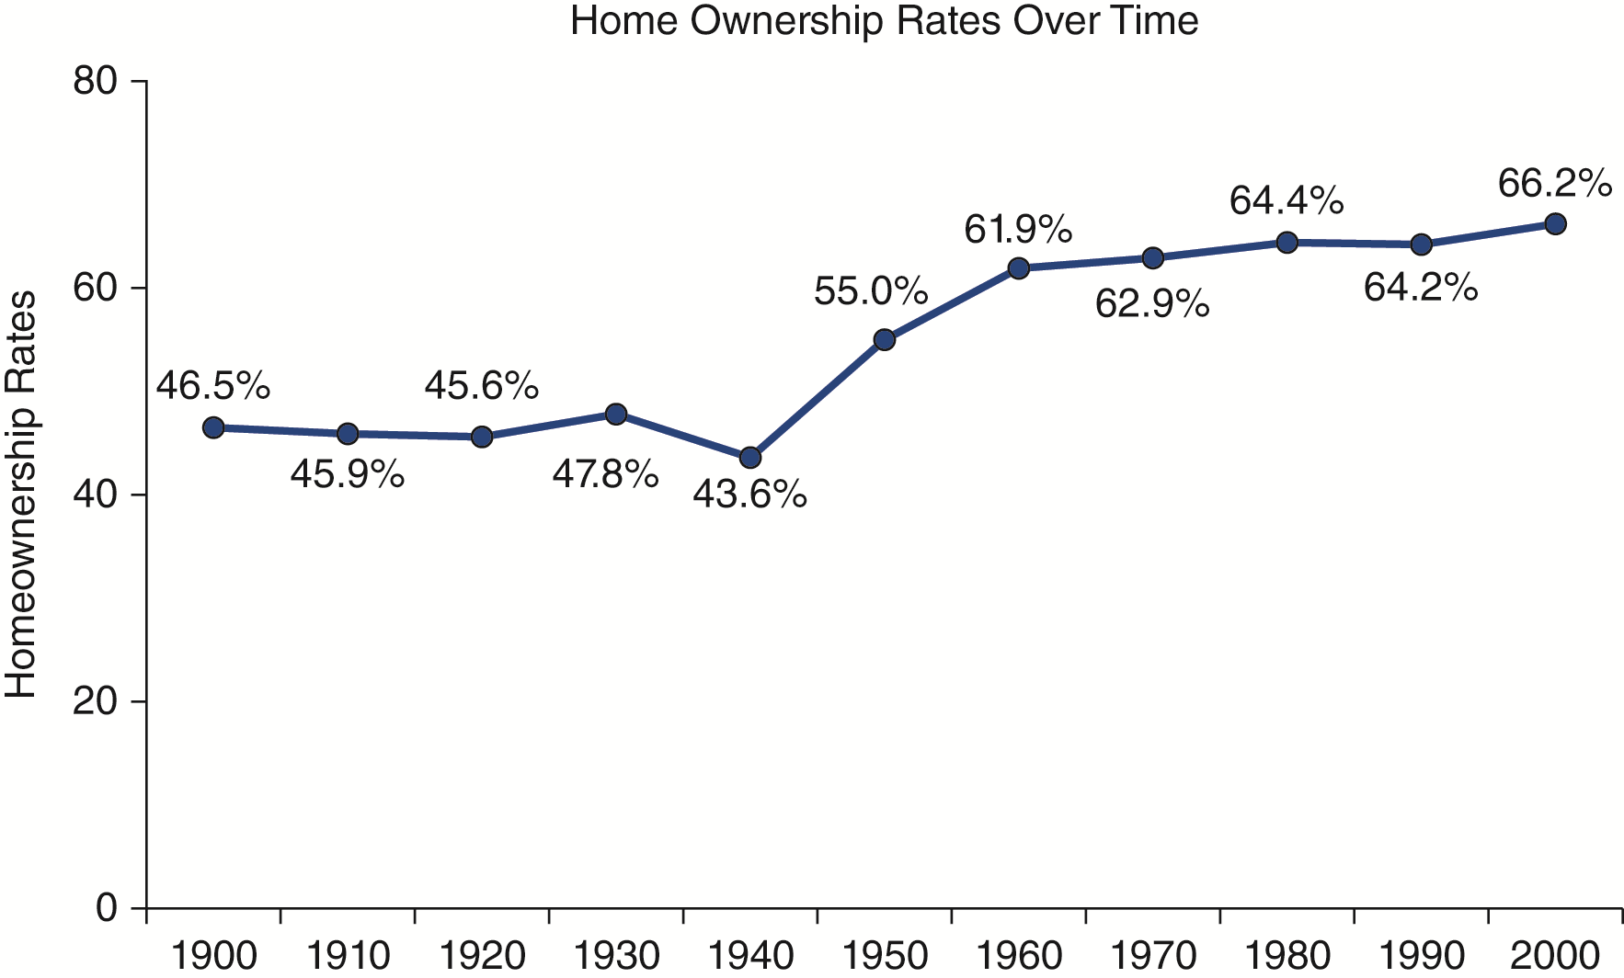

Created for the New York State K–12 Social Studies Toolkit by Agate Publishing, Inc., 2015. Data from the US Census Bureau, Historical Census of Housing Tables: http://www.census.gov/hhes/www/housing/census/historic/owner.html.

Supporting Question 3
Featured Source | Source A: Long Island Library Resources, collection of historical images from the Levittown Public Library, Long Island Memories
Long Island Memories Collection
NOTE: The suburban ideal can be examined through multiple lenses, including primary source texts, detailed charts and metrics, and imagery. The Long island Memories collection contains a trove of photographs that serve to tell the visual story of the growth of Levittown, New York.
This collection is from the Long Island Library Resources (LILRC) Regional Digitization Program. Images from the Levittown Public Library may be found here: http://cdm16373.contentdm.oclc.org/cdm/search/collection/p15281coll37/order/title/ad/asc.
To support their research, students should be directed to browse this collection with an eye toward key questions such as:
- Other than the homes, what other features did the developers use to draw people to Levittown?
- What was the relationship between assembly-line techniques and price?
- What was the rationale for designing curved streets?
- Why were these homes attractive to veterans?

Supporting Question 3
Featured Source | Source B: State Museum of Pennsylvania, collection of historical images from the exhibit Building the Suburban Dream
Building the Suburban Dream Collection
NOTE: Suburbs provided the housing to support the booming postwar birth rates trend, but these planned communities also promoted organized social engagement and fostered the growth of America’s consumer culture. Although critics argue that the suburbs homogenized the American experience, supporters identify benefits related to strengthened social institutions (e.g., American Legion, Little League baseball, women’s clubs) and an economy that grew as a result of social mobility and a pioneering spirit.
These photographs are from the State Museum of Pennsylvania exhibit Building the Suburb Dream, about the Levittown, Pennsylvania, development. They are available at http://statemuseumpa.org/levittown/.
To support their research, students should be directed to browse this collection and related readings with an eye toward key questions such as:
- What social institutions promoted a strong connection to Levittown, Pennsylvania?
- What role did the television play in suburban life?
- Which consumer products promoted a sense of affluence?
- How did the Levittown kitchen represent progress?

Supporting Question 4
Featured Source | Source A: Malvina Reynolds, song about tract housing, “Little Boxes,” 1962

NOTE: Malvina Reynolds and her husband were on their way from their home in Berkeley, California, through San Francisco and down the peninsula to La Honda, where she was to sing at a meeting of the Friends’ Committee on Legislation. As she drove through Daly City, she said “Bud, take the wheel. I feel a song coming on.” A video of “Little Boxes” sung by Pete Seeger is available at YouTube: https://www.youtube.com/watch?v=HlSpc87Jfr0&list=RDHlSpc87Jfr0#t=95.

Little Boxes
Little boxes on the hillside,
Little boxes made of ticky tacky
Little boxes on the hillside,
Little boxes all the same,
There's a pink one and a green one
And a blue one and a yellow one
And they're all made out of ticky tacky
And they all look just the same.

And the people in the houses
All went to the university
Where they were put in boxes
And they came out all the same
And there's doctors and lawyers
And business executives
And they're all made out of ticky tacky
And they all look just the same.

And they all play on the golf course
And drink their martinis dry
And they all have pretty children
And the children go to school,
And the children go to summer camp
And then to the university
Where they are put in boxes
And they come out all the same.

And the boys go into business
And marry and raise a family
In boxes made of ticky tacky
And they all look just the same,
There's a pink one and a green one
And a blue one and a yellow one
And they're all made out of ticky tacky
And they all look just the same.

From the song “Little Boxes.” Words and music by Malvina Reynolds. Copyright 1962 Schroder Music Co. (ASCAP); Renewed 1990. Used by permission. All rights reserved.

Supporting Question 4
Featured Source | Source B: John Kenneth Galbraith, book about the effects of suburbanization, The Affluent Society (excerpts), 1958
In the years following World War II, the papers of any major city—those of New York were an excellent example—told daily of the shortages and shortcomings in the elementary municipal and metropolitan services. The schools were old and overcrowded. The police force was under strength and underpaid. The parks and playgrounds were insufficient. Streets and empty lots were filthy, and the sanitation staff was underequipped and in need of men. Access to the city by those who work there was uncertain and painful and becoming more so. Internal transportation was overcrowded, unhealthful and dirty. So was the air.…
An affluent society, that is also both compassionate and rational, would no doubt, secure to all who needed it the minimum income essential for decency and comfort.…
To eliminate poverty efficiently we should invest more than proportionately in the children of the poor community. It is there that high quality schools, strong health services, special provision for nutrition and recreation are most needed to compensate for the very low investment which families are able to make in their own offspring.
Reprinted with permission from J. K. Galbraith. The Affluent Society. Boston: Houghton Mifflin Company, 1958.

Supporting Question 4
Featured Source | Source C: Michael Harrington, book about the effects of suburbanization on social classes, The Other America (excerpts), 1962

There is a familiar America. It is celebrated in speeches and advertised on television and in the magazines. It has the highest mass standard of living the world has ever known.

In the 1950s this America worried about itself, yet even its anxieties were products of abundance. The title of a brilliant book was widely misinterpreted, and the familiar America began to call itself “the affluent society.” There was introspection about Madison Avenue and tail fins; there was discussion of the emotional suffering taking place in the suburbs. In all this, there was an implicit assumption that the basic grinding economic problems had been solved in the United States. In this theory the nation’s problems were no longer a matter of basic human needs, of food, shelter, and clothing. Now they were seen as qualitative, a question of learning to live decently amid luxury.

While this discussion was carried on, there existed another America. In it dwelt somewhere between 40,000,000 and 50,000,000 citizens of this land. They were poor. They still are....

If the middle class never did like ugliness and poverty, it was at least aware of them. “Across the tracks” was not a very long way to go. There were forays into the slums at Christmas time; there were charitable organizations that brought contact with the poor. Occasionally, almost everyone passed through the Negro ghetto or the blocks of tenements, if only to get downtown to work or to entertainment.

Now the American city has been transformed. The poor still inhabit the miserable housing in the central area, but they are increasingly isolated from contact with, or sight of, anybody else. Middle-class women coming in from Suburbia on a rare trip may catch the merest glimpse of the other America on the way to an evening at the theater, but their children are segregated in suburban schools. The business or professional man may drive along the fringes of slums in a car or bus, but it is not an important experience to him. The failures, the unskilled, the disabled, the aged, and the minorities are right there, across the tracks, where they have always been. But hardly anyone else is.

In short, the very development of the American city has removed poverty from the living, emotional experience of millions upon millions of middle-class Americans. Living out in the suburbs, it is easy to assume that ours is, indeed, an affluent society.
This new segregation of poverty is compounded by a well-meaning ignorance. A good many concerned and sympathetic Americans are aware that there is much discussion of urban renewal. Suddenly, driving through the city, they notice that a familiar slum has been torn down and that there are towering, modern buildings where once there had been tenements or hovels. There is a warm feeling of satisfaction, of pride in the way things are working out: the poor, it is obvious, are being taken care of.

The irony in this… is that the truth is nearly the exact opposite to the impression. The total impact of the various housing programs in postwar America has been to squeeze more and more people into existing slums. More often than not, the modern apartment in a towering building rents at $40 a room or more. For, during the past decade and a half, there has been more subsidization of middle- and upper-income housing than there has been for the poor.…

And finally, the poor are politically invisible. It is one of the cruelest ironies of social life in advanced countries that the dispossessed at the bottom of society are unable to speak for themselves. The people of the other America do not, by far and large, belong to unions, to fraternal organizations, or to political parties. They are without lobbies of their own; they put forward no legislative program. As a group, they are atomized. They have no face; they have no voice.…

That the poor are invisible is one of the most important things about them. They are not simply neglected and forgotten as in the old rhetoric of reform; what is much worse, they are not seen.

Reprinted with permission from Michael Harrington. The Other America. New York: Penguin, 1962.

