6th Grade China and Rome Inquiry
Did the Chinese and Romans Know Each Other?
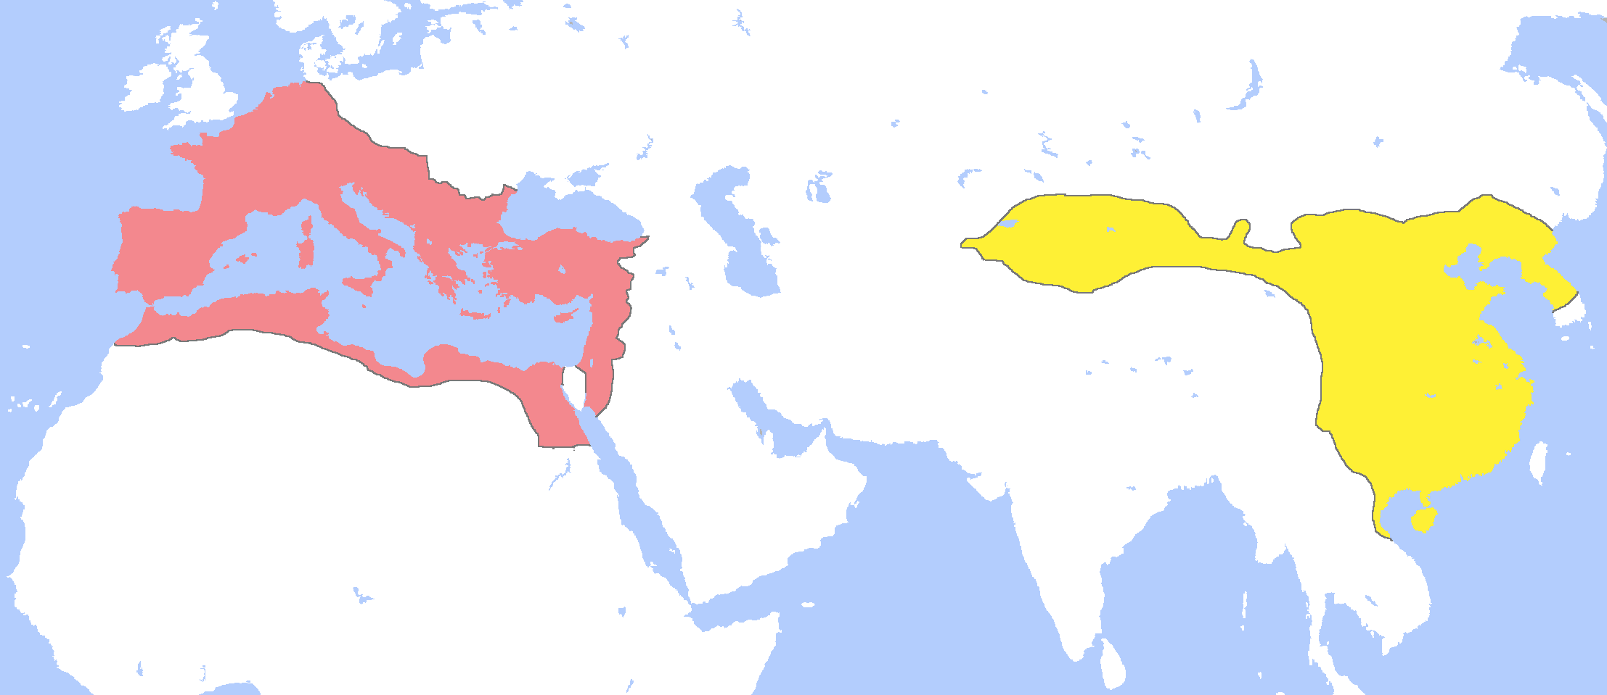

Outline map with general locations of the Roman and Chinese Empire in 1 CE.

Supporting Questions
- Where were the Roman and Chinese Empires located?
- What did the Chinese know about the West?
- What did the Romans know about the East?
- How did the Chinese and Romans interact with one another?

6th Grade China and Rome Inquiry

Did the Chinese and Romans Know Each Other?
New York State Social Studies Framework Key Idea & Practices | 6.7 INTERACTIONS ACROSS THE EASTERN HEMISPHERE (ca. 600 CE–ca. 1450 CE): Trade networks promoted the exchange and diffusion of language, belief systems, tools, intellectual ideas, inventions, and diseases.  Gathering, Using, and Interpreting Evidence Geographic Reasoning Economics and Economic Systems  Comparison and Contextualization
Staging the Question | Create a map showing a route from home to school.

Supporting Question 1 |  | Supporting Question 2 |  | Supporting Question 3 |  | Supporting Question 4
Where were the Roman and Chinese Empires located? |  | What did the Chinese know about the West? |  | What did the Romans know about the East? |  | How did the Chinese and Romans interact with one another?
Formative  Performance Task |  | Formative  Performance Task |  | Formative  Performance Task |  | Formative  Performance Task
Write a description of the relative locations and geographic features of the Roman and Chinese Empires. |  | Start a T-chart that compares what the Romans and Chinese knew about each other. |  | Complete the T-chart that compares what the Romans and Chinese knew about each other. |  | Make a claim about how the Romans and Chinese interacted with each other.
Featured Sources |  | Featured Sources |  | Featured Sources |  | Featured Sources
Source A: Outline map with general locations of the Roman and Chinese Empires  Source B: Detailed map of Roman and Chinese Empires |  | Source A: Description of the West by Sima Qian  Source B: Map bank: Maps of Chinese exploration  Source C: Description of Romans by Yu Huan |  | Source A: Description of China by Pliny the Elder  Source B: Excerpts from Ptolemy’s Geography |  | Source A: Map bank: 1st and 2nd Century CE Global Trade Route Maps

Summative Performance Task | ARGUMENT Did Chinese and Romans know each other? Construct an argument (e.g., a speech, movie, poster, or essay) that explains to what extent the Chinese and Romans knew and interacted with each other using specific claims and relevant evidence from historical sources.
 | EXTENSION Create an annotated timeline that describes what Chinese and Roman historians and scholars wrote and drew about each other.
Taking Informed Action | UNDERSTAND Identify a culture or group of people in the world that students would like to know more about.  ASSESS Create a set of questions that students would like to explore with people from that culture.  ACT Invite representatives of the selected group to visit the school, either in person or virtually.

Overview

Inquiry Description
In this inquiry, students examine the extent to which the Chinese and Romans had knowledge of and interacted with one another. Knowledge of one another accumulated over time, and a long history of interaction was part of the process that led to the establishment of regular trade and cultural relations along the Silk Road. This inquiry is about the historical antecedent to the Silk Road. The compelling question asks, “Did Chinese and Romans know each other?” Although this is a yes/no question, the complexity lies in between those poles. Students will likely find themselves answering “maybe” and needing to explain why.
The 500-year Roman Empire was relatively short-lived compared to the 3,000 years of Chinese dynastic history. However, the period from the first century CE to the middle of the fifth century was critical in creating long-lasting connections between East and West that continue to this day. During this time, China and Rome expanded their influence on one another. Initially just trying to establish knowledge of the other culture, the Chinese and Roman Empires grew substantially in mutual awareness and interaction over the centuries. Eventually, important cultural and economic trading routes known as the Silk Road came to define global interaction between East and West.
In addition to the Key Idea expressed earlier, this inquiry covers the following Conceptual Understanding:
- (6.7a) The Silk Road, the Indian Ocean, and the Trans-Saharan routes formed the major Afro-Eurasian trade networks connecting the East and the West. Ideas, people, technologies, products, and diseases moved along these routes.
NOTE: This inquiry is expected to take two to four 40-minute class periods. The inquiry time frame could expand if teachers think their students need additional instructional experiences (i.e., supporting questions, formative performance tasks, and featured sources). Teachers are encouraged to adapt the inquiries​ in order to meet the needs and interests of their particular students. Resources can also be modified as necessary to meet individualized education programs (IEPs) or Section 504 Plans for students with disabilities.

Structure of the Inquiry
In addressing the compelling question “Did the Chinese and Romans know each other?” students work through a series of supporting questions, formative performance tasks, and featured sources in order to construct an argument with evidence while acknowledging competing perspectives.

Staging the Compelling Question
The compelling question may be staged by having students create maps showing routes from their homes to school. Working from memory, students may have only a vague sense about how the distance and the routes they travel should actually be represented on a map. Students can then be prompted to think about how ancient people such as the Chinese and Romans must have felt with only partial knowledge about how to get from one place to another and how they might be received by the other culture. Students might then think about going places they only know vaguely, such as the high school, a new neighborhood, or a new community.

Supporting Question 1
The first supporting question—“Where were the Roman and Chinese Empires located?”—initiates this inquiry by encouraging students to think about the relative location of each empire. The formative performance task asks students to write a description of the relative locations and geographic features of the Roman and Chinese Empires. The two featured sources provide maps outlining the general locations of the two empires along with some of the geographic features of each place. These geographic features would largely shape how interaction between the two groups emerged over time.

Supporting Question 2
The second supporting question—“What did the Chinese know about the West?”—continues the inquiry by encouraging students to think about the earliest efforts by the Chinese to explore their western frontier. The tumultuous time in Chinese history known as the Warring States came to an end in 221 BCE with the establishment of the important but short-lived Qin dynasty. Afterwards, the Chinese consolidated under the four-century-long Han Dynasty. It was under Han rule that the Chinese began to expand and explore to the west. The formative performance task requires students to complete the first portion of a T-chart that compares what the Chinese and Romans knew about one another. The featured sources for this inquiry include three accounts of these explorations from Chinese historians Sima Qian, Fan Ye, and Yu Huan and a map bank.

Supporting Question 3
The third supporting question—“What did the Romans know about the East?”—extends the inquiry by redirecting students’ attention to early exploratory efforts by the Romans. Like the Chinese, the Romans were interested in expanding their influence. The Romans were able to build on the success of the Greeks who had previous interactions with far-Eastern cultures. Students complete the T-chart they began in the second formative performance task that compares the efforts of the Chinese and Romans to learn more about one another. The featured sources include writings from two Roman scholars—Pliny the Elder and Ptolemy— as well as first-century map created by Ptolemy that places China with remarkable accuracy on a map of the world.

Supporting Question 4
The fourth supporting question—“How did the Romans and Chinese interact with one another?”—brings the two civilizations together to consider how they viewed one another on maps and how they understood one another’s cultures. The formative performance task calls on students to write a claim about how the ancient Romans and Chinese understood each other. The featured source is a bank of 1st and 2nd century CE maps depicting trade routes that helped to loosely connect the Roman and Chinese.

Summative Performance Task
At this point in the inquiry, students have examined several historical sources to learn about how and what the Chinese and Romans understood about each other. Students should be expected to demonstrate the breadth of their understandings and abilities to use evidence from multiple sources to support their claims. In this task, students are asked to construct an evidence-based argument responding to the compelling question “Did the Chinese and Romans know each other?” It is important to note that students’ arguments could take a variety of forms, including a detailed outline, poster, or essay.
Students’ arguments likely will vary, but could include any of the following:
- The Chinese and Romans barely knew about each other and made many mistakes when trying to describe the other’s location and culture.
- Given the lack of roads and other ways to move around, it is amazing how much the Chinese and Romans knew about each other.
- Over time, the Chinese and Romans came to know more about each other because they made specific efforts to do so.
Students could extend these arguments by creating an annotated timeline that describes what Chinese and Roman historians and scholars wrote and knew about the other region. This annotated timeline might also include information about why the Chinese and Romans wanted to learn more about each other.
Students have the opportunity to Take Informed Action by considering a culture or group of people that they would like to know more about. Students understand this group of people by gathering information about where they live and their cultural characteristics. To assess their understanding, students make a list of questions they would like to ask a person from that group. And to act, students invite a representative from the group to visit their school, either in person or virtually.

Supporting Question 1
Featured Source | Source A: Author unknown, map with general locations of the Roman and Chinese Empire in 1 CE, “Locator Map for the Roman Empire and the Chinese Han dynasty,” 2009

NOTE: On the map below, the Roman Empire is highlighted in red and the Chinese empire is highlighted in yellow.

© Gabagool. Reproduced under the Creative Commons Attribution-Share Alike 3.0 Unported License. http://commons.wikimedia.org/wiki/File:RomanandHanEmpiresAD1.png.

Supporting Question 1
Featured Source | Source B: Thomas Lessman, detailed map of Roman and Chinese Empire in 200 CE, “Eastern Hemisphere in 200 AD,” 2008

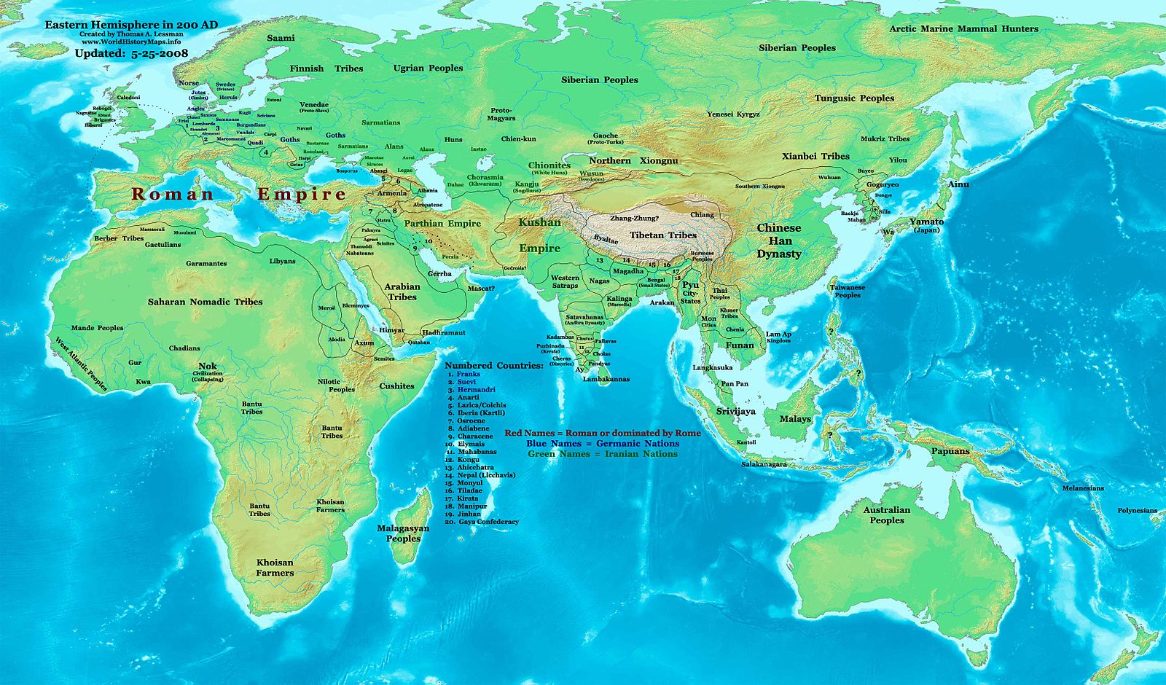
© Thomas Lessman. Reproduced under the Creative Commons Attribution-Share Alike 3.0 Unported License. http://commons.wikimedia.org/wiki/File:East-Hem_200ad.jpg.

Supporting Question 2
Featured Source | Source A: Sima Qian, description of Zhang Qian’s travels in the West, Records of the Great Historian and Travels of Zhang Qian (excerpts), 130 BCE
NOTE: Sima Qian is considered by many to be China’s first and greatest historian. He wrote the following account of the accomplishments of Zhang Qian, who was one of China’s first explorers into the West. Zhang Qian explored territory to the west of China reaching as far as modern day Mesopotamia. Zhang Qian described a people he met called the Yuezhi who lived in an area west of India that was well known to the Romans. Zhang Qian also explored Mesopotamia, which was later governed by Rome. Some scholars credit Zhang Qian’s explorations as establishing the knowledge that would be needed to create Silk Roads.
“The Great Yuezhi live some 2,000 or 3,000 li [1,000 or 1,200 kilometers] west of Dayuan, north of the Gui (Oxus) river. They are bordered to the south by Daxia [in modern-day Afghanistan], on the west by Anxi (Parthia) [in modern-day Iran], and on the north by Kangju [in modern-day Tajikistan]. They are a nation of nomads, moving place to place with their herds and their customs are like those of the Xiongnu. They have some 100,000 or 200,000 archer warriors." (Shiji, 123, Zhang Qian quote, trans. Burton Watson)
“Daxia is situated over 2,000 li [1,000 kilometers] southwest of Dayuan (Ferghana), south of the Gui (Oxus) river. Its people cultivate the land, and have cities and houses. Their customs are like those of Dayuan. It has no great ruler but only a number of petty chiefs ruling the various cities. The people are poor in the use of arms and afraid of battle, but they are clever at commerce. After the Great Yuezhi moved west and attacked and conquered Daxia, the entire country came under their sway. The population of the country is large, numbering some 1,000,000 or more persons. The capital is Lanshi (Bactra) where all sorts of goods are bought and sold." (Shiji, 123, Zhang Qian quote, translation Burton Watson).
“Southeast of Daxia is the kingdom of Shendu (India)....Shendu, they told me, lies several thousand li southeast of Daxia (Bactria). The people cultivate the land and live much like the people of Daxia. The region is said to be hot and damp. The inhabitants ride elephants when they go in battle. The kingdom is situated on a great river (Indus)" (Shiji, 123, Zhang Qian quote, trans. Burton Watson).
“Anxi is situated several thousand li west of the region of the Great Yuezhi. The people are settled on the land, cultivating the fields and growing rice and wheat. They also make wine out of grapes. They have walled cities like the people of Dayuan (Ferghana), the region contains several hundred cities of various sizes. The coins of the country are made of silver and bear the face of the king. When the king dies, the currency is immediately changed and new coins issued with the face of his successor. The people keep records by writing on horizontal strips of leather. To the west lies Tiaozhi (Mesopotamia) and to the north Yancai and Lixuan (Hyrcania)." (Shiji, 123, Zhang Qian quote, trans. Burton Watson).
“Tiaozhi (Mesopotamia) is situated several thousand li west of Anxi (Parthia) and borders the Western Sea (Persian Gulf/ Mediterranean?). It is hot and damp, and the people live by cultivating the fields and planting rice….The people are very numerous and are ruled by many petty chiefs. The ruler of Anxi (Parthia) give orders to these chiefs and regards them as vassals." (Shiji, 123, Zhang Qian quote, trans. Burton Watson).
Schools Wikipedia sponsored by SOS Children. Used under the GNU Free Documentation License. http://www.cs.mcgill.ca/~rwest/link-suggestion/wpcd_2008-09_augmented/wp/z/Zhang_Qian.htm.

Supporting Question 2
Featured Source | Source B: Map bank: Maps of Chinese exploration
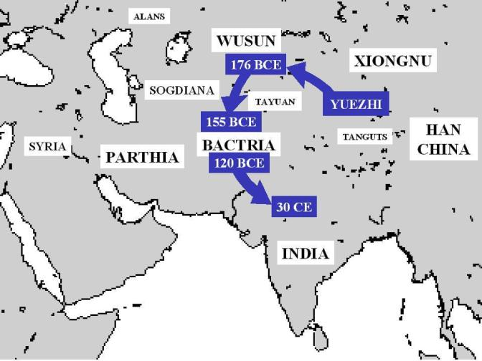
Map 1: Author unknown, map of Map of Yuezhi migrations in the 1st and 2nd century BCE, 2006.
Reproduced under the Creative Commons Attribution-Share Alike 3.0 Unported License. http://commons.wikimedia.org/wiki/File:Yueh-ChihMigrations.jpg.

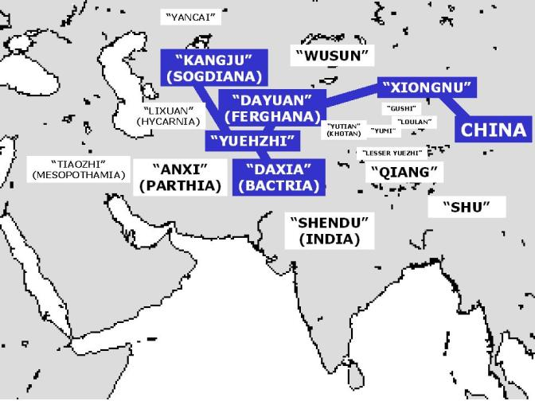
Map 2: Author unknown, map of Zhan Qian’s travels in the West in the 2nd century BCE, 2005.
Reproduced under the Creative Commons Attribution-Share Alike 3.0 Unported License. http://commons.wikimedia.org/wiki/File:ZhangQianTravel.jpg/.

Supporting Question 2
Featured Source | Source C: Fan Ye, description of the West based on travels of Gan Ying in 97 CE, Hou Hanshu or History of the Han (excerpts), 5th century CE
NOTE: The excerpts below come from the Hou Hanshu (also known as History of the Later Han), which was compiled by historian Fan Ye in the 5th century CE. Fan Ye followed in the tradition of Sima Qian. Fan Ye wrote a description of the Roman Empire that he created in 97 CE based on the travels of Gan Ying.

Section 11 – The Kingdom of Da Qin (the Roman Empire)
The Kingdom of Da Qin (the Roman Empire) is also called Lijian. As it is found to the west of the sea, it is also called the Kingdom of Haixi (Egypt). Its territory extends for several thousands of li [three li equals one mile]. It has more than four hundred walled towns. There are several tens of smaller dependent kingdoms. The walls of the towns are made of stone….
The people of this country are all tall and honest. They resemble the people of the Middle Kingdom and that is why this kingdom is called Da Qin [literally, ‘Great China’].
Section 12 – The Products of Da Qin (the Roman Empire)
This country produces plenty of gold, silver, and precious jewels, luminous jade, ‘bright moon pearls,’ fighting cocks, rhinoceroses, coral, yellow amber, opaque glass, whitish chalcedony, red cinnabar, green gemstones, drawn gold-threaded and multi-coloured embroideries, woven gold-threaded net, delicate polychrome silks painted with gold, and asbestos cloth….
The people of this country are honest in business; they don’t have two prices. Grain and foodstuffs are always in good supply. The resources of the state are abundant. When envoys from a neighbouring kingdom arrive at their border, they use the courier stations to get to the royal capital, and when they arrive, they give them gold coins.
The king of this country always wanted to send envoys to the Han, but Anxi (Parthia), wishing to control the trade in multi-coloured Chinese silks, blocked the route to prevent [the Romans] getting through [to China].
From Through the Jade Gate – China to Rome, Volume I. 2nd Edition. © John Hill. Charleston: CreateSpace, 2015. Used with permission.

Supporting Question 2
Featured Source | Source D: Yu Huan, description of Romans, Weilue or Brief History of the Wei (excerpts), 265 CE
NOTE: Weilue, or the brief history of the Wei, was written by Yu Huan. Wei or Cao Wei was one of three states in that vied for power in the Three States Period of Chinese dynastic history (220-280 CE). In this passage Yu Huan draws on several sources to describe Romans.

This country (the Roman Empire) has more than four hundred smaller cities and towns. It extends several thousand li in all directions. The king has his capital (that is, the city of Rome) close to the mouth of a river (the Tiber). The outer walls of the city are made of stone.
…The ruler of this country is not permanent. When disasters result from unusual phenomena, they unceremoniously replace him, installing a virtuous man as king, and release the old king, who does not dare show resentment.
The common people are tall and virtuous like the Chinese, but wear hu (‘Western’) clothes. They say they originally came from China, but left it.
They have always wanted to communicate with China but, Anxi (Parthia), jealous of their profits, would not allow them to pass (through to China).
From China Meets the West: The “Peoples of the West” During the 3rd Century CE According to the Weilue (forthcoming). © John Hill. 2015.

Supporting Question 3
Featured Source | Source A: Pliny the Elder, description of China, Natural History (excerpts), 77 CE

NOTE: This text appeared in the Roman writer Pliny the Elder’s Natural History VI, 54. Natural History was a far-reaching effort by Pliny the Elder to describe the world. He wrote several volumes on geography, which included the following text about silk production in China. Pliny the Elder refers to the people who created silk as Seres.

The Seres are famous for the woolen substance obtained from their forests; after a soaking in water they comb off the white down of the leaves….So manifold is the labour employed, and so distant is the region of the globe drawn upon, to enable the Roman maiden to flaunt transparent clothing in public.
Public domain.

Supporting Question 3
Featured Source | Source B: Claudius Ptolemy, a description and map of the Asia, Geography (excerpt), 150 CE
NOTE: Ptolemy was an Egyptian-born mathematician and geographer who lived in the city of Alexandria during the Roman Empire. One of Ptolemy’s greatest works was his atlas titled Geography. In this book, Ptolemy published some of the first western descriptions and maps of China.

The inhabited part of our earth is bounded on the east by the Unknown Land which lies along the region occupied by the easternmost nations of Asia Major, the Sim and the nations of SERICE; and on the south likewise by the Unknown Land which shuts round the Indian Sea, and encompasses that Ethiopia to the south of Libya which is called the land of Agisymba; to the west by the Unknown Land which embraces the Ethiopic Gulf of Libya, and then by the Western Ocean which lies along the most westerly parts of Libya and of Europe; and on the north by that continuation of the same ocean which encircles the Britannic Isles and the most northerly parts of Europe, and which goes by the names of Duecalydonian and Sarmatie, and by an Unknown Land which stretches along the most northerly parts of Asia Major, viz., Sarmatia, Scythia, and Serice.
Public domain. Available at http://dsr.nii.ac.jp/toyobunko/III-2-F-b-2/V-1/page/0162.html.ja.

NOTE: This map by 2nd century geographer Ptolemy represented China as two places. Ptolemy called the northern part of China, the Serica or the Land of Silk. Below Serica was Sinae, or the Land of Qin.
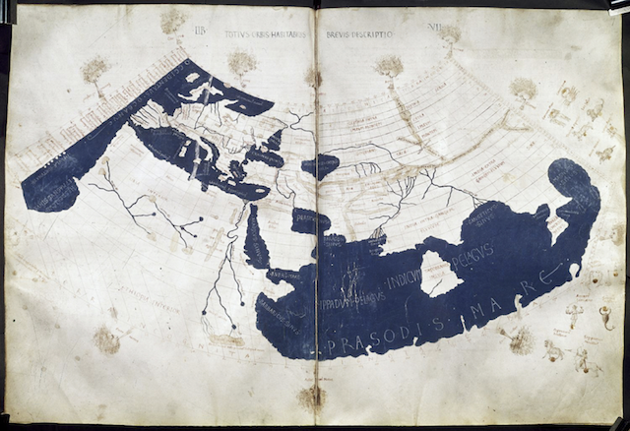
Public domain. Credited to Francesco di Antonio del Chierico. Available at http://upload.wikimedia.org/wikipedia/commons/2/23/PtolemyWorldMap.jpg.

Supporting Question 4
Featured Source | Source A: Map bank: 1st and 2nd Century CE global trade route maps

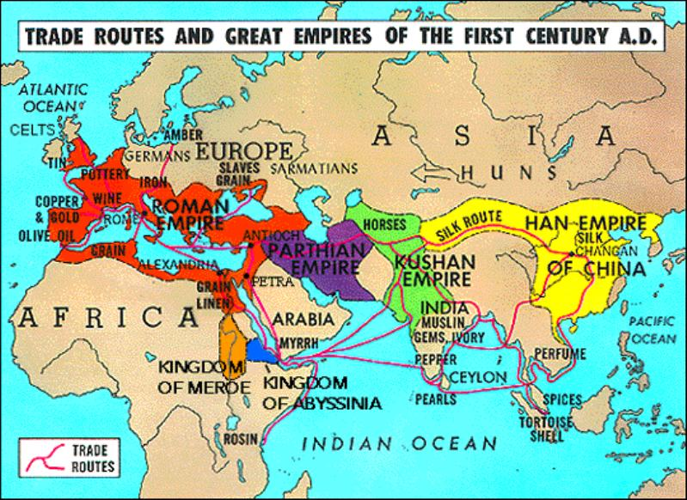
Map 1: Map illustrating various global trade route maps, “Trade Routes and Great Empires of the First Century A.D.” 2010.
Reproduced with permission from Dr. Neil Goldberg, The Dalton School. http://people.uncw.edu/zervosg/Pr236/New%20236/Public%20Domain%20for%20Web/EmpiresICE.JPG.

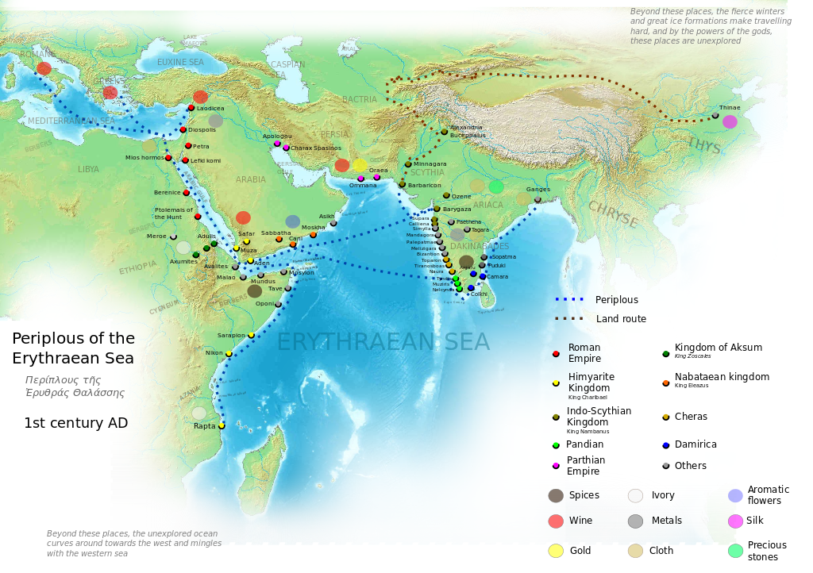
Map 2: Map illustrating land and sea trade routes between Europe and Asia, “Periplous of the Erythraean Sea, 1st century AD,” 2014.
© George Tsiagalakis. Reproduced under the Creative Commons Attribution-Share Alike 4.0 License. https://commons.wikimedia.org/wiki/File:Periplous_of_the_Erythraean_Sea.svg.

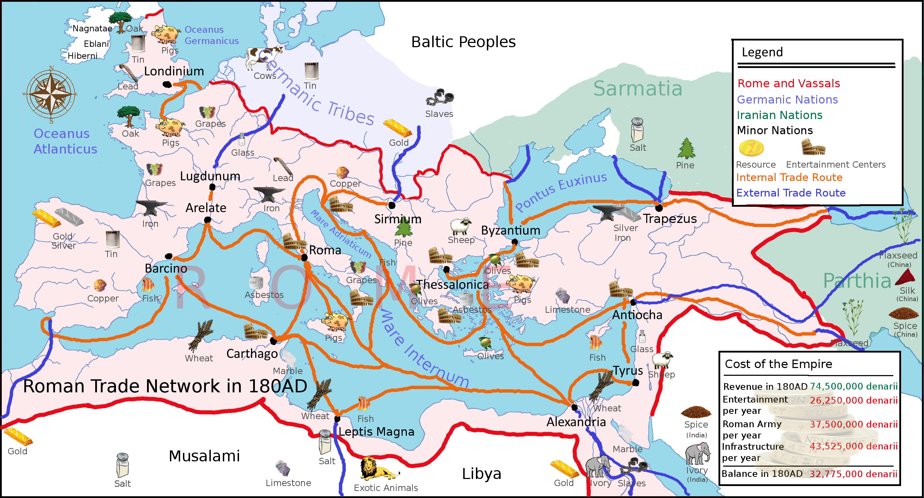
Map 3: Map illustrating trade routes in the Roman Empire, “Roman Trade Network in 180 AD,” 2010.
© Adhavoc. Reproduced under the Creative Commons Attribution-Share Alike 3.0 Unported License. https://commons.wikimedia.org/wiki/File:Europe_180ad_roman_trade_map.png.

