10th Grade Industrialization Inquiry
How Did the Industrial Revolution Move People?
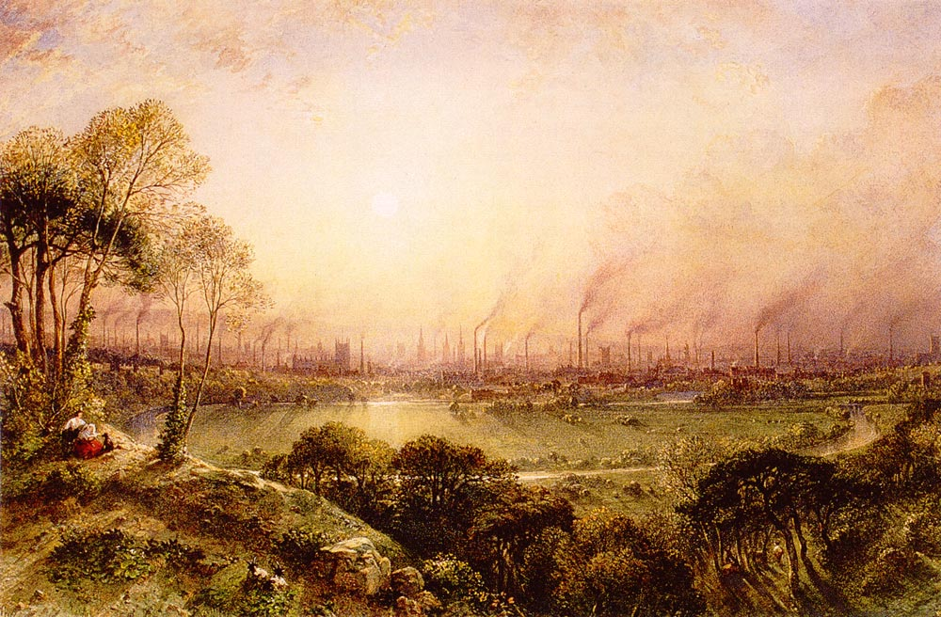

William Wyld, painting of industrial landscape in Manchester, England, Manchester from Kersal Moor, 1852. Public domain.

Supporting Questions
- Where did people move to and from during the Industrial Revolution?
- How did daily life move before and during the Industrial Revolution?
- How did the Industrial Revolution move society backward?
- How did the Industrial Revolution move society forward?

10th Grade Industrialization Inquiry
How Did the Industrial Revolution Move People?
New York State Social Studies Framework Key Idea & Practices |  | 10.3 CAUSES AND EFFECTS OF THE INDUSTRIAL REVOLUTION: Innovations in agriculture, production, and transportation led to the Industrial Revolution, which originated in Western Europe and spread over time to Japan and other regions. This led to major population shifts and transformed economic and social systems.  Gathering, Using, and Interpreting Evidence Chronological Reasoning and Causation  Economics and Economic Systems Geographic Reasoning
Staging the Question |  | Using a map showing technological innovations from 1715 to 1815, preview the growth of industry in Great Britain by having students make predictions about how these innovations affected daily life and society.
Supporting Question 1 |  | Supporting Question 2 |  | Supporting Question 3 |  | Supporting Question 4
Where did people move to and from during the Industrial Revolution? |  | How did daily life move before and during the Industrial Revolution? |  | How did the Industrial Revolution move society backward? |  | How did the Industrial Revolution move society forward?
Formative  Performance Task |  | Formative  Performance Task |  | Formative  Performance Task |  | Formative  Performance Task
Draw a population map of Britain highlighting where people were moving and annotate the pull factors that led them there. |  | Using a Venn diagram, compare and contrast the ways daily life moved before and during the Industrial Revolution. |  | Develop a claim supported by evidence that explains how the Industrial Revolution moved society backward. |  | Develop a counterclaim for the previous claim using evidence that explains how the Industrial Revolution moved society forward.
Featured Sources |  | Featured Sources |  | Featured Sources |  | Featured Sources
Source A: Image bank: Maps of Great Britain and the Industrial Revolution  Source B: Manchester from Kersal Moor  Source C: Excerpt from Observations On the Effect of the Factory System |  | Source A: Excerpt from A Tour Through the Whole Island of Great Britain  Source B: Interview with Michael Crabtree, child laborer  Source C: Excerpt from a factory inspector’s report |  | Source A: Excerpt from The Condition of the Working-Class in England in 1844  Source B: Excerpt from Hard Times  Source C: “Age Distribution in Cotton Factories” |  | Source A: Excerpt from Thrift  Source B: “Life Expectancy at Birth, Cities in England, 1850s–1890s”

Summative Performance Task | Argument How did the Industrial Revolution move people? Construct an argument (e.g., detailed outline, poster, essay) that addresses the compelling question using specific claims and relevant evidence from historical sources while acknowledging competing views.
 | Extension Students hold a classroom debate on how the Industrial Revolution moved people, ultimately coming to a conclusion on whether it moved society backward or forward.
Taking Informed Action | Understand Investigate the challenges of an economic boom/bust in the community by researching a company, business, factory, etc. that recently moved in or out of the region.  Assess Weigh the positive and negative impacts for various stakeholders (e.g., laborers, company owners, government employees) that come with the company or factory’s moving in or moving out.  Action Write an editorial for a local newspaper detailing your opinion on the company or factory’s decision to move in or out and whether or not this movement benefits the community as a whole.

Overview

Inquiry Description
This inquiry leads students through the political, social, geographic, and economic changes brought about by the Industrial Revolution in Great Britain between roughly the years of 1760 and 1840. By investigating the compelling question “How did the Industrial Revolution move people?” students consider the ways in which movement (e.g., people, goods, services) affects a person’s geographic location and daily life as well as the structure of society. Students examine the ways in which the Industrial Revolution influenced people to physically move, how it moved aspects of workers’ daily lives, and how it metaphorically moved people forward and backward by analyzing how it affected progress. In investigating historical, geographic, and economic evidence, students develop an interpretation of the positive and negative influences of the Industrial Revolution and the extent to which these influences affected people in the past and people today.
In addition to the Key Idea listed earlier, this inquiry highlights the following Conceptual Understanding:
(10.3c) Shifts in population from rural to urban areas led to social changes in class structure, family structure, and the daily lives of people.
NOTE: This inquiry is expected to take six to eight 40-minute class periods. The inquiry time frame could expand if teachers think their students need additional instructional experiences (i.e., supporting questions, formative performance tasks, and featured sources). Teachers are encouraged to adapt the inquiries​ in order to meet the needs and interests of their particular students. Resources can also be modified as necessary to meet individualized education programs (IEPs) or Section 504 Plans for students with disabilities.

Structure of the Inquiry
In addressing the compelling question “How did the Industrial Revolution move people?” students work through a series of supporting questions, formative performance tasks, and featured sources in order to construct an argument supported by evidence while acknowledging competing perspectives.

Staging the Compelling Question
Teachers might stage the compelling question “How did the Industrial Revolution move people?” by having students examine a map of industry in Great Britain from 1715 to 1815. Teachers could allow students to speculate about how these technological changes affected daily life and society during this time. Teachers could also use this experience to introduce students to the concepts they will uncover throughout the inquiry, namely, urbanization, factory life, technological advancement, and the problems facing the working class.

Supporting Question 1
The first supporting question—“Where did people move during the Industrial Revolution?”—helps students create an understanding of the urbanization and population growth that coincided with the Industrial Revolution in Britain between 1760 and 1840. The formative performance task requires students to draw a population map of Britain highlighting where people moved. Students then annotate their maps, detailing the pull factors that led people to these areas. As students investigate the featured sources—a bank of maps; a painting of Manchester, England; and an excerpt from Robert Owen’s observations on the factory system—they should be able to decipher the geographic spaces people moved toward and create a rationale for this historic urban movement and industrial growth.

Supporting Question 2
For the second supporting question—“How did daily life move before and during the Industrial Revolution?”—students build upon their understanding of 18th-century British urbanization by investigating the demands and characteristics of worker life in urban settings and cottage industries. The use of the word “move” here suggests the literal movement of actions in a day (i.e., what did the schedule of daily life look like before and after the Industrial Revolution?). The formative performance task requires students to complete a Venn diagram comparing and contrasting the daily life of a worker in a cottage industry and the daily life of a factory worker. Featured Source A is an excerpt from Daniel Defoe’s observations of cottage-industry workers; Featured Sources B and C are an interview of a former child laborer and a report by a factory inspector. NOTE: Teachers may encourage students to use the information and sources from Supporting Question 1 to help complete the Venn diagram.

Supporting Question 3
For the third supporting question—“How did the Industrial Revolution move society backward?”—students draw upon what they already know about where people moved and what their daily lives looked like during the Industrial Revolution to further examine the complications and challenges British society faced during this time of industrial growth. The formative performance task asks students to develop a claim using evidence that explains how the Industrial Revolution moved society backward. Featured Sources A and B consist of excerpts from Friedrich Engels’s The Condition of the Working-Class in England in 1844 and from Charles Dickens’s novel Hard Times. Featured Source C is a graph on the age distribution of cotton factory workers that helps students understand the prevalence of child labor.

Supporting Question 4
The final supporting question—“How did the Industrial Revolution move society forward?”—challenges the students’ previous work on the negative effects of industrial growth. The formative performance task directs students to create a counterclaim to the claim they developed as part of the previous task. Their counterclaim should suggest that the Industrial Revolution moved society forward, or progressed society. Students draw on evidence to support their claims from the featured sources, which are an excerpt from Samuel Smiles’s Thrift and a graph of life expectancy at birth in cities in England.

Summative Performance Task
At this point in the inquiry, students have examined why the Industrial Revolution physically moved people, how it transformed the movement of their days, and how it moved society both forward and backward in certain ways. Students should be expected to demonstrate the breadth of their understandings and their abilities to use evidence from multiple sources to support their distinct claims. In this task, students construct evidence-based arguments responding to the compelling question “How did the Industrial Revolution move people?” It is important to note that students’ arguments could take a variety of forms, including a detailed outline, poster, or essay.
Students’ arguments will likely vary, but could include any of the following:
- The Industrial Revolution moved people farther apart through the stratification of social classes.
- The Industrial Revolution moved people toward each other through urbanization and close-quartered urban life.
- The Industrial Revolution moved people away from their humanity as they dealt with unsanitary and/or unsafe living and working conditions.
- The Industrial Revolution moved people toward opportunity as technology made travel easier and manufacturing jobs gave rise to a middle class.
Students could extend these arguments by holding a classroom debate on how the Industrial Revolution moved people. Students should ultimately come to a class conclusion on whether or not these factors moved society forward or backward.
Students have the opportunity to Take Informed Action by demonstrating their ability to understand the costs and benefits of historical industrial growth by applying that understanding to examples of modern-day booms and busts. To assess the factors involved, they investigate the positive and negative effects on various stakeholders when a factory or company moved into or out of the region. Students act by writing a letter to the editor weighing in on whether or not the movement of the company or factory benefits the community as a whole.

Staging the Compelling Question
Featured Source | Source A: Map of Industry in Great Britain, 1715–1815, 2015

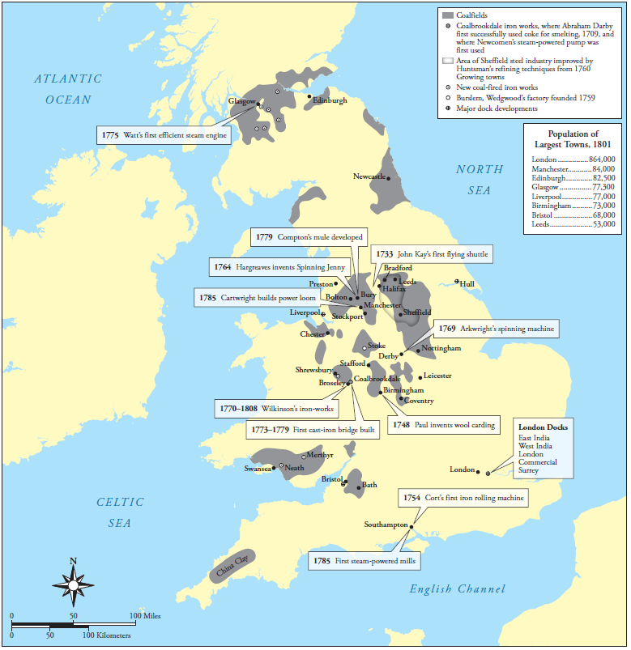
Created for the New York State K–12 Social Studies Toolkit by Agate Publishing, Inc., 2015, based on information from the Mr.Bevan website: http://www.mrbevan.com/06-the-industrial-revolution.html.

Supporting Question 1
Featured Source | Source A: Image bank: Maps of Great Britain before, during, and after the Industrial Revolution, 1701–1911

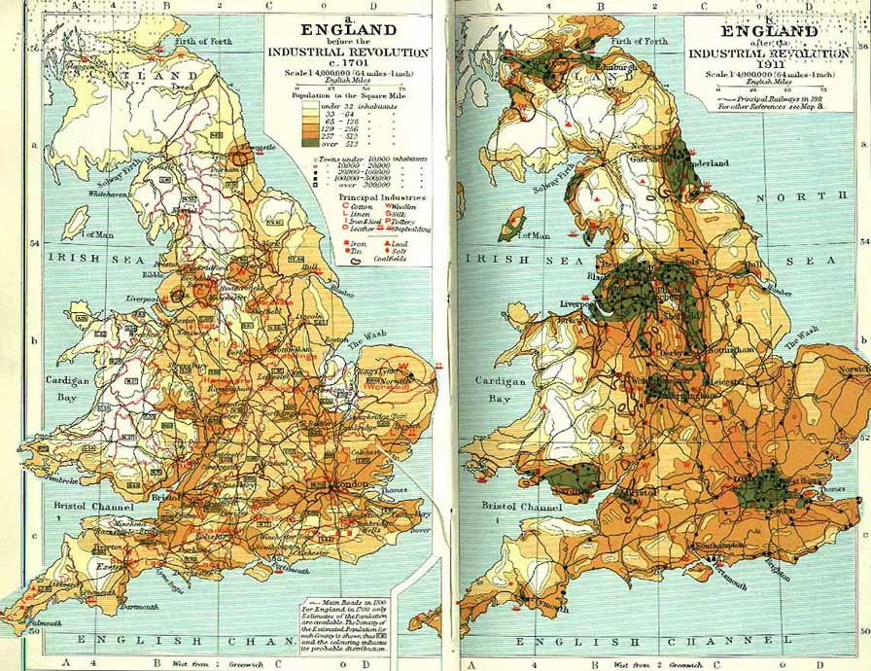

Image 1: Map comparing population density in Great Britain, 1701 and 1911.
Public domain. Ramsay Muir, Philips' New Historical Atlas for Students, first edition, 1911, George Philip & Son, Ltd., London: The London Geographical Institute. Available at Culture 4.0: The Contextual Guide and Internet Index to Western Civilization: http://www.culturalresources.com/images/maps/EngIndRevBig.jpg.

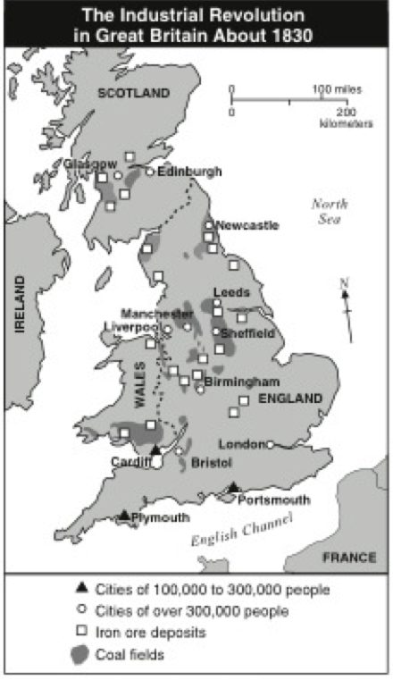

Image 2: The Industrial Revolution in Great Britain, 1830.
From World History: Patterns of Civilization, Burton F. Beers. Copyright ©1993 Pearson Education, Inc. Used with permission. All rights reserved.

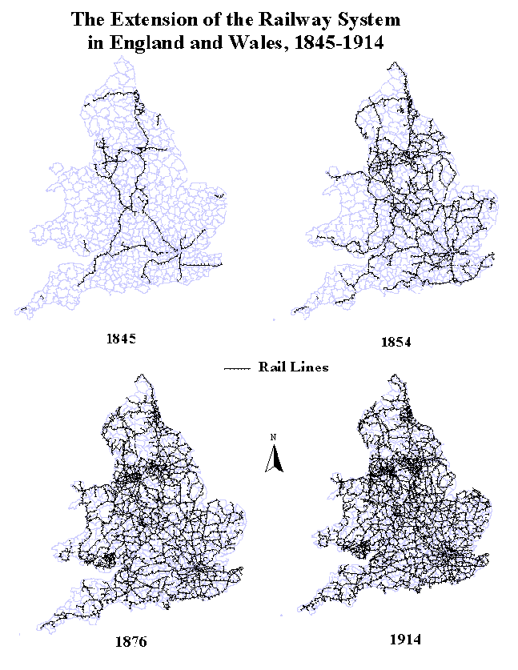

Image 3: Map of the extension of the railway system in England and Wales, 1845–1914.
© Robert Schwartz Mt. Holyoke College. https://www.mtholyoke.edu/courses/rschwart/rail/intro_hist_gis.htm.

Supporting Question 1
Featured Source | Source B: William Wyld, oil painting of Manchester, England, Manchester from Kersal Moor, 1852

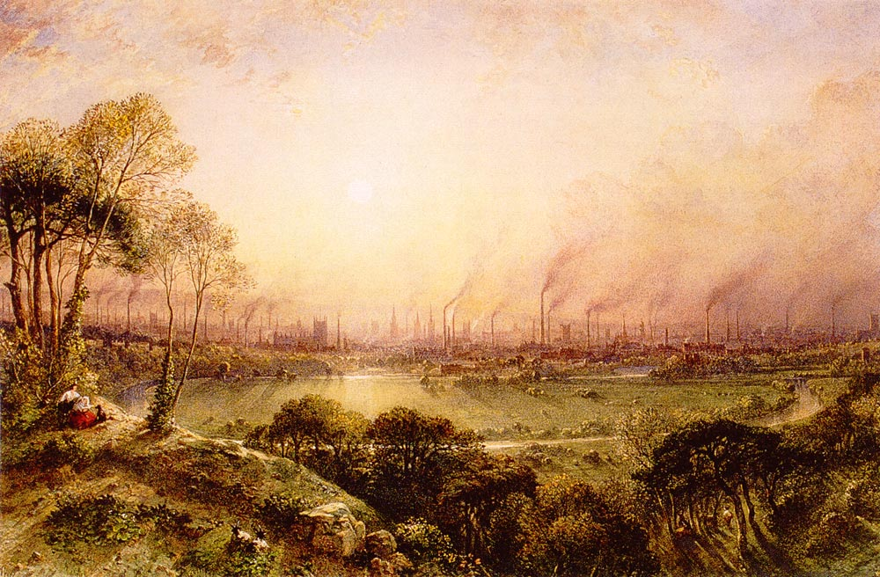

Public domain. Available at the Academic Dictionaries and Encyclopedias website: https://www.royalcollection.org.uk/collection/920223/manchester-from-kersal-moor.

Supporting Question 1
Featured Sources | Source C: Robert Owen, book describing factory life, Observations On the Effect of the Factory System (excerpt), 1815

Those who were engaged in the trade, manufactures, and commerce of this country thirty or forty years ago, formed but a very insignificant portion of the knowledge, wealth, influence, or population of the Empire.

Prior to that period, Britain was essentially agricultural. But, from that time to the present, the home and foreign trade have increased in a manner so rapid and extraordinary as to have raised commerce to an importance, which it never previously attained in any country possessing so much political power and influence.

(By the returns to the Population Act in 1811, it appears that in England, Scotland and Wales, there are 895,998 families chiefly employed in agriculture—1, 129,049 families chiefly employed in trade and manufactures—640,500 individuals in the army and navy—and 519,168 families not engaged in any of these employments. It follows that nearly half as many more persons are engaged in trade as in agriculture—and that of the whole population the agriculturists are about 1 to 3.)

This change has been owing chiefly to the mechanical inventions which introduced the cotton trade into this country, and to the cultivation of the cotton tree in America. The wants which this trade created for the various materials requisite to forward its multiplied operations, caused an extraordinary demand for almost all the manufactures previously established, and, Of course, for human labour. The numerous fanciful and useful fabrics manufactured from cotton soon became objects of desire in Europe and America: and the consequent extension of the British foreign trade was such as to astonish and confound the most enlightened statesmen both at home and abroad.

Public domain. Available at the Orion website, Loyola University: http://orion.it.luc.edu/~sjones1/owen.htm.

Supporting Question 2
Featured Source | Source A: Daniel Defoe, narrative account of traveling through Great Britain, Tour Through the Whole Island of Great Britain (excerpt), 1724

The nearer we came to Halifax, we found the houses thicker, and the villages greater. The sides of hills, which were very steep, were spread with houses; for the land being divided into small enclosures, that is to say, from two acres to six or seven acres each, seldom more; every three or four pieces of land had a house belonging to it. Their business is the clothing trade. Each clothier must keep a horse, perhaps two, to fetch and carry for the use of his manufacture, to fetch home his wool and his provisions from the market, to carry his yarn to the spinners, his manufacture to the fulling mill, and, when finished, to the market to be sold. Among the manufacturers’ houses are likewise scattered an infinite number of cottages or small dwellings, in which dwell the workmen which are employed, the women and children of whom, are always busy carding, spinning, etc. so that no hands being unemployed all can gain their bread, even from the youngest to the ancient; anyone above four years old works.
Public domain. Available at Spartacus Educational: http://spartacus-educational.com/TEXdomestic.htm.

Supporting Question 2
Featured Source | Source B: Michael Sadler, interview with former child laborer Michael Crabtree, 1832

Question: What age are you?
Answer: Twenty-two.
Question: What is your occupation?
Answer: A blanket manufacturer.
Question: Have you ever been employed in a factory?
Answer: Yes.
Question: At what age did you first go to work in one?
Answer: Eight.
Question: How long did you continue in that occupation?
Answer: Four years.
Question: Will you state the hours of labour at the period when you first went to the factory, in ordinary times?
Answer: From 6 in the morning to 8 at night.
Question: Fourteen hours?
Answer: Yes.
Question: With what intervals for refreshment and rest?
Answer: An hour at noon.
Question: When trade was brisk what were your hours?
Answer: From 5 in the morning to 9 in the evening.
Question: Sixteen hours?
Answer: Yes.
Question: With what intervals at dinner?
Answer: An hour.
Question: How far did you live from the mill?
Answer: About two miles.
Question: Was there any time allowed for you to get your breakfast in the mill?
Answer: No.
Question: Did you take it before you left your home?
Answer: Generally.
Question: During those long hours of labour could you be punctual; how did you awake?
Answer: I seldom did awake spontaneously; I was most generally awoke or lifted out of bed, sometimes asleep, by my parents.
Question: Were you always in time?
Answer: No.
Question: What was the consequence if you had been too late?
Answer: I was most commonly beaten.
Question: Severely?
Answer: Very severely, I thought.
Question: In those mills is chastisement towards the latter part of the day going on perpetually?
Answer: Perpetually.
Question: So that you can hardly be in a mill without hearing constant crying?
Answer: Never an hour, I believe.
Question: Do you think that if the overlooker were naturally a humane person it would still be found necessary for him to beat the children, in order to keep up their attention and vigilance at the termination of those extraordinary days of labour?
Answer: Yes; the machine turns off a regular quantity of cardings, and of course, they must keep as regularly to their work the whole of the day; they must keep with the machine, and therefore however humane the slubber may be, as he must keep up with the machine or be found fault with, he spurs the children to keep up also by various means but that which he commonly resorts to is to strap them when they become drowsy.
Question: At the time when you were beaten for not keeping up with your work, were you anxious to have done it if you possibly could?
Answer: Yes; the dread of being beaten if we could not keep up with our work was a sufficient impulse to keep us to it if we could.
Question: When you got home at night after this labour, did you feel much fatigued?
Answer: Very much so.
Question: Had you any time to be with your parents, and to receive instruction from them?
Answer: No.
Question: What did you do?
Answer: All that we did when we got home was to get the little bit of supper that was provided for us and go to bed immediately. If the supper had not been ready directly, we should have gone to sleep while it was preparing.
Question: Did you not, as a child, feel it a very grievous hardship to be roused so soon in the morning?
Answer: I did.
Question: Were the rest of the children similarly circumstanced?
Answer: Yes, all of them; but they were not all of them so far from their work as I was.
Question: And if you had been too late you were under the apprehension of being cruelly beaten?
Answer: I generally was beaten when I happened to be too late; and when I got up in the morning the apprehension of that was so great, that I used to run, and cry all the way as I went to the mill.

Public domain. Available from the Modern World History Interactive Textbook: http://webs.bcp.org/sites/vcleary/ModernWorldHistoryTextbook/IndustrialRevolution/PSMikeCrabtree.html.

Supporting Question 2
Featured Source | Source C: Factory inspector’s report, statement on factory working conditions, British Parliamentary Papers No. 353, 1836

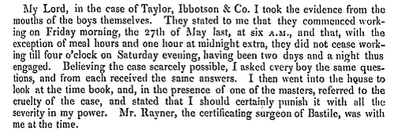

Transcript
My Lord, in the case of Taylor, Ibbotson & Co. I took the evidence from the mouths of the boys themselves. They stated to me that they commenced working on Friday morning, the 27th of May last, at six A.M., and that, with the exception of meal hours and one hour at midnight extra, they did not cease working till four o’clock on Saturday evening, having been two days and a night thus engaged. Believing the case scarcely possible, I asked every boy the same questions, and from each received the same answers. I then went into the house to look at the time book, and in the presence of one of the masters, referred to the cruelty of the case, and stated that I should certainly punish it with all the severity in my power. Mr. Rayner, the certificating surgeon of Bastile, was with me at the time.

Public domain. Available from the National Archives: http://www.nationalarchives.gov.uk/education/resources/1833-factory-act/source-1/.

Supporting Question 3
Featured Source | Source A: Friedrich Engels, book about English laborers, The Condition of the Working-Class in England in 1844 (excerpt), 1844

Manchester proper lies on the left bank of the Irwell, between that stream and the two smaller ones, the Irk and the Medlock, which here empty into the Irwell….The whole assemblage of buildings is commonly called Manchester, and contains about four hundred thousand inhabitants, rather more than less. The town itself is peculiarly built, so that a person may live in it for years, and go in and out daily without coming into contact with a working-people’s quarter or even with workers, that is, so long as he confines himself to his business or to pleasure walks. This arises chiefly from the fact, that by unconscious tacit agreement, as well as with outspoken conscious determination, the working people's quarters are sharply separated from the sections of the city reserved for the middle-class.…
I may mention just here that the mills [factories] almost all adjoin the rivers or the different canals that ramify throughout the city, before I proceed at once to describe the labouring quarters. First of all, there is the old town of Manchester, which lies between the northern boundary of the commercial district and the Irk. Here the streets, even the better ones, are narrow and winding, as Todd Street, Long Millgate, Withy Grove, and Shude Hill, the houses dirty, old, and tumble-down, and the construction of the side streets utterly horrible. Going from the Old Church to Long Millgate, the stroller has at once a row of old-fashioned houses at the right, of which not one has kept its original level; these are remnants of the old pre-manufacturing Manchester, whose former inhabitants have removed with their descendants into better built districts, and have left the houses, which were not good enough for them, to a population strongly mixed with Irish blood. Here one is in an almost undisguised working-men's quarter, for even the shops and beer houses hardly take the trouble to exhibit a trifling degree of cleanliness. But all this is nothing in comparison with the courts and lanes which lie behind, to which access can be gained only through covered passages, in which no two human beings can pass at the same time. Of the irregular cramming together of dwellings in ways which defy all rational plan, of the tangle in which they are crowded literally one upon the other, it is impossible to convey an idea. And it is not the buildings surviving from the old times of Manchester which are to blame for this; the confusion has only recently reached its height when every scrap of space left by the old way of building has been filled up and patched over until not a foot of land is left to be further occupied.
Right and left a multitude of covered passages lead from the main street into numerous courts, and he who turns in thither gets into a filth and disgusting grime, the equal of which is not to be found—especially in the courts which lead down to the Irk, and which contain unqualifiedly the most horrible dwellings which I have yet beheld. In one of these courts there stands directly at the entrance, at the end of the covered passage, a privy without a door, so dirty that the inhabitants can pass into and out of the court only by passing through foul pools of stagnant urine and excrement. Below it on the river there are several tanneries which fill the whole neighbourhood with the stench of animal putrefaction. Below Ducie Bridge the only entrance to most of the houses is by means of narrow, dirty stairs and over heaps of refuse and filth. The first court below Ducie Bridge, known as Allen's Court, was in such a state at the time of the cholera that the sanitary police ordered it evacuated, swept, and disinfected with chloride of lime….At the bottom flows, or rather stagnates, the Irk, a narrow, coal-black, foul-smelling stream, full of debris and refuse, which it deposits on the shallower right bank.
In dry weather, a long string of the most disgusting, blackish-green, slime pools are left standing on this bank, from the depths of which bubbles of miasmatic gas constantly arise and give forth a stench unendurable even on the bridge forty or fifty feet above the surface of the stream. But besides this, the stream itself is checked every few paces by high weirs, behind which slime and refuse accumulate and rot in thick masses. Above the bridge are tanneries, bone mills, and gasworks, from which all drains and refuse find their way into the Irk, which receives further the contents of all the neighbouring sewers and privies. It may be easily imagined, therefore, what sort of residue the stream deposits. Below the bridge you look upon the piles of debris, the refuse, filth, and offal from the courts on the steep left bank; here each house is packed close behind its neighbour and a piece of each is visible, all black, smoky, crumbling, ancient, with broken panes and window frames. The background is furnished by old barrack-like factory buildings. On the lower right bank stands a long row of houses and mills; the second house being a ruin without a roof, piled with debris; the third stands so low that the lowest floor is uninhabitable, and therefore without windows or doors. Here the background embraces the pauper burial-ground, the station of the Liverpool and Leeds railway, and, in the rear of this, the Workhouse, the “Poor-Law Bastille” of Manchester, which, like a citadel, looks threateningly down from behind its high walls and parapets on the hilltop, upon the working-people’s quarter below.
Everywhere heaps of debris, refuse, and offal; standing pools for gutters, and a stench which alone would make it impossible for a human being in any degree civilised to live in such a district….Passing along a rough bank, among stakes and washing-lines, one penetrates into this chaos of small one-storied, one-roomed huts, in most of which there is no artificial floor; kitchen, living and sleeping-room all in one. In such a hole, scarcely five feet long by six broad, I found two beds—and such bedsteads and beds!—which, with a staircase and chimney-place, exactly filled the room. In several others I found absolutely nothing, while the door stood open, and the inhabitants leaned against it. Everywhere before the doors refuse and offal; that any sort of pavement lay underneath could not be seen but only felt, here and there, with the feet. This whole collection of cattle-sheds for human beings was surrounded on two sides by houses and a factory, and on the third by the river, and besides the narrow stair up the bank, a narrow doorway alone led out into another almost equally ill-built, ill-kept labyrinth of dwellings....
Such is the Old Town of Manchester, and on re-reading my description, I am forced to admit that instead of being exaggerated, it is far from black enough to convey a true impression of the filth, ruin, and uninhabitableness, the defiance of all considerations of cleanliness, ventilation, and health which characterise the construction of this single district, containing at least twenty to thirty thousand inhabitants. And such a district exists in the heart of the second city of England, the first manufacturing city of the world. If any one wishes to see in how little space a human being can move, how little air—and such air!—he can breathe, how little of civilisation he may share and yet live, it is only necessary to travel hither. True, this is the Old Town, and the people of Manchester emphasise the fact whenever any one mentions to them the frightful condition of this Hell upon Earth; but what does that prove? Everything which here arouses horror and indignation is of recent origin, belongs to the industrial epoch.
Public domain. Available from the Modern World History Interactive Textbook: http://webs.bcp.org/sites/vcleary/ModernWorldHistoryTextbook/IndustrialRevolution/PSEnglesManchester.html.

Supporting Question 3
Featured Source | Source B: Charles Dickens, description of the fictional factory town Coketown, Hard Times (excerpt), 1854
Let us strike the key-note, Coketown, before pursuing our tune.
It was a town of red brick, or of brick that would have been red if the smoke and ashes had allowed it; but as matters stood, it was a town of unnatural red and black like the painted face of a savage. It was a town of machinery and tall chimneys, out of which interminable serpents of smoke trailed themselves for ever and ever, and never got uncoiled. It had a black canal in it, and a river that ran purple with ill-smelling dye, and vast piles of building full of windows where there was a rattling and a trembling all day long, and where the piston of the steam-engine worked monotonously up and down, like the head of an elephant in a state of melancholy madness. It contained several large streets all very like one another, and many small streets still more like one another, inhabited by people equally like one another, who all went in and out at the same hours, with the same sound upon the same pavements, to do the same work, and to whom every day was the same as yesterday and to-morrow, and every year the counterpart of the last and the next.
These attributes of Coketown were in the main inseparable from the work by which it was sustained; against them were to be set off, comforts of life which found their way all over the world, and elegancies of life which made, we will not ask how much of the fine lady, who could scarcely bear to hear the place mentioned. The rest of its features were voluntary, and they were these.
You saw nothing in Coketown but what was severely workful. If the members of a religious persuasion built a chapel there—as the members of eighteen religious persuasions had done—they made it a pious warehouse of red brick, with sometimes (but this is only in highly ornamental examples) a bell in a birdcage on the top of it. The solitary exception was the New Church; a stuccoed edifice with a square steeple over the door, terminating in four short pinnacles like florid wooden legs. All the public inscriptions in the town were painted alike, in severe characters of black and white. The jail might have been the infirmary, the infirmary might have been the jail, the town-hall might have been either, or both, or anything else, for anything that appeared to the contrary in the graces of their construction. Fact, fact, fact, everywhere in the material aspect of the town; fact, fact, fact,
Everywhere in the immaterial. The M’Choakumchild school was all fact, and the school of design was all fact, and the relations between master and man were all fact, and everything was fact between the lying-in hospital and the cemetery, and what you couldn't state in figures, or show to be purchaseable in the cheapest market and saleable in the dearest, was not, and never should be, world without end, Amen
Public domain. Available at the University of North Carolina at Pembroke. http://www2.uncp.edu/home/rwb/coketown.html.

Supporting Question 3
Featured Source | Source C: Graph depicting the age distribution of child laborers, “Age Distribution in Cotton Factories,” 1818–1819, 2015

Created for the New York State K–12 Social Studies Toolkit by Agate Publishing, Inc., 2015. Based on data from Wade Thatcher, Child Labor During the English Industrial Revolution. http://wathatcher.iweb.bsu.edu/childlabor/. British Parliamentary Papers (BPP) (1818) Minutes of Evidence on the Health and Morals of Apprentices and others employed in Cotton Mills and Factories. Sessional Papers, House of Lords, vol. 96, appendix. BPP (1919) Minute of Evidence on the State and Condition of the Children employed in Cotton Factories, Sessional Papers, House of Lords, vol. 110, appendix.

Supporting Question 4
Featured Source | Source A: Samuel Smiles, description of industrial effects on society, Thrift (excerpts), 1875

England is one of the richest countries in the world. Our merchants are enterprising, our manufacturers are industrious, our labourers are hard-working. There is an accumulation of wealth in the country to which past times can offer no parallel. The Bank is gorged with gold. There never was more food in the empire; there never was more money. There is no end to our manufacturing productions, for the steam-engine never tires. And yet notwithstanding all this wealth, there is an enormous mass of poverty. Close alongside the Wealth of Nations, there gloomily stalks the Misery of Nations, —luxurious ease resting upon a dark background of wretchedness.

Much of the existing misery is caused by selfishness—by the greed to accumulate wealth on the one hand, and by improvidence on the other. Accumulation of money has become the great desire and passion of the age. The wealth of nations, and not the happiness of nations, is the principal aim. We study political economy, and let social economy shift for itself. Regard for “Number One” is the prevailing maxim.

High profits are regarded as the summum bonum [highest good], —no matter how obtained, or at what sacrifice. Money is our god.…

The large earnings of the working classes is an important point to start with. The gradual diffusion of education will help them to use, and not abuse, their means of comfortable living. The more extended knowledge of the uses of economy, frugality, and thrift, will help them to spend their lives more soberly, virtuously, and religiously.

Public domain. Available at Project Gutenberg: http://www.gutenberg.org/cache/epub/14418/pg14418.html.

Supporting Question 4
Featured Source | Source B: Chart depicting life expectancy rates in 19th-century England, “Life Expectancy at Birth,” 2015

Created for the New York State K–12 Social Studies Toolkit by Agate Publishing, Inc., 2015. Data from
Simon Szreter. “Urbanization, Mortality, and the Standard of Living Debate: New Estimates of the Expectation of Life at Birth in Nineteenth-Century British Cities.” Economic History Review 50, no. 1 (1998): 84–112.

