Can we get everything we need and want?

Glass of water. © iStock.com/© ClaudioVentrella.

Supporting Questions
- What do we want? What do we need?
- How do goods and services meet our needs and wants?
- What happens when there isn’t enough for everyone?

Kindergarten Economics Inquiry

Can we get everything we need and want?
New York State Social Studies Framework Key Idea and Practices |  | K.9 People have economic needs and wants. Goods and services can satisfy people’s wants. Scarcity is the condition of not being able to have all of the goods and services that a person wants or needs.  Economics and Economic Systems Civic Participation
Staging the Question |  | Brainstorm examples of wants and needs and discuss examples of goods and services.
Supporting Question 1 |  |  |  | Supporting Question 2 |  | Supporting Question 3
What do we want? What do we need? |  |  |  | How do goods and services meet our needs and wants? |  | What happens when there isn’t enough for everyone?
Formative  Performance Task |  |  |  | Formative  Performance Task |  | Formative  Performance Task
Sort and categorize items as needs or wants. |  |  |  | Identify a need or want and determine ways in which it could be satisfied through goods and services. |  | Participate in a discussion of options people have when faced with scarcity.
Featured Source |  |  |  | Featured Source |  | Featured Source
Source A: Image bank: Needs and wants |  |  |  | Source A: Image bank: Goods and services |  | Source A: Image bank: Scarcity
Summative  Performance Task | Argument In small groups, construct arguments, supported with evidence, that address the question of whether or not we can ever get everything we need and want.
 | Extension Create two-sided collages with images of needs (or goods) on one side and wants (or services) on the other.
Taking Informed Action | Understand Identify a need or want for the classroom.  Assess Brainstorm methods of fulfilling the need or want for the classroom.  Act Select and act on a method of fulfilling the need or want for the classroom.

Overview

Inquiry Description
This inquiry focuses on the economics concept of scarcity by developing an understanding of needs and wants and goods and services through the compelling question, “Can we get everything we need and want?” The distinctions between these constructs serve as the necessary components of an examination of the choices people must make when faced with potential limitations.
Teachers will want to be sensitive to the innate, and sometimes naive, perspectives of children, whose interpretations of needs and wants often differ from those of adults. At times, students use the term “need” to indicate a sense of urgency associated with a desired but unnecessary good or service (i.e., “I need this new toy.”). When faced with limitations that impede their ability to satisfy a want, students generate curiosity around why they cannot have what they might consider to be a need. This inquiry provides them with an opportunity to explore the sometimes blurred distinction between a want and a need as they engage in discussions around economic concepts they face in their daily lives.
In their investigation of needs and wants, students begin by identifying and discussing the difference between the two terms by determining the ways in which needs and wants can be fulfilled through goods and services and by exploring the choices people face in situations of scarcity. By examining the featured sources in this inquiry, they will use their individual and collective experiences to wrestle with the condition of scarcity and how it affects humans’ desire to satisfy their needs and wants.
NOTE: This inquiry is expected to take three to five 30-minute class periods. The inquiry time frame might expand if teachers think that their students need additional instructional experiences (i.e., supporting questions, formative performance tasks, and sources). Teachers are encouraged to adapt the inquiries to meet the requirements and interests of their particular students. Resources can also be modified as necessary to meet individualized education plans (IEPs) for students receiving special education services.

Content Background
The economics principles presented in this inquiry provide students with an opportunity to begin thinking about concepts they will continue to revisit throughout their lives. As basic principles, we understand a “need” as something a person must have for health and survival (e.g., food, water, shelter, clothing) and a “want” is something a person would like to have (e.g., luxury items). Despite our ability to define these terms generally, those distinctions can blur fairly quickly. Moreover, our ideas about and perceptions of these concepts may vary greatly due to factors including, but not limited to, geography, socioeconomic status, age, health, values, and culture. Distinguishing between needs and wants is also a function of context: The sugared drink that would seem to be a want when presented as a choice with a glass of water could become a need if no other drink were available.
The line between goods and services is a bit easier to draw: Goods are those tangible things we can use, keep, and consume; services are those things that others do for us. Both goods and services help satisfy our needs and wants, but the complication comes when trying to decide the relative value of two or more goods or services. For example, although tap water and Perrier are both liquids that can serve an important need, they are valued in very different ways. Similarly, two snow-removal services—one performed by a teenager with a shovel, another by a snow plow company—contribute to the same goal but may have different values.
Helping students define and explore these basic economics principles serves as a foundation as they discuss the options citizens have when making decisions in times of scarcity. As a result, we ask ourselves as individuals and collectively as a society, “Can we get everything we need and want?”
Throughout this inquiry, students will use their emergent understandings of needs, wants, goods, services, and scarcity to make economic decisions. The sources provided in this inquiry are intended to provide them with opportunities to identify and interpret economics concepts based on sets of images. This inquiry has been designed to provide students with an occasion to apply the social studies practices of Economics and Economic Systems as well as Civic Participation to further their inquiry.

Content, Practices, and Literacies
The formative performance tasks represented in this inquiry build students’ content knowledge of economics through the associated social studies practices. The first formative performance task focuses their attention on a “need” as something that people must have for health and survival, while a “want” is something people would like to have (Economics and Economic Systems). Students build their understanding of these terms by exploring and discussing visual sources (Gathering, Using, and Interpreting Evidence). The second formative performance task focuses on the idea that goods are objects that can satisfy people’s needs and wants, while services are activities that do the same. Both tasks use the practice of Economics and Economic Systems. The third formative performance task provides students with the opportunity to identify examples of scarcity and the choices people make when faced with these conditions (Civic Participation; Economics and Economic Systems).
Evident across the three formative performance tasks is an increasing complexity of thinking. The first task works at the identification level, in that students are sorting and categorizing needs and wants. The second task begins at the identification level, in that students are asked to identify a need or want, and then it moves into the application level when they are asked to discuss and determine ways in which the need or want could be satisfied. In the third task, students move to the level of interpretation by making an economic decision based on a given event. Finally, the Taking Informed Action component allows students to participate in an activity that focuses on a classroom issue (Civic Participation).
The New York State P–12 Common Core Learning Standards for English Language Arts & Literacy offer social studies teachers numerous opportunities to integrate literacy goals and skills into their social studies instruction. The Common Core supports the inquiry process through reading rich informational texts, writing evidence-based arguments, speaking and listening in public venues, and using academic vocabulary that complements the pedagogical directions advocated in the New York State K–12 Social Studies Framework. At the end of this inquiry is an explication of how teachers might integrate literacy skills throughout the content, instruction, and resource decisions they make. The Common Core connections are listed on the last page of this inquiry.

Staging the Compelling Question
Compelling Question | Can we get everything we need and want?
Featured Sources (optional) | Source A: Photograph of a glass of water  Source B: Photograph of a sports drink

Glass of water.
© iStock.com/© Aaron Amat.
Sports drink.
© diego_cervo.
This inquiry opens with the compelling question, “Can we get everything we need and want?” The question focuses on the key economics concept of scarcity through an understanding of the distinction between needs and wants. Teachers should have a real-life example of items that humans need or want (e.g., a glass of clear water and a sports drink) available for the brainstorm session.
Teachers might begin the class by having students identify and name the general and specific similarities and differences between the pair of objects. Having students pay close attention in this fashion should expose a range of ideas about the nature and use of the objects. Teachers can then introduce the language of “need” and “want” and ask students to begin developing class-level definitions of the terms, which they will record on a whiteboard or chart paper. (Teachers may begin this activity by modeling their own thinking about the difference between a need, or “need to have,” and a want, or “want to have”; they may also want to talk through a couple of additional examples before having the students engage in making their own thoughts public.) With a set of initial definitions in mind, teachers can have the students test them by returning to the paired objects and talking through their conclusions as to whether one or both objects appear to be a need or a want. As a result of this discussion, teachers should be prepared for students to revise and refine their class-generated definitions.
To reinforce students’ emergent understandings, teachers should display other categories of goods—for example, food (a slice of bread and a decorated doughnut) or clothing (a plain knit hat and one that has an intricate design)—and ask students to repeat their prior experience of identifying and naming similarities and differences, and then applying their definitions of want and need to reach a conclusion about how to categorize the objects. At this point, teachers and students might develop symbols for “need” and “want” as a way to keep the terms in mind.
NOTE: Because this inquiry hinges on the definition of terms like “needs,” “wants,” “goods,” “services,” and “scarcity,” teachers may want to review the teacher resource Bringing Words to Life: Rich and Robust Vocabulary Instruction by Isabel L. Beck, Margaret G. McKeowan, and Linda Kucan (2nd ed., New York, Guilord Press). This book offers thoughtful advice on how to (1) introduce a new term, (2) develop student-friendly definitions, and (3) engage students with examples and nonexamples to keep them active and engaged in the process of using and applying a particular term.

Supporting Question 1
Supporting  Question | What do we want? What do we need?
Formative Performance Task | Sort and categorize items as needs or wants.
Featured Source | Source A: Image bank: Needs and wants
Conceptual Understandings | A need is something that a person must have for health and survival, while a want is something a person would like to have.
Content Specifications | Students will identify basic needs (food, clothing, and shelter).  Students will distinguish between a need and a want.
Social Studies Practices | Economics and Economic Systems

Supporting Question
Supporting Question 1 suggests that all people have needs and wants and that there is a difference between the two. As students begin to think about and investigate this supporting question and the related source images, they will explore various examples of needs and wants. This variety of images offers initial insights into the difference between the two categories.

Formative Performance Task
This formative performance task calls upon students to identify, sort, and explain their decisions about the categorization of a variety of images as needs or wants (Economics and Economic Systems). After an instructional activity using the photographic images in Featured Source A, students will demonstrate their initial understanding of needs and wants by (1) naming the items, (2) cutting out the images from the set provided, and (3) pasting them in the columns of the graphic organizer they deem appropriate. Alternatively, teachers may want to print the images on card stock, laminate the images, or load the images onto an interactive whiteboard so students can move them by touch.
After students have completed the task, teachers should lead a class discussion about why they categorized the images as they did. Disagreements about what qualifies as a need or want may still surface, as some students may identify a bed as a want, arguing that although sleep is a physical need, a person can sleep on the floor if necessary (Economics and Economic Systems). Because students are still exploring the ideas of needs and wants, it is important to hear the reasoning behind their choices. Based on this task, students may decide that they again want to revise their definitions of the needs and wants. Encouraging them to revisit complex ideas enables them to see the benefit of continued reflection and precision in language use.
Although the results of this formative performance task may mean that students’ conceptions of needs and wants are still developing, the activity helps prepare them for the Summative Performance Task by establishing a foundation of the terms “needs” and “wants” by sorting and categorizing examples.

Needs and Wants Task
Name _________________________________________________________ Date _____________________________
Cut out and sort the pictures, and then glue each one in the box where you think it belongs.
Needs | Wants

Cut out and paste these items onto the chart in the appropriate column.
© iStock.com/© ericb007. | © iStock.com/© briang77.
© Owat Tasai. | © briang77.
© iStock.com/© Benderonny. | © feoris.
© AptitudeAgency. | © einegraphic.
© iStock.com/© Mr.Vi. | 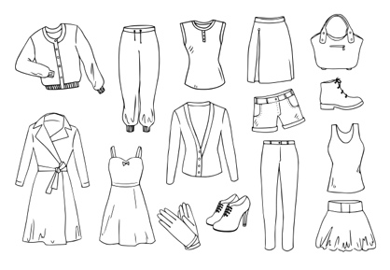  © iStock.com/© shoo_arts.

Featured Source
Featured Source A is an image bank with a variety of photographs representing needs and wants. As the distinction between a need and a want is often complex and may be based on a range of factors, these photographs offer students opportunities to participate in rich conversations with their teachers and peers.
The photographs in Featured Source A allow students to continue developing their ideas about what makes something a need or a want. Teachers might choose to model their thinking process by talking through their ideas about whether, for example, a coat is a want or a need. Because clothing is typically considered a need, the teacher might talk about why it is a need and what could happen if that need is not met. They might then want to do a similar modeling exercise around the picture of a bracelet. (Teachers may want to make the issue a bit more interesting by making a distinction between a bracelet intended as a form of jewelry and a medical ID bracelet). Then they might have a couple of students share their thinking by talking through their ideas about another photograph. Teachers might then give the remaining photographs to small groups of students to analyze.
Student ideas may bring about complex discussions around objects one person defines as a want but another person defines as a need. Students might wrestle with the array of items included within an image. For example, as in the opening of this inquiry, if the choice is between a glass of water and a sports drink, the first is clearly a need while the second is a want. But if the choice is between choosing a sports drink in the middle of playing a soccer game versus in the middle of playing a soccer video game, what was a want could be conceived of as a need. The key to defining the difference between a need and want, then, depends as much on the situation as it does the objects themselves. Teachers will want students to identify an image as a want or need and listen carefully to the rationales they offer to support their conclusions.
After analyzing and sorting the photographs, teachers might revisit the definitions of “want” and “need” that emerged when they staged the question. In doing so, teachers should ask students to cite specific examples and to support their thinking. It is possible that they will arrive at one or more useful conclusions. For example, while needs are typically defined as basic human conditions of survival (i.e., food, water, clothing, and shelter), students may decide that other things, such as education, health care, and companionship might also seem like basic needs.

Supporting Question 1
Featured Source A | Source A: Image bank: Needs and wants

Needs:
Container of food.  © iStock.com/© klenova. | Glass of water.  © iStock.com/© ClaudioVentrella.
Cabin.  © davemantel. | Coat.  © iStock.com/© zoom-zoom.

Wants:
Bracelet.  © American Medical ID. www.americanmedical-id.com. | 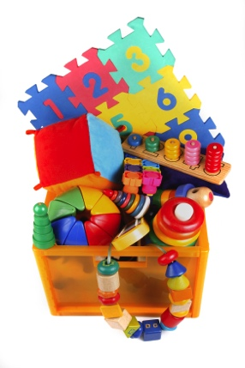  Box of toys.  © iStock.com/© misha_ru.
Stuffed Animal.  Courtesy of Vermont Teddy Bear. www.vermontteddybear.com. | Sports equipment.  © iStock.com/© miflippo.

Needs or Wants: (depending on a student’s ability to defend his or her decision or conclusion one way or another)
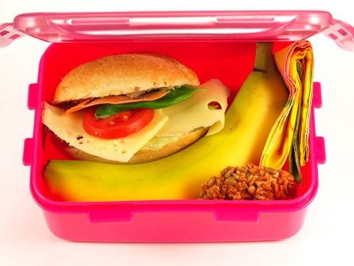  Student lunch.  © iStock.com/  © KatarzynaBialasiewicz. | Ice cream cone.  © iStock.com/  © KatarzynaBialasiewicz. | Family.  © iofoto.

Additional Resources
The sources described earlier are featured sources because they offer ways to talk about the ideas teachers may use to teach the unit; they are not meant to be a final or exhaustive list of sources.
Additional or alternative resources include
- Colleen Hord, Need It or Want It? North Mankato, MN: Rourke Publishing, 2012.
- Jennifer S. Larson, Do I Need It? Or Do I Want It? Making Budget Choices. Minneapolis, MN: Lerner Publishing Group, 2010.
- Shirley Neitzel, The Bag I'm Taking to Grandma's. New York, NY: Greenwillow Books, 1998.
- Gillia M. Olson, Needs and Wants. Mankato, MN: Capstone Press, 2008.
- Mo Williams, The Pigeon Wants a Puppy. New York, NY: Disney-Hyperion, 2008.
Additional or alternative web-based resources include
- “Needs and Wants,” Brain Pop Jr. http://www.brainpopjr.com. (Note: subscription required.)
- “Needs and Wants,” Pebble Go. http://www.pebblego.com. (Note: subscription required.)

Supporting Question 2
Supporting  Question | How do goods and services meet our needs and wants?
Formative Performance Task | Identify a need or a want and determine how it could be satisfied through goods and services.
Featured Source | Source A: Image bank: Goods and services
Conceptual Understandings | Goods are objects that can satisfy people’s needs and wants; services are activities that can do the same.
Content Specifications | Students will identify examples of goods and services.
Social Studies Practices | Economics and Economic Systems

Supporting Question
For the second supporting question, students continue their investigation of basic economic constructs by looking at the relationship between needs and wants and between goods and services. Students will begin by determining the ways in which they can satisfy a need or a want by focusing their investigation on how they can obtain goods and services.

Formative Performance Task
The formative performance task calls upon students to identify and discuss the means of satisfying a need or a want through a good and a service (Economics and Economic Systems). Students will (1) illustrate one good and one service related to food and one good and one service related to school and (2) determine a means by which they might acquire each of those goods and services.
Teachers may want students to do this task individually as a means of surveying their understandings of the relationship between needs and wants and between goods and services. They may follow up the activity by giving students opportunities to share their work with a partner so that each student has a chance to verbalize the thinking behind her or his effort. Differences of perspectives can be brought to the attention of the whole class for discussion.
The task provides students with an opportunity to identify, discuss, and describe the ways in which human needs and wants are satisfied. This formative performance task prepares students for the Summative Performance Task by allowing students to determine how those are satisfied by goods and services.

Draw pictures and answer the following questions about goods and services
Draw a picture of a good related to food.  I could get this by_______________________________  ____________________________________________________ | Draw a picture of a service related to food.  I could get this by___________________________________  ________________________________________________________
Draw a picture of good related to school.  I could get this by_______________________________  ____________________________________________________ | Draw a picture of a service related to school.  I could get this by___________________________________  ________________________________________________________

Featured Source
Featured Source A is a set of three images representing the constructs of goods and services. The distinction between goods and services is more clear-cut than that between needs and wants, yet it is typically the case that people performing services use goods in the course of their work. For example, a plumber who provides the service of thawing water pipes uses tools and materials that qualify as goods.
The images represented in this inquiry, then, depict examples of people using goods to offer their services (e.g., a firefighter with a fire truck and other equipment). Teachers should display and discuss each image in turn, have students identify the service being performed, and then have students identify the goods the person is using to complete the job. Using their prior knowledge, students should be encouraged to suggest other goods that such service providers might use that are not evident in the photograph (e.g., lumber, plumbing supplies, and tools in the hardware-store clerk image). Once the images have been discussed in terms of goods and services, teachers may want to have students work through them again to further their understandings of needs and wants. For example, the farmer offers a service (e.g., cutting hay for animal feed) that is typically considered a need; some goods purchased from the hardware-store clerk may be wants instead of needs (e.g., expensive wall paint). As with the previous discussions of the distinction between needs and wants, it is less important to pursue a right answer about whether an object is a need or a want than it is to have students articulate the reasoning behind their conclusions.

Supporting Question 2
Featured Source A | Source A: Image bank: Goods and services

Image 1: Farmer working in a hay field.
© iStock.com/© kevinmwalsh.

Image 2: Clerk working in a hardware store.
© Getty Images.

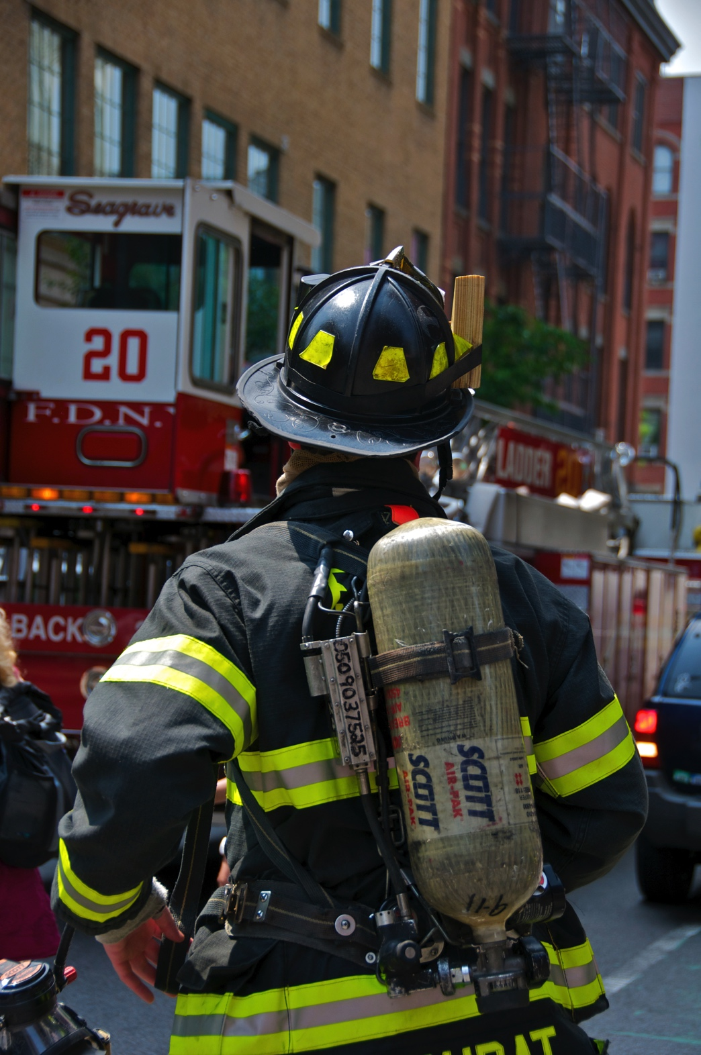

Image 3: Firefighter wearing firefighting equipment.
© JayLazarin.

Additional Resources
The sources described earlier are featured sources because they offer ways to talk about the ideas teachers may use to teach the unit; they are not meant to be a final or exhaustive list of sources.
Additional or alternative resources include
- Ellen K. Mitten, Goods or Services? North Mankato, MN: Rourke Publishing, 2012.
- Janet Nolan, PB&J Hooray!: Your Sandwich’s Amazing Journey from Farm to Table. Park Ridge, IL: Albert Whitman & Company, 2014.
- Laura Numeroff, If You Give a Mouse a Cookie. New York, NY: HarperCollins, 2010.
- Vera B. Williams, A Chair for My Mother. New York, NY: Greenwillow Books, 2007.
Additional or alternative web-based resources include
- “Goods and Services,” Brain Pop Jr. http://www.brainpopjr.com. (Note: subscription required.)
- “Goods and Services,” Pebble Go. http://www.pebblego.com. (Note: subscription required.)

Supporting Question 3
Supporting  Question | What happens when there isn’t enough for everyone?
Formative Performance Task | Participate in a discussion of options people have when faced with scarcity.
Featured Source | Source A: Image bank: Scarcity
Conceptual Understandings | Scarcity is the condition of not being able to have all of the goods and services that a person wants or needs.
Content Specifications | Students will identify examples of scarcity.
Social Studies Practices | Economics and Economic Systems Civic Participation

Supporting Question
The third supporting question puts forth the concept of scarcity as a condition of not being able to have all the goods and services that a person needs or wants. Goods or services can become scarce under certain conditions. For instance, when weather destroys crops, farmers have fewer goods to sell. When faced with situational scarcity, people must make decisions—pay a higher price, buy something else, or wait until the supply increases. This supporting question is intended to provide students with opportunities to explore the options people have when faced with conditions of scarcity.

Formative Performance Task
The formative performance task calls on students to engage in a discussion about a given scenario based around scarcity (Economics and Economic Systems). Through small-group discussions, students will brainstorm options people have when faced with scarcity and share their options with the class. This kind of structured classroom discussion can help them discover their emerging ideas.
Teachers could use an observational checklist to monitor students’ understandings and participation throughout the class discussions: They may use a simple notation system (+ or -) to record the strength of students’ understandings and participation. They may also make note of relevant comments as a reminder to talk with individual students or the class about ideas that surface in the discussion.
Scarcity Discussion Date:
STUDENT NAME | PARTICIPATION | UNDERSTANDING | COMMENTS

Featured Source
Featured Source A is an image bank with empty shelves, illustrating an example of scarcity in a grocery store. These images allow students to brainstorm and discuss the choices they might make when facing the given scenario. Teachers might choose to analyze the images together as a class or provide the images to small groups of students.
Teachers could provide the whole class with a scenario like the following:
The Weather Channel predicts that there will be a snowstorm tonight. On your way home from school, your family decides to stop at the grocery store to pick up a few items they need in case it does snow.
Teachers might then ask the class to brainstorm a list of items they might need when faced with the given situation. Students will then use the list to identify the three items most needed in the event of a storm. Teachers might then provide students with additional elements of the scenario:
Now, you travel to the store to get the things you need. When you get to the grocery store, you see a long line extending out the entrance.
At this point, teachers might show the class the image of a long line outside a store. Teachers could then continue setting the stage of the scenario:
Many people are waiting to get inside. Once it’s finally your turn, the store is out of the item you are looking for. What could your family do next?
Then, teachers might provide one picture from the image bank to each group, indicating the item that the individual group is seeking to purchase (e.g., milk, water, bread) is no longer in stock. Students could then work in small groups to collaboratively develop ideas about the choices they might make based on the scenario.
After students have brainstormed their options, teachers might want to bring them together to share their ideas, charting the ideas and identifying three or four choices people have when faced with situations of scarcity. This chart will be used as a tool for students during the summative assessment. Teachers might write down the argument and reasons for students.
Students’ ideas likely will vary, but could include any of the following:
The family might
- try to find the item somewhere else
- buy something else instead
- trade with a neighbor or friend
- wait until the store gets more
Teachers might revisit the responses and reasons generated by the class on another day, providing students with an opportunity to evaluate and revise their responses.

Additional Resources
The sources described earlier are featured sources because they offer ways to talk about the ideas teachers may use to teach the unit; they are not meant to be a final or exhaustive list of sources.
Additional or alternative resources include
- Janeen R. Adil, Scarcity. North Mankato, MN Capstone Press, 2006.
- Pat Hutchins, The Doorbell Rang. New York, NY: Greenwillow Books, 1989.
Additional or alternative web-based resources include
- “Making Choices and Scarcity,” Pebble Go. http://www.pebblego.com. (Note: subscription required.)
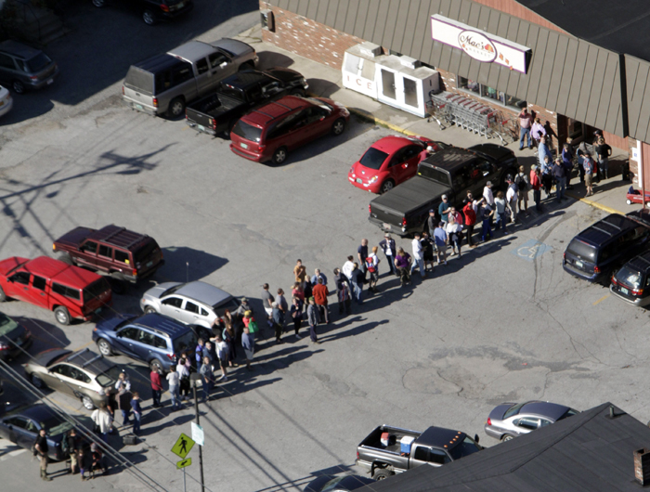

People line up outside a Vermont grocery store to get supplies after Hurricane Irene.
AP Photo/Toby Talbot.

Supporting Question 3
Featured Source A | Source A: Image bank: Scarcity at the grocery store

Image 1: Bread aisle at the supermarket.
© REUTERS/Lucas Jackson.
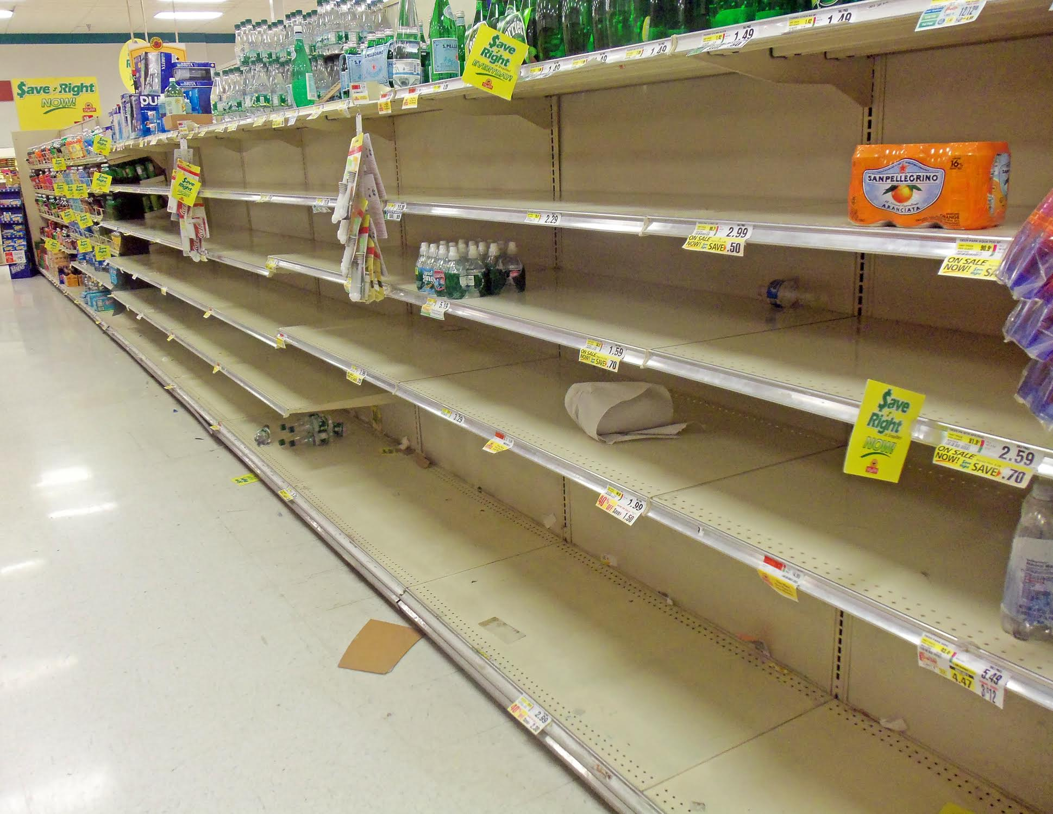
Image 2: Bottled water aisle at the supermarket.
Used courtesy of Daniel Case under Creative Commons License.
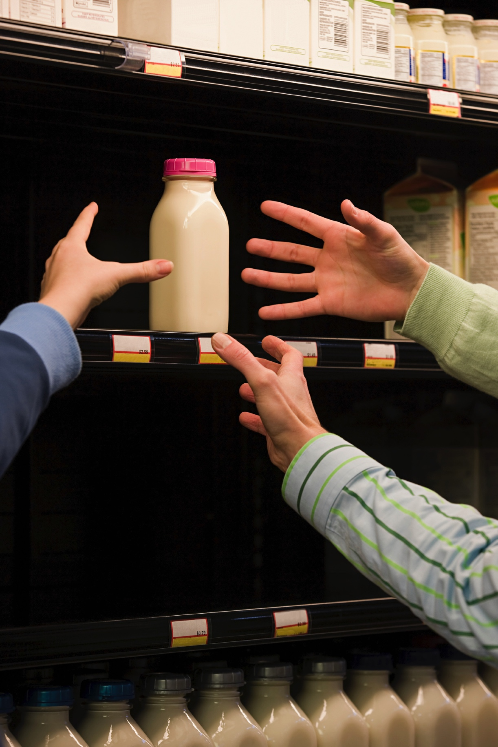
Image 3: Milk refrigerator at the supermarket.
© iStock.com/© XiXinXing.

Summative Performance Task
Compelling Question | Can we get everything we need and want?
Summative Performance Task | Argument In small groups, construct arguments, supported with evidence, that address the question of whether or not we can ever get everything we need and want.
 | Extension Create two-sided collages with images of needs (or goods) on one side and wants (or services) on the other.

Building an Argument
At this point in the students’ inquiry, they have defined and identified examples of needs, wants, goods, services, and scarcity. Students have also explored the choices citizens have when they encounter situations where needs are scarce. In the Summative Performance Task, students show their new understandings by answering an argument-based prompt and discussing their reasoning with classmates.
Before the Summative Performance Task, it might be helpful for students to review the choices that can be made during times of scarcity; doing so should help them identify an argument and work with their peers to develop claims and evidence to support that argument.
To stage this task, teachers might begin by leading a whole-class review of the definitions and lists of needs and wants created in the opening of this inquiry. This review may turn into a discussion as students return to the idea that identifying needs and wants can be complicated depending on a person’s particular situation or perspective.
Students can begin suggesting argument statements that describe their emergent understandings. Some examples of prompts that could be developed by the class may include the following:
We can get everything we need and want because ______________.
We cannot get everything we need and want because ____________.
We can get what we need, but not everything we want, because ________.
Students would then select a prompt with which they agree and meet with classmates who have selected the same prompt to discuss their reasoning around, and evidence for, their arguments. To record ideas, teachers might write them down for individual groups, have individual students report group evidence during a whole-class share, or have students record their evidence using various forms of technology, such as iPads.
Once groups have identified and recorded their ideas and evidence, the teacher can lead a whole-class discussion and have students explain the reasons for their argument. This discussion will also offer an opportunity to redirect and clarify any misunderstandings.
Students’ arguments likely will vary, but could include any of the following:
We can get everything we need and want because
- when I want something, my mom/dad will get it for me
- I/we need all that stuff
- it would be fun
We cannot get everything we need and want because
- stores might run out of stuff
- I/we don’t have that much money
- I/we should only take what I/we really need
- my mom/dad might say no
We can get what we need, but not everything we want, because
- there is always going to be something I want that I cannot afford
- there is not enough money to get everything I want
- I have to get what I need first

Extension
To extend students’ understanding of the concepts of needs, wants, goods, services, and scarcity, teachers can divide the class into two groups. The first group of students could be given sheets of paper divided vertically in half, with the words Needs and Wants written at the top on each side; the second group of students could be given similarly divided sheets of paper with Goods and Services written at the top. Students would then be given a range of magazines and the instructions to cut out images of the respective concept and paste them in the appropriate columns. Afterward, students might be placed in mixed groups to share their work by naming the images and explaining why they represent each concept.

Taking Informed Action
Compelling Question | Can we get everything we need and want?
Taking Informed Action | Understand Identify a need or want for the classroom.  Assess Brainstorm methods of fulfilling the need or want for the classroom.  Act Select and act on a method of fulfilling the need or want for the classroom.
Taking informed action can manifest in a variety of forms and in a range of venues. Students may express action through discussions, debates, surveys, video productions, and the like; these actions may take place in the classroom, in the school, in the local community, across the state, and around the world. The three activities described in this inquiry represent a logic that asks students to (1) understand the issues evident from the inquiry in a larger and/or current context, (2) assess the relevance and impact of the issues, and (3) act in ways that allow students to demonstrate agency in a real-world context.
For this inquiry, students are able to apply their knowledge of economics to make a positive change to their classroom community. Students might begin the understand component of taking action by making a list of needs or wants for their classroom. While there may be some silly suggestions, if students understand that they are involved in making real changes to their classroom, they will be more likely to consider each suggestion seriously. With a list of possible needs and wants, students can then assess the possibilities for meeting those needs and wants. Their list of needs and wants could be either goods or services and may be things that the students, their parents, or other adults might supply. As they brainstorm the methods by which the needs and wants may be fulfilled, students will also be considering the feasibility of each. Once they have brainstormed the approaches to satisfying a range of needs and wants, students can engage in an exercise of coming to consensus around one idea (or more). Part of their discussion should be the time, energy, and cost of attempting to satisfy a given need or want. With their goals in mind and having considered a thoughtful approach to achieve them, the teacher and students can act to satisfy those goals.

Common Core Connections
Social studies teachers play a key role in enabling students to develop the relevant literacy skills found in the New York State P–12 Common Core Learning Standards for English Language Arts and Literacy. The Common Core emphasis on more robust reading, writing, speaking and listening, and language skills in general and the attention to more sophisticated source analysis, argumentation, and the use of evidence in particular are evident across the Toolkit inquiries.
Identifying the connections with the Common Core Anchor Standards will help teachers consciously build opportunities to advance their students’ literacy knowledge and expertise through the specific social studies content and practices described in the annotation. The following table outlines the opportunities represented in this kindergarten inquiry through illustrative examples of each of the standards represented.
Compelling Question | Can we get everything we need and want?
Common Core Anchor Standard Connections
Reading | CCSS.ELA-LITERACY.CCRA.R.1 Read closely to determine what the text says explicitly and to make logical inferences from it; cite specific textual evidence when writing or speaking to support conclusions drawn from the text.  See Featured Source A (p. 5): After reading the source, the teacher and students will chart needs and wants and then sort those ideas into goods and services
Writing | This inquiry supports the development of CCSS.ELA-LITERACY.CCRA.W.1 (Write arguments to support claims in an analysis of substantive topics or texts using valid reasoning and relevant and sufficient evidence) AND CCSS.ELA-LITERACY.CCRA.W.5 (Develop and strengthen writing as needed by planning, revising, editing, rewriting, or trying a new approach), but teachers are doing most of the writing of students’ arguments and their reasoning in support of them.  For example, see Summative Performance Task (p. 27): Students offer a range of argument statements, meet with other students who have selected the same position to generate their reasons for supporting this argument, and revise their positions if necessary.
Speaking and Listening | CCSS.ELA-LITERACY.CCRA.SL.1 Prepare for, and participate effectively in, a range of conversations and collaborations with diverse partners, building on others’ ideas and expressing their own clearly and persuasively.  See Formative Performance Task 3 (p. 20): Students participate in a class discussion in which they brainstorm options when faced with scarcity.  CCSS.ELA-LITERACY.CCRA.SL.6 Adapt speech to a variety of contexts and communicative tasks, demonstrating command of formal English when indicated or appropriate.  See Formative Performance Task 3 (p. 20): After brainstorming options for dealing with a scarcity situation, teachers chart the students’ ideas and the reasons for them.
Language | CCSS.ELA-LITERACY.CCRA.L.3 Apply knowledge of language to understand how language functions in different contexts, to make effective choices for meaning or style, and to comprehend more fully when reading or listening.  See Staging the Compelling Question (p. 5): Teachers help students begin to distinguish between the concepts of needs and wants by identifying similarities and differences in two similar objects.

Appendix A: Needs and Wants Inquiry Vocabulary
Term | Definition
choice | Decisions made among similar ideas or objects.
good | A tangible object that can be used, kept, or consumed and that satisfies a want or need.
need | A good or service necessary for health and survival.
scarcity | Condition when there are insufficient goods or services.
service | Action taken by another person that satisfies a want or need.
want | A good or service that satisfies a desire.

